**Validation Testing for M08 Final**

**Braeden Cunningham**

**This is the data test for the validation of user input for user and order information and the deletion and completion of orders.**

**User Information validation testing:**

**Valid user input:**



**This displays the user inputting information for each entry and their information being successfully submitted.**

**Invalid user input:**

**· Blank entries**

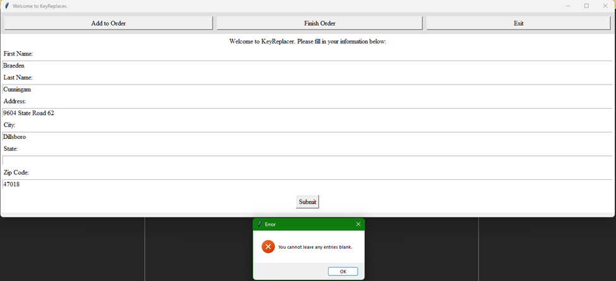

**This displays an error message being presented when the user leaves and the entry blank.**

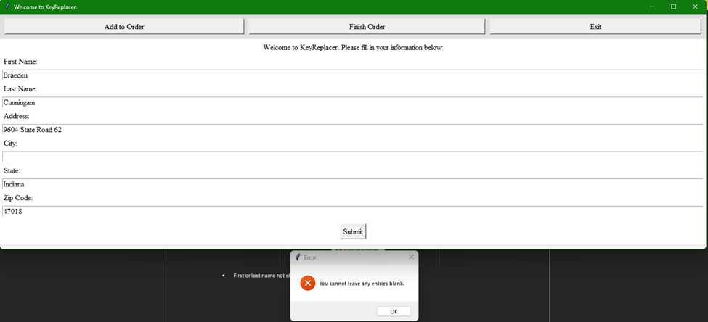

**This shows an example of it showing the same error message for a different blank entry.**

**· First or last name not alphabetical**



**This displays the error message that appears when the user inputs non-alphabetical characters into the first or last name entry.**

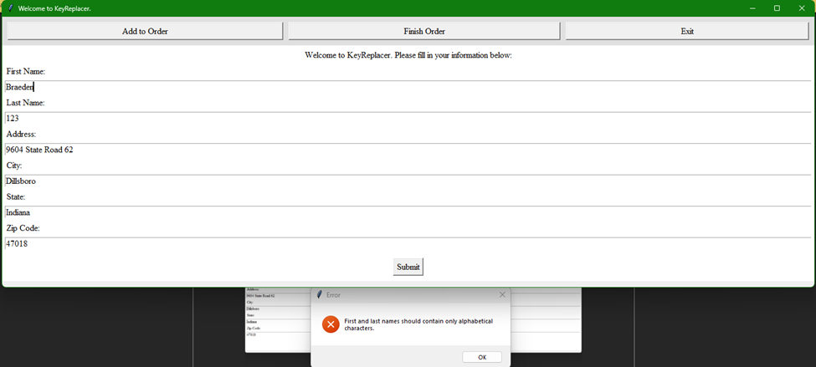

**This shows the same error message for if just one is non-alphabetical.**

**· Zip Code non-numeric:**

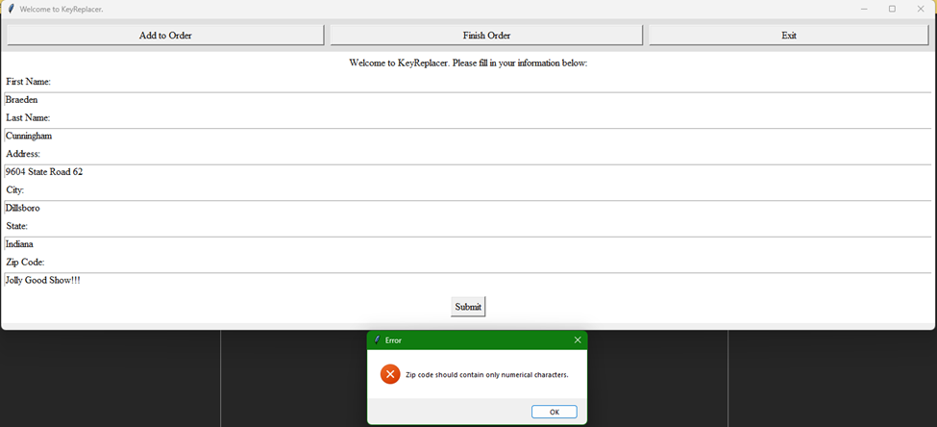

**This displays an error message that appears if the user enters non-numeric characters into the zip code entry.**

**User and order information deletion:**

**Proper deletion:**



**This gif displays the proper deletion of information from the order and how the program returns the user back to the main window and there is no longer any information stored.**

**Improper deletion:**

**· No order information to delete:**

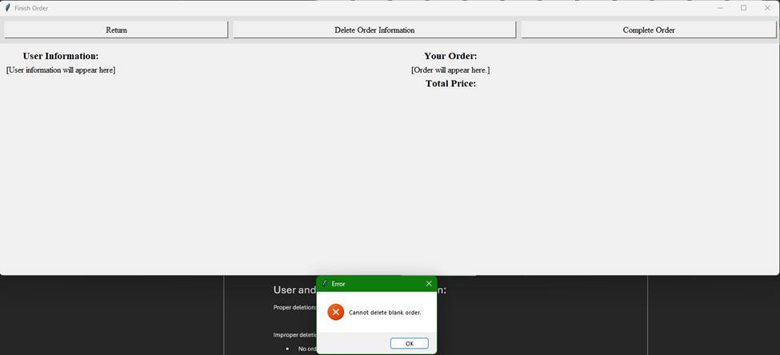

**This displays the error that is displayed if both user and order information are blank. There is no error if only one is blank because the individual information for both separately can be cleared.**

**User and order information completion:**

**Proper completion:**

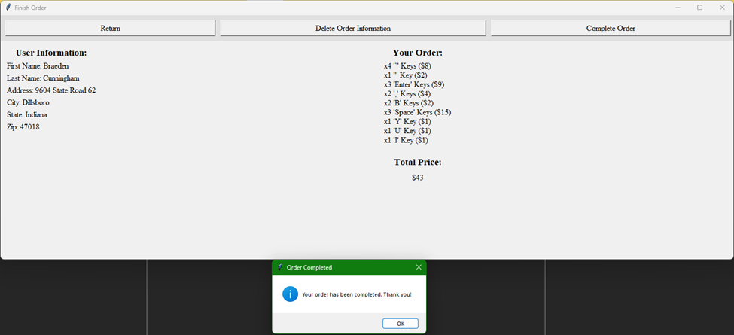

**This displays the proper completion of an order that has valid user info and order info.**

**Improper completion:**

**· No user information:**

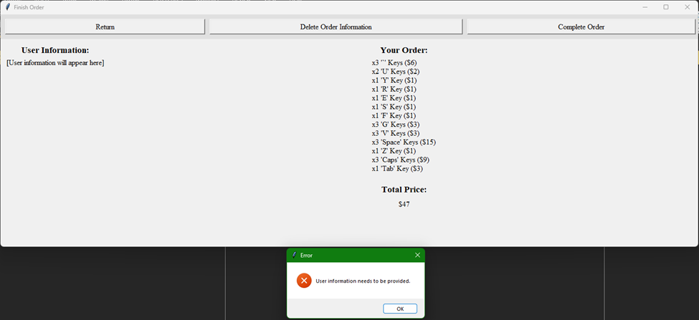

**This displays the error message when only the order info has been provided and not the user info.**

**· No order information:**

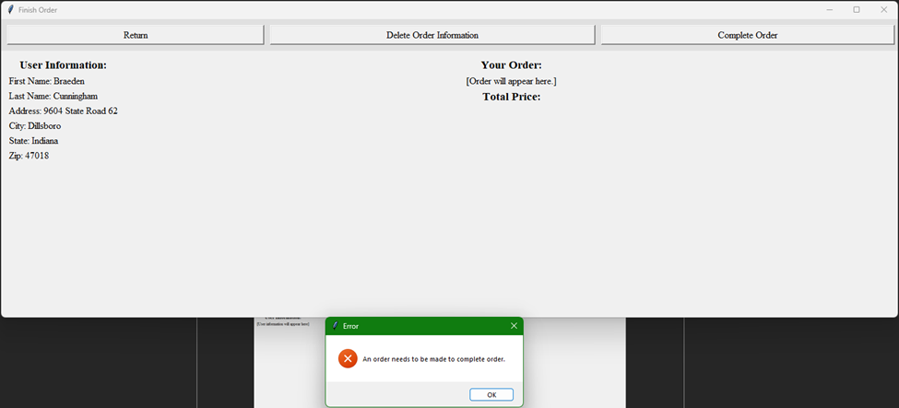

**This displays the error message that is shown when only the user information is provided and no order.**

**· Neither user nor order information:**

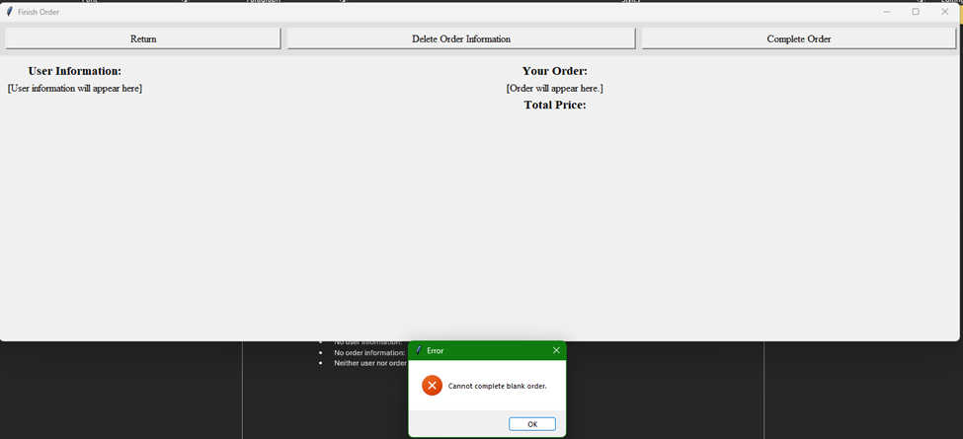

**This displays the error message that appears when the user has no information at all to have the order completed with.**