Network Scripting Lab 7

# **Introduction:**

*This lab introduces you to take a closer look defining functions and scopes in Python. To deepen your understanding of Python you are required to attempt all activities and questions presented within this Lab.*

# **Activity 1 – Simple Programs**

**These programs will relate directly to contact covered in today’s session.**

1. For each of the variables in the following program, indicate the scope. Then determine what the program prints:  
   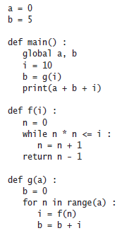

Hint: For each individual instance of a,b,i… detail if the scope at that location is local or global.

Hint: It may not be as easy as you think to determine what the program prints as there are currently semantic errors. First step through the program bit by bit (perhaps perform some trace debugging (print statements) to get an idea). Then, determine what the program is trying to print.

1. Use recursion to determine the number of digits in an integer n.   
   Hint: If n is < 10, it has one digit (e.g. 5 has 1 digit). Otherwise, it has one more digit than n // 10, which will form the basis of your recursion statement.

# **Activity 2 – Challenging Programs**

**These programs will challenge what you have learnt in today’s session. You may wish to pseudocode or flow chart them before programming**

1. Write the following functions.
   1. def firstDigit(n) (returning the first digit of the argument)
   2. def lastDigit(n) (returning the last digit of the argument)
   3. def digits(n) (returning the number of digits of the argument)

For example, firstDigit(1729) is 1, lastDigit(1729) is 9, and digits(1729) is 4

Provide a program that tests your functions.

1. Write a program that converts a Roman number such as MCMLXXVIII to its decimal number representation. Hint: First write a function that yields the numeric value of each of the letters.

Then use the following algorithm:

total = 0

While the roman number string is not empty

If value(first character) is at least value(second character), or the string has length 1

Add value(first character) to total.

Remove the character.

Else

Add the difference, value(second character)-value(first character), to total.

Remove both characters.

Hint: You may get stuck at the very end of this, in which case think about how the ordering of your conditional statements could cause errors.

1. Use recursion to implement a function find(string, match) that tests whether match is contained in string:

b = find("Mississippi", "sip") # Sets b to true

Hint: If string starts with match, you are done. If not, consider the string that you obtain by removing the first character.

Hint: Slices within the recursion statement will be very helpful here.

Hint: Make sure you’re only checking as many characters as the potential portion string contains (else you will never find it).

# **Activity 3 – Reflection**

**Provide written responses to the questions below. Answers to these questions can be located in the corresponding topic presentation for this session.**

1. Review the following code:

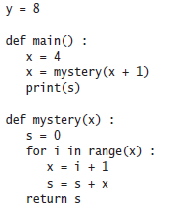

1. Which lines are in the scope of the variable i used in line 10?
2. Which lines are in the scope of the parameter variable x defined in line 8?
3. The program defines two local variables with the same name whose scopes don’t overlap. What are they?
4. Which line defines a global variable?
5. There is a scope error in the main function. What is it, and how do you fix it?