4. Work to date
Zou et al. (2022) evaluated ResNet-50 on VisA. For our supervised pilot, we used a smaller ImageNet-pretrained ResNet-18 to classify candle images. The official two-class high-shot split provided 660 labeled training images (600 normal, 60 defective) and 440 held-out test images (400 normal, 40 defective). We froze the feature extractor and trained its binary output layer for 10 epochs using AdamW, a learning rate of 0.00001, and batches of 16 images.
Training loss fell from 0.434 to 0.325, but at the preset 0.5 threshold the classifier labeled every test candle normal (Figure 1). It achieved 90.9% accuracy while detecting zero of the 40 defects, giving defect recall and F1 scores of zero. The final probability scores also ranked defects poorly across thresholds (Figure 2). Average precision was 0.088 against a test defect prevalence of 0.091, and ROC AUC was 0.444.
This single run used all available training labels and gives us a reference for the candle task. Before comparing acquisition strategies, we plan to check defect ranking and threshold choices on a validation split drawn from the training data. We will then compare random selection, predictive entropy, and Bayesian disagreement from the same starting labels and at matching labeling budgets. Reporting defect recall and average precision alongside accuracy will show whether selecting new images helps the model find defects.
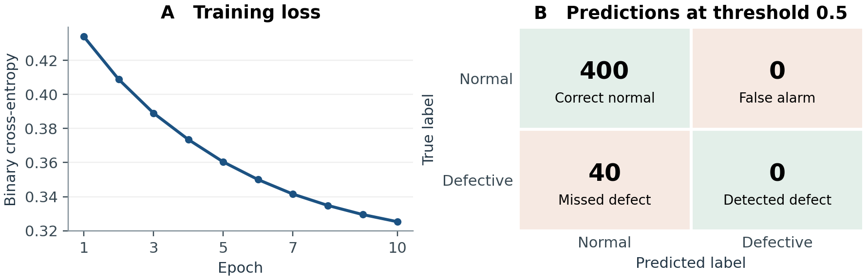
Figure 1. Training loss over 10 epochs and final test predictions at the preset threshold.
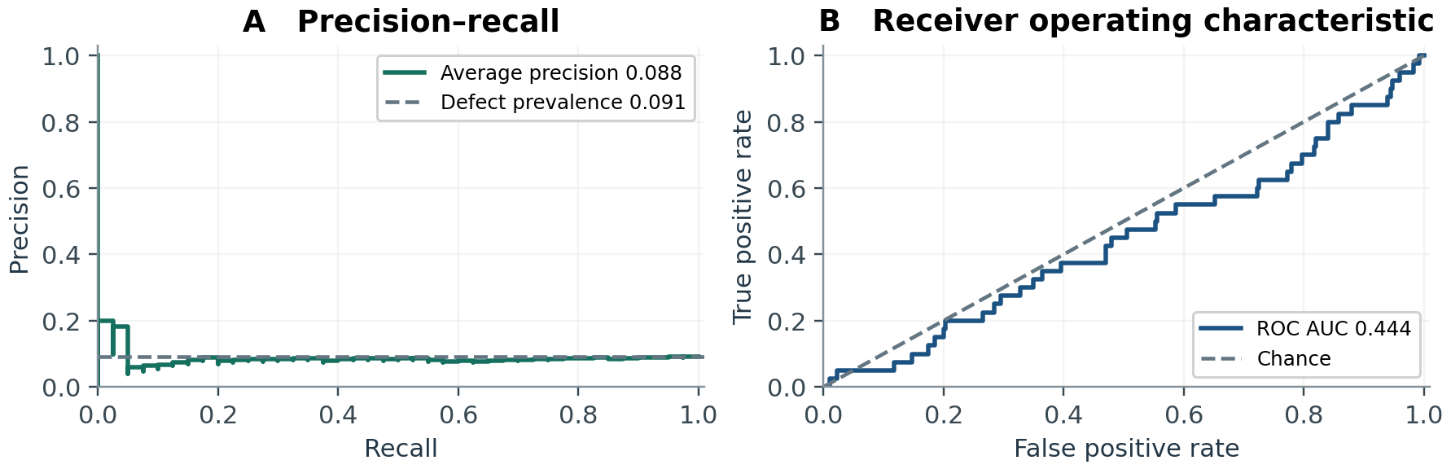
Figure 2. Final test precision–recall and ROC curves. Dashed lines mark defect prevalence and chance ROC performance, respectively.

