**Lazarev Lucia**

Defect nr.ID: 01

Title: News line in Romanian Language (MD)

Description: Web site - Airport.md after checking more than 2 times at the news line, I found issue with 2 letters (letter T and S). Issue is reproducible in the 3 browsers: Firefox, Chrome and Edge and only in Romanian language.

Platform: Win10 64 bit/ Google Chrome x86; Mozilla Firefox; Microsoft Edge

Pre-condition: Users can see difference in sizes of letters

Steps to reproduce: Two letters (T and S) fall out of news line (they are below of the news line)

Log in http: Airport.md site (MD)

Navigate in web site

Author -> Any

Categories - > Web Home

Click on “Anunta”, “Chisinau” for sort (ascending)

Click on “Anunta”, “Chisinau” for sort again (descending)

Click on “Anunta”, “Chisinau” for sort again (ascending)

Actual result: in words “Anun**t**a” and “Chi**s**inau” – two letters T and S are different than others

Expected result: Sizes of letters in one sentences should be the same.

Severity: Medium

Priority: 3

Screenshot attached (the defect): 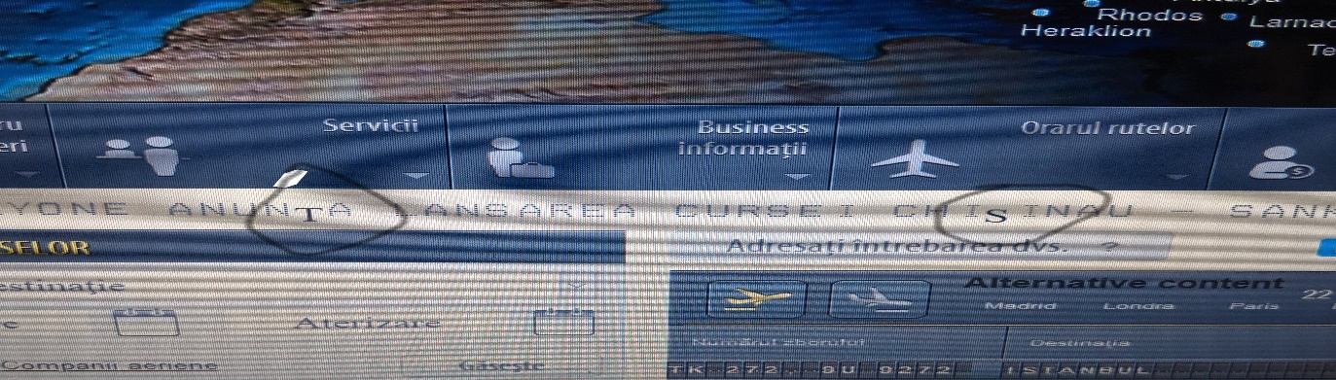

Defect nr.ID: 02

Title: City name in news line in English (EN)

Description: Web site - Airport.md after checking more than 2 times of news line in English, I found issue with 2 letters – ST (incomprehensible lettering). Issue is reproducible in the 3 browsers: Firefox, Chrome and Edge and only in Romanian language.

Platform: Win10 64 bit/ Google Chrome x86; Mozilla Firefox; Microsoft Edge

Pre-condition: Users can’t understand what’s mean these two letters - **ST**

Steps to reproduce: Two letters – “ST” supposed to change in name of the city

Log in http: Airport.md site (EN)

Navigate in web site

Author -> Any

Categories - > Web Home

Click on “ST” for sort (ascending)

Click on “ST” for sort again (descending)

Click on “ST” for sort again (ascending)

Actual result: it is not clear for customers what it means “ST”

Expected result: Should write name of the city

Severity: High

Priority: 2

Screenshot attached (the defect):

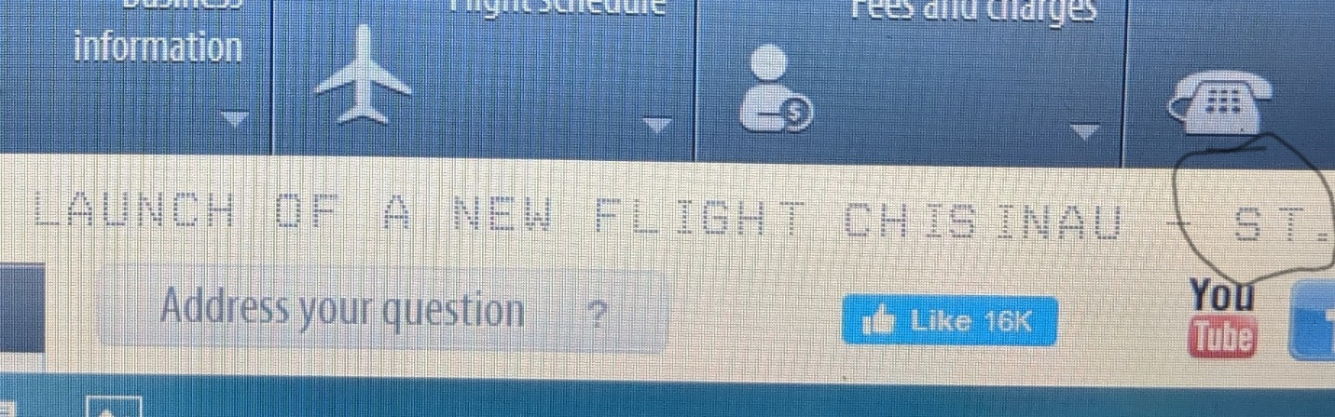

Defect nr.ID: 03

Title: Weather information does not appear in all 3 languages when you press weather button

Description:

Web site - Airport.md after checking more than 2 times of button weather in English, Romanian and Russian I found, that, the information about weather in Chisinau is not appear. Issue is reproducible in the 3 browsers: Firefox, Chrome and Edge in all 3 languages.

Platform: Win10 64 bit/ Google Chrome x86; Mozilla Firefox; Microsoft Edge

Pre-condition: Users can’t find information about weather in Chisinau

Steps to reproduce: The weather information button should show the weather information in Chisinau

Log in http: Airport.md site (EN, MD, RU)

Navigate in web site

Actual result: can’t see information about weather in Chisinau

Expected result: Should show the information about weather in Chisinau

Severity: Moderate

Priority: 2

Screenshot attached (the defect):

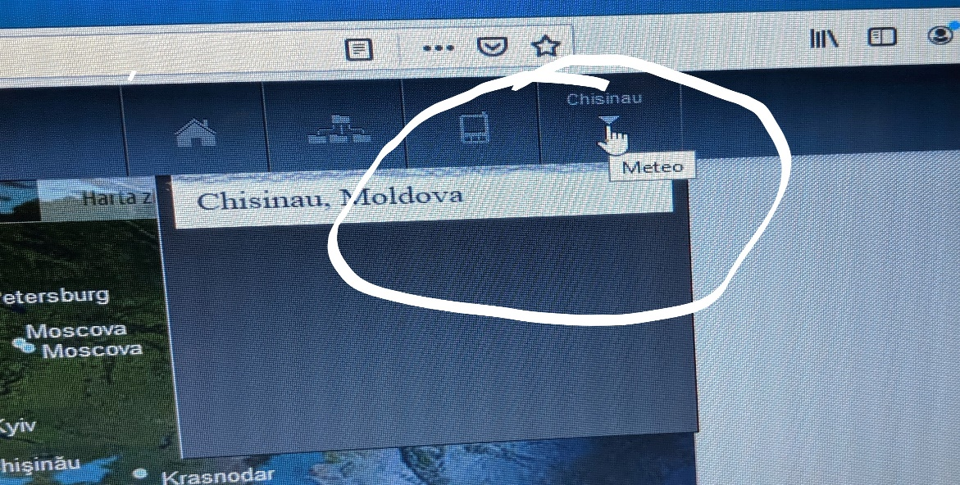

Defect nr.ID: 04

Title: The button of Instagram it is not working (web site), from RU, MD and EN languages

Button Instagram it’s not working

Description: Web site - Airport.md after checking more than 2 times of button Instagram in English, Romanian and Russian I found, that, the button of Instagram is not working. Issue is reproducible in the 3 browsers: Firefox, Chrome and Edge in all 3 languages.

Platform: Win10 64 bit/ Google Chrome x86; Mozilla Firefox; Microsoft Edge

Pre-condition: Users cannot go to the page of Instagram when pressing specific button with image of Instagram

Steps to reproduce: Customers suppose to go to the web-site of Instagram when pressing specific button of Instagram

Log in http: Airport.md site (EN, MD, RU)

Navigate in web site

Author -> Any

Categories - > Web Home

Click on button of Instagram for sort (ascending)

Click on button of Instagram for sort again (descending)

Click on button of Instagram for sort again (ascending)

Actual result: can’t go to Instagram from button of Instagram

Expected result: Should go to Instagram when pressing specific button of Instagram

Severity: Moderate

Priority: 2

Screenshot attached (the defect):

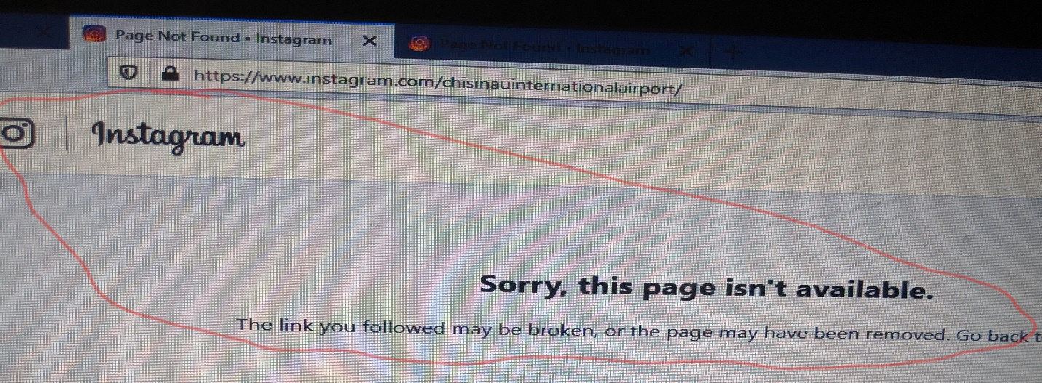

After checking more than 2 times Web site - Airport.md in browsers: Firefox, Google Chrome and Microsoft Edge, button Instagram is not working in English, Romanian and Russian languages.

Platform: Win10 64 bit/ Google Chrome x86; Mozilla Firefox; Microsoft Edge

Pre-condition: When users press button of Instagram they supposed to be redirected to the web site of Instagram.

Steps to reproduce: Specific button with logo - Instagram, should be working (to redirect customers).

Actual result: By pressing button Instagram you are not going to the web site of Instagram

Expected result: Should go to Instagram when pressing specific button of Instagram

Severity: lower

Priority: lower

Description (Optional)elibrary site after sorting more than 2 times at the “Title” link return

HTTP status 500. Issue is reproducible in the 2 browser (firefox, chrome)

Platform: Win7 64 bit/ Firefox 49.0.2 /(Chrome Версия 54.0.2840.87 m)

Pre-condiotion: User can not select ‘Moldova’ from drop down “Country”

Steps to reproduce:

1. Log in http://81.180.75.144:8080/elibrary site

2. Navigate in All Book

3. Author -&gt; Any

4. Categories - &gt; Web

5. Click on “Title” for sort (ascending)

6. Click on “Title” for sort again (descending)

7. Click on “Title” for sort again (ascending)

Actual result:

HTTP Status 500 - Request processing failed; nested exception is

org.springframework.web.client.HttpClientErrorException: 404 Not Found

Expected result: The list of books sorted by title.

Severity: Low, Moderate or Medium, high, critical

Priority: Medium 1, 2, 3,4

Screenshot attached (the defect):