**Practical assessment 1 - Creating UI elements**

**Time: 8:00 – 11:30**

In the past two week, we reviewed some important HTML/CSS concepts that are important in the design of web-based user interfaces. We developed a basic admin dashboard that we can use to develop full fledged system, in this exercise you are going to implement various components that we can find in a typical user interface like tables, form elements, buttons, alerts and cards.

**Steps**

* Download the base project from the google classroom.
* Initialise the project as a git repository.
* Create a private repository on GitHub and add **davemunthali** as a collaborator.
* Link your local repository with the remote repository on GitHub.

**Task 1- implement the dashboard**

Implement a web page like the one in the following diagram, use the icons from <https://www.w3schools.com/icons/fontawesome_icons_webapp.asp>. You can request specific colours from your invigilator, but the room for creativity is wide open.

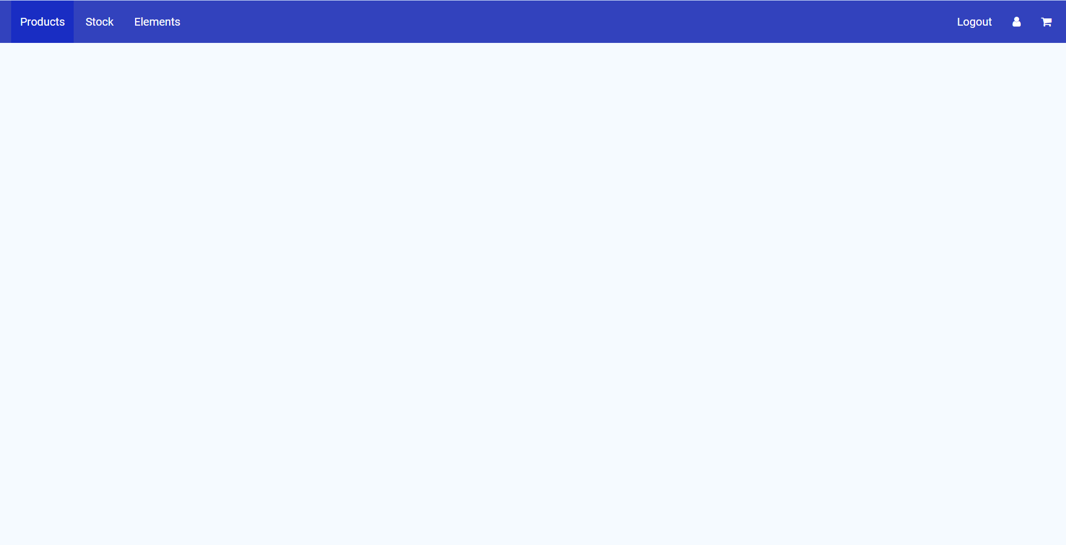

**Task 2 – The product cards**

Implement cards like in the following diagram, the content should be in the **products** page.

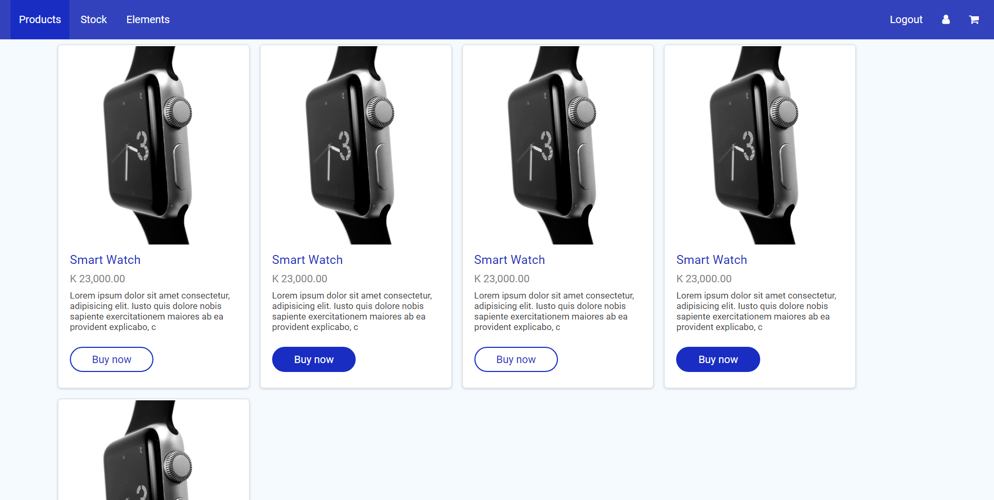

**Task 3- Implement a table**

Implement the following table, it should be display as part of the stock page. Users should view this content when they have clicked the **stock** link.

**Task 4 – Implementing components**

Implement the following components in the elements file.

