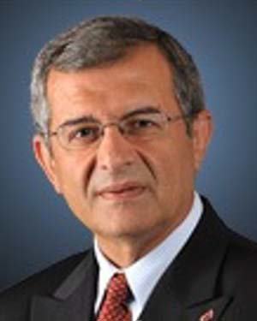
Collaborators:
Dr. Maarouf Saad (Senior Member, IEEE) received
the B.Sc. and M.Sc. degrees in electrical engineering
from École Polytechnique of Montreal,
Montreal, QC, Canada, in 1982 and 1984, respectively,
and the Ph.D. degree in electrical engineering
from McGill University, Montreal, QC,
Canada, in 1988.
In 1987, he joined École de Technologie
Supérieure, Montreal, QC, Canada, where he
is teaching control theory and robotics courses.
His research interests are in nonlinear control
and optimization applied to robotics and flight control system, rehabilitation
robotics, power systems, and distributed.

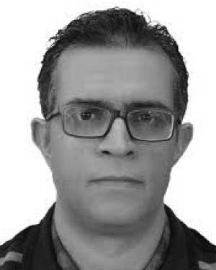
Dr. Jawhar Ghommam (Member, IEEE) received
the B.Sc. degree in computer and control engineering
from the National Institute of Applied
Science and Technology (INSAT), Tunis,
Tunisia, in 2003, the M.Sc. degree in robotics
from LIRMM, University of Montpellier, Montpellier,
France, in 2004, and the joint Ph.D. degree
in computer and control engineering from
the National Engineering School of Sfax and
the University of Orleans, Orleans, France, in
2008.
From 2008 to 2017, he was an Associate Professor with INSAT.
Since January 2018, he has been with the Department of Electrical and
Computer Engineering, Sultan Qaboos University (SQU), Seeb, Oman,
and is currently an Associate Researcher with GREPCI-Lab, École de
Technologie Supérieure, Montreal, QC, Canada. His research focuses
on motion control for nonholonomic systems, nonlinear and adaptive
control, autonomous networked systems, team cooperation, and sensor
networks.

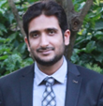
Dr. Naveed Iqbal
received the B.S. and M.S. degrees in electrical engineering from the University of Engineering and Technology, Peshawar, Pakistan, and the Ph.D. degree from the King Fahd University of Petroleum and Minerals (KFUPM), Saudi Arabia. He is currently an Assistant Professor at KFUPM. His research interests include adaptive algorithms, compressive sensing, heuristic algorithms, seismic signal processing, machine learning, and data acquisition networks.

Dr. Raouf Fareh
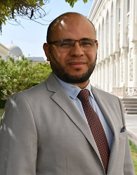
Raouf Fareh, Associate Professor at University of Sharjah since 2014. He got Ph.D (2013, honor) in Engineering from university of Quebec, Canada under supervision of Professor Maarouf Saad at the Power Electronics and Industrial Control Research Group (GREPCI). He got the specialized graduate diploma (DESS) in electrical engineering from university of Quebec, Canada in 2008. He got MSc degree in Electrical Engineering from the ENIM, Tunisia in 2006 and Bsc degree in Electrical and Automation Engineering from ENIG, Tunisia in 2003. He worked as postdoctoral fellow in the Sensing and Machine Vision for Automation and Robotic Intelligence at university of Ottawa, Canada, 2013-2014. His research interests include (but not limited to): Process Modeling, Control, Robotics, Path planning, machine vision. He is the author of about 38 technical papers in international journals and conferences. He serves as a regular referee for many international journals in the field of electrical engineering. Finally, he is a member of Institute of Electrical and Electronics Engineering (IEEE), and a member in the steering committee for UAE IEEE student’s competitions.

Postdoc :
Dr. Abderraouf Maoudj
received the Ph.D. degree in Control and Robotics from the University of Science and Technology Houari Boumediene (USTHB), Algeria, in 2018. From 2014 to 2020, he was a researcher with the Center for the Development of Advanced Technologies (CDTA). In 2021, he joined the University of Southern Denmark (SDU), Denmark, as a Postdoctoral Researcher, where he worked extensively on AI-based methods for optimizing multi-robot fleet coordination in warehouses and fulfillment centers. His contributions have had a significant impact on automated warehousing and smart manufacturing, enabling robust and adaptable systems for next-generation industrial automation. Since 2023, he has been a Postdoctoral Research Fellow at the Interdisciplinary Research Center for Intelligent Manufacturing \& Robotics (IRC-IMR), KFUPM. His research interests include reinforcement learning, imitation learning, world-model-based policy optimization, and human–robot interaction, with a particular focus on multi-robot learning and coordination, and next-generation robotic manipulation systems.
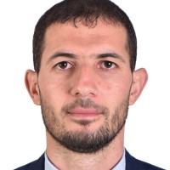

Students:
Ms students
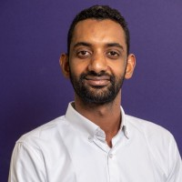
Ali Mustafa : “ MSc student in Electrical Engineering (Control) at King Fahd University of Petroleum & Minerals (KFUPM) his thesis about “Trajectory Tracking for a 4-DoF Robotic Arm Manipulator Based on Game Theory”

