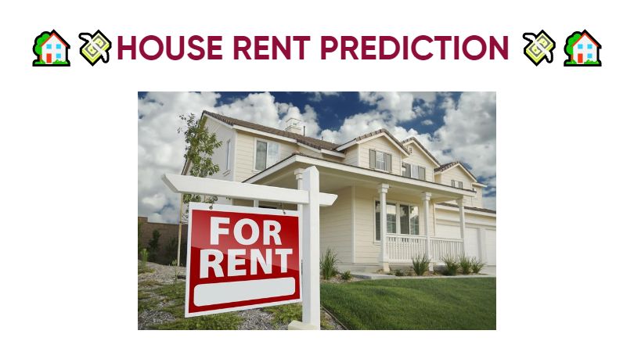

Context

Dataset Glossary (Column-Wise)
- BHK: Number of Bedrooms, Hall, Kitchen.
- Rent: Price of the Houses/Apartments/Flats.
- Size: Size of the Houses/Apartments/Flats in Square Feet.
- Floor: Houses/Apartments/Flats situated in which Floor and Total Number of Floors (Example: Ground out of 2, 3 out of 5, etc.)
- Area Type: Size of the Houses/Apartments/Flats calculated on either Super Area or Carpet Area or Build Area.
- Area Locality: Locality of the Houses/Apartments/Flats.
- City: City where the Houses/Apartments/Flats are Located.
- Furnishing Status: Furnishing Status of the Houses/Apartments/Flats, either it is Furnished or Semi-Furnished or Unfurnished.
- Tenant Preferred: Type of Tenant Preferred by the Owner or Agent.
- Bathroom: Number of Bathrooms.
- Point of Contact: Whom should you contact for more information regarding the Houses/Apartments/Flats.

Importing Libraries
import numpy as np
import pandas as pd
import matplotlib.pyplot as plt
import seaborn as sns
import plotly.express as px
from wordcloud import WordCloud
from sklearn import metrics
from sklearn.model_selection import train_test_split, cross_val_score
from sklearn.linear_model import LinearRegression
from sklearn.tree import DecisionTreeRegressor
from sklearn.ensemble import RandomForestRegressor
from sklearn.svm import SVR
from sklearn.metrics import r2_score, mean_absolute_error, mean_squared_error
import warnings
warnings.filterwarnings('ignore')

Loading Data
rent_data = pd.read_csv('/kaggle/input/house-rent-prediction-dataset/House_Rent_Dataset.csv')
rent_data.head()
Posted On BHK Rent Size Floor Area Type \
0 2022-05-18 2 10000 1100 Ground out of 2 Super Area
1 2022-05-13 2 20000 800 1 out of 3 Super Area
2 2022-05-16 2 17000 1000 1 out of 3 Super Area
3 2022-07-04 2 10000 800 1 out of 2 Super Area
4 2022-05-09 2 7500 850 1 out of 2 Carpet Area
Area Locality City Furnishing Status Tenant Preferred \
0 Bandel Kolkata Unfurnished Bachelors/Family
1 Phool Bagan, Kankurgachi Kolkata Semi-Furnished Bachelors/Family
2 Salt Lake City Sector 2 Kolkata Semi-Furnished Bachelors/Family
3 Dumdum Park Kolkata Unfurnished Bachelors/Family
4 South Dum Dum Kolkata Unfurnished Bachelors
Bathroom Point of Contact
0 2 Contact Owner
1 1 Contact Owner
2 1 Contact Owner
3 1 Contact Owner
4 1 Contact Owner
rent_data.info()
<class 'pandas.core.frame.DataFrame'>
RangeIndex: 4746 entries, 0 to 4745
Data columns (total 12 columns):
# Column Non-Null Count Dtype
--- ------ -------------- -----
0 Posted On 4746 non-null object
1 BHK 4746 non-null int64
2 Rent 4746 non-null int64
3 Size 4746 non-null int64
4 Floor 4746 non-null object
5 Area Type 4746 non-null object
6 Area Locality 4746 non-null object
7 City 4746 non-null object
8 Furnishing Status 4746 non-null object
9 Tenant Preferred 4746 non-null object
10 Bathroom 4746 non-null int64
11 Point of Contact 4746 non-null object
dtypes: int64(4), object(8)
memory usage: 445.1+ KB
rent_data.isna().sum()
Posted On 0
BHK 0
Rent 0
Size 0
Floor 0
Area Type 0
Area Locality 0
City 0
Furnishing Status 0
Tenant Preferred 0
Bathroom 0
Point of Contact 0
dtype: int64

Observations:
- There is no null value for any column in the dataset.

Descriptive Statistics
rent_data.describe()
BHK Rent Size Bathroom
count 4746.000000 4.746000e+03 4746.000000 4746.000000
mean 2.083860 3.499345e+04 967.490729 1.965866
std 0.832256 7.810641e+04 634.202328 0.884532
min 1.000000 1.200000e+03 10.000000 1.000000
25% 2.000000 1.000000e+04 550.000000 1.000000
50% 2.000000 1.600000e+04 850.000000 2.000000
75% 3.000000 3.300000e+04 1200.000000 2.000000
max 6.000000 3.500000e+06 8000.000000 10.000000

Data Analysis and Visualization

Pairplot of data
sns.pairplot(rent_data,height=2)
plt.show()
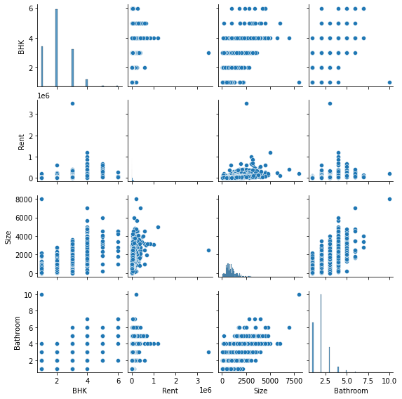

Univariate Analysis

Rent (Our Target Variable)
fig = px.histogram(rent_data,x='Rent',color_discrete_sequence = px.colors.qualitative.Set3, title="Rent Prices Distribution Histogram")
fig.show()
fig = px.box(rent_data, x="Rent", title='Boxplot for Rent Prices')
fig.show()

Observations:
- There is one outlier so far out of the inter-quantile range.

Actions:
- To remove outlier, as it may affect our assumptions about other variables and analysis

Checking the position of Outlier
print(np.where(rent_data['Rent']>2000000))
(array([1837]),)

Observations:
- Outlier's position is at 1837th position in a dataframe.

Deleting the Outlier
rent_data.drop([1837], axis=0, inplace=True)
fig = px.box(rent_data, x="Rent",title='Boxplot for Rent Prices')
fig.show()

BHK
rent_data['BHK'].value_counts()
2 2265
1 1167
3 1097
4 189
5 19
6 8
Name: BHK, dtype: int64
sns.set_style('whitegrid')
fig,axes = plt.subplots(figsize=(12,8))
colors = ['#87ace8','#e3784d', '#6ecc64','#b644e3','#eb7c87', '#EAE509']
ax = sns.countplot(x='BHK',data=rent_data, palette=['#e3784d','#87ace8', '#6ecc64','#b644e3','#eb7c87','#EAE509'])
for container in ax.containers:
ax.bar_label(container)
plt.title('Frequency of different number of BHKs present in Houses available for Rent',fontsize=15)
plt.show()
fig = px.pie(rent_data, names='BHK', height=700, width= 700, color_discrete_sequence=px.colors.sequential.deep, title='Pie Chart for different number of BHKs present in Houses available for Rent')
fig.update_traces(textfont_size=15)
fig.show()
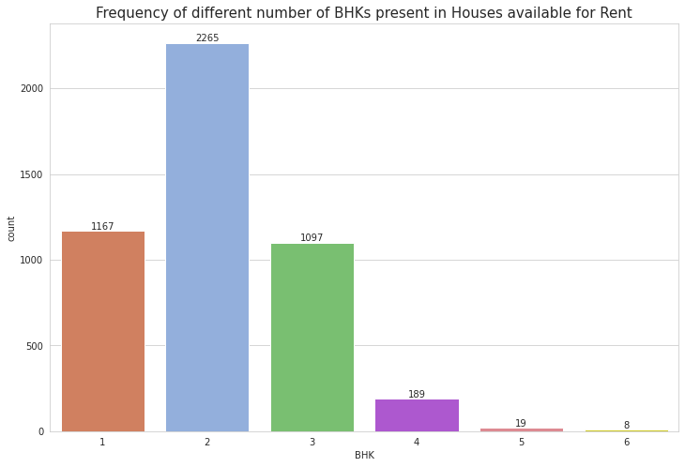

Observations:
- Mostly 2 BHK house are rented the most, as it is mostly under budget for the people and can be rented soon.
- 5 and 6 BHK house are put less for rent, because there is very less demand for such big spacious houses in India.

Bathroom
rent_data['Bathroom'].value_counts()
2 2291
1 1474
3 748
4 156
5 60
6 12
7 3
10 1
Name: Bathroom, dtype: int64
sns.set_style('whitegrid')
fig,axes = plt.subplots(figsize=(12,8))
colors = ['#87ace8','#e3784d', '#6ecc64','#b644e3','#eb7c87', '#EAE509','#fab1f3','#86f7d7']
ax = sns.countplot(x='Bathroom',data=rent_data, palette=['#e3784d','#87ace8', '#6ecc64','#b644e3','#eb7c87','#fab1f3','#86f7d7','#EAE509'])
for container in ax.containers:
ax.bar_label(container)
plt.title('Frequency of different number of Bathrooms present in Houses available for Rent',fontsize=15)
plt.show()
fig = px.pie(rent_data, names='Bathroom', height=700, width= 700, color_discrete_sequence=px.colors.sequential.deep, title='Pie Chart for different number of Bathrooms present in Houses available for Rent')
fig.update_traces(textfont_size=15)
fig.show()
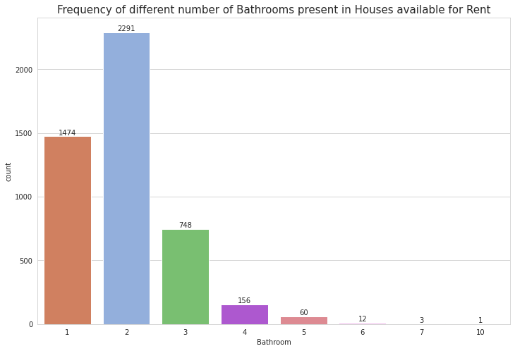

Observations:
- House with 2 Bathrooms are most common for the houses put up on rent.
- Houses with 7 and 10 bathroom quite seems inappropriate and not much of use.

City
rent_data['City'].value_counts()
Mumbai 972
Chennai 891
Bangalore 885
Hyderabad 868
Delhi 605
Kolkata 524
Name: City, dtype: int64
sns.set_style('whitegrid')
fig,axes = plt.subplots(figsize=(12,8))
colors = ['#87ace8','#e3784d', '#6ecc64','#b644e3','#eb7c87', '#EAE509']
ax = sns.countplot(x='City',data=rent_data, palette=['#EAE509','#87ace8', '#6ecc64','#eb7c87','#e3784d','#b644e3'])
for container in ax.containers:
ax.bar_label(container)
plt.title('City wise Houses available for Rent',fontsize=15)
plt.show()
fig = px.pie(rent_data, names='City', height=700, width= 700, color_discrete_sequence=px.colors.sequential.deep, title='Pie Chart for Houses available for Rent in different cities')
fig.update_traces(textfont_size=15)
fig.show()
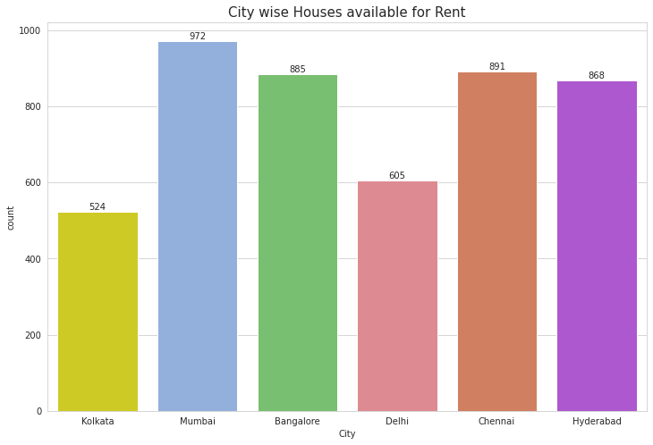

Observations:
- Mumbai, followed by Chennai and Hyderad has most number of rented houses, seems like there is very high demand considering the job corporates and other factors.

Area Type
rent_data['Area Type'].value_counts()
Super Area 2446
Carpet Area 2297
Built Area 2
Name: Area Type, dtype: int64
colors = ['#87ace8', '#6ecc64', '#EAE509']
sns.set_style('whitegrid')
fig,axes = plt.subplots(figsize=(12,8))
ax = sns.countplot(x='Area Type',data=rent_data, palette=['#87ace8', '#6ecc64', '#EAE509'])
for container in ax.containers:
ax.bar_label(container)
plt.title('Area wise Rented Housed Distribution',fontsize=15)
plt.show()
plt.figure(figsize = (20, 10))
rent_data['Area Type'].value_counts().plot.pie(explode=[0.05, 0.05,0.05],textprops={'fontsize': 12}, autopct='%1.2f%%',colors=colors, shadow=True)
plt.title('Pie Chart for Area Type',fontsize=15)
plt.axis('equal')
plt.legend( loc = "best")
plt.show()
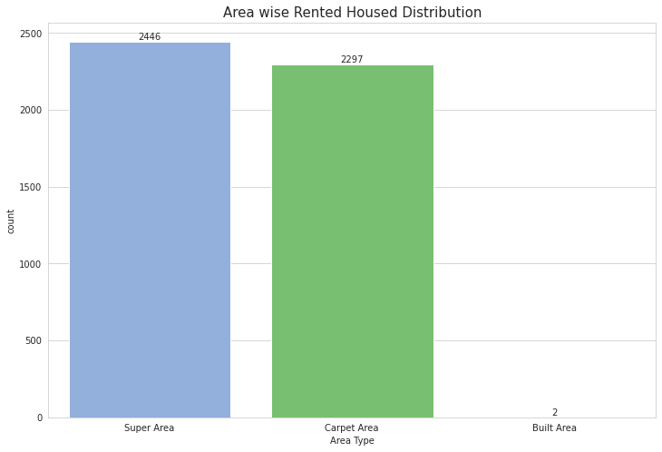
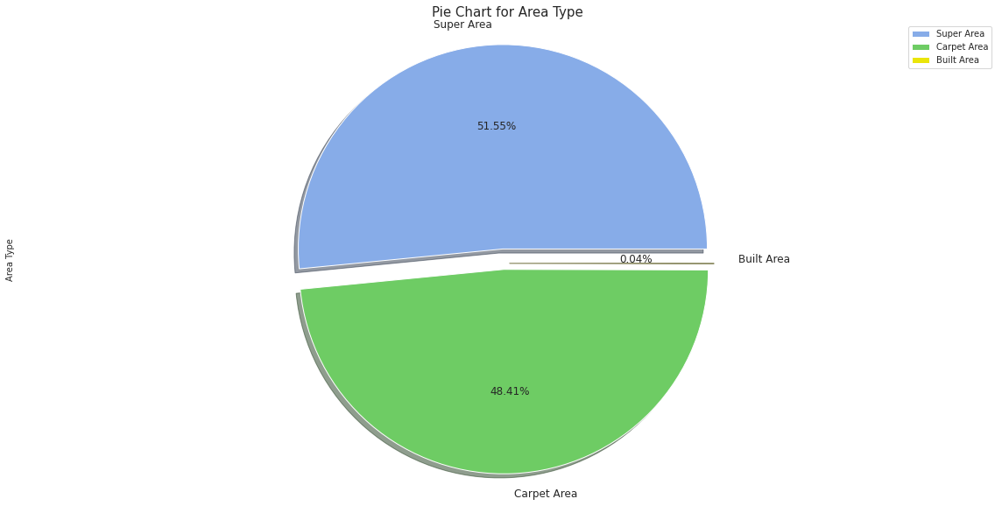

Observations:
- Super area houses are more put up on rent.
- Built Area wise rented houses are very less.

Point of Contact
rent_data['Point of Contact'].value_counts()
Contact Owner 3216
Contact Agent 1528
Contact Builder 1
Name: Point of Contact, dtype: int64
colors = ['#87ace8', '#6ecc64', '#EAE509']
sns.set_style('whitegrid')
fig,axes = plt.subplots(figsize=(12,8))
ax = sns.countplot(x='Point of Contact',data=rent_data, palette=['#87ace8', '#6ecc64', '#EAE509'])
for container in ax.containers:
ax.bar_label(container)
plt.title('Point of Contact Distribution for House Renting',fontsize=15)
plt.show()
plt.figure(figsize = (20, 10))
rent_data['Point of Contact'].value_counts().plot.pie(explode=[0.05, 0.05,0.05],textprops={'fontsize': 12}, autopct='%1.2f%%',colors=colors, shadow=True)
plt.title('Pie Chart for Area Type',fontsize=15)
plt.axis('equal')
plt.legend( loc = "best")
plt.show()
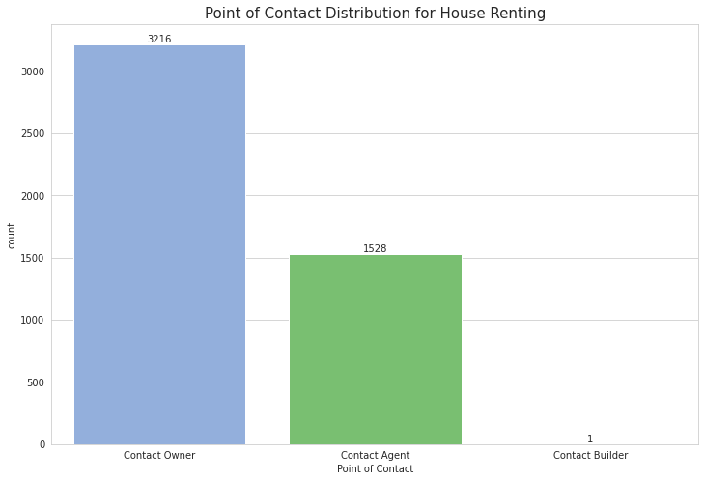
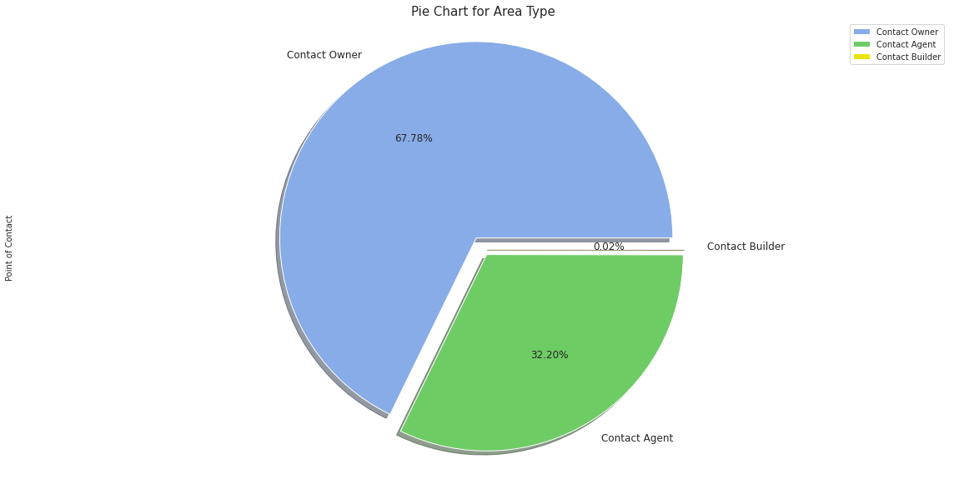

Observations:
- Contact wise most have put the contact of owner only, as it directly more helps with negotiation and verification.

Tenant Preferred
colors = ['#87ace8', '#6ecc64', '#EAE509']
sns.set_style('whitegrid')
fig,axes = plt.subplots(figsize=(12,8))
ax = sns.countplot(x='Tenant Preferred',data=rent_data, palette=['#87ace8', '#6ecc64', '#EAE509'])
for container in ax.containers:
ax.bar_label(container)
plt.title('Tenant Preferred Distribution for House Renting',fontsize=15)
plt.show()
plt.figure(figsize = (20, 10))
rent_data['Tenant Preferred'].value_counts().plot.pie(explode=[0.05, 0.05,0.05],textprops={'fontsize': 12}, autopct='%1.2f%%',colors=colors, shadow=True)
plt.title('Pie Chart for Tenant Preferred',fontsize=15)
plt.axis('equal')
plt.legend( loc = "best")
plt.show()
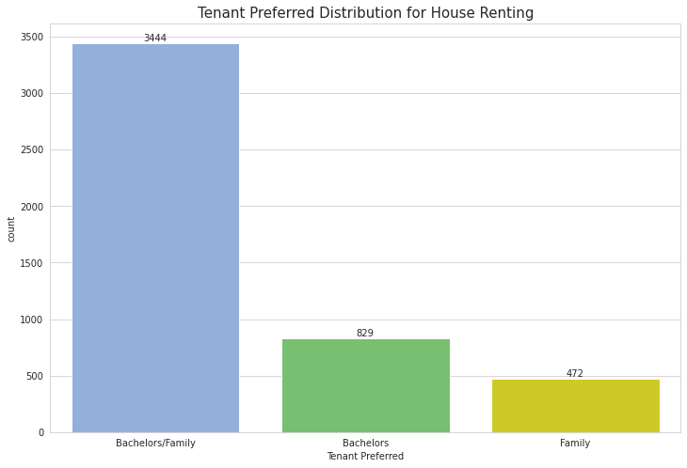
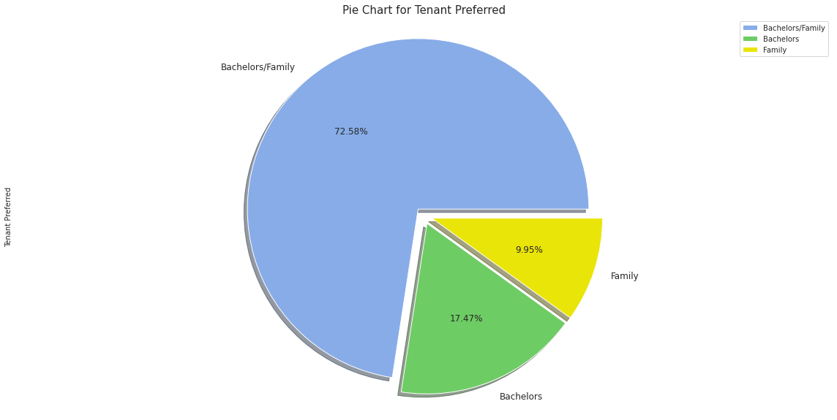

Observations:
- It seems most rented houses have no special category. They are okay with both Bachelors and Family.

Furnishing Status
colors = ['#87ace8', '#6ecc64', '#EAE509']
sns.set_style('whitegrid')
fig,axes = plt.subplots(figsize=(12,8))
ax = sns.countplot(x='Furnishing Status',data=rent_data, palette=['#87ace8', '#6ecc64', '#EAE509'])
for container in ax.containers:
ax.bar_label(container)
plt.title('Furnishing Status Distribution for House Renting',fontsize=15)
plt.show()
plt.figure(figsize = (20, 10))
rent_data['Furnishing Status'].value_counts().plot.pie(explode=[0.05, 0.05,0.05],textprops={'fontsize': 12}, autopct='%1.2f%%',colors=colors, shadow=True)
plt.title('Pie Chart for Furnishing Status',fontsize=15)
plt.axis('equal')
plt.legend( loc = "best")
plt.show()
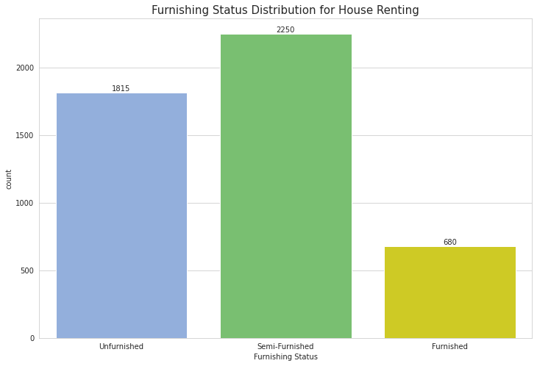
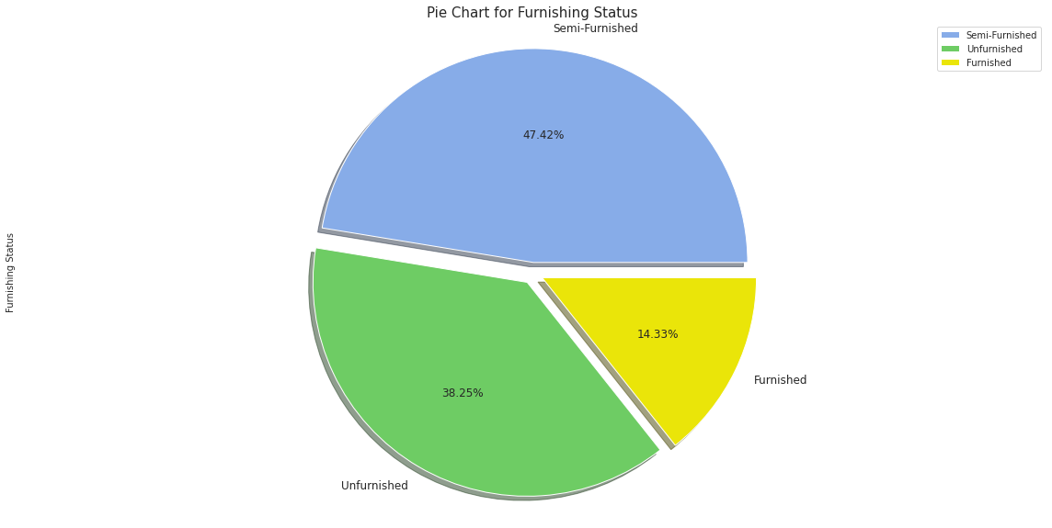

Observations:
- Most Rented Houses are semi-furnished.
- Also cost wise these houses will be quite good to stay and pocket friendly.

Size
fig = px.histogram(rent_data, x="Size", title='Size Distribution')
fig.show()
fig = px.box(rent_data, x="Size", title='Boxplot for Size')
fig.show()

Observations:
- The smallest house rented has size of about 10 sq. feet.
- The biggest house rented has size of about 8000 sq. feet.
- The median of house rented has size of about 850 sq. feet.

Bivariate Analysis

BHK and Rent distribution
fig,axes = plt.subplots(figsize=(15,10))
sns.boxenplot(x="BHK", y='Rent',data=rent_data)
plt.title('Boxenplot for BHK and Rent',fontsize=15)
plt.show()
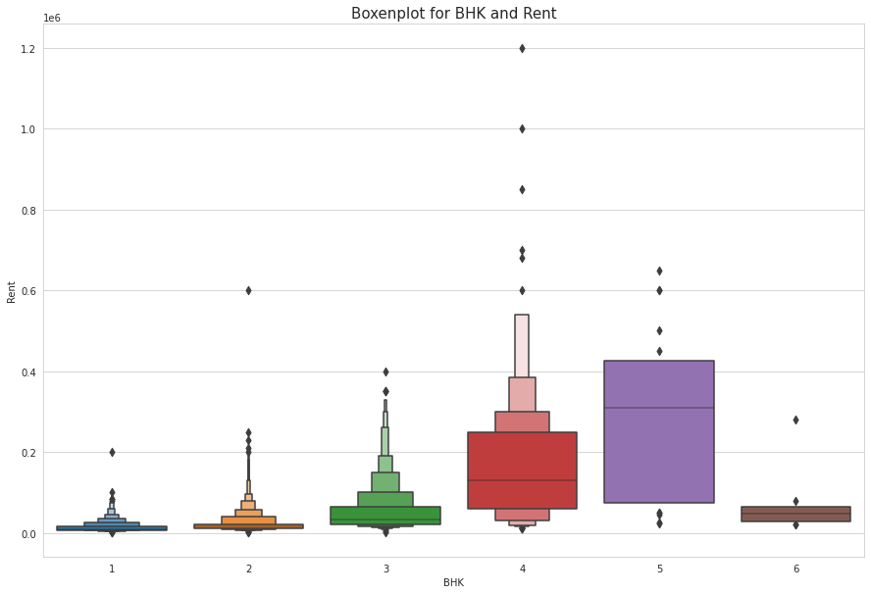

Obseervations:
- The rent of the houses is subsequently increasing with increase in BHK.
- For 6 BHK, things doesn't seem feasible and they are less in demand so rent is very less.

Bathroom and Rent distribution
fig,axes = plt.subplots(figsize=(15,10))
sns.boxenplot(x="Bathroom", y='Rent',data=rent_data)
plt.title('Boxenplot for Bathroom and Rent',fontsize=15)
plt.show()
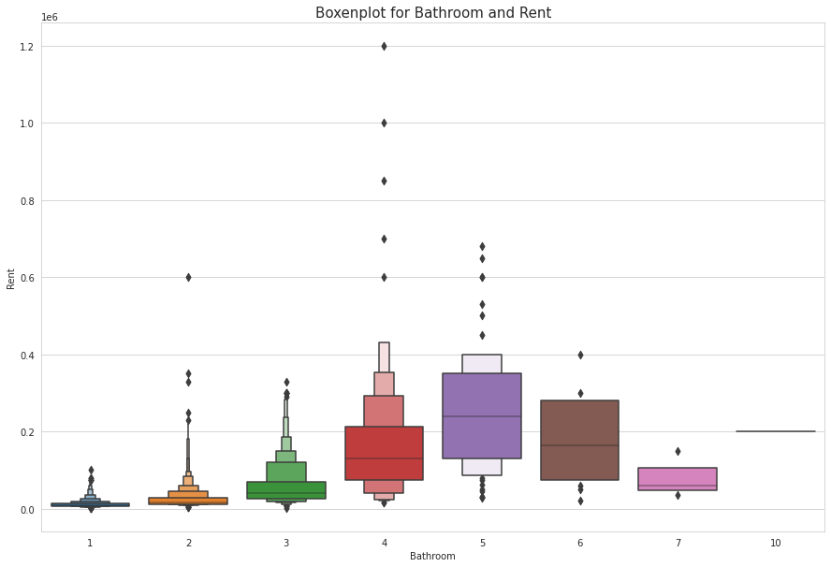

Observations:
- The House rent is increasing with increase in bathrooms in house.
- But having more than 4-5 bathrooms in a house doesn't seem good or feasible, so they are less in demand and that's why there rent is less.

Area Type and Rent Distribution
fig,axes = plt.subplots(figsize=(15,10))
sns.boxenplot(x="Area Type", y='Rent',data=rent_data)
plt.title('Boxenplot for Area Type and Rent',fontsize=15)
plt.show()
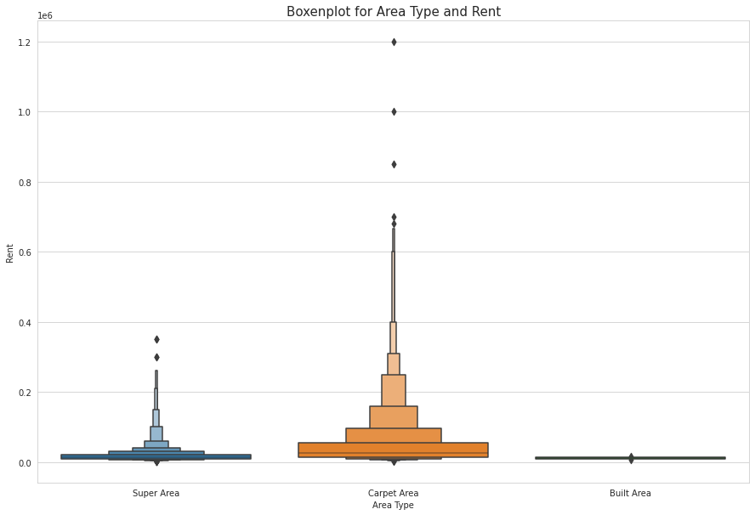

Observations:
- Houses with Carpet Area have more rent as compared to Super Area.
- Built Area are less in demand , so rent is kept less.

City and Rent Distribution
fig,axes = plt.subplots(figsize=(15,10))
sns.boxenplot(x="City", y='Rent',data=rent_data)
plt.title('Boxenplot for City and Rent',fontsize=15)
plt.show()
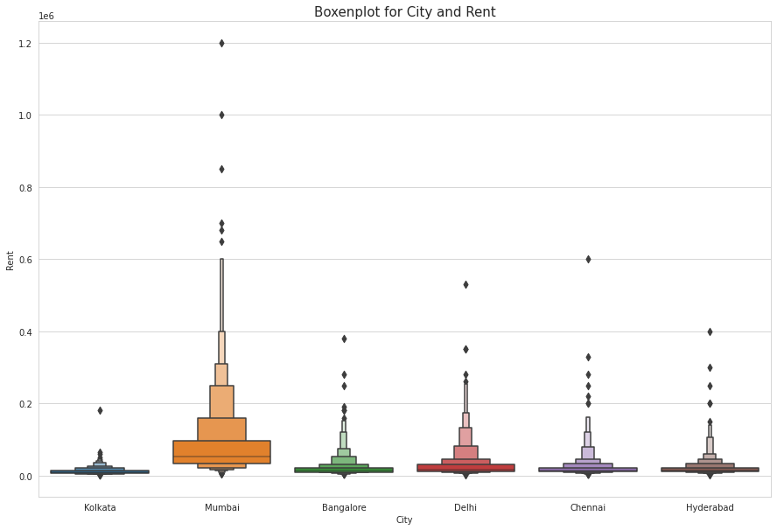

Observations:
- Seems Mumbai is having too much demand for houses, so rent is also very high. The immigrations of job corporates to Mumbai is high. This could be one of the reason of more demand in rented houses.
- All other cities except Kolkata are having fair equal amount of rent.
- Kolkata is not very much flourised in terms of job sectors and lifestyle as compared to other cities. Moreover it is also less developed compared to them. So demand is less there, so rent is also less.

Furnishing Status and Rent Distribution
fig,axes = plt.subplots(figsize=(15,10))
sns.boxenplot(x="Furnishing Status", y='Rent',data=rent_data)
plt.title('Boxenplot for Furnishing Status and Rent',fontsize=15)
plt.show()
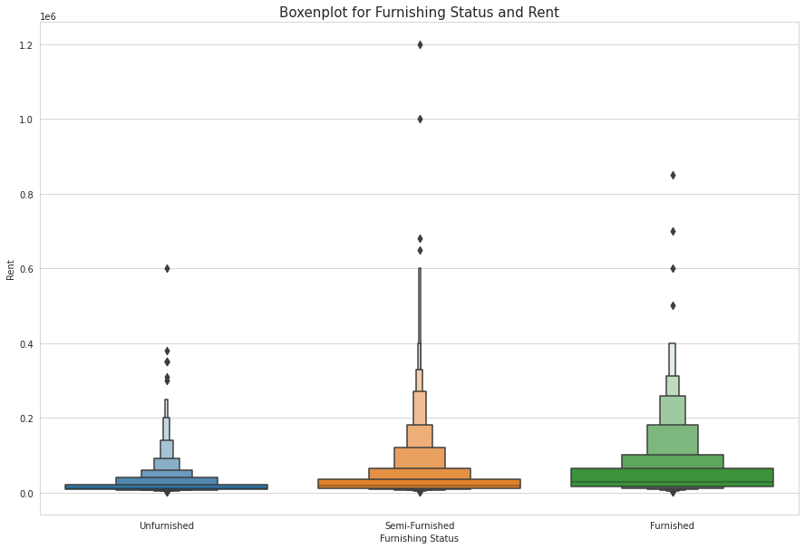

Observations:
- Unfurnished houses for rent are having less rent as compared to others.

Tenant Preferred and Rent Distribution
fig,axes = plt.subplots(figsize=(15,10))
sns.boxenplot(x="Tenant Preferred", y='Rent',data=rent_data)
plt.title('Boxenplot for Tenant Preferred and Rent',fontsize=15)
plt.show()
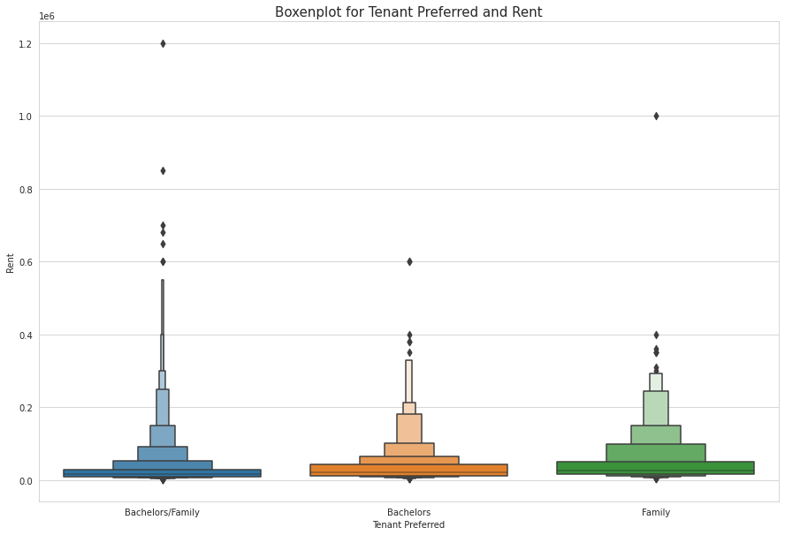

Observations:
- Houses rented with no tenant conditions are having a bit more rent as compared to others.

Point of Contact and Rent Distribution
fig,axes = plt.subplots(figsize=(15,10))
sns.boxenplot(x="Point of Contact", y='Rent',data=rent_data)
plt.title('Boxenplot for Point of Contact and Rent',fontsize=15)
plt.show()
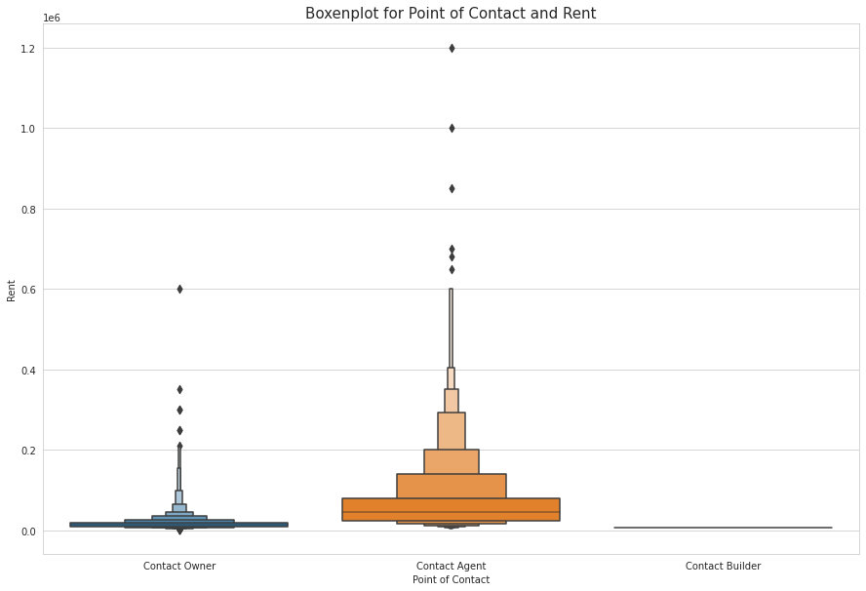

Observations:
- As having a contact agent to get you a house rented also involves paying him/her. So this could be one of the reason that rent for Contact Agent pount of contact is bit high to compensate that.
- Directly contacting Builder involves less rent.

Sunburst Chart
fig = px.sunburst(rent_data, path=['City','Area Type', 'Furnishing Status', 'Tenant Preferred'], width=900,
height=900,title='Allotment of flats according to Bachelors/Family/(Bachelors/Family)',color_discrete_sequence=px.colors.cyclical.Phase)
fig.show()
text = " ".join(area for area in rent_data["Area Locality"])
wordcloud = WordCloud(background_color="white",
max_words=200,
width=1500,
height=800,
colormap="magma" ).generate(text)
plt.figure(figsize=(32,8))
plt.imshow(wordcloud, interpolation='bilinear')
plt.axis("off")
plt.show()
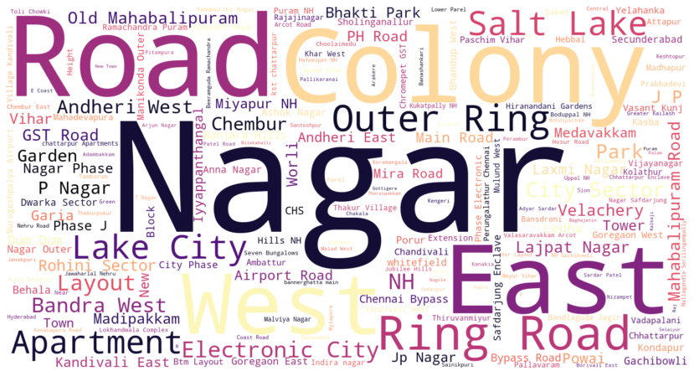

Heatmap of Correlation
corr = rent_data.corr()
plt.subplots(figsize=(8,6))
sns.heatmap(corr, vmax = 1,square = False,annot=True)
plt.show()
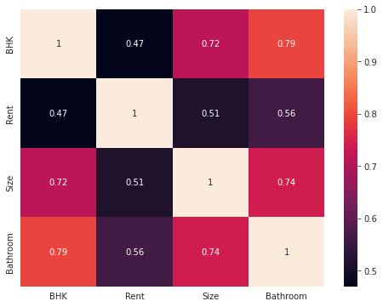
##Dropping unnecesaary columns from dataset
rent_data = rent_data.drop(['Posted On','Area Locality','Floor'],axis=1)
rent_data.head()
BHK Rent Size Area Type City Furnishing Status Tenant Preferred \
0 2 10000 1100 Super Area Kolkata Unfurnished Bachelors/Family
1 2 20000 800 Super Area Kolkata Semi-Furnished Bachelors/Family
2 2 17000 1000 Super Area Kolkata Semi-Furnished Bachelors/Family
3 2 10000 800 Super Area Kolkata Unfurnished Bachelors/Family
4 2 7500 850 Carpet Area Kolkata Unfurnished Bachelors
Bathroom Point of Contact
0 2 Contact Owner
1 1 Contact Owner
2 1 Contact Owner
3 1 Contact Owner
4 1 Contact Owner
rent_data = pd.get_dummies(rent_data, columns=['Area Type', 'City', 'Furnishing Status', 'Tenant Preferred', 'Point of Contact'])
rent_data.head()
BHK Rent Size Bathroom Area Type_Built Area Area Type_Carpet Area \
0 2 10000 1100 2 0 0
1 2 20000 800 1 0 0
2 2 17000 1000 1 0 0
3 2 10000 800 1 0 0
4 2 7500 850 1 0 1
Area Type_Super Area City_Bangalore City_Chennai City_Delhi ... \
0 1 0 0 0 ...
1 1 0 0 0 ...
2 1 0 0 0 ...
3 1 0 0 0 ...
4 0 0 0 0 ...
City_Mumbai Furnishing Status_Furnished Furnishing Status_Semi-Furnished \
0 0 0 0
1 0 0 1
2 0 0 1
3 0 0 0
4 0 0 0
Furnishing Status_Unfurnished Tenant Preferred_Bachelors \
0 1 0
1 0 0
2 0 0
3 1 0
4 1 1
Tenant Preferred_Bachelors/Family Tenant Preferred_Family \
0 1 0
1 1 0
2 1 0
3 1 0
4 0 0
Point of Contact_Contact Agent Point of Contact_Contact Builder \
0 0 0
1 0 0
2 0 0
3 0 0
4 0 0
Point of Contact_Contact Owner
0 1
1 1
2 1
3 1
4 1
[5 rows x 22 columns]

Modeling
X = rent_data.drop('Rent',axis=1)
y = rent_data['Rent']

Splitting into Train and Test dataset
X_train, X_test, y_train, y_test = train_test_split(X, y,test_size=0.3, random_state=42)

Scaling the data
# Scaling the data
y_train= y_train.values.reshape(-1,1)
y_test= y_test.values.reshape(-1,1)
from sklearn.preprocessing import StandardScaler
sc_X = StandardScaler()
sc_y = StandardScaler()
X_train = sc_X.fit_transform(X_train)
X_test = sc_X.fit_transform(X_test)
y_train = sc_X.fit_transform(y_train)
y_test = sc_y.fit_transform(y_test)
print(X_train,y_train)
[[-1.29973557 -0.41868795 -1.09947045 ... -0.68565262 -0.01735525
0.68612724]
[-0.10471292 -0.41868795 -1.09947045 ... -0.68565262 -0.01735525
0.68612724]
[-0.10471292 0.36670492 0.04443349 ... -0.68565262 -0.01735525
0.68612724]
...
[-0.10471292 -0.18307009 0.04443349 ... -0.68565262 -0.01735525
0.68612724]
[-1.29973557 -0.96846295 -1.09947045 ... -0.68565262 -0.01735525
0.68612724]
[-1.29973557 -0.81138438 0.04443349 ... 1.45846448 -0.01735525
-1.45745561]] [[-0.42245895]
[-0.39738427]
[-0.3388767 ]
...
[-0.1717122 ]
[-0.4726083 ]
[-0.15499575]]

Linear Regression
The most extensively used modelling technique is linear regression, which assumes a linear connection between a dependent variable (Y) and an independent variable (X). It employs a regression line, also known as a best-fit line. The linear connection is defined as Y = c+m*X + e, where ‘c’ denotes the intercept, ‘m’ denotes the slope of the line, and ‘e’ is the error term.
The linear regression model can be simple (with only one dependent and one independent variable) or complex (with numerous dependent and independent variables) (with one dependent variable and more than one independent variable).
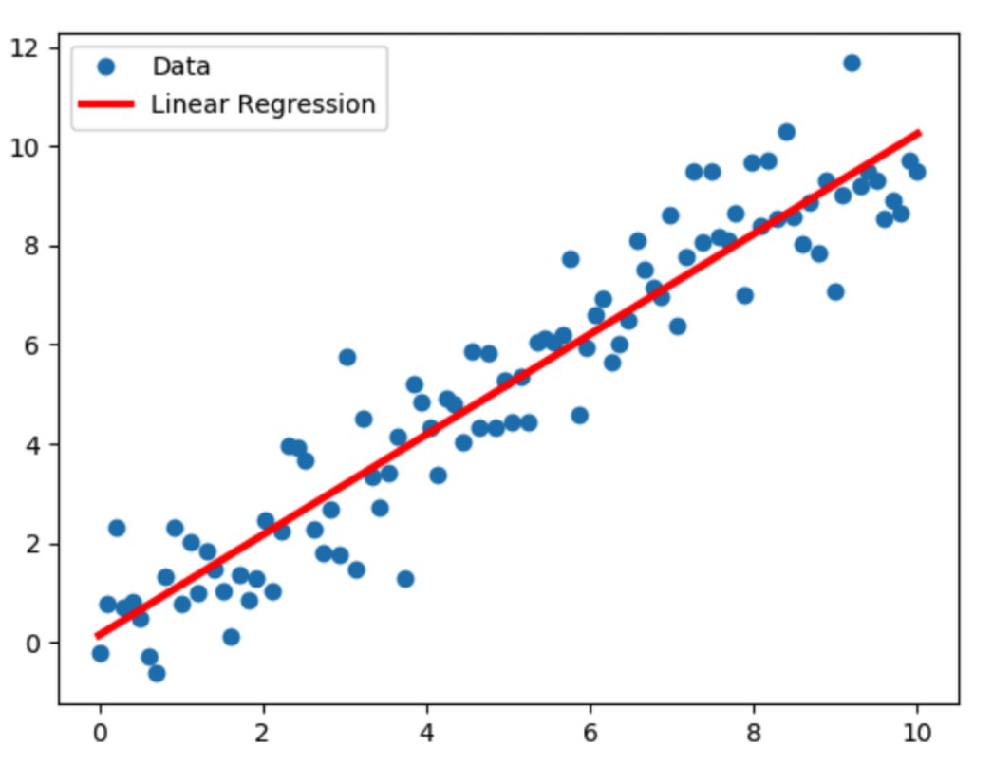
lm = LinearRegression()
lm.fit(X_train,y_train)
lm_prediction = lm.predict(X_test)
# Evaluation metrics
mae_lm = metrics.mean_absolute_error(y_test, lm_prediction)
mse_lm = metrics.mean_squared_error(y_test, lm_prediction)
rmse_lm = np.sqrt(mse_lm)
print('MAE:', mae_lm)
print('MSE:', mse_lm)
print('RMSE:', rmse_lm)
MAE: 5468443462.803723
MSE: 5.364877113932917e+19
RMSE: 7324532144.739975

Decision Tree
Decision Tree is one of the most commonly used, practical approaches for supervised learning. It can be used to solve both Regression and Classification tasks with the latter being put more into practical application.
It is a tree-structured classifier with three types of nodes. The Root Node is the initial node which represents the entire sample and may get split further into further nodes. The Interior Nodes represent the features of a data set and the branches represent the decision rules. Finally, the Leaf Nodes represent the outcome. This algorithm is very useful for solving decision-related problems.
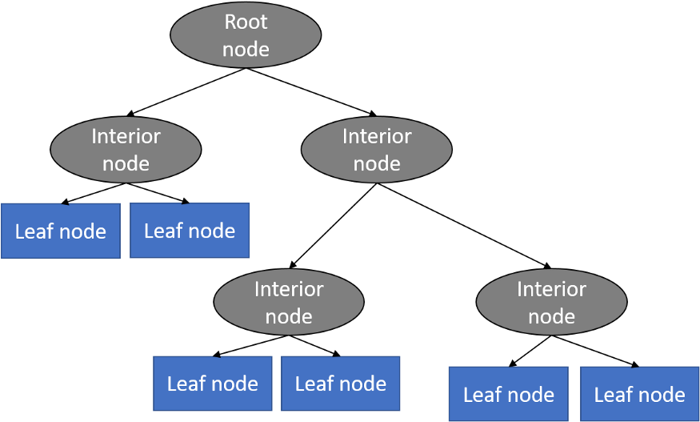
dt = DecisionTreeRegressor(random_state = 100)
dt.fit(X_train, y_train)
dt_prediction = dt.predict(X_test)
# Evaluation metrics
mae_dt = metrics.mean_absolute_error(y_test, dt_prediction)
mse_dt = metrics.mean_squared_error(y_test, dt_prediction)
rmse_dt = np.sqrt(mse_dt)
print('MAE:', mae_dt)
print('MSE:', mse_dt)
print('RMSE:', rmse_dt)
MAE: 0.25767891524169967
MSE: 0.4224998679675354
RMSE: 0.6499998984365578

Support Vector Regressor
Support Vector Regression (SVR) uses the same principle as SVM, but for regression problems. Let’s spend a few minutes understanding the idea behind SVR.
The problem of regression is to find a function that approximates mapping from an input domain to real numbers on the basis of a training sample. So let’s now dive deep and understand how SVR works actually.
Consider these two red lines as the decision boundary and the green line as the hyperplane. Our objective, when we are moving on with SVR, is to basically consider the points that are within the decision boundary line. Our best fit line is the hyperplane that has a maximum number of points.
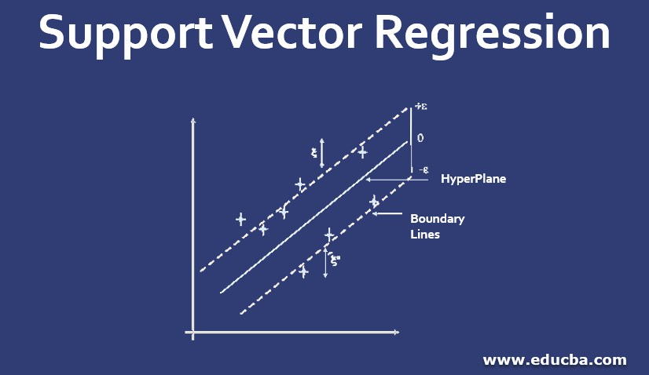
The first thing that we’ll understand is what is the decision boundary (the danger red line above!). Consider these lines as being at any distance, say ‘a’, from the hyperplane. So, these are the lines that we draw at distance ‘+a’ and ‘-a’ from the hyperplane. This ‘a’ in the text is basically referred to as epsilon.
svr = SVR()
svr.fit(X_train, y_train)
svr_prediction = svr.predict(X_test)
# Evaluation metrics
mae_svr = metrics.mean_absolute_error(y_test, svr_prediction)
mse_svr = metrics.mean_squared_error(y_test, svr_prediction)
rmse_svr = np.sqrt(mse_svr)
print('MAE:', mae_svr)
print('MSE:', mse_svr)
print('RMSE:', rmse_svr)
MAE: 0.19318449711918328
MSE: 0.35531971011457375
RMSE: 0.5960869987800218

Random Forest
Random Forest Regression is a supervised learning algorithm that uses ensemble learning method for regression. Ensemble learning method is a technique that combines predictions from multiple machine learning algorithms to make a more accurate prediction than a single model.
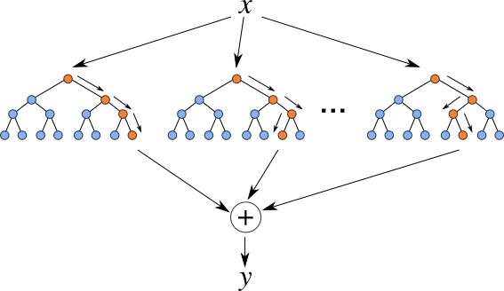
rf = RandomForestRegressor(n_estimators = 100)
rf.fit(X_train, y_train)
rf_prediction = rf.predict(X_test)
# Evaluation metrics
mae_rf = metrics.mean_absolute_error(y_test, rf_prediction)
mse_rf = metrics.mean_squared_error(y_test, rf_prediction)
rmse_rf = np.sqrt(mse_rf)
print('MAE:', mae_rf)
print('MSE:', mse_rf)
print('RMSE:', rmse_rf)
MAE: 0.2085165071623965
MSE: 0.3026413085279006
RMSE: 0.5501284472992654
from sklearn import linear_model
clf = linear_model.Lasso(alpha=0.1)
clf.fit(X_train, y_train)
clf_prediction = clf.predict(X_test)
# Evaluation metrics
mae_clf = metrics.mean_absolute_error(y_test, clf_prediction)
mse_clf = metrics.mean_squared_error(y_test, clf_prediction)
rmse_clf = np.sqrt(mse_clf)
print('MAE:', mae_clf)
print('MSE:', mse_clf)
print('RMSE:', rmse_clf)
MAE: 0.32968860404858025
MSE: 0.522145413635148
RMSE: 0.7225963005960853

💬 Thanks for reading till the end!! If you liked the notebook till here then please do Upvote👍, and all ears to advice/remarks if you think anything needs to be added/modified.

