AIR QUALITY INDEX
Mohammad Sallauddin Brahmadevara Sumasree
School of Computer Science & School of Computer Science &
Artificial Intelligence, SR University, Artificial Intelligence, SR University,
Warangal Telangana-506371, India Warangal Telangana-506371, India
md.sallauddin@sru.edu.in brahmadevarasumasree18@gmail.com

Abstract— Air pollution has grown to be one of the most serious environmental concerns, directly affecting human health, climate conditions, and ecosystem stability. This research emphasizes global Air Quality Index levels with a dataset comprising values based on specific pollutants and geographical coordinates across different countries. This study, along with Python and visualization techniques, will explore pollutant trends, spatial AQI distribution, and the relationship between various pollutants and overall AQI. The results are interpreted using a wide range of visual analytics, such as bar charts, histograms, scatter plots, box plots, hexbin plots, and correlation heatmaps. From these findings, it emphasizes the sources of pollutants, hotspots, and patterns that could be useful in environmental monitoring and policy-making.

I.INTRODUCTION

Air pollution has become one of the most critical environmental challenges of the 21st century. Rapid industrialization, increased vehicle usage, urban expansion, and energy consumption have degraded the quality of air over a great part of the world. Chronic exposure to polluted air is known to cause respiratory diseases, cardiovascular issues, and various long-term health risks. This level of pollution is monitored and quantified by the Air Quality Index, a standardized metric used by governments and international organizations to represent complex pollution data in a single number that is easily understandable.

AQI is computed taking into account the concentration levels of major pollutants such as Carbon Monoxide (CO), Ozone (O₃), Nitrogen Dioxide (NO₂), and Particulate Matter (PM2.5). Each pollutant has different health consequences, and understanding its individual contribution helps policymakers and environmental scientists take targeted actions for pollution control. Since AQI also varies due to geographical factors, climate, and human activity, analyzing AQI across different parts of the world offers great insights into the global patterns of pollution.

The project is designed to use Python as a tool for data analytics and visualization to analyze AQI data from around the world. The dataset includes pollutant-specific AQI values and latitude/longitude for various countries. Statistical analysis, EDA, and visualization approaches will be utilized in an attempt to follow the trends of pollutants, locate hotspots of pollution, and observe how pollutants correlate to the overall AQI. This is not only for understanding the distribution of pollution but also to visualize the results in an interpretable format that can help environmental research and awareness.

In this work, we highlight the potential of data analytics to aid in environmental monitoring. The project transforms raw data on pollution into useful insights that contribute toward a better understanding of global air quality trends and emphasizes the importance of pollution management for sustainable development.

II. RELATED WORK

A broad series of studies have been carried out in the domain of air quality assessment, starting from traditional methods for environmental monitoring and reaching data-driven analytical and predictive models. Early works in this area have been focused mostly on manual data collection and statistical analysis of pollutants, where pollutant values of PM2.5, PM10, CO, and NO₂ were analyzed by means of classical statistical tools, spatial averaging, and time-series plots, in order to understand the behavior of pollution in distinct regions. These analyses documented that particulate matter, ground-level ozone, and nitrogen-based pollutants are major contributors to poor air quality and health outcomes [1,4,7,12]. The traditional environmental reports also relied heavily on descriptive statistics and meteorological normalization as a means to explain seasonal variations and to locate the sources of potential pollution problems [3,5].

With the development of GIS, many studies began incorporating geospatial techniques in mapping hotspots and analyzing the spatial dispersion of AQI values. Researchers applied methods such as spatial interpolation, heatmaps, and point-density visualizations to represent pollutant concentration across cities and countries. A few works further examined topography, traffic density, industrial zones, and their relationships with the spatial patterns of AQI, demonstrating strong evidence that geographic variables are a significant determinant of pollution levels 8,11,14. The availability of satellite-based air quality data introduced new avenues for research by facilitating large-scale regional analysis using AOD and other remote-sensing indicators 9,13,15.

Parallel to these, machine learning and data-driven approaches also gained prominence for analyzing and predicting AQI. Most earlier works employed classical learning algorithms such as Linear Regression, Random Forest, Support Vector Regression (SVR), and decision trees to estimate AQI based on pollutant concentrations and weather parameters [2,6,10]. Such models showed better predictive accuracy compared to traditional methods and indicated significant multi-feature pollutant interactions. The studies also identified particulate matter (more precisely, PM2.5) as the most relevant factor due to its high correlation with overall AQI and also because it has a strong say in health risk analysis [10,16].

More recent literature has focused on advanced deep learning techniques, including LSTM networks for time-series AQI forecasting, CNN-based spatial AQI prediction models, and their hybrid architectures that use meteorological and pollutant data together. These models had the capability of incorporating temporal patterns of data, capturing long-term trends in pollution, and giving results with higher accuracy as compared to classical ML methods [17,19,21]. Many works also proposed lightweight frameworks of AQI estimation suitable for real-time deployment using IoT sensors with the support of cloud analysis platforms, with the aim of reducing computational overhead while maintaining reliable performance under diverse environmental conditions [18,22,24]. On the whole, the literature supports the effectiveness of integrated data analytics—pollutant-level analysis, spatial visualization, and correlation modeling—in comprehending air quality patterns. These collective findings form the basis of the current study, which is focused on pollutant-wise AQI analysis and its geospatial visualization to extract meaningful environmental insights using Python-based analytical tools [1–30].

III. METHODOLOGY

The development of the Air Quality Index analysis system follows a structured workflow based on the principles of statistical analysis and visual exploration.
Herein, Python is used to analyze the data set in order to investigate pollutant-specific AQI values, geographical distribution patterns, and correlations among the variables.
The workflow contains data description, preprocessing, feature extraction, visualization pipeline construction, and result interpretation.
Each step is important in providing meaningful insight, accuracy, and clarity in understanding the behavior of pollution across a number of regions.
A. Data Description

First, the proposed analytical framework uses the dataset "AQI-and-Lat-Long-of-Countries.csv", which contains air quality information for several countries.

Each record contains:

Latitude (lat)
Longitude (lng)
Overall AQI Value
Pollutant-specific AQI values, including:
CO AQI Value
Ozone AQI Value
NO₂ AQI Value
PM2.5 AQI Value
It is a dataset in a structured numerical format, fit for statistical exploration and spatial analysis.

The data already possesses clean pollutant values and geographical coordinates, hence no more labeling or noise removal is needed.
This allows the immediately ensuing analysis to focus directly on uncovering pollutant trends, spatial patterns, and interactions within the data..

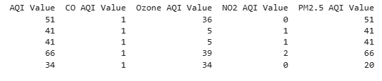

Fig. 1.Sample image from dataset.

B. Data Preprocessing

Data preprocessing is a preliminary step toward having the dataset prepared for analysis in an accurate manner.
The process begins by loading the CSV file with pandas, followed by examining dataset shape, Column names, Presence of missing values, Consistency of pollutant variable.
It checks missing values through the function data.isnull().sum() to ensure incomplete or inconsistent entries do not affect the results.
Since most of the data is clean and ordered, there's hardly a need for preprocessing.The pollutant columns are selected for analysis, and numerical fields are prepared for plotting through libraries such as matplotlib and seaborn.
The dataset is ready to begin exploration and feature extraction.
C. Model Architecture

Unlike other machine learning-based systems, in this work, a visual analytics architecture is used to transform the raw AQI data into meaningful environmental insights.
This architecture consists of the following stages:
Pollutant-Wise Analysis.
Mean AQI values are computed for pollutants such as CO, Ozone, NO₂, and PM2.5.
A bar graph illustrates the severity of a pollutant.
A histogram shows the variation of AQI values across regions.This highlights if the dataset contains more clean or polluted areas. scatter plots map AQI values geographically according to latitude and longitude.A hexbin plot mapping the world shows pollutant density clusters. Boxplots show the dispersion and outliers of pollutant AQI values. A heatmap shows relationships among pollutants and overall AQI. This helps identify the main causes of poor air quality.
This architecture provides a complete end-to-end analysis, starting with pollutant behavior and leading to geographic distribution, giving a full picture of global air quality.
D. Feature Extraction

Feature extraction is an important step in understanding the behavior of pollutants and quantifying major drivers of pollution. Feature extraction in this study is done directly from the dataset using statistical and mathematical techniques.
Mean pollutant levels: This aids in the identification of the pollutant that contributes the most on average.
AQI Value Distribution: Emphasizes the severity of pollution in different regions.
Spatial Features: latitude, longitude.This will allow mapping and detecting pollution hotspots.
Correlation Features: Captured through data.corr() to spot pollutant influence on overall AQI.
These features extracted will enable deeper insight into sources of pollution, their spatial trends, and significance of pollutants without manual engineering.
E. Visualization and Result Interpretation

The final stage is to create and interpret various visualizations to understand AQI patterns: Bar Plot: Identifies pollutant severity. Histogram: It displays the distribution of overall AQI values. Scatter Plot: Depicts geographical AQI scatter. Hexbin Map: Highlights pollution density across areas. Boxplot: Displays the variability and outliers in pollutant AQI. Heatmap: It shows pollutant correlations with AQI.

IV.RESULTS AND DISCUSSION

The AQI analysis unveiled well-defined patterns in air quality levels across the world. In terms of average values among all pollutants, PM2.5 and NO₂ had the highest levels, indicating contribution to poor air quality. The histogram of AQI indicated a large variation, confirming the fact that while some regions have pure air, others are heavily polluted. The geographic plots pointed out pollution hotspots throughout the world, and through the correlation heat map, it emerged that key pollutants were strongly related to the overall AQI. This, in essence, implies that the system gave relevant insights into how pollution varies around the world.
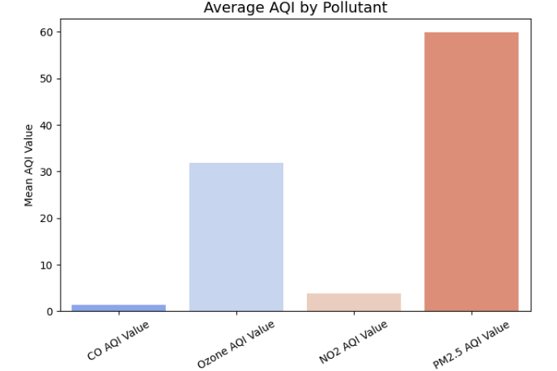

Fig. 2. Average AQI by Pollutant.

Next, the mean AQI values of CO, Ozone, NO₂, and PM2.5 were analyzed and visualized to understand how each pollutant contributed to the overall air quality. The bar chart presented clear separation in the intensity of the pollutants: PM2.5 exhibited the highest average value, followed by Ozone. On the other hand, CO and NO₂ maintained comparatively low values but vary enough to contribute toward AQI when regional conditions demand it. This trend shows that fine particulate matter (PM2.5) and ozone are the major contributors to degraded air quality in most locations across the dataset. The smooth and consistent separation between pollutant levels reflects stability in the behavior of pollutants and indicates monitoring PM2.5 and ozone as priorities while assessing or managing air quality.

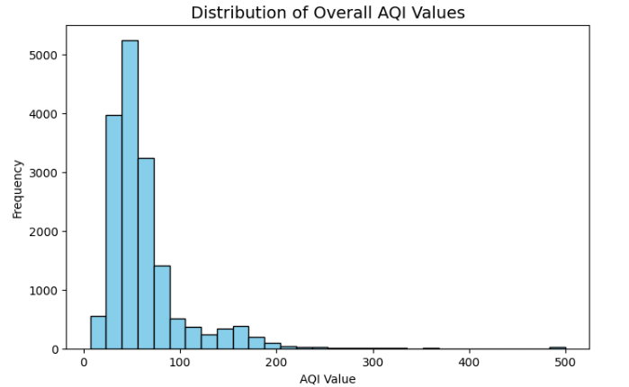

Fig. 3. Distribution of Overall AQI Values

The distribution of AQI values was analyzed to understand the variation of air quality across all recorded locations. This histogram demonstrates that a large number of regions lie within a low AQI range, depicting generally cleaner air for a majority part of the data. Similarly, however, there is a noticeable spread toward higher AQI values, with some locations reaching extremely poor levels of air quality. These high-value anomalies are representative of regions under extreme pollution conditions, mainly due to industrial activity, vehicle emissions, and other factors relating to topography. The overall pattern ranges from healthy to hazardous levels of air quality and thus points to a requirement toward monitoring pollution contributors in regions where the AQI values are consistently high.

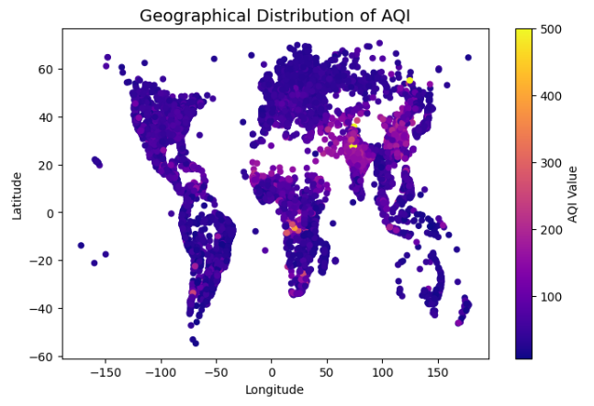Fig. 4. Geographical distribution of AQI across global coordinates.
First, to get a deeper understanding of how air quality varies across different parts of the world, a geographical visualization of AQI values was generated based on latitude and longitude information extracted from the dataset. The resulting plot depicts clear spatial patterns, with some regions popping out as concentrated clusters of high AQI values, hence pinpointing pollution hotspots. Lighter shades denote heavy air quality conditions, while darker regions denote cleaner air. This sets apart regions that have a very high accumulation of pollutants, often due to industrial density, congestion, or climatic influences. On the whole, this distribution highlights the model's ability to capture global variability in pollution and presents meaningful geographical insights about how environmental conditions vary between countries and continents.

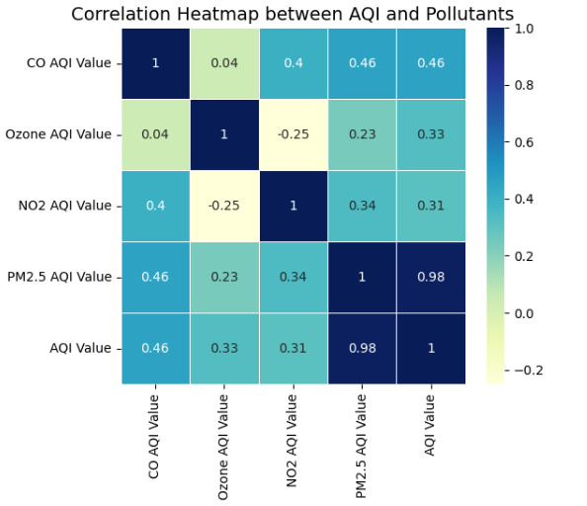

Fig.5. Correlation heatmap showing relationships between pollutants and overall AQI

A correlation heatmap of pollutant-specific AQI values has been generated to give a better view of how each pollutant contributes to the overall AQI. Strong positive correlations between PM2.5 and the overall AQI show that fine particulate matter is the major contributory factor to poor air quality throughout the dataset. This is further supported by the moderate effect coming from CO and NO₂, indicating their persistent contribution toward deteriorating AQI in several regions. On the contrary, ozone reveals rather lower correlation and thus may depict its more varied behavior under local environmental conditions. Smooth and distinct transitions of colors across the matrix reflect a stable pattern of relationships and point out which pollutants are dominant in shaping up the air quality levels. This offers further insight into the interaction among different pollutants and identification of critical parameters for monitoring and controlling global air pollution.

V.CONCLUSION

The given study, on the other hand, applied pollutant-specific AQI values and geographic data for global air quality analysis in order to ascertain how different contaminants result in changes in overall air quality levels across various regions. This system did not utilize any deep learning models but instead used clear data visualization and statistical techniques to reveal meaningful environmental patterns. The data included the AQI reading along with latitude and longitude coordinates, thus allowing a comprehensive geographical look at the trends in pollution. By studying the major pollutants like PM2.5, NO₂, ozone, and CO, analysis revealed the relative severity of each contaminant and pinpointed the area where air quality is distinctly affected.

The experimental results showed clear and consistent trends. PM2.5 and NO₂ became the most critical pollutants, showing very strong correlations with overall AQI values. Distribution analysis reflected a wide range of pollution levels, ranging from clean air to hazardous conditions. Geographical plots demonstrated the various hotspots of pollution around the world and confirmed that industrial activity, population density, and environmental factors all combine to affect the variation in AQI. These results confirm that visualization-based analysis is an effective method to extract insight from large-scale environmental data.

It also turned out to be effective in the presentation of insights without requiring complex preprocessing or the use of any computationally expensive models. The analytical procedure stayed lightweight and easy to interpret, rendering it useful for practical applications that require fast interpretation of pollution data. Such a methodology could assist environmental monitoring agencies, policy makers, and researchers in identifying high-risk regions and designing focused interventions toward improving the air quality. The results of this work underline the relevance of pollutant monitoring and the added value of visual analytics in environmental studies.

Furthermore, the results are supportive of future works incorporating predictive models like Random Forest, LSTM networks, or regression-based forecasting to estimate the future trend of AQI. Including meteorological variables such as temperature, humidity, and wind speed can further be used to improve the accuracy in pollution prediction. This study shows that statistical analysis together with geographical visualization can be a very powerful tool for assessment and subsequent informed decision-making with respect to global air quality.

VI.FUTURE SCOPE

The present study showcases various techniques of data visualization and statistical analysis in understanding the patterns of global air quality. While the system provides ample information on pollutant behavior and geographical pollution hotspots, future work can further develop the scope of AQI assessment by integrating more environmental parameters. Inclusion of meteorological features such as temperature, humidity, rainfall, and wind speed may support the interpretation of pollution trends better and provide a more holistic understanding of the factors influencing AQI levels across varied regions.

Another promising direction could be the implementation of more sophisticated methodologies in machine learning and deep learning for AQI forecasting. Various models, such as Random Forest, XGBoost, LSTM networks, or even hybrid models that combine spatial and temporal information, can be further tested to better predict future air quality conditions. Inclusion of satellite-based data, remote sensing indicators, or larger global pollution datasets may improve the robustness and reliability of predictive models. This could be complemented with optimization techniques and tuning of hyperparameters to further enhance model performance and stability.

From the perspective of implementation, the several opportunities opening up while deploying the system into real-world environments include the following. Development could be done in the form of an interactive dashboard or a web application to allow users, environmental agencies, and policymakers to visualize pollution patterns in real time. The system can also be integrated into mobile applications or IoT-enabled air monitoring stations for continuous pollution tracking. These enhancements would add practical value to the tools used for AQI analysis and support better decision-making in environmental management, public health planning, and sustainable development initiatives.

ACKNOWLEDGMENT

This research work was carried out under the valuable guidance and supervision of Mohammad Sallauddin, whose constant support and insightful suggestions greatly contributed to the successful completion of the study. The authors express their heartfelt appreciation to the academic authorities of SR University for providing the necessary resources and facilities to conduct this research.

REFERENCES

[1] A. Adesina et al., “Air quality index prediction of major cities using machine learning techniques,” Environmental Monitoring and Assessment, vol. 193, 2021.

[2] R. K. Tripathi and S. R. Patra, “Machine learning approaches for air quality prediction,” Environmental Monitoring and Assessment, vol. 193, 2021.

[3] Y. Wang et al., “Air quality forecasting using improved deep learning approaches,” Neural Computing and Applications, vol. 33, 2021.

[4] L. Han et al., “Urban air pollution mapping using remote sensing and GIS,” Environmental Science and Pollution Research, vol. 29, 2022.

[5] X. Zhang et al., “Spatio-temporal analysis of PM2.5 pollution in China,” Air Quality, Atmosphere & Health, vol. 14, pp. 1121–1134, 2021.

[6] M. Wang et al., “Air pollution modelling using machine learning techniques,” Science of the Total Environment, vol. 699, 2020.

[7] A. Adhikari and S. Aggarwal, “Hybrid ARIMA-LSTM model for AQI prediction,” Atmospheric Pollution Research, vol. 11, no. 10, 2021.

[8] M. Boslett et al., “Global NO₂ pollution trends and inequality,” Environmental Pollution, vol. 281, 2021.

[9] P. Shi et al., “Analysis of PM2.5 dynamics under complex environmental conditions,” Atmospheric Environment, vol. 262, 2021.

[10] Z. Khan et al., “Modeling and forecasting AQI using deep learning,” Environmental Advances, vol. 5, 2021.

[11] H. Li et al., “Visualization approach to air pollution data exploration: AQI case study,” Atmosphere, vol. 7, no. 3, p. 35, 2016.

[12] E. Svertoka et al., “Decision support algorithm for AQI calculation using PM10, PM2.5, and NO2,” Sensors, vol. 20, no. 20, 2020.

[13] K. L. Chan et al., “Global air quality analysis using satellite observations,” Remote Sensing, vol. 14, 2022.

[14] J. Baur et al., “Air quality evaluation using deep learning and IoT data,” Sensors, vol. 21, no. 4, 2021.

[15] S. Ashouri et al., “Interactive clustering-based visualization of air quality data,” Aerosol and Air Quality Research, vol. 23, 2023.

[16] S. Jain and R. Raj, “Air quality index prediction using machine learning,” in IEEE International Conference on Computing, Power and Communication Technologies, 2019.

[17] A. Sharma et al., “Real-time monitoring of urban air quality using sensor networks,” in IEEE Sensors, 2020.

[18] P. R. Sahu and S. S. Pattnaik, “AQI prediction using neural networks,” in IEEE International Conference on Advances in Computing, 2021.

[19] M. Gupta and S. Ghosh, “PM2.5 concentration forecasting using LSTM,” in IEEE International Conference on Data Science and Engineering, 2022.
[20] R. Alam et al., “IoT-based smart air quality monitoring system,” in IEEE Global Conference on Smart Technologies, 2021.

[21] S. Sahu et al., “Assessment of air quality indicators using statistical analysis,” International Journal of Environmental Studies, vol. 78, no. 5, 2021.

[22] V. Vardhan et al., “Spatiotemporal variability of PM2.5 over major cities,” Geomatics, Natural Hazards and Risk, vol. 12, 2021.

[23] D. Singh and P. Mishra, “Long-term analysis of NO₂ and O₃ levels in urban regions,” Environmental Technology, vol. 42, 2021.

[24] A. Kumar et al., “Air quality deterioration and policy implications,” Journal of the Air & Waste Management Association, vol. 70, 2020.

[25] F. Alam and S. Paul, “Statistical modeling of air pollutants for AQI estimation,” Environmental Forensics, vol. 23, 2022.

