1. Count the number of Movies vs TV Shows

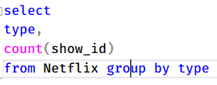

1. Find the most common rating for movies and TV shows

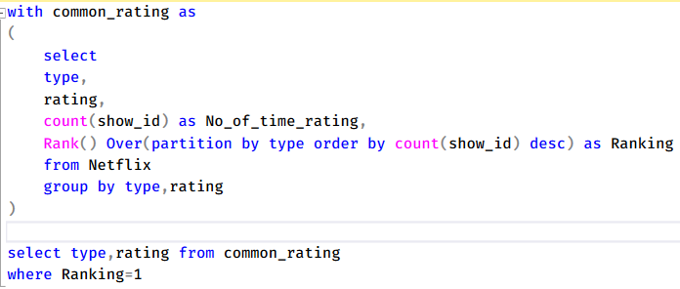

1. List all movies release in a specific year (e.g., 2020)



1. Find the top 5 countries with the most content on Netflix

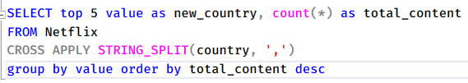

1. Identify the longest movie

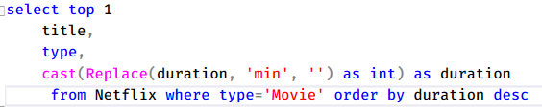

1. Find the content that added in the last 5 year



1. Find All the movies/Tv shows by director ‘Rajiv Chilaka’



1. List all the TV shows with more than 5 seasons



1. Count the number of content items in each genre

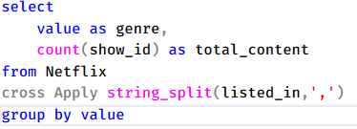

1. Find each year and the average numbers of content release by India on Netflix. Return top 5 year with the highest avg content release.

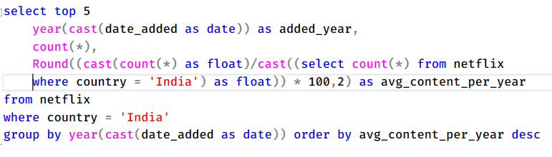

1. List all the movies that are documentaries

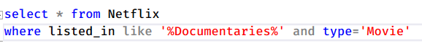

1. Find all the content without a director



1. Find how many movies actor ‘Salman Khan’ appeared in last 10 year

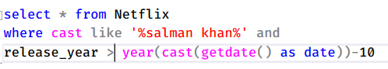

1. Find the top 10 actors who have appeared in the highest number of movies produced in India.

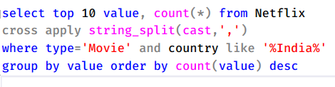

1. Categorize the content based on the presence of the keywords ‘kill’ and ‘violence’ in the description field. Label content containing these keywords as ‘Bad’ and all other content as ‘Good’. Count how many items fall into each category.

