Implementation & Environmental view diagram

# Component diagram:

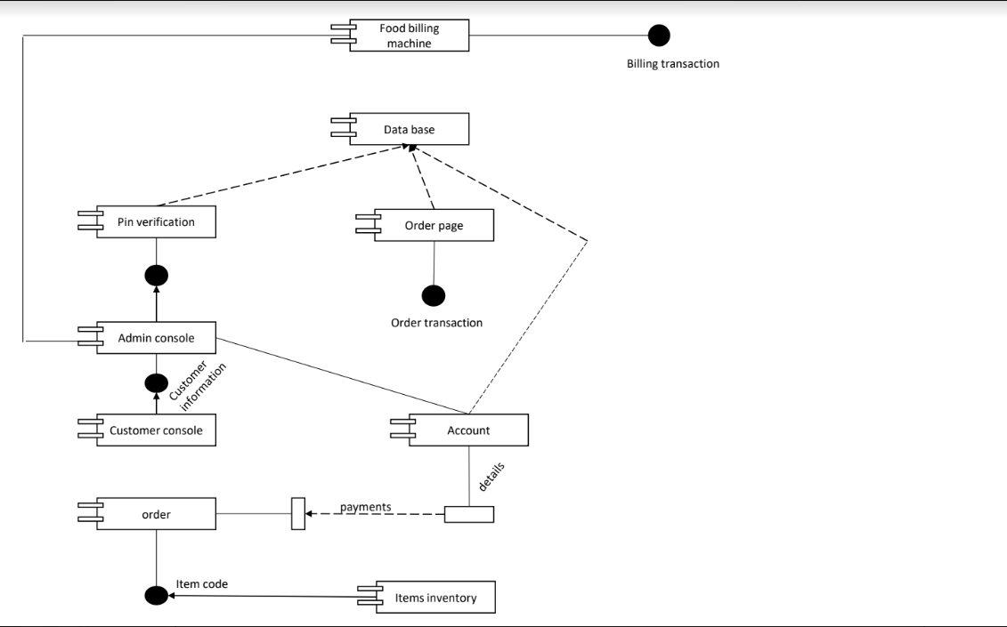

# Deployment diagram:

