Welcome to Game Development
Gearing learning Game Development? Have an interest in JavaScript? Take this path to learn how to combine the two using Phaser.js!

Welcome
Video games. These two words are enough to grab most people’s attention and it’s very likely they’re the two words that brought you here. You might be wondering: “How are they made?”, “Can I make these games?”, and “Is that cake a lie?”. The answer (to the first two) is a resounding YES!
You’ll gain the necessary skills through this skill path by building out video games using a combination of HTML, JavaScript, and Phaser. After all, what better way to find answers than actually experiencing it first-hand?
HTML is used to create web pages, and JavaScript is the de facto language of the web, but what is Phaser? Well, Phaser is an open-source game development framework, a collection of code pre-written, that gives us a lot of tools for quickly making browser-based games! Phaser is built using JavaScript and its development is headed by Richard Davey. In order for you to adeptly wield these tools of game construction, you must also learn how to write proficient vanilla (read: plain) JavaScript.

What will you do?
Before you dive into the world of game development, you first have to build strong JavaScript foundations - creating variables, functions, arrays, iterators, and objects. While learning the fundamentals, you’ll get a taste of how these concepts fit into Phaser. You’ll be tasked with completing a Phaser game that is missing some core features using the very JavaScript skills you just learned! You’ll also be able to get an early sense of how Phaser games are organized. These games will include:
- Business Outfitted Bob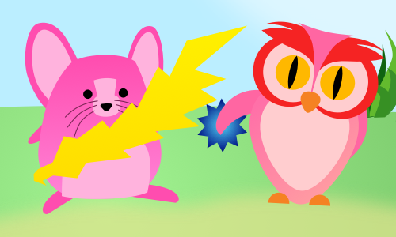
- Electric Mouse
After you’ve completed the JavaScript portion along with the sample games, you’ll dive into the world of Phaser and game development.
The focus will shift to a heavier emphasis on using the Phaser framework and the thought process behind game creation. You’ll also continue to hone your JavaScript skills with a lesson on classes and finish off with more advanced techniques to make your Phaser games shine. The games in this section include:
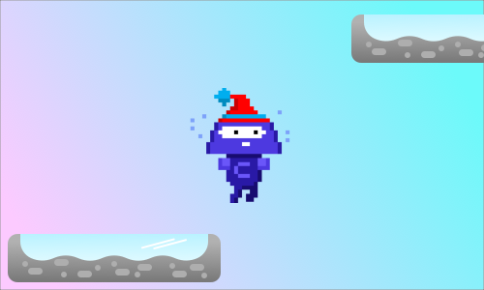
- Codey Jump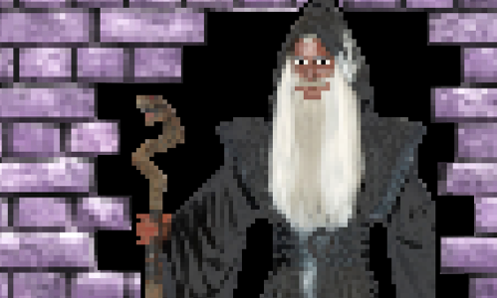
- Create an Adventure
Your final challenge is, a capstone project that encapsulates all that you’ve learned and pushes you to learn more!
So make sure your HP is maxed out, your mana is plenty, and your stamina is full. It’s time to jump into a whole new world!

