**AS001**

**Personal Information**

Brady Griffin

S3980132

S3980132@student.rmit.edu.au

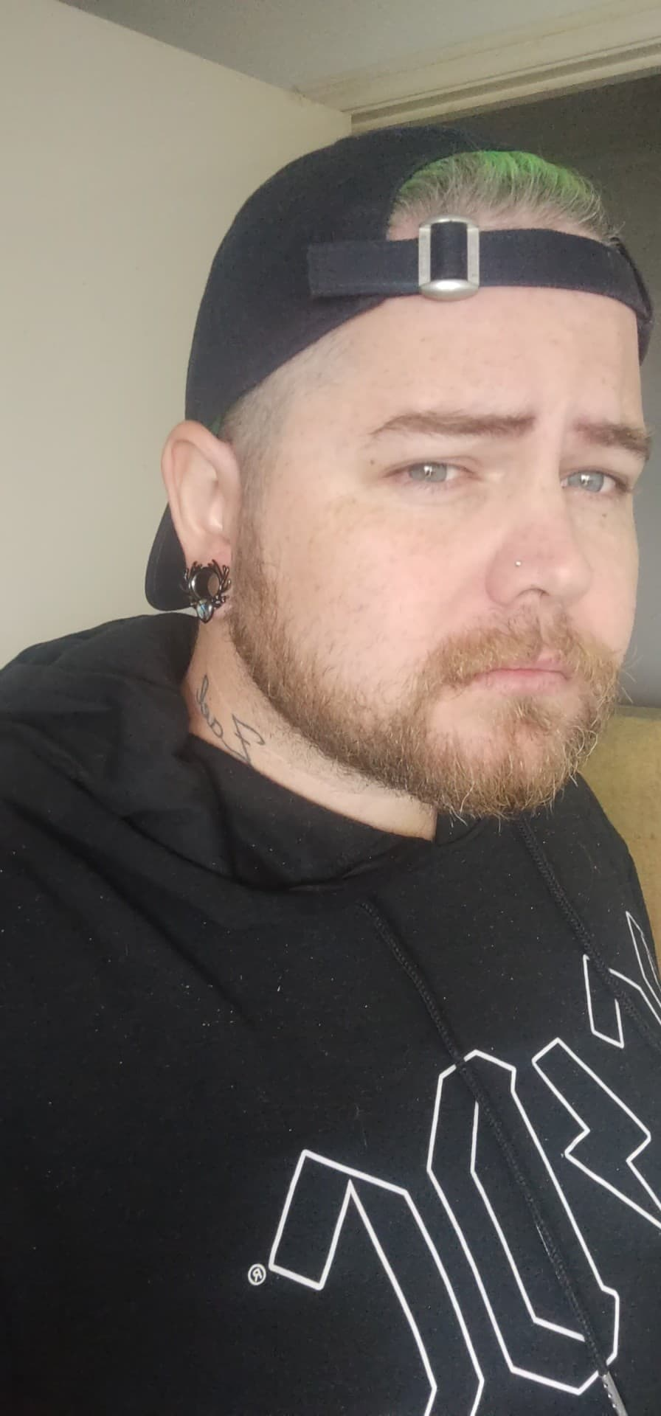

I’m a 30 year old stay at home dad, I’m ADHD so I never really knew what I wanted to do with my life up until now, it takes us a bit longer to understand and know wants and needs. I’m a pretty old school person as I don’t fit in with the gen Z way of living and sugar coating everything in the world. I believe the world is a harsh place and you have to work hard for your goals.

I’m Australian born, Aboriginal runs through my DNA and I’m proud to identify. I’m also English and Scandinavian, which I’m also equally proud of.

I’ve finished year 12 and done a cert 3 in warehousing, cert 2 in business, cert 2 in health and safety practices. Other than that I've never really done anything else with myself.

I speak fluent English and beginner-Intermediate in Spanish as I’m still currently learning.

The most interesting fact about me that a lot of people seem to have the same opinion is I'm very humble and kind despite being covered in tattoo’s and looking like I'd punch everyone.

I played Football(soccer) growing up and played State futsal, I've since lost the drive and passion as I became a father it slowly left my life. Now I'm a gamer, father and own an Indian ringneck Parrot who is my best friend.

**Interest in IT**

**What is your interest in IT?**

My interest in I.T is learning to create and build objects or programs to hit life goals in a field I’m super comfortable with and something I've been comfortable with most of my life as using a PC has become second nature to me.

**When did your interest in IT start?**

My dad started showing me bit and pieces of computing when I was around 12-13 and it has developed into the last 18 years of owning a PC and using it nearly everyday and trying to learn more and more, which brings me to this course.

**Was there a particular event or person that sparked your interest? Outline your IT experience (if any).**

My Father. He would show me all these cool things you can do on a PC and he’d create his own websites and taught himself to code, to hack, how to create servers for games and just all round basic pc knowledge, he has been a huge inspiration into the I.T world and I'd like to make a career out of what he has taught me and what I can learn from RMIT.

**Why did you choose to come to RMIT?**

It kind of just happened, I was looking for courses online to make a career for myself and I stumbled across RMIT and just felt like it was the right course for me to be in, almost like I was drawn to the university.

**What do you expect to learn during your studies?**

I’d hopefully learn the basics of the computing world if not a little bit more than basic, as I'd really enjoy a career in this field. I want to learn how every little detail can create an app or webpage and hopefully learn a lot more that will help me in my future of I.T.

**IDEAL JOB**

**The job advertisement itself. Include a link, and a snapshot of it.**

I’ve chosen IT support as I'd like to be able to help people in a company who know very little about the computing world. This is an ideal job I'd be after as I enjoy helping others.

https://www.seek.com.au/job/58310510?type=standard#sol=2f61fb41dfd2ceb7f3c9a3c0b1ec87180876d9c1

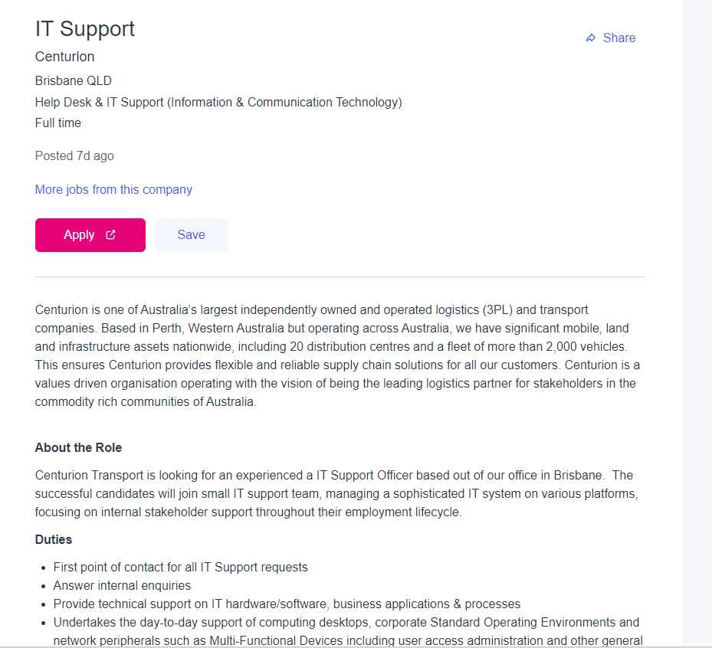

**A description (in your own words) of the position, and particularly what makes this position appealing to you.**

The position is a support desk job for IT and fixing issues that some staff members may stumble across on their everyday use of computers. It appeals to me because it’s a full time employment and as mentioned before it would provide me with comfortability as I enjoy using pc’s and I would enjoy helping fix peoples problems.

**A description (in your own words) of the skills, qualifications and experience required for the position.**

The Skills require are Tertiary qualifications in IT and Experienced in IT with at least 3 years, experience. A solid technical understanding of Computer hardware and peripherals, Also solid understanding of Windows 7 / 10. With hands on experience with Microsoft Exchange and experience with Windows Server.

**A description (in your own words) of the skills, qualifications and experience you currently have.**

At this current point in time the only experience I have is home use of some of the requirements they’re asking for with no professional experience or qualifications.

**A plan describing how you will obtain the skills, qualifications and experience required for the position.**

I’m in this course to try and obtain the skills required for this role and gain experience and knowledge to not only secure a job in the future but pursue a career.

**A plan describing how you will obtain the skills, qualifications and experience required for the position, building on those you have now. This need not be greatly detailed, (and will probably change significantly over time anyway), but try to be as specific as you can.**

My plan is currently underway to obtain the skills and qualifications needed to be able to do a position such as the one above.