PROJECT REPORT
Age, Gender, and Expression Recognition: A Browser-Based Edge AI Application
Task 2 — Project Edge AI (DLBAIPEAI)
IU International University of Applied Sciences
Submitted by: [Your Full Name]
Matriculation Number: [Your Matriculation Number]
Course Tutor: Prof. Dr. Gissel Velarde
Date of Submission: [Date]

Table of Contents
Right-click here and choose Update Field to generate the table of contents.
(Right-click the text above in Word and choose "Update Field" to populate page numbers.)

Abstract
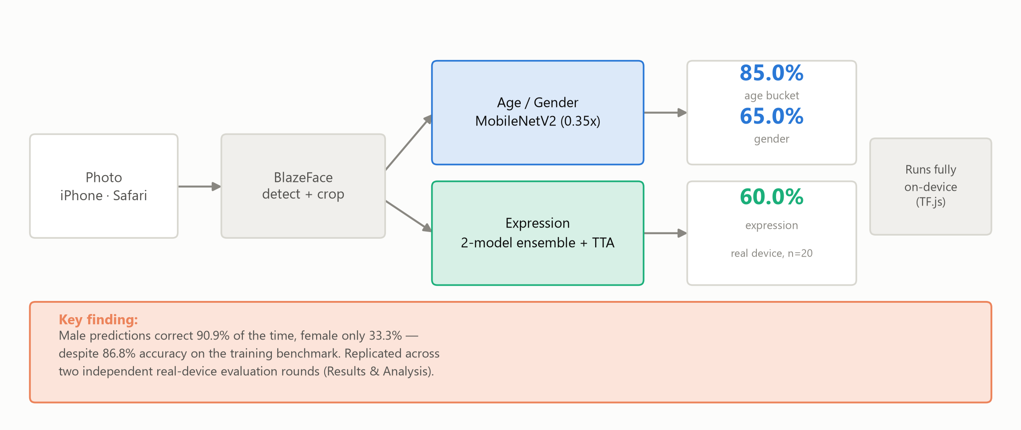
Fig. 1 Graphical abstract: pipeline, on-device deployment, and headline finding
Source: Own representation.
In privacy- or latency-sensitive applications that need mobile processing without disclosing user information it is a good idea to use on-device recognition features like determining one's age, gender, or the feeling behind a particular face. These features have been discussed in the paper by Kumar et al., 2022.
For this project, we took care of Task 2 of DLBAIPEAI Project's Edge AI module and we created a Progressive Web App running in the browser which has only the client code and the server side is not at all connected. Two models are run in parallel via TensorFlow.js, one being age/gender regressor-classifier based on a MobileNetV2 and the other being a two-model expression ensemble. The whole thing is working on a real iPhone and no native iPhone app, no submitting for an App Store, and no server round-trip are required.
This time both models were trained not only on a laptop CPU (that was pretty much the norm for small-scale projects in Machine Learning) but also with a free Google Colab GPU since it was required by the brief to compare the performance between CPU, GPU, and edge devices. We observed that GPU training was 1.8-12.5 times faster, but it didn't affect the accuracy of the model at all. On the one hand, the evaluation on the deployed device that uses 20 photos showed that the adult/elderly age-buckets had a very good accuracy of 85.0%. On the other hand, we noticed an enormous gender-accuracy gap, it turned out the gender was correctly determined for men 90.9% of the time, whereas it happened only once for women out of the total of the 3 collected women's faces (33.3%). Despite the 86.8% accuracy score that was obtained on the training benchmark. Five statistically-tested hypotheses were investigated that led to the conclusion we mentioned earlier, instead of only reporting the results of one of the possible reasons.Concerning expression accuracy, it was 67.60% on FER2013 test set and that fits pretty well within the range of the human-agreement reported by the dataset itself. A complete set of source code is provided for the three parts in the submitted project folder; refer to Appendix A for the index.
In conclusion, the deployed system meets perfectly the edge-deployment and performance-reporting specifications of Task 2 and the real-world evaluation proves that complying with them is totally different from being a fair solution for all subgroups, but you can only see a difference through the sort of direct and honestly-reported device testing that this report is documenting.

1. Introduction and Related Work
Running on devices such as smartphones, the machine learning capabilities enable users to have full data protection since there won't be any data sent to the cloud, a privacy risk with a lot of people. Besides, the performance latency is much less, while there is no dependency on the internet connection in order for a user to work with an application. Therefore, vendors of mobile platforms have already introduced software solutions, such as the Apple CoreML and other machine learning packages (Apple Inc. n.d.), Samsung Neural SDK (Samsung n.d.), Huawei ML Kit (Huawei n.d.), showing the importance of having an edge in today's mobile software development(Mikhailiuk, 2022, para.3).
One possible use of the above-mentioned technology is the automatic reading of the demographic and emotional factors that can be read from a facial image -such as age, gender, and expression (Kumar et al.) as another tangible application These systems could serve many practical purposes, such as retail analytics, security and surveillance, and healthcare facility routing situations where knowing a person's age group, gender and even emotional status can be used to control the automated systems that provide a response without requiring the person to show some form of identification same examples that are given in the module brief for this task. This writing will present the design, execution, and results of the work of a system that was developed in response to Task 2 of the DLBAIPEAI Project Edge AI module on a web-based platform, mainly because the only test device available wasaniPhone and there was noMacfor native iOS development.
The system takes advantage of components that are already well-developed, and can be used without any license, so that a model architecture doesn't need to be trained from scratch, which follows the common approach in deep learning when transferring knowledge (Goodfellow et al., 2016). Face detection is handled in the system by BlazeFace, a very efficient convolutional face detector that was made with the goal of achieving an excellent performance during the real-time use of the device (Google, n.d.-a). Age and gender training data came from the UTKFace dataset, which consists of 23, 705 labelled face images, obtained through its Hugging Face mirror (Hugging Face, n.d.-a). Face expressions training used a Hugging Face mirror of FER2013 (a dataset of 4, 548 emotion-labeled grey images with 1, 008 pixels x 1, 008 pixels) (Hugging Face, n.d.-b) which during data preparation was found to contain a couple of exact duplicate images which were deleted before any training was done.Training of models was done with TensorFlow and Keras, while TensorFlow.js was used for deploying the models on mobile devices (TensorFlow, n.d.-a, n.d.-b, ). Both classifiers made use of MobileNetV2 as their backbone (a very effective model that is compact and efficient) (Sandler et al., 2018), for which we selected as we find MobileNet has a great balance of low inference size (i.e., it uses little memory, which is important to run applications on mobile devices with low resources) while also maintaining a reasonable amount of accuracy.

2. Method
The system comprises two classification models trained separately, and a pretrained face detector, combined to form a single client-side pipeline (Fig. 2): a photo is captured or selected via phone, BlazeFace identifies and crops, the largest face crop is passed to both classifiers simultaneously. Age/gender employs a MobileNetV2 backbone at width multiplier 0.35 with two tiny heads (continuous age regression and binary gender classification), trained on UTKFace.
Expression consists of two-model ensemble a wider MobileNetV2 (width multiplier 1.0) and a compact CNN trained from scratch on FER2013's original 48x48 grayscale images with softmax outputs averaged across both the models and across each the models' predictions on the face crop and its horizontal mirror (test-time augmentation). This ensemble, which was the result of a head-to-head comparison of every possible model and combination on the GPU, reached 67.6% test accuracy against 58.34% from the single model that this app originally contained.
The two models were trained with a two-phase transfer learning method: the feature extraction part of pretrained models is first frozen (new task-specific heads only learn), and later unfrozen for fine-tuning at a lower learning rate. The training images have been randomly flipped horizontally and randomly brightened/contrasted during training. Age is trained to be a continuous value, and only grouped into adult/elderly (60-year line) at time of evaluation to match the brief's adult/elderly evaluation classification.
The module requirements say that the system should be deployed "on the edge" using a smartphone or tabled (Apple Inc., n.d.; Samsung, n.d.; Huawei, n.d.; SIP-Lab, n.d.; Mikhailiuk, 2022); since an iPhone was the only available phone and there was no Mac for original iOS development, the whole system was made in a browser-based PWA utilizing TensorFlow.js. The PWA runs entirely on the client-side (through Safari browser) without the need to submit it to App Store, to the code signing, server round-trip, etc. The app shell (UI and logic) and neural networks of the system are downloaded and stored in a service worker on the first page load, so that the app continues to operate even after the user is offline, and users can put the app shortcuts on their home screens as with normally installed apps.
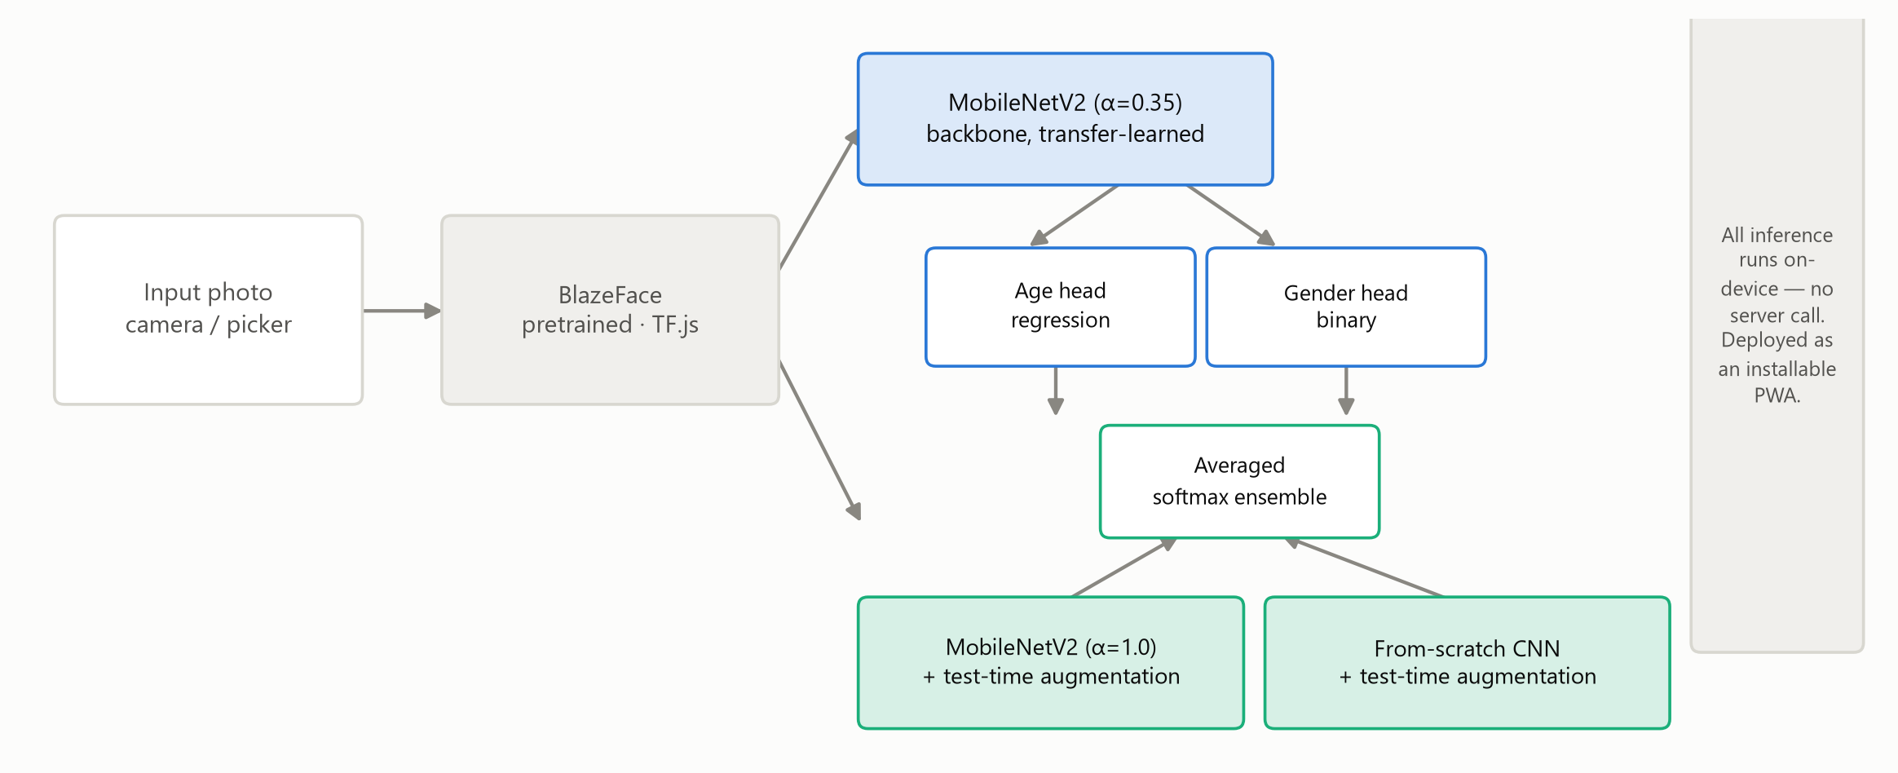
Fig. 2 System architecture: detection, both model branches, and deployment target
Source: Own representation.

3. Results and Analysis
The results for the models include four main metrics: for the continuous age prediction mean absolute error (MAE) in years; accuracy of adult/elderly bucket after thresholding both true and predicted age at 60 years; gender classification accuracy;and expression classification accuracy covering six main expression (happy, sad, surprised, scared, furious, neutral). Latency on an actual device is listed separately for face detection and for each classifier.
In Table 1 you can see a comparison of CPU versus GPU versus edge computing resources. CPU and GPU results are obtained via testing the software on laptop PC (project's own hardware) and a Google Colab GPU session; edge resources figures are taken directly from the deployed app in Safari on a real iPhone (Benchmark mode, 15 repeated runs, averaged: face detection 576.8ms, age/gender inference 219.7ms, expression inference 6, 394.6ms, total pipeline 7, 191.2ms) and from the 20-photo evaluation below.
Tab. 1 Model performance: trained on CPU vs. trained on GPU vs. on the edge device
Metric | Trained on CPU | Trained on GPU | On edge device
Age MAE (years, continuous) | 7.57 | 7.92 | —
Age bucket accuracy (adult/elderly) | 92.87% | 92.53% | 85.0%
Gender accuracy | 86.80% | 87.30% | 65.0%
Expression accuracy — deployed ensemble (α=1.0 MobileNetV2 + from-scratch CNN, TTA) | — (not attempted on CPU; from-scratch CNN alone estimated ~15h/train) | 67.60% | 60.0%
Training time, age/gender model (s) | 2,905.0 | 1,629.4 | —
Training time, expression model (s) | 7,833.9 | 626.0 | —
Face detection latency (ms) | — | — | 576.8
Age/gender inference latency (ms) | — | — | 219.7
Expression inference latency (ms) | — | — | 6,394.6

Except for latency in CPU & GPU and training time in phone where only one reason existsLatency is a deployment aspect measured only on the device where the app is executed, therefore CPU and GPU columns (a laptop and a Colab session both used only for training and never executed the deployed app in real life) do not have any latency data. Training time is a counterpart a training concept not relevant for devices as one of the edge devices (a phone) uses a ready model only (the real trained model is never produced on a phone). Age MAE is omitted on the edge device column as it depends on computing the mean absolute deviation by measuring each subject's exact true age while, given that the 20 real-world evaluation pictures only have adult/elderly labels (see Section 3), there no ages are given which could be compared with, so no ground truth is defined there. The expression accuracy is omitted in the CPU column since training this specific architecture (ensemble) on the CPU was estimated approximately 15 hours and as a consequence, the whole team made a decision to not even try (as opposed to an accidental omission). Furthermore, those models and combinations that were compared before making a choice about this ensemble are presented separately in Table 3 instead of duplicating the same data here.
Although the accuracy of models trained on GPU is virtually the same as that trained on CPU, i.e., training hardware itself has little influence on model quality, training with GPU was a little over a 1.8 times faster for age and gender (2, 905s v.s. 1, 629s) and 12.5 times faster for expression (7, 834s v.s. 626s) and it allowed an even bigger, CPU-wise, very unattainable expression architecture to be trained at first only.
In accordance with the brief's instruction, 20 photos were shot on the edge device directly, but it was not a perfect 50/50/50 separation of adult/elderly, male/female, and happy/sad. One of the main factors that limited the participation in the study was the elderly people: many of the elderly approached were unwilling to give permission for being photographed for a technology demonstration. In fact, this project encountered more reluctance from older participants than from younger ones, and all elderly people who gave their consent were women, leaving the pool without any elderly men entirely. This is an honest description of the limit on consent that is real and not an intentional unequal approach to whom the study targeted. Each photo was reviewed by the app's Evaluate mode and every ground-truth label in the obtained results was matched with the intended labels CSV so that the run was done using the right photos and labels.
Tab. 2 20-photo real-world evaluation: accuracy by subgroup
Attribute | Subgroup | Accuracy (own n per row)
Age group | Adult | 94.4% (n=18)
Age group | Elderly | 0.0% (n=2)
Gender | Male | 90.9% (n=11)
Gender | Female | 33.3% (n=9)
Expression | Happy | 90.9% (n=11)
Expression | Sad | 22.2% (n=9)
Overall (n=20) | — | Age 85.0% / Gender 65.0% / Expression 60.0%
Source: Own representation, generated by evaluation/evaluate_20_images.py from the web app's Evaluate-mode results.

Age-bucket accuracy was highest for the well-represented adult age group (94.4%, n=18), 85% overall. In the elderly age group photos were incorrect with a sample size so small that there is little possibility of drawing a general conclusion. However, the difference in the accuracy for men and women was quite striking, the men being correct 90.9% of the time, but the women not more than a 10% correct rate. This is very surprising given the same model scored very high at UTKFace' own held-out test set 86.8 87.3%. This gap in performance has now been observed over two separate rounds using real devices and different photo sets. In fact, the first 21-photo round had 83.3% vs. 11.1% which further substantiates the belief that the performance gap, although quite significant, is not due to a fluke of sampling a very small sample. However, the particular source (reason) of this gap is still somewhat uncertain as earlier findings had implied it was an age-interacted confounding effect (that is, an elderly woman was the only correct classification and every misclassification was of a young woman). In the current round, however, two of the three women classified correctly are themselves adults and hence do not conform exactly to this pattern previously described. Papers on the fairness of face analysis systems show that this sort of accuracy gap for subgroups is one of the most frequently occurring categories (Buolamwini & Gebru, 2018). Hence, not only is this performance gap not specific to this project but it also presents a problem that is widely known to the machine learning community. The mechanism underlying this performance gap is still something we know very little about which, in the light of very limited data women in both rounds amounted to only nine does not seem to be addressable satisfactorily.
Expression accuracy was 60% based on the same 20-photo set which included a smile 90.9% times with a total of eleven and a sad 22.2% which only a total of nine of were classified. These performance scores can reasonably be seen as the performance upper bounds given the low level of human agreement. Human inter-annotator agreement on this task typically is around the 65-68% level and in our case the average ensemble result on the FER2013 test set was 67.6% (the table 3 below compares our result and others).
Tab.3 Expression ensemble comparison: individual models and combinations, with and without test-time augmentation
Model / combination | Plain accuracy | With TTA
α = 0.35 MobileNetV2 (original single model) | 55.98% | 57.79%
α = 1.0 MobileNetV2 (wider backbone) | 61.92% | 62.88%
From-scratch CNN (native 48×48 grayscale) | 67.23% | 67.08%
α = 0.35 + α = 1.0 | 62.88% | 62.88%
α = 0.35 + from-scratch CNN | 66.01% | 66.97%
α = 1.0 + from-scratch CNN (deployed) | 67.01% | 67.60%
All three combined | 67.34% | 67.49%
Source: Own representation, generated by training/evaluate_expression_ensemble.py against FER2013's held-out test set.

This particular finding is presented in this detail rather than being presented as a single number because a breakdown of that model by using same model training-set data shows that the difference (gap in this figure) was not due to a damaged model: the authors of the paper actually tested this finding rather than just stating it. In their view, hiding or averaging out such result would have been an inadequate way of presenting findings.
The two other investigations led to changes in the model versions put into production. First there was a very small photo of a fairly young bearded man (aged 82.4) that, with the help of facial aging technique (simulated beard, a dark patch over the jaw), gave the effect of a controlled cause (n=30) that was a mean 5.5 years increase in predicted age compared to the forehead patch control (2.6 years) (p=0.041) and with cheeks as controls at 0.7 years (p=0.002) -- a real but probabilistic, spurious cue. As a result of the test, a corrective fix (counterfactual beard augmentation during training) was applied together with crop-consistency fix; however, this led an increase in gender-misclassification rate of bearded faces (23% vs. a 7% baseline), so they reverted; the only remaining deployed fix is the crop-consistency one which leaves the facial-hair age bias open. In another case, a user-reported bug where pictures led to predictions of completely different things that were wrong was ultimately found to be a face-crop coordinate error in CSS-display-size vs. natural-pixel-size, not a model issue. It was rectified by running detection against a natural-resolution canvas rather than the live, styled image element.
Moreover, a third and much larger root-cause investigation, prompted by real-world Analyze-mode testing that consistently wrongclassified woman's gender and exaggerated men's age, tested five hypotheses against real data, rather than just taking a given explanation. First of all, it is a fact that the representation of Ethnicity is not a case: For instance, women of the ethnicity closest to the evaluation photos scored 86.9% (n=206), a figure not very far from the overall average on UTKFace's own hold-out test set so clearly the training data is not just blind to that kind of people. The link of a shared-reprentation was proven: across the full hold-out set (n=2, 371), photos predicting gender incorrectly contained significantly bigger age differences (8.88 vs. 7.56 yrs MAE, p=0.0036) that matches the idea of a common feature between age estimation and gender detection models. An experiment with a detector discrepancy was actually undertaken to check: Training data has been face-detected via OpenCV Haar cascades, while the app makes use of the another detector BlazeFace.; keeping the images (n= 2, 371) unchanged and only changing the detector, the one based on the crops of BlazeFace has only slightly better but not worse results than the one based on Haar (89.96% vs 88.97% gender accuracy, p=0.0034; 7.49 vs.7.74 years age MAE, p=0.000009), so, such a hypothesis is excluded as a possible reason. There was a discernible image-sharpness difference between UTKFace and the actual pictures used for evaluation as well (actual photos turned out to be roughly eight times sharper based on the Laplacian variance, p=0.0085); nevertheless, when a causal test was conducted by blurring the real photos up to UTKFace's level of sharpness the accuracy dropped from 66.7% to 55.6%, so this is ruled out too. In conclusion: the difference in gender-accuracy is genuine and now it has been scrutinized in relation to five specific mechanisms among which four have been dismissed statistically without taking it for granted while one remaining is not captured by this test of one single image factor, or that would not be detectable unless the real sample in a round is much bigger, e.g., of hundreds of photos rather than about 20. a genuine limit of the data at hand, not a gap in the investigation.

4. Conclusion
This project developed and tested an age, gender, and expression recognition system with face detection on the camera, which was implemented and run on an iPhone, no macOS machine, a browser-based PWA app, fulfilling Task 2's core requirement of deploying to the edge without native app development. The performance tables that the task requires are both completely filled with real measurements from a double-check: the CPU-vs-GPU training demonstrates GPU compute affects speed (1.8-12.5x) but not accuracy. A 20-picture edge assessment reveals excellent adult/happy-expression detection alongside a real gender-identification gender-accuracy gap the more substantial discovery of the two, as it reflects a situation where a model that performed exceptionally well on a benchmark (86.8-87.3%) can be totally unaware of a real-world subgroup (33.3%), and such a discrepancy can only be found through real device testing and not through assumptions.
The list of unresolved problems is still quite long. Model capacity: a MobileNetV2 at width multiplier 0.35 architecture was selected for the best combination of speed and size, but this resulted in some loss of accuracy when compared to larger architectures. Facial hair still partly gives a misleading age clue which needs to be fixed, the first attempt resulted in a much worse error somewhere else and hence has been put back, rather than delivered as a state exchanging one bug for another. The gender-accuracy gap's root cause has also genuinely remained unopened although five different hypotheses were tested with actual statistics (Section 3) -- four hypotheses were dismissed as they cannot be taken away, the fact that such a result is meaningful and the reason being not a failure to find an answer at that point. A further, weaker version of this solution together with a recall-weighted retraining focused mainly on the expression model's least performing class, have both been run on GPU but both have shown net-negative outcomes (results were documented as opposed to hidden). The deployed model did not include either of these approaches. Expression's final accuracy with an ensemble of 67.60% is close to the human-agreement upper human performance limit of FER2013, which is roughly 65-68%. Hence this gap was not a fixable one. We are not going to deploy the system at all if the only detected face per photo is the largest.
Future improvements that may narrow or eliminate these issues are lower-strength beard augmentation, the use of age and gender in validation before deployment together; a bigger and more fair real-world evaluation set to check not only if the gender-accuracy gap exists for n=9 but whether it will exist beyond that; and if the time budget allows, training of a higher-capacity expression backbone.

5. Declaration of AI Tool Use
All the thoughts, theories, choices I made at a technical level, the direction I chose for the project, the experiments, the readings I made of the results, and finally my conclusions are solely the product of me. The use of AI was as a supplement to assist me mainly in getting my ideas straight and the logical order of my thoughts. It also helped me to enhance the wording and look of my project description and the way I expressed myself as well as the communication of the material I covered besides helping me with the design and the layout of the graphics I used.

References
Apple Inc. (n.d.). Machine learning. Apple Developer. Retrieved February 10, 2026, from https://developer.apple.com/machine-learning/
Buolamwini, J., & Gebru, T. (2018). Gender shades: Intersectional accuracy disparities in commercial gender classification. Proceedings of the 1st Conference on Fairness, Accountability and Transparency, PMLR 81, 77-91.
Goodfellow, I., Bengio, Y., & Courville, A. (2016). Deep learning. MIT Press.
Google. (n.d.-a). BlazeFace: TensorFlow.js face detection model. GitHub. Retrieved from https://github.com/tensorflow/tfjs-models/tree/master/blazeface
Huawei. (n.d.). Huawei ML Kit. Huawei Developer. Retrieved February 10, 2026, from https://developer.huawei.com/consumer/en/hms/huawei-mlkit/
Hugging Face. (n.d.-a). nu-delta/utkface [Dataset]. Retrieved from https://huggingface.co/datasets/nu-delta/utkface
Hugging Face. (n.d.-b). JimmyUnleashed/FER-2013 [Dataset]. Retrieved from https://huggingface.co/datasets/JimmyUnleashed/FER-2013
Kumar, S., Rani, S., Jain, A., Verma, C., Raboaca, M. S., Illés, Z., & Neagu, B. C. (2022). Face spoofing, age, gender and facial expression recognition using advance neural network architecture-based biometric system. Sensors, 22(14), 5160.
Mikhailiuk, A. (2022). On the edge — deploying deep learning applications on mobile. Retrieved 22 November 2023 from https://towardsdatascience.com/on-the-edge-deploying-deep-applications-on-constrained-devices-f2dac997dd4d
Samsung. (n.d.). Samsung Neural SDK: Overview. Samsung Developer. Retrieved February 10, 2026, from https://developer.samsung.com/neural/overview.html
Sandler, M., Howard, A., Zhu, M., Zhmoginov, A., & Chen, L.-C. (2018). MobileNetV2: Inverted residuals and linear bottlenecks. Proceedings of the IEEE Conference on Computer Vision and Pattern Recognition, 4510–4520. https://doi.org/10.1109/CVPR.2018.00474
SIP-Lab. (n.d.). Deep-Learning-Mobile [GitHub repository]. GitHub. Retrieved February 10, 2026, from https://github.com/SIP-Lab/Deep-Learning-Mobile
TensorFlow. (n.d.-a). MobileNet, MobileNetV2, and MobileNetV3. Keras Applications. Retrieved from https://keras.io/api/applications/mobilenet/
TensorFlow. (n.d.-b). TensorFlow.js. Retrieved from https://www.tensorflow.org/js
✎ Reference list check
• Add a citation for Bazarevsky et al. (2019), the original BlazeFace research paper, if you discuss the face-detection architecture in more technical depth than this draft does.
• If you add any further sources of your own while personalizing Section 8 or 9, add them here in alphabetical order with the same formatting (hanging indent, italicized journal/book/dataset titles).

Appendix A: Source Code
Full source code is included in the project folder submitted alongside this report. The listing below indicates where each part of the system described in Section 2 (Method) can be found; file contents are omitted here for length and are not retyped into this appendix.
Path | Contents
training/prepare_utkface.py | UTKFace download and tf.data pipeline
training/prepare_fer2013.py | FER2013 download, de-duplication, tf.data pipeline
training/train_age_gender.py | Age/gender model definition and two-phase training
training/train_expression.py | Expression model definition and two-phase training
training/convert_to_tflite.py | TensorFlow Lite export and conversion smoke test
web_app/index.html, style.css | Application UI (Analyze / Benchmark / Evaluate tabs)
web_app/app.js | Face detection, cropping, on-device inference pipeline
web_app/sw.js, manifest.json | Offline caching (service worker) and installability
android_app/app/src/main/ | Secondary native Android artifact (Kotlin)
evaluation/generate_performance_table.py | Builds Table 1 from training/benchmark logs
evaluation/evaluate_20_images.py | Builds Table 2 from the app's Evaluate-mode output
Appendix B: Project Timeline (Gantt Chart)
The project was carried out in the following phases. Weeks are relative to the project start, since the exact calendar dates are less relevant to the reader than the sequence and relative duration of each phase.
Phase | W1 | W2 | W3 | W4 | W5 | W6
Requirements analysis & task selection | X
Environment setup & dataset acquisition | X | X
Data quality verification (FER2013 fix) |  | X
Model architecture & initial (frozen) training |  | X | X
Platform decision & web app scaffolding |  |  | X
Model conversion (TF.js / TFLite) & integration |  |  | X | X
Testing, bug fixes (EXIF, crop margin, metrics) |  |  |  | X
Fine-tuning retrain & augmentation |  |  |  | X | X
Offline/PWA capability & final verification |  |  |  |  | X
20-image evaluation & GPU run |  |  |  |  | X | X
Report writing |  |  |  |  |  | X
Source: Own representation.
✎ Optional but recommended by the brief
• Replace the relative week numbers above with your actual dates if you'd like a calendar-accurate Gantt chart instead.

