**GRADUATION THESIS**



**FACULTY : ARCHITECTURE AND ENGINEERING**

**DEPARTMAN : ELECTRICAL-ELECTRONICAL ENGINEERING**

**THE ADVISOR :** [**Doç. Dr. Murat AKSOY**](https://avesis.cu.edu.tr/aksoy)

**STUDENT : Osman ÇİÇEK (2015513013)**

**TOPIC: AVIONICS SYSTEMS FOR MODEL ROCKETS**

**AVIONICS SYSTEMS FOR MODEL ROCKET**

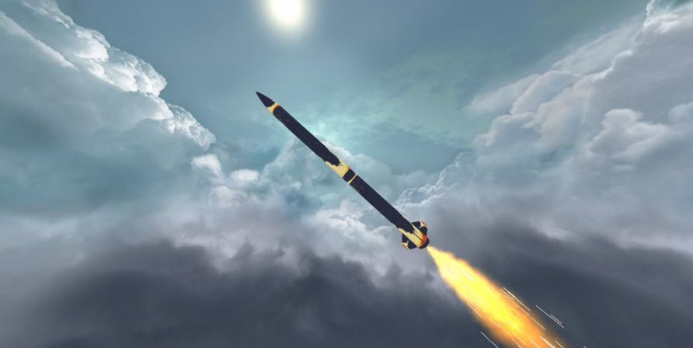

**CONTENTS:**

**1.0 INTRODUCTION………………………………………………………………………………3**

**1.1 WHAT’S THE AVIONIC SYSTEMS?………………………………………………………..3**

**1.2 WHAT’S THE TEKNOFEST?…………………………………………………………..…....4**

**1.3 WHAT’RE EXPECTATIONS FROM AVIONIC SYSTEMS?..………………………….....5**

**1.4 WHICH PARAMETERS DOES ROCKET USE?…………………………………………..5**

**2 ORIGINAL AVIONIC SYSTEM……………………………………………………………..….6**

**2.1 IGNITION FLIGHT COMPUTER………………………………………………………...…..6**

**2.2 TELEMETRY FLIGHT COMPUTER…………………………………………………….…17**

**2.3 GROUND STATION………………………………………………………………………....21**

**2.4 COMMON ELEMENTS………………………………………………………………...…...24**

**3. DESIGN……………………………………………………………………………………..….27**

**3.1 HARDWARE DESIGN…………………………………………………………………...….27**

**3.2 SOFTWARE DESIGN……………………………………………………………………….31**

**4. PRODUCTION………………………………………………………………………………...32**

**5. TESTS………………………………………………………………………………………….33**

**1. INTRODUCTION**

Avionics are the elektronic systems used on rocket, aircraft, spacecraft etc. Avionic systems are ecosystems of all flight computers. Aim of using avionics system is that making every electronical process and produce some data and command then transmit this data to ground station or make specific task as using command. Avionics system of model rocket has two fundamental task. One of them is telemetry, other one is ignition under specific condition. More details are given at next part.

**1.1 WHAT’S THE AVIONIC SYSTEMS?**

A literal blend of the terms "aviation" and "electronics," the avionics installed in an aircraft or spacecraft can include engine controls, flight control systems, navigation, communications, flight recorders, lighting systems, threat detection, fuel systems, electro-optic (EO/IR) systems, weather radar, performance monitors, and systems that carry out hundreds of other mission and flight management tasks.

Every modern aircraft, spacecraft, and artificial satellite uses electronic systems of varying types to perform a range of functions pertinent to their purpose and mission.

I am interesting in avionic systems of model rocket. Actual we can think that Avionic System is the ecosystem of all flight computer. There are two model rocket competition at the world for now. One of them is IREC, other one is Teknofest rocket compitetion. Most of model rockets where designed at turkey are designed according to rules of Teknofest rocket compatitions at Turkey. So, my design was created under theese conditions. What’s Teknofets and What’s theese rules?

**1.2 WHAT’S THE TEKNOFEST?**

TEKNOFEST Aviation, Space and Technology Festival, Turkey Technology Team Foundation (Foundation T3) and T. C. Industry and Technology Ministry's executive, many organizations that play a critical role in the development of national technology in Turkey is the world's largest festival organized by the fellowship. TEKNOFEST Aviation, Space and Technology Festival, which has been held annually since 2018; technology competitions, air shows, concerts, aviation and aerospace event titled, on the increasing interest in the technology community by hosting several activities such as talks and Turkey's transformation into a society that produce national technology aims to create awareness.

In TEKNOFEST 2019, from aviation to automotive, within the scope of TEKNOFEST Aviation, Space and Technology Festival, the competition areas, competition specifications, which take place in technology competitions, which are held under the guidance and consultancy of experts and institutions in a wide spectrum ranging from flying car design to unmanned underwater systems, technology for the benefit of humanity and biotechnology innovation, security principles and procedures, factors such as the refereeing committee of management and reward programs shipped by Turkey Technology Team Foundation and is administered.

You can see the regulatory and stakeholder organizations by visiting the Teknofest website.

Link : https://www.teknofest.org/duzenleyici-kuruluslar.html

**1.3 WHAT’RE EXPECTATIONS FROM AVIONIC SYSTEMS?**

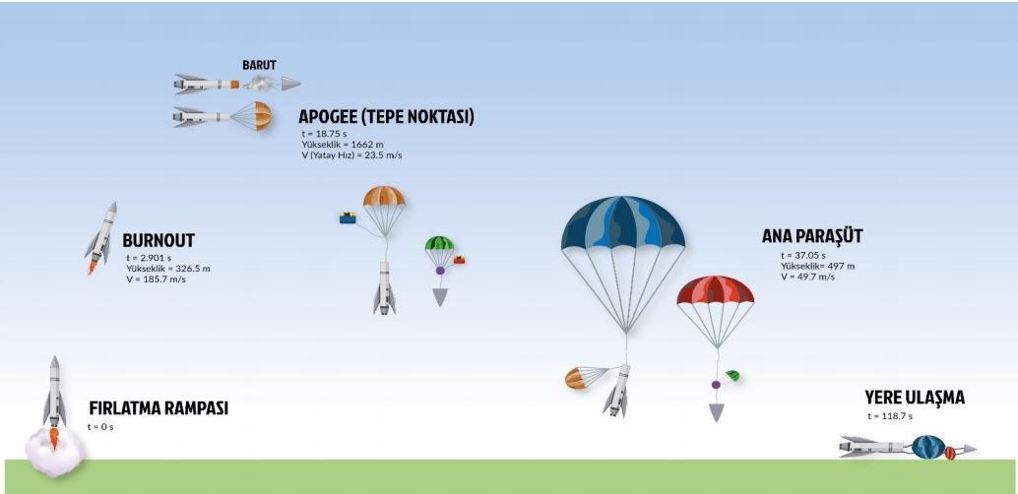**Fig. Concept of Operation**

According to rules, Avionic systems have two main tasks. Theese are communication with ground station, split rocket from main part to sub parts and putting payload at target altitude. Communication must be real time and accurate, division can be make with a lot of technic. For example some kind of motor can be used or mechanical device can been trig as using gunpowder and achieved division. System ignite directly gunpower and impulse is become thanks to pressure which caused the explodation. Then This impulse push the nose cone. And parachutes and payload is released to air. Important point is Which parameters will be used by flight computer for ignition. Theese parameters will be investigated next section.

**1.4 WHICH PARAMETERS DOES ROCKET USE?**

According to rules, Avionics systems have to use minimum two parameter. According to my experiences and my reseaurces, I decided to use z axis acceleration and rocket's altitude at my algorithim as parameter. Actually I aveluated gyro datas but because of that rocket vibrate very fast, gyro didn't provide reliable data so I eliminate gyro datas. According to Open Rocket Datas, Rocket will reach apogee point in apporixametly 5 second then it falls down thank to gravity effect. When Rocket start to fall down, Wings start to fill with air and bottom of the rocket will rise to sky, the rocket's upper body is positioned down. Thus, Z axis value decreases under to zero. Z axis and altitude datas can be used for ignition. I will give more details at next parts.

Location datas are so important for finding the rocket. Most convenient GPS module and communication module are choosen according to geographic conditions and rocket’s distance range.

**2 ORIGINAL AVIONIC SYSTEM**

Accordİng to my eveluation, barometer and acceleremater will be used. There must be some creterias for selecting available sensors. Theese creterias are resolution, mechanical size, reliabletivity, range of measurement, whether there is a filter or not etc. Theese criterias was investigated at sub sections. There are a lot of products as barometer and acceleremetor in the country. While sensors was been selecting, have to be careful that sensor can reachable in the country. There is spesific volume for avionic in the rocket. Dimentions are 25 cm height and 55mm radius. Because of our limitations, sensors and modules size are so important. Avinoic was diveded two subparts for having more size and more stability. Avionics system was tried one part but GPS and telemetry modules are slow down algorithm and ignition is late. Additionaly, Fitting all modules in one area is occurred some problems. One of them is that All system feed from one battery and this situtation increase battery requiretments.

Thus Avionic is divided two parts. Task of one part is ignition and task of anoher one is just telemetry, sending location datas. Also, A ground station was designed. Details are at next parts. Now, Other criterias can be evaulated. At this stage, Firstly modules were selected, then microcontroller was selected according to our comminication protocol and performans requiretments.

**2.1 IGNITION FLIGHT COMPUTER**

**BAROMETER**

A digital barometer uses a detection cell (i.e. a chip) to measure the air temperature/ This chip will be vital and is sensitive to atmospheric pressure which influences its capacity to conduct/relay electricity.

Barometers provide pressure data and this data is calculated thanks to some formula, altitude data occurred. When resolation increase, Algorithm will be more reliable.

* **BME280**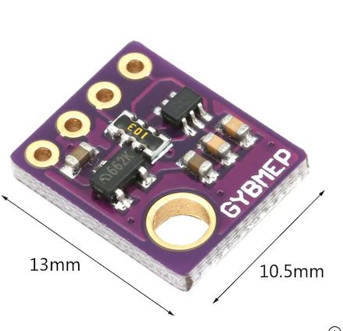, the precision sensor from , is soldered onto PCB.
* Not only the pressure and the temperature, this sensor can measure humidity.
* It uses both I2C and SPI (supports 3-, 4-wire SPI) interface.
* That dimensions are smalls and has small energy consumtions are among selection properties.
* Module has chip of Bosch and specific parameters are given below

**Fig. BME 280**

|  |  |
| --- | --- |
| Parameter | Technical data |
| Operation range | Pressure: 300...1100 hPa Temperature: -40…85°C |
| Supply voltage VDDIO Supply voltage VDD | 1.2 ... 3.6 V 1.71 ... 3.6 V |
| Interface | I²C and SPI |
| Average current consumption (typ.) (1Hz data refresh rate) | 1.8 μA @ 1 Hz (H, T) 2.8 μA @ 1 Hz (P, T) 3.6 μA @ 1 Hz (H, P, T) T = temperature |
| Average current consumption in sleep mode | 0.1 μA |
| **Humidity sensor** Response time (τ63%) Accuracy tolerance Hysteresis | 1 s ±3% relative humidity ≤2% relative humidity |
| **Pressure sensor** RMS Noise Sensitivity Error  Temperature coefficient offset | 0.2Pa (equiv. to 1.7cm) ±0.25% (equiv. to 1m at 400m height change)  ±1.5Pa/K (equiv. to ±12.6cm at 1 °C temperature change) |
| RoHS compliant, halogen-free, MSL1 |  |
| Package dimensions | 8-Pin LGA with metal 2.5 x 2.5 x 0.93 mm³ |

According to table, our pressure range is 300-1100 hPa. If we make unit conversion, for altitude range is -698 m - 9160.1 m according to some calculation websites.

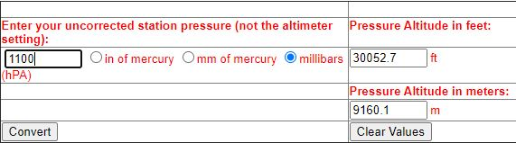

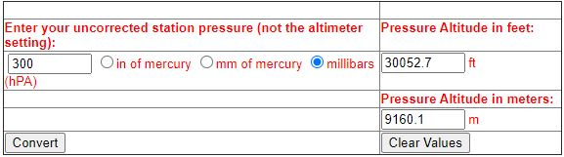

**Fig. Covertion Calculation**

Additional, BME280 has IIR filter. This filter prevent high noise occuration. An infinite impulse response(IIR) filter is a digital filter that depends linearly on a finite number of input samples and a finite number of previous filter outputs.

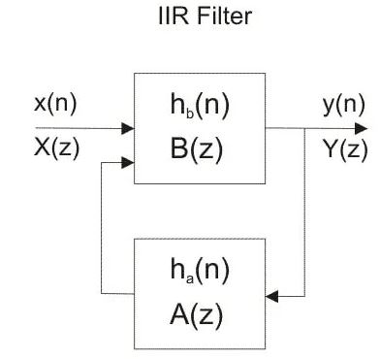 In other words, it combines a FIR Filter with feedback from previous filter outputs. Mathematically, for some coefficients bi and aj:



**Fig. Formula of IIR Fılter**

**ACCELEROMETER**

An accelerometer is a device that measures the vibration, or acceleration of motion of a structure. The force caused by vibration or a change in motion (acceleration) causes the mass to "squeeze" the piezoelectric material which produces an electrical charge that is proportional to the force exerted upon it. Since the charge is proportional to the force, and the mass is a constant, then the charge is also proportional to the acceleration.

Task of accelerometer at my system is determinig posture and and sending this data to micro controller for making ignition. According to OpenRocket datas, Rocket expose 92 m/s^2 acceleration, its means is that rocket expose approximatelly 9 g. Acceleroemeter have to stand against to minumum 10 g.

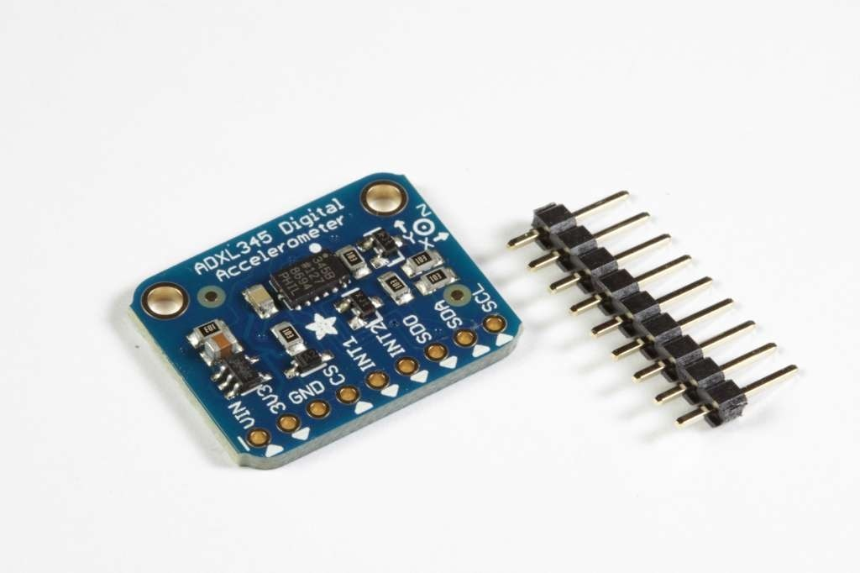**ADAFRUIT ADXL345** is choosen because of its g range is apropriate for rocket g forces and have internal 5 V to 3.3 V regulator and it has IIC and SPI communication protocols. Dimensions are a bit of big but it can be tolerate.

## How it Works:

## MEMS - Micro Electro-Mechanical Systems

The sensor consists of a micro-machined structure on a silicon wafer. The structure is suspended by polysilicon springs which allow it to deflect smoothly in any direction when subject to acceleration in the X, Y and/or Z axis. Deflection causes a change in capacitance between fixed plates and plates attached to the suspended structure. This change in capacitance on each axis is converted to an output voltage proportional to the acceleration on that axis.

I2C communication protocol will be used for drawing data.

**I2C Wiring:**

The ADXL345 Breakout has an I2C address of 0x53. It can share the I2C bus with other I2C devices as long as each device has a unique address. Only 4 connections are required for I2C communication:

GND->GND

VIN->+5v

SDA->SDA (Analog 4 on "Classic Arduinos")

SCL->SCL (Analog 5 on "Classic Arduinos")

The Adafruit breakout has level shifting and regulation circuitry so you can power it from 3-5V and use 3V or 5V logic levels for i2c

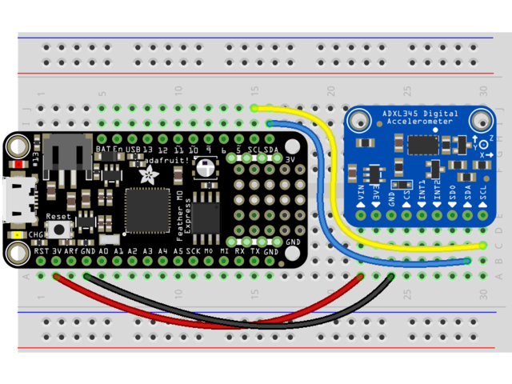

**Fig. Sample connection**

**IGNITION CONTROLLER**

Microcontroller is brain of avionic system. STM32F103C8T6 (Blue pill) was chosen . Reasons of this choice are that it is cheap and easily available and it has ARM CORTES -M3 CPU CORE, big performance capacitiy (up to 72 Mhz) compared to arduino any model, small size (it is important for us because there is no much more area in rocket), a lot of pwm pins, low power cosumption compared to rasperry pi and I think much important difference from other some microcontroller and microproccesor is that it has 3 UART, I2C and SPI comminication port. Some knowledges and pin configuration is given about STM32F103C8T6…

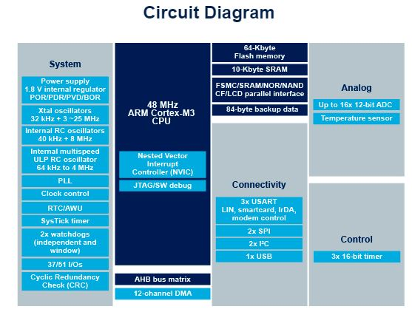

**Fig. STM32F103C8 Circuit Diagram**

**KEY FEATURES**

ARM®32-bit Cortex®-M3 CPU Core

* + 72 MHz maximum frequency,1.25 DMIPS/MHz (Dhrystone 2.1) performance at 0 wait state memory access
  + Single-cycle multiplication and hardware division
* Memories
  + 64 or 128 Kbytes of Flash memory
  + 20 Kbytes of SRAM
* Clock, reset and supply management
  + 2.0 to 3.6 V application supply and I/Os
  + POR, PDR, and programmable voltage detector (PVD)
  + 4-to-16 MHz crystal oscillator
  + Internal 8 MHz factory-trimmed RC
  + Internal 40 kHz RC
  + PLL for CPU clock
  + 32 kHz oscillator for RTC with calibration
* Low-power
  + Sleep, Stop and Standby modes
  + VBAT supply for RTC and backup registers
* 2 x 12-bit, 1 μs A/D converters (up to 16 channels)
  + Conversion range: 0 to 3.6 V
  + Dual-sample and hold capability
  + Temperature sensor
* DMA
  + 7-channel DMA controller
  + Peripherals supported: timers, ADC, SPIs, I2Cs ans USARTS

Up to 80 fast I/O ports

* + 26/37/51/80 I/Os, all mappable on 16 external interrupt vectors and almost all 5 V-tolerant
* Debug mode
  + Serial wire debug (SWD) & JTAG interfaces
* 7 timers
  + Three 16-bit timers, each with up to 4 IC/OC/PWM or pulse counter and quadrature (incremental) encoder input
  + 16-bit, motor control PWM timer with dead-time generation and emergency stop
  + 2 watchdog timers (Independent and Window)
  + SysTick timer 24-bit downcounter
* Up to 9 communication interfaces
  + Up to 2 x I2C interfaces (SMBus/PMBus)
  + Up to 3 USARTs (ISO 7816 interface, LIN, IrDA capability, modem control)
  + Up to 2 SPIs (18 Mbit/s)
  + CAN interface (2.0B Active)
  + USB 2.0 full-speed interface
* CRC calculation unit, 96-bit unique ID
* Packages are ECOPACK®

**BLUE PILL LAUNCH BOARD(STM32F103C8T6)**

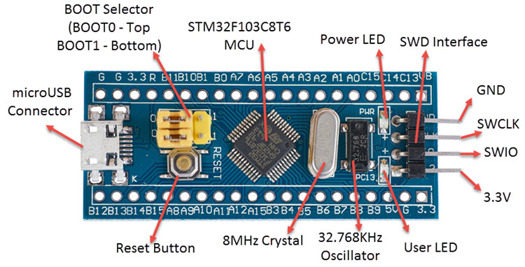

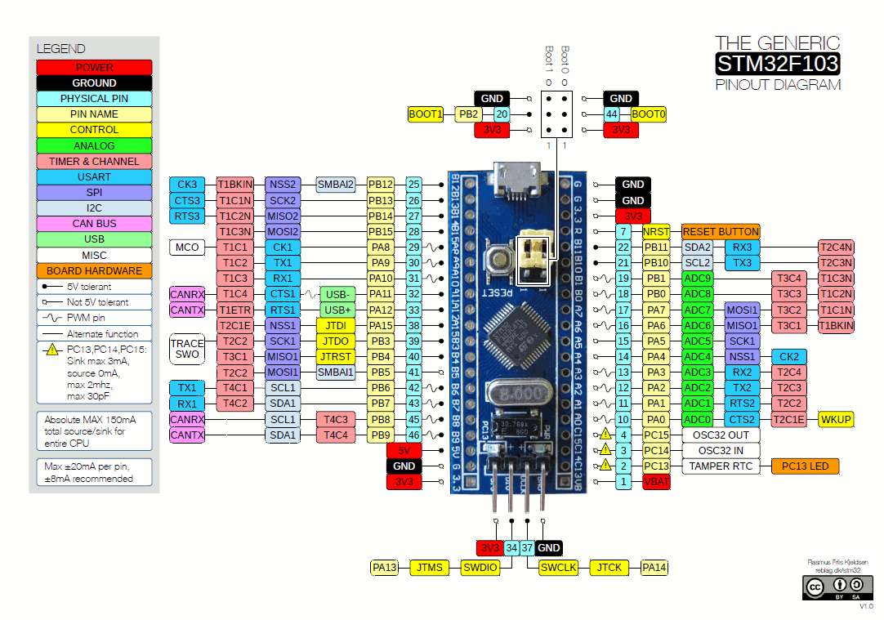

**Fig. BLUEPILL Pin Configuration**

### **Issues with STM32 Blue Pill Board**

If you are planning to buy the cheaper version (which probably most of us will), then there are some known issues with the boards that you have to be aware of. I have taken these issues from various forums and faced some problems (USB related) myself.

* The first main issue is the 3.3V regulator. Though some boards have used genuine LM1117 3.3V regulators from TI, most of the cheap development board are found with small, knock-off regulators from an unknown manufacturer. These regulators do not have any thermal protection and are easily damaged. The solution is to use an external regulated power supply, if you have the option.
* The next two issues are related to the USB. First, the soldering quality of the microUSB port is very poor and if you frequently remove and insert the cable into this port, then there is a high chance that the microUSB connector will come off the board. You can use hot glue to cover the connector.
* The other issue related to USB is the usage of wrong pull-up resistor. According to the reference manual of the MCU, the USB D+ (named USBDP) must be pulled high to 3.3V using a 1.5KΩ resistor. But as per the schematics of several Blue Pill boards, all those are using a 10KΩ resistor. If you are planning to work on USB data transfer, then you might not get accurate results. If you are in desperate need for a solution, then you can solder a 1.8KΩ resistor is parallel to the existing 10KΩ resistor. For this, connect the 1.8KΩ resistor between pins A12 and 3.3V pin.
* Other known issues are very hard to press reset button, analog power is connected to digital power, no Schottky Diode protection for USB, etc.

ST company make categorization own product. For micro controller, every character represent some specification. You can observe from below table

|  |  |  |
| --- | --- | --- |
| **Character(s)** | **Significance** | **Possible Values** |
| STM | Manufacturer (STMicroelectronics) | —- |
| 32 | 32-bit MCU | —- |
| F | Type of MCU | F: Mainstream, L: Low power, H: High Performance, W: Wireless |
| 1 | ARM Core Type | 0: M0, 1: M3, 2: M3, 3: M4, 4: M4, 7: M7 |
| 03 | Line of MCU | Details about speed, peripherals, Silicon Process, etc. |
| C | No. of Pins | F: 20, G: 28, K: 32, T: 36, S: 44, C: 48, R: 64,66, V: 100, Z: 144, I: 176 |
| 8 | Flash Size | 4: 16, 6: 32, 8: 64, B: 128, C: 256, D: 384, E: 512, F: 768, G: 1024, H: 1536, I: 2048 KB |
| T | Package | P: TSOOP, H: BGA, U: VFQFPN, T: LQFP, Y: WLCSP |
| 6 | Temperature Range | 6: -40°C to 85°C, 7: -40°C to 105°C |

**IGNITION MECHANIZM**

There are a lot of division mechanism. Theese can be mechanical or ignitional mechanizm or gasses exposition system. Because of, simple appications and easy armming features, black power was selected. For ignition operation, A lot of method was evaulated like spark plug, arc jenarator etc… But theese methods has big volume and needed extra cost. Match head was choosen.

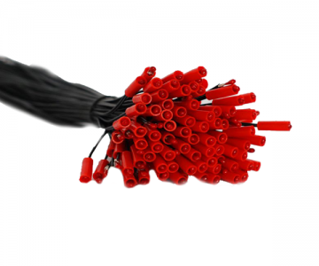**MATCH HEAD:**

* Wire length is 30 cm
* It is used in electronic ignition of pyrotechnic products.
* Minumum 0.5 amper is needed for making ignition

For using match head, electronic switch have to be used. Transistors are more suitable than electronic relay for minor electronic systems. TIP31C is choosen for using easly reachable and controllable current which passes in the copper trace and wiring. Thanks to below formula, Collector – emiter voltage was calculated.

I (ce) = ((Vb – Vbe(sat)) / Rgate ) * (1 + Hfe)

**TIP31C**

The TIP31C is a base island technology NPN power transistor in TO-220 plastic package with better performances than the industry standard TIP31C that make this device suitable for audio, power linear and switching applications. The PNP type is TIP32C.

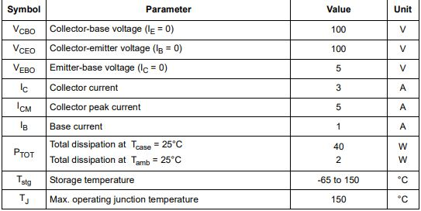

**Fig.Absolute max rating**

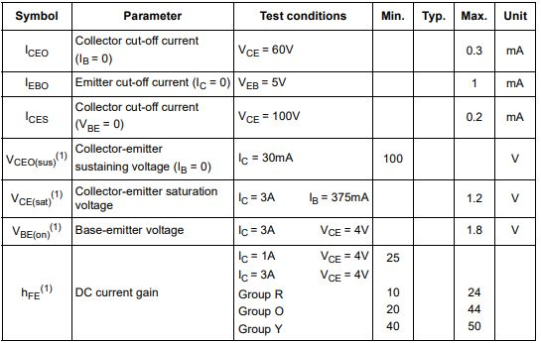

**Fig. Elecktical Characteristic**

Heat power losses was calculated:

Ploses = 1.2 * 1.07 = 1.284 watt

**2.2 TELEMETRY FLIGHT COMPUTER**

**GPS (GLOBAL POSİTİON SYSTEM)**

Rocket launch ramp from ground station with 85 degree angle to opposite direction have to be position. Rocket will rise 3 km, deploy drag parachute at apogee then land to 500 meters and deploy main paratchute. When air speed put in the calculations, Rocket go away to min 3 km at horizontal axcis. For finding the rocket, location data have to be taken from rocket. So NEO 7M GPS module was choicen.

**U-BLOX NEO 7M**

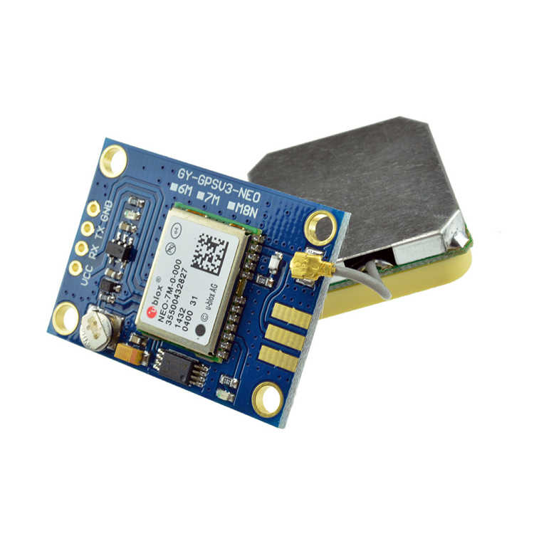NEO 7M can use neigther GPS and GLONASS sattelites.

**Fig. GPS NEO-7M**

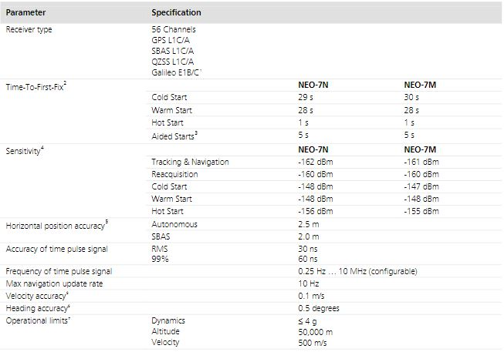

**Fig. GPS Perfotmance**

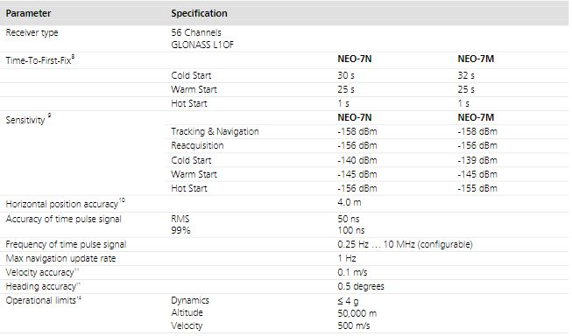

**GLONASS Performance**

Product of U-blox can be maken configuration thanks to U-Center as software tool.

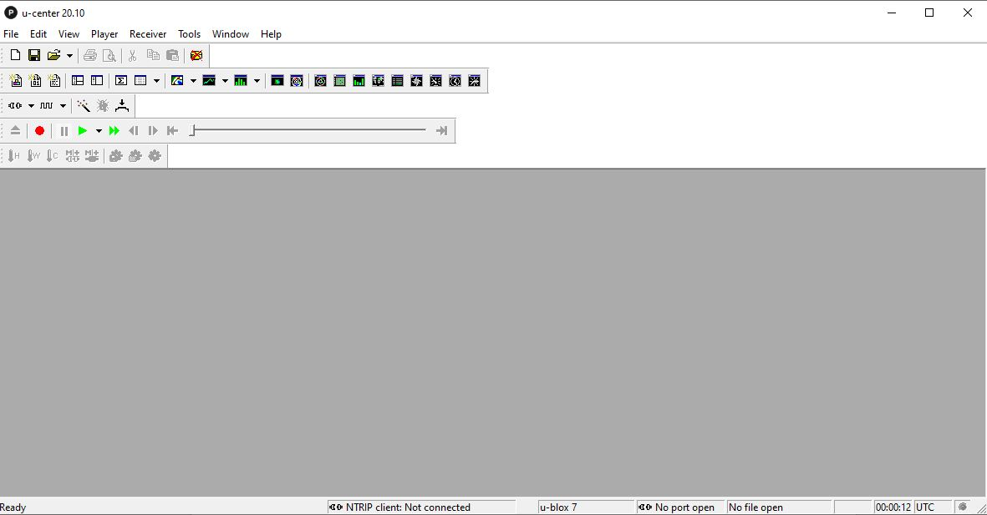

**Fig. U-Center Interface**

To draw location data from sattelite, It has to connect minumum 4 sattelite. GPS takes location of theese sattelite and make some calculation thus find out own location data.GPS modules send data as NMEA type, This data is decoded find out own location.GPS’s have 2 starting mode. Theese are hot start and cold start modes. If GPS hasn’t work for long time, It download ALMANAC data when it opened. Download process can taken some minutes. This process is called as cold start mode. But If GPS don’t start firstly, It can connect easly sattelite at short time like 1, 2 second. This process is called as hot start mode.

**TELEMETRY MODULE**

According to rules, There have to be real time communication between ground station and rocket avionic system during to all launching and landing steps. For this task, Lora E32-868T20D will be used as transmitter. Lora protocol provide long range communication with low energy comsumption. E32-868T20D is produced by E BYTE wireless communication and telemetry systems company. It is easy controllable and programmable device. It can work at four modes. Theese modes were explained at user manual which is published by product company. At this project, Lora will be used at normal mode. So mode pins of lora can be fixed to ground for normal mode. Module works 5 V nomianlly as Vin So it can be directly fixed to regulator. But Ttl pins work with 3.3V. If they connected to 5 volts pin, module can take damage. But our telemetry micro controller use 3.3 Volt for pins, There is no problem for now. But Situatios are different for ground station.

**E32-868T20D**

IC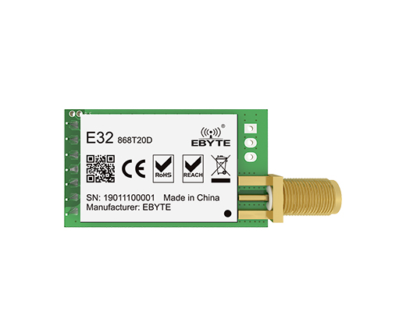: SX1276

Frequency: 862~893MHz

Power: 10~20dBm

Distance: 3.0km

Interface: UART

**Fig. E32-868T20D**

Weight: 6.7±0.1g

**Introduction:** 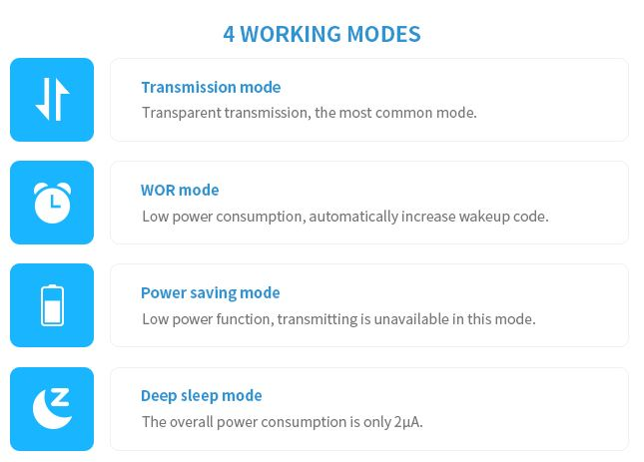E32-868T20D is a 100mW wireless transceiver module, operates at 862~893MHz, based on original imported RFIC SX1276 from SEMTECH. The module adopts LoRa spread-spectrum technology, which means the transmitting distance is much longer than before.

**Fig. Mode of E32-868T20D**

Module works under four mode thees modes are arranged thanks to M1 and M2 mode pin combinations. Just two mode was be used at this project. One of them is normal mode (other name is transmisison mode) for communication. Other mode is deep sleep mode for programming device.

For programming device, A programming card was desinged.

**TELEMETRY MICRO CONTROLLER**

Telemetry flight card has two module as digital elements. GPS and LORA use serial communication protocol so number of serial poart’s at micro controller is important. Minumum port reqipment at micro controller have to be two. So NODEMCU LOLIN V3 was selected for this task. It has two serial ports, clock speed of it is 80 Mhz and programmable easyly thanks to some software tools. It’s volume is a bit big but it can be tolerate.

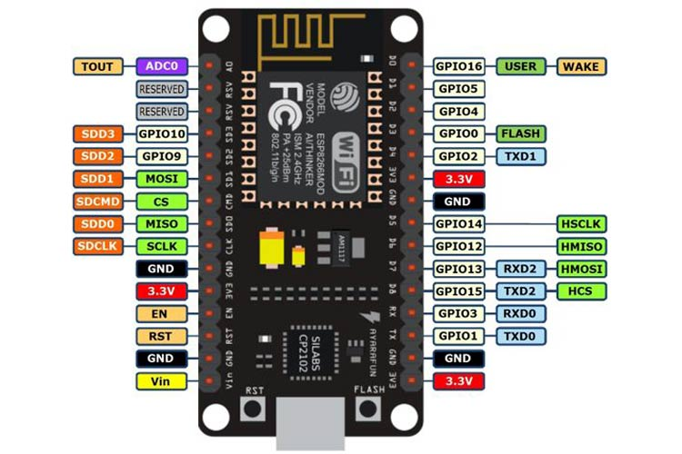**FEATURES:**

* Operating Voltage: 3.3V
* Input Voltage: 7-12V
* Digital I/O Pins (DIO): 16
* Analog Input Pins (ADC): 1
* UARTs: 2
* SPIs: 1
* I2Cs: 1

**Fig. NODEMCU LOLIN V3**

* Flash Memory: 4 MB
* SRAM: 64 KB
* Clock Speed: 80 MHz
* USB-TTL based on CP2102 is included onboard, Enabling Plug n Play
* PCB Antenna

**2.3 GROUND STATION**

Fundamental task of ground station is taking data from telemetry and diplay that data. Actually, ground stations is usually designed as fixing to computer. But at this project, ground station doesn’t depend on computer. For completing task, It has receiver, diplay and storage unit. **E32-868T20D** was used as receiver, LCD 2*16 screen was selected for diplaying and mini SD card module used for storing data. Also, Arduino NANO, logic level shifter and some buttons were used at ground station. Lora module won’t explain again, It was explained at previous section.

**MICRO SD CARD MODULE**

SD card module have to be log data which is from receiver. It must be fast so It uses SPI communication protocol. Pın diagram given below:

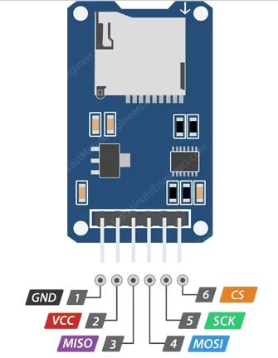

There are two so important point for this module. One of them is that Module must be stopped to logging before turn off. And for some writing or reading operation, last operation have to be stoppped. If sd card is wantted to use, It has to formatted in available format.

**DISPLAY SCREEN (2X16)**

**Fig. SD Reader**

Display screen is selected for user friendly. There is no other criteria

**LOGIC LEVEL SHIFTER**

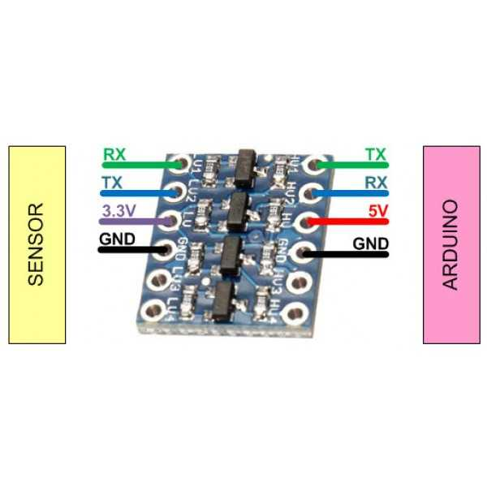According to user manual of E32-868T20D, TTL pins must work with 3.3V for safety. But microcontroller GPIO pins work with 5 V. For lora don’t take damage, Logic level shifter have to be used between lora TTL pins and micro controller TTL pins. Logic level shifters provide energy convertions thanks to transistor gates.

Connections can provided like picture.

**Fig. LLS**

**GROUND STATION MICRO CONTROLLER**

Ground stations requipments are minimal operations like receive data display and storoge. So Arduino NANO can be used for this task. Low price, easy reachability and user friend structure are reasons of selection.

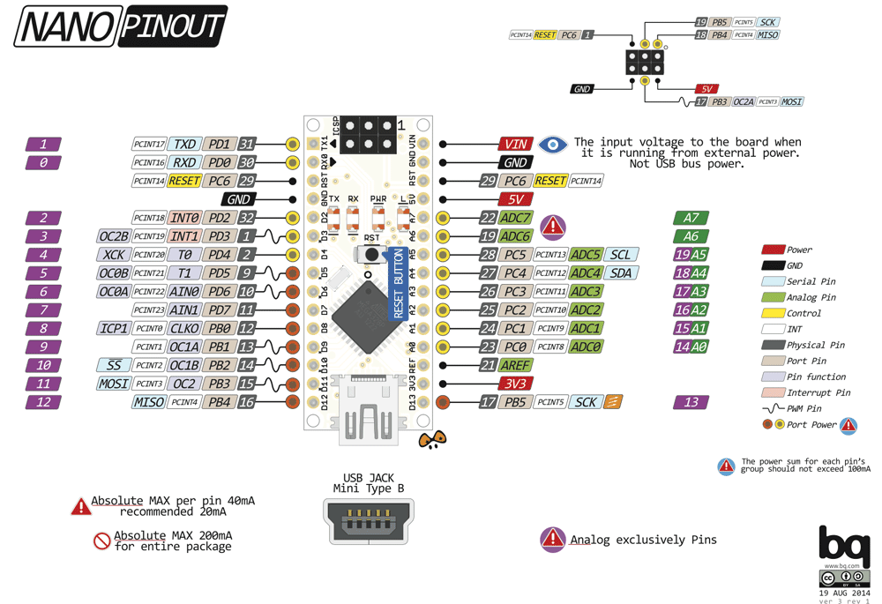

* It has 22 input/output pins in total.
* 14 of these pins are digital pins.
* Arduino Nano has 8 analogue pins.
* It has 6 PWM pins among the digital pins.
* It has a crystal oscillator of 16MHz.
* It's operating voltage varies from 5V to 12V.
* It also supports different ways of communication, which are:
* Serial Protocol.
* I2C Protocol.
* SPI Protocol.
* It also has a mini USB Pin which is used to upload code.
* It also has a Reset button on it.

**2.4 COMMON ELEMENTS**

**REGULATOR**

Regulator is used to drop voltage level for using by micro controller and enviromental modules which need 5V for working. There are two kind of regulator. One of them is lineer regulator, other one is buck convertor. There is some advantages and disadvantages over each other. If to give a example;

* Buck convertors are more efficient than lineer regulator.
* Size of buch convertor can be bigger than a lot of lineer regulator.
* Lineer regulators can be so hot at short time. Reason of that buck convertors can’t be so hot is using inductors
* Lineer regulators usually can’t be controlled output voltages (Some models of LR are arranged by combination of output and adjust resistors). Buck convertors can control output voltages easly thanks to potantiometer or infinite trimpot.

**LM317T**

The LM317 device is an adjustable three-terminal positive-voltage regulator capable of supplying up to 1.5 A over an output-voltage range of 1.25 V to 37 V. It requires only two external resistors to set the output voltage. The device features a typical line regulation of 0.01% and typical load regulation of 0.1%. It includes current limiting, thermal overload protection, and safe operating area protection. Overload protection remains functional even if the ADJUST terminal is disconnected. The LM317 device is versatile in its applications, including uses in programmable output regulation and local oncard regulation. Or, by connecting a fixed resistor between the ADJUST and OUTPUT terminals, the LM317 device can function as a precision cu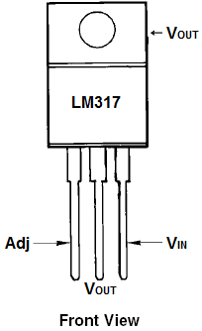rrent regulator. An optional output capacitor can be added to improve transient response. The ADJUST terminal can be bypassed to achieve very high ripple-rejection ratios, which are difficult to achieve with standard three-terminal regulators.

**Fig. LM317T**

**FEATURES:**

• Output voltage range adjustable from 1.25 V to 37 V

• Output current greater than 1.5 A

• Internal short-circuit current limiting

• Thermal overload protection

• Output safe-area compensation

**Recommended Operating Conditions**

|  |  |  |  |
| --- | --- | --- | --- |
|  |  | **MIN MAX** | **UNIT** |
| Vo | Output voltage | 1.25 37 | V |
| Vi – Vo | Input-to-output differential voltage | 3 40 | V |
| Io | Output current | 0.01 1.5 | A |
| Tj | Operating virtual junction temperature | 0 125 | °C |

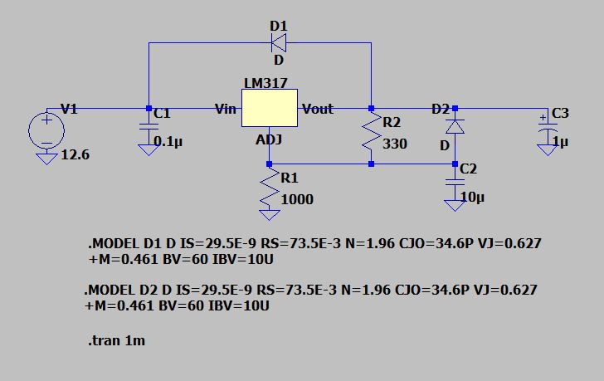

Source unit simulated at Ltspice application. And R1 and R2 values were determined thanks to formula which is shown below

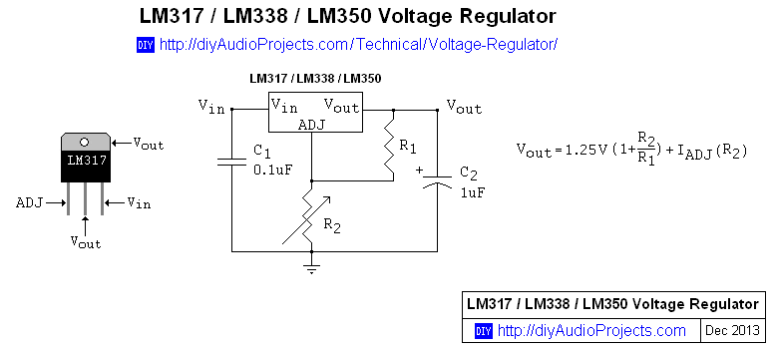

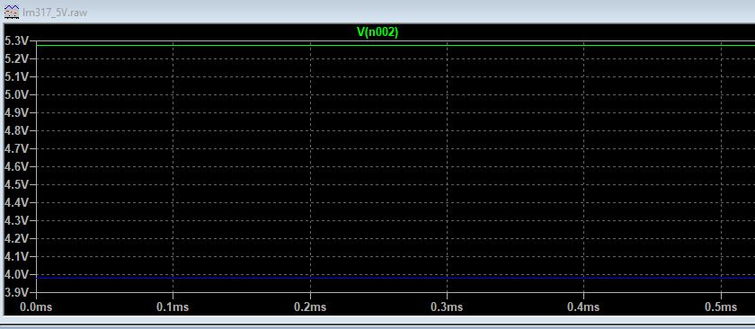

**Ltspice analysis LM317**

**Green => Vout , Blue => Vadj**

**Fig. Ltspice LM317 Recommended Circuit**

Source unit simulated at Ltspice application.

**SHORT CIRCUIT PROTECTION**

There are a lot of protection elements for short circuit for example resistor type fuse glass fuse, capacitor type fuse and PTC’s. PTC was selected for project. Reason of this selection is that PTC is kind of resistor which is depend of temperature and It can use again and again. When, uncontrollable current is passing throug to system, PTC’s internal resistance increase and cut off the current of system. There are three important parameter

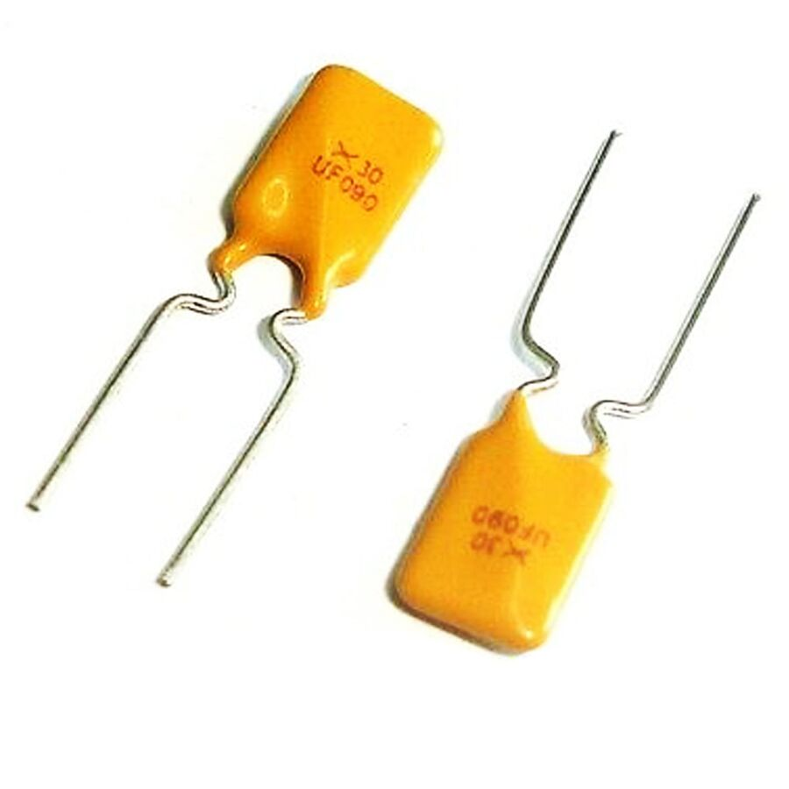(hold current, Rmin and Rmax). Hold current is limit current fuse. If hold current is passed or closed, current heats ptc and internal resistance of PTC decrease current but can’t cut off the current completely. Rmin and Rmax are ranges of internal resistance for normal operation condition. Actually PTC is selected according to demand current of system. Hold current must be %135 of demand current according to some engineer.

**Fİg. PTC Fuse**

|  |  |
| --- | --- |
| **Manufacturer** | TYCO |
| **Mounting Type** | THT |
| **Package / Case** | RADIAL |
| **Pitch** | 5.8mm |
| **Resistance (Min)** | 0.07R |
| **Resistance (Max)** | 0.12R |
| **Current - Hold** | 900mA |
| **Current - Trip** | 1.8A |
| **Current (Max)** | 100A |
| **Voltage (Max)** | 30V |
| **Time - Trip (Sec)** | 5.9s |
| **Dimension (mm)** | 12.20x7.40 |

**MARKERS**

Markers is used for understanding any trouble about system or modules. Markers can be leds or buzzers. Ignition flight computer has buzzer, telemetry flight computer has leds as marker. Actually, Buzzers are usually used for flight computer at most of times. At ignition flight computer, Buzzer was used to check for understanding to work modules. Leds are shown that modules communicate between each other.

**3. DESIGN**

Project design was divided two parts as hardware and software design.

**3.1 HARDWARE DESIGN**

Hardware was designed as using Proteus V8.9 circuit design program. So, Design was discussed under two header. One of them is schematic other one is PCB layout. Both of them is shown connections of modules and microcontroler. I2C communication protocol was used for needing less connection at ignition flight computer design.

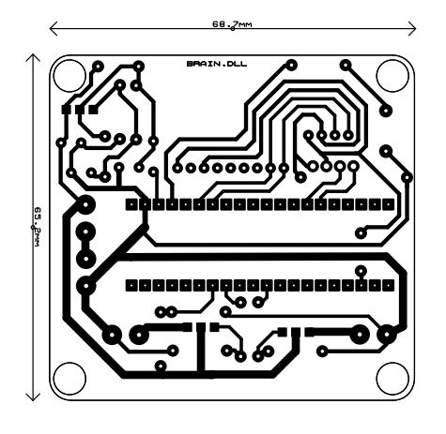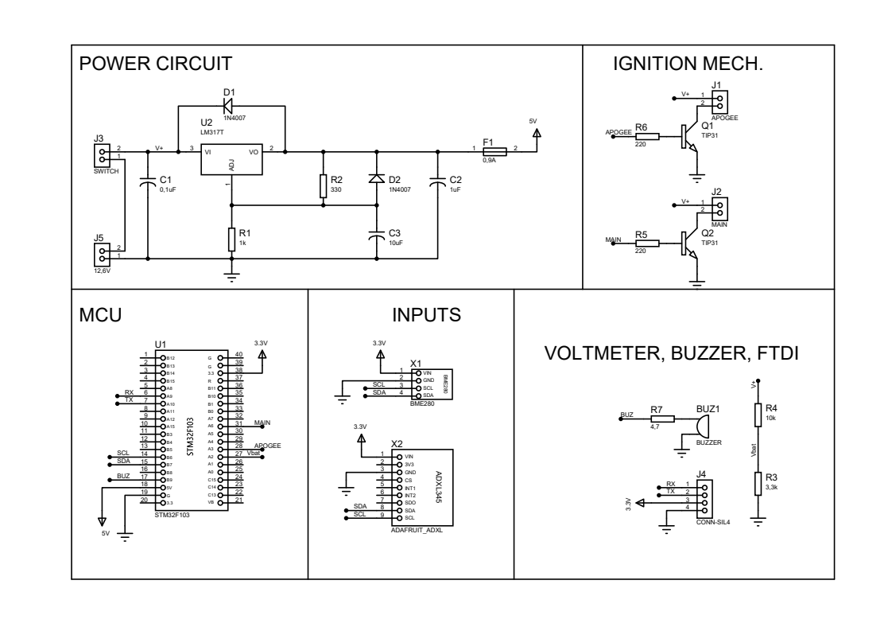

**Fig. Ignition Flight Computer Schematic**

**Fig. Ignition Flight Computer PCB Layout**

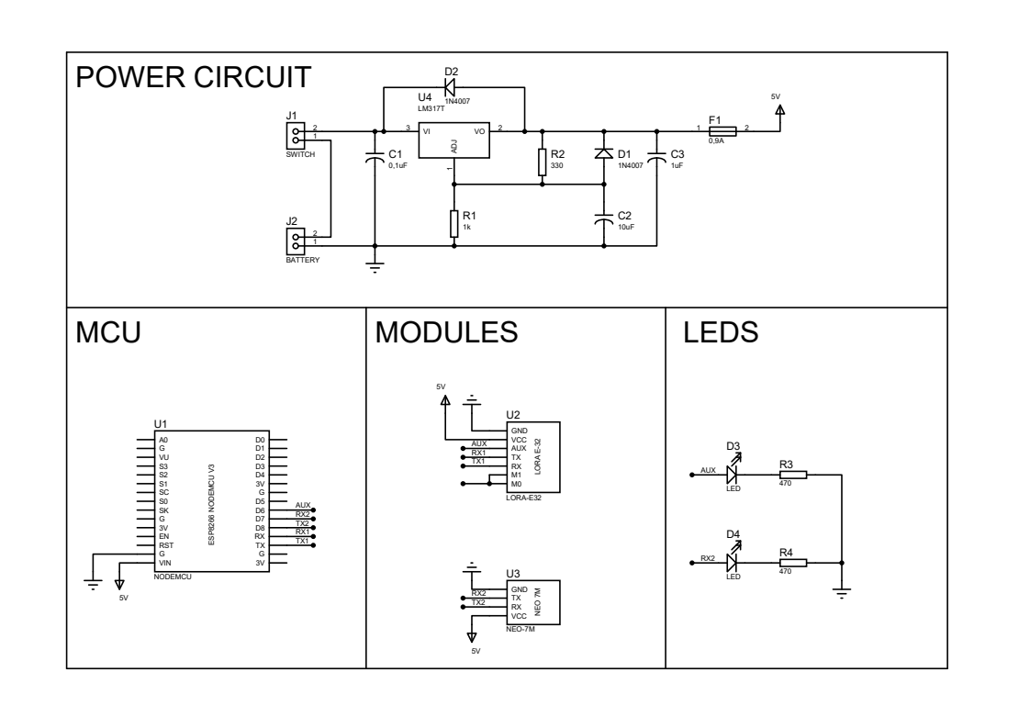

**Fig. Telemetry Flight Computer Schematic**

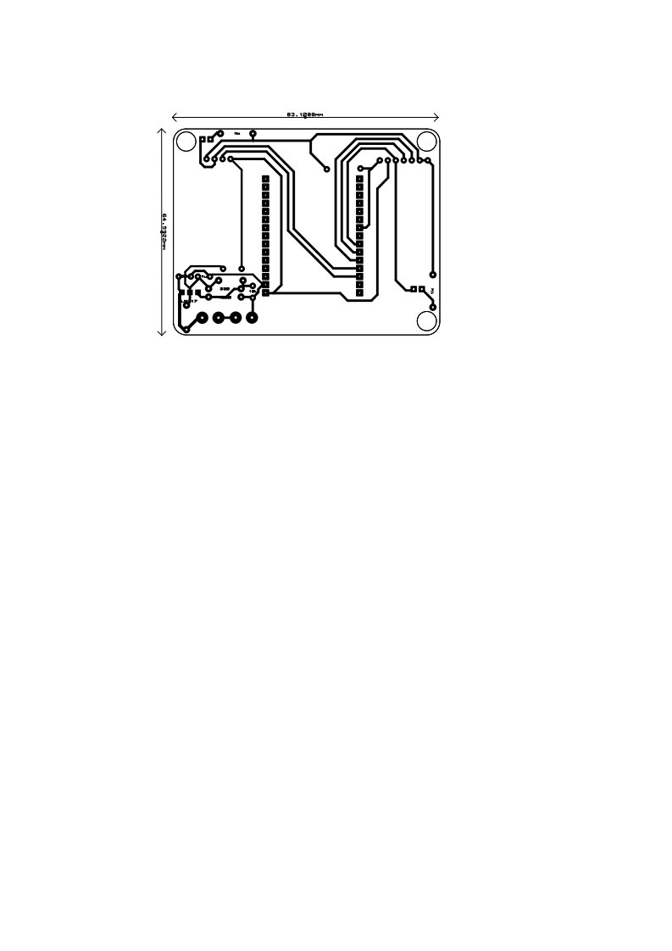

**Fig. Telemetry Flight Computer PCB Layout**

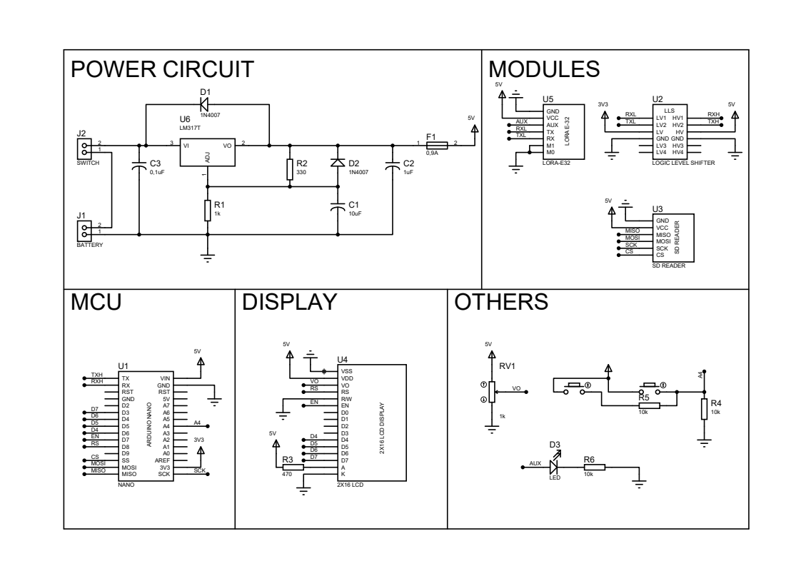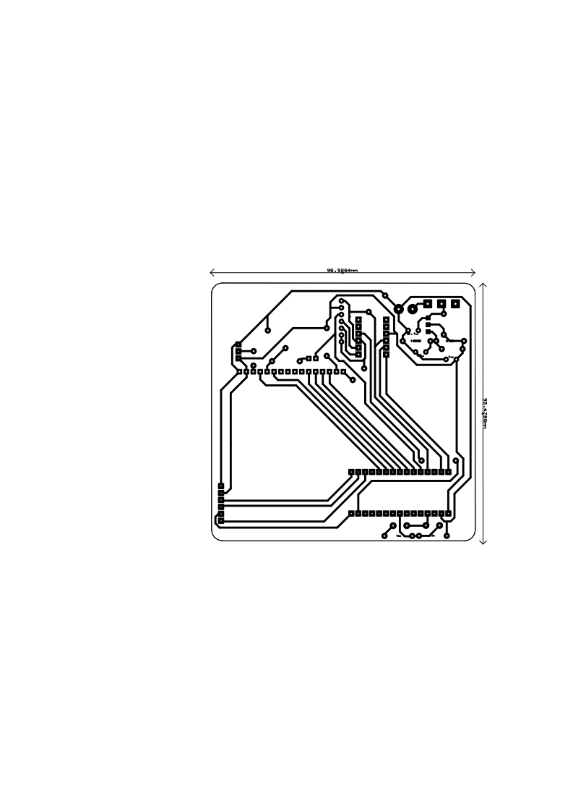

**Fig. Ground Station Schematic**

**Fig. Ground Station PCB Layout**

**3.2 SOFTWARE DESIGN**

For Systems are independent from each other, Two separate flow diagram will be shown.

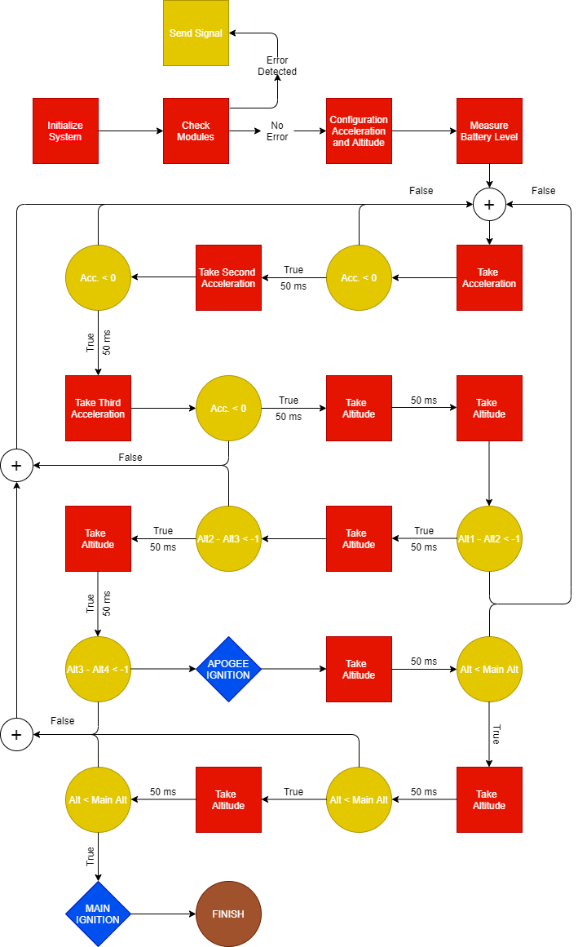

**Fig. Ignition Flight Computer Flow Diagram**

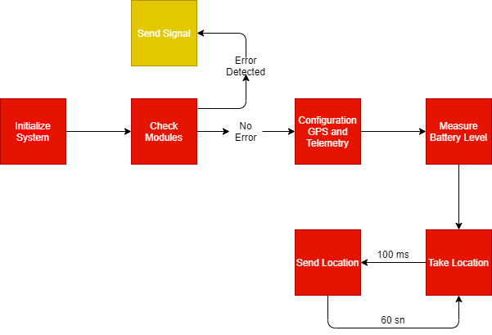

Algorithm flow diagrams are shown above, Telemetry processes have to go on until completing recovery processes.

**Fig. Telemetry Flight Computer Flow Diagram**

**4. PRODUCTION**

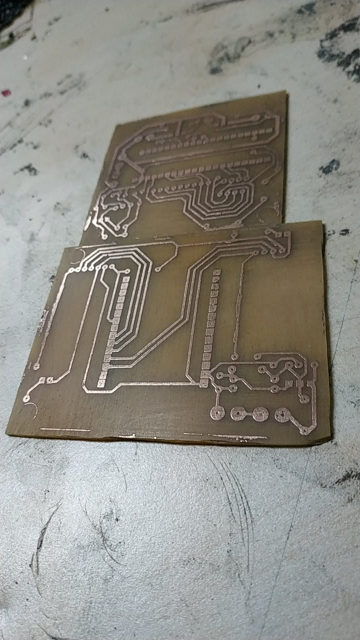All PCBs was producted with printed circuit technique. For this operation, circuit have to be put in the lamination machine and maken a solution. One scale Peridhrol and 3 scale salt spirit have to be used.

After PCB producing, Necessary soldering was maken and Flights computer was prepared for tests

**5. TESTS**

**5.1 IGNITION TEST**

**Purpose :** To learn that BJT and other sensors work correctly and learning that ignition current is enough or not for ignite black power.

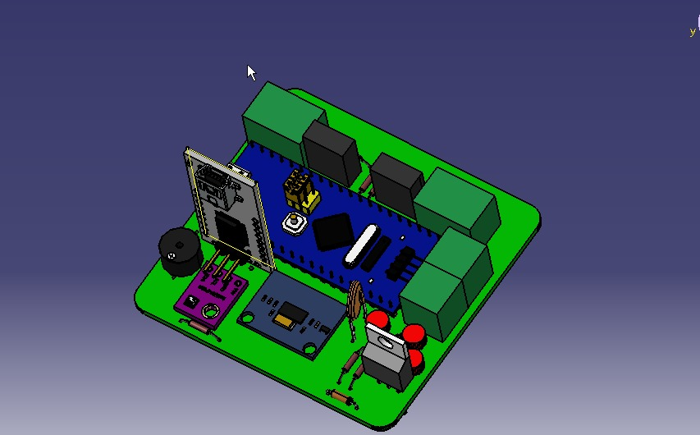

**Result :** Test is successful

**5.2 TELEMETRY TEST**

**Purpose :** To learn that Telemetry and GPS modules are work at communication range correctly.

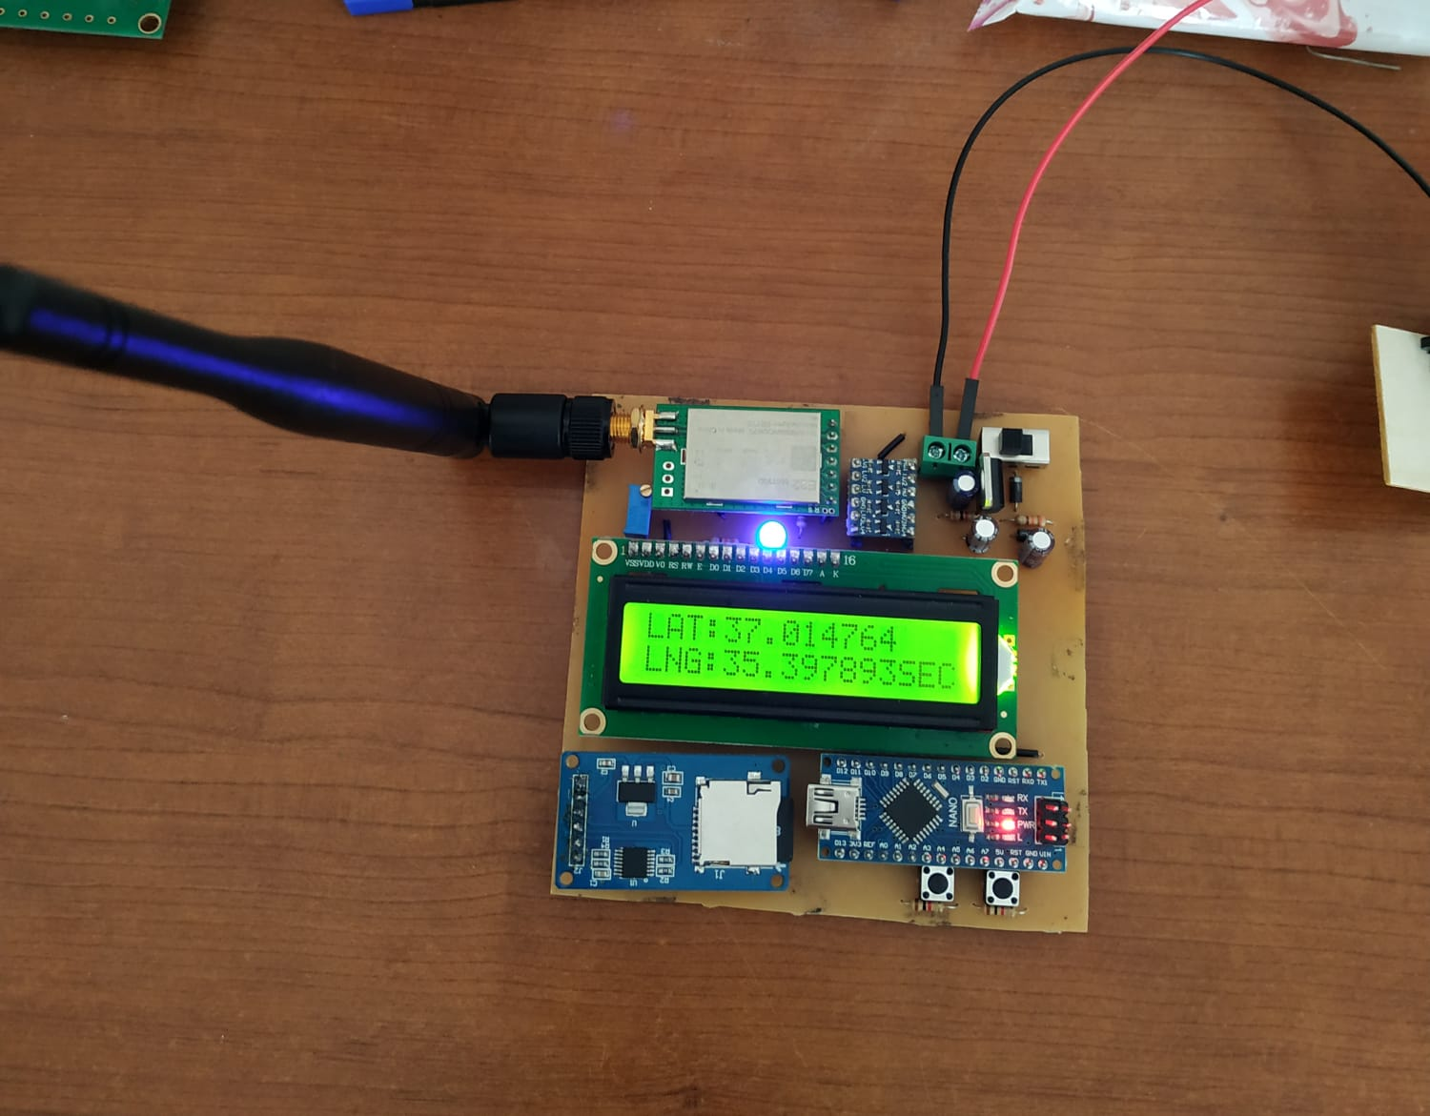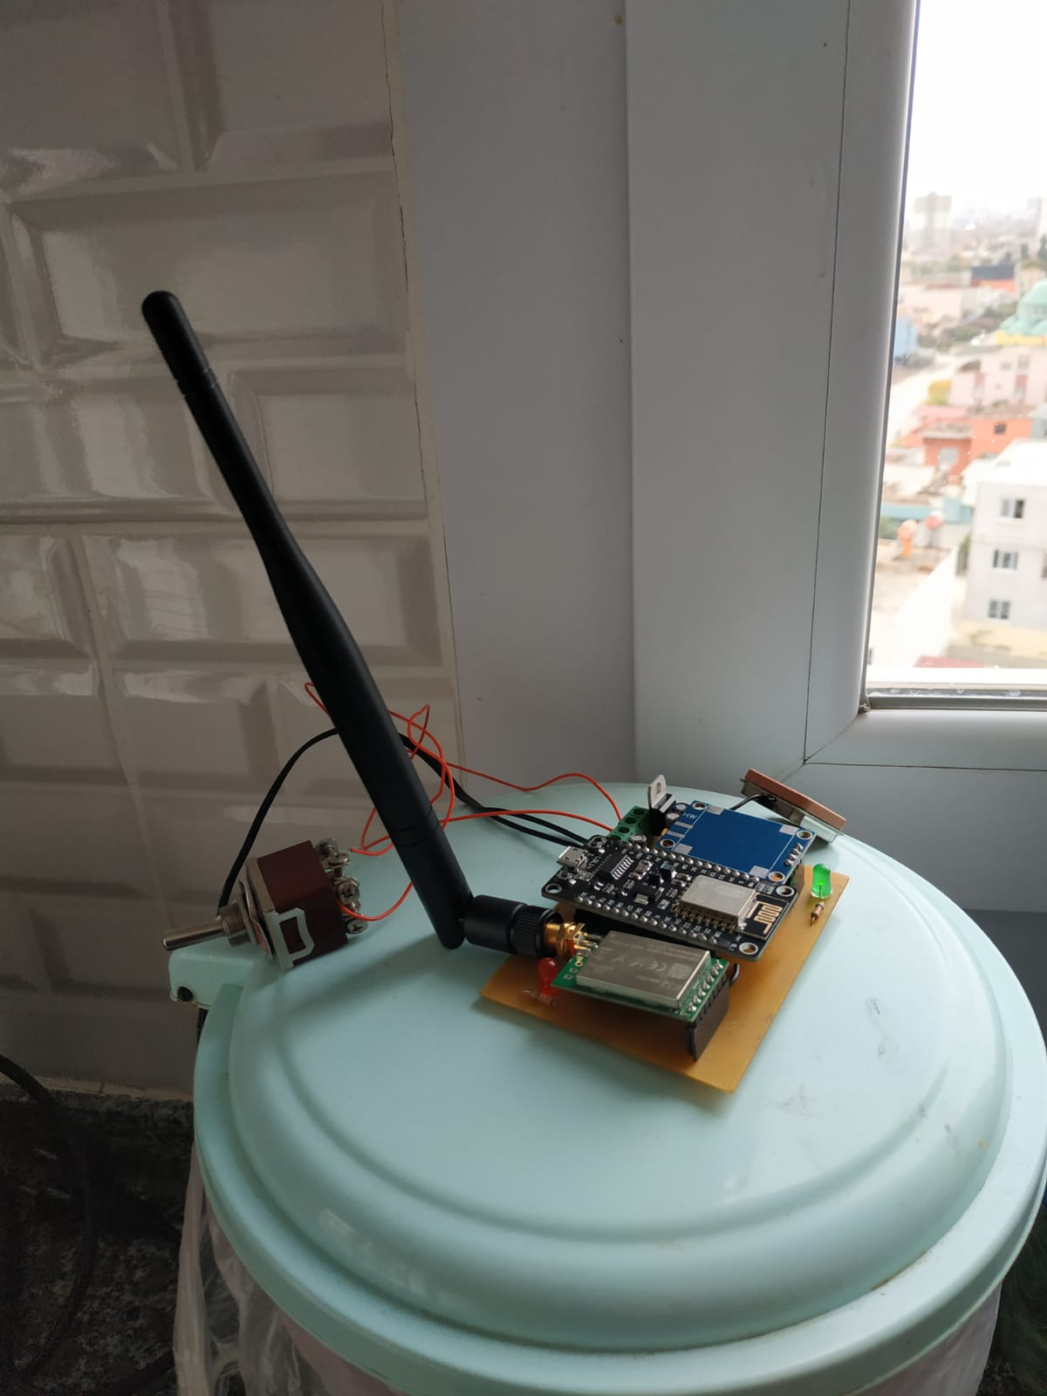

**Result :** Test is successful but for taking location data from satellites, System have to position close to windows and air have to be open.