

**University of Arkansas – CSCE Department**

**Capstone I – Final Proposal – Fall 2023**

# Brain Ballast Sensor

**Drew** **Stull, Braeden Morgan, Andrew Murphy,**

**Clayton Warstler, Fernanda Caero**

**Project Sponsors: Dr. Michelle Lee Barry, Mr. Ben Davis**

## Abstract

The Brain Ballast Sensor project addresses a critical issue involving railroad ballast and the maintenance of railroad tracks. Ballast are the small rocks that sit below and support railroad tracks. Over time the pressure applied from the trains and the environment wear the ballast down [22]. To confront this problem, our goal is to improve upon an existing sensor so that it can accurately detect and measure localized core water pressures within the ballast, which is one of the leading causes in faulted ballast [10]. Our goal will include testing this sensor in different conditions in a laboratory environment with a specific device designed to apply pressure to a ballast sample. The focus is to make improvements to an existing sensor system to make it small, powered wirelessly, and capable of transmitting data wirelessly from within the interior ballast. The project’s approach involves evaluating different types of components that can be added to the existing sensor to further its accuracy and expand its use cases. We will investigate different components that can improve on the existing device which will ultimately be added to and used as part of the “Brain Ballast Sensor” prototype. The significance of this project involves increasing railroad safety by providing important data so that railroad maintenance crews can tell the quality of the ballast without having to dig anything up. Additionally, this will decrease the spending needed by the railroad industry to monitor the quality of the ballast, which will benefit both the railroad industry and public safety.

## Problem

Railroads play a big role in today's modern infrastructure. They are a large contributor to economic activities and in connecting our country with supplies. For the United States to continue to use our network of railroads, the railroad industry is continuously needing to make repairs. There are many problems involving railroad maintenance, but one of the biggest challenges involves the ballast beneath the tracks [22]. The railroad ballast that sits underneath railroad tracks helps with the track geometry and weight distribution. The pressure applied from the loads on the track and deterioration from the environment wear this ballast down and the result is what is known as “fouled ballast". Fouled ballast, “refers to the condition when the ballast layer changes its composition and becomes much finer in grain size distribution.” [10]. There is a significant danger in railroad safety involving fouled ballast since it causes instability of the tracks and, in severe cases, derailments [25]. There are a couple of existing solutions, but all are too costly, timely, or disruptive. Currently there is no way to detect inner faulted railroad ballast without digging up all the exterior first or by using large scale equipment that scans the ballast from the exterior.

The consequences of such can be maintenance on ballast that has not yet fouled, additional time needed for repairs, not knowing when ballast has fouled, and the need for expensive equipment not available to all parts of the track. This results in an increase in expenses for the railroad industry and a decrease in railroad safety. That is why there is an urgent need for a wireless sensor system capable of accurately reading the localized water pressure within the ballast. The Brain Ballast Sensor project's goal is to solve this problem.

## Objective

The objective of this project is to make improvements on a wireless water pressure sensor that can be placed within the inner ballast that can detect core water pressure and transmit the data wirelessly from within the interior of railroad ballast. When water pressure builds up within the ballast it becomes a key reason for the inner ballast to become fouled. Our goal is to make improvements to an existing sensor that can more accurately detect core water pressure and transmit the data wirelessly. If this can be done, the data collected can be used to infer when ballast has become fouled and needs to be replaced. Not only this but the sensor will be able to help detect when ballast is still of good quality and does not yet need to be replaced.

The main objective of this project is to get measurements within a laboratory setting to prove that our proposed idea is possible and prove that the device can work in a field environment. Our primary goal is to adapt an existing device to use our own software application that connects to the device via Bluetooth, add additional hardware components, redesign the housing of the device, and if time permits extend the battery life along with improving the wireless signal transmitted from the device. Before we can start the implementation process, we first need to test the selected hardware components that we intend to add to the sensor outside of the system individually. This will allow our team to ensure that we know how to work with these new components and collect the desired data before attempting to add them to the system. Both the current water pressure sensor and the components we intend to add have their own software application. Both applications are proprietary making adaptations to the software difficult, but knowing how these applications work will be helpful in making the new hardware work properly with the existing hardware within the sensor. Because these applications are proprietary, our group will be required to create our own application that can connect with the device via Bluetooth. The overall goal of the project is to get accurate measurement readings from the device. Because of this the application we intend to build will be simple in design and mainly used to prove that the device works. The group will then add these new hardware components into the existing system. Testing the modified device will be required to ensure the new components work as intended and that we are able to display this data within our application. The next goal for our project will be to redesign the housing for the device. The goal of redesigning the housing is to reduce the size of the device and make it more organically shaped. Again, testing of this new housing will be required to ensure it does not prohibit the sensor's functionality. These are the three main goals we intend to accomplish over the semester. But if time permits, we will then move our focus on improving the battery life of the device and the wireless signal transmitted to retrieve data from the device. Overall, our objective is to first test the hardware components individually that we intend to add to the device, create an application that can connect to the device via Bluetooth and display the voltage readings from the current device, connect the tested components to the sensor system, test the modified device to ensure that the new hardware is working properly and that data collection is still possible from our software application, redesign the housing of the device using computer aided design software, test the modified device within the new housing, and then improve upon the battery life and wireless signal of the device. All of which have the goal in mind of improving the housing and functionality of the device as well as decreasing the cost of railroad maintenance.

## Background

### Key Concepts

For the Brain Ballast project, there are many different concepts and technologies relating to core water pressure sensors such as ballast hub material, wireless and wired implementations, and power production. It is important to understand the contribution each technology plays in the project since current measurement systems do not achieve accurate core water pressure in granular soils and wired systems are fragile and inadequate for our project. Most water pressure sensors on the market currently are not designed to measure pressures from within granular soils. This is why adaptations must be made to an existing device to achieve the goals of this project.

The device that we have chosen to build upon is already a Bluetooth device. The device is manufactured by a company called ‘Transducers Direct’ and the model of the device is ‘CirrusSense TDWLB0050034 Wireless pressure transducer’ [27]. This device is already capable of transmitting water pressure data to the company’s proprietary application. This application is called the ‘Pressure Pro app’ and is available on both IOS and android devices [8]. This application is neat in the fact that it allows the data collected to be stored locally on the device or in Transducers Direct’s cloud-based database. The drawback of this application is that it is proprietary making us unable to make modifications to the application. One of the first goals of the project is to find a way to get away from this application and send voltage measurements from the device directly to a Bluetooth connected device. To do this our group will create our own application to connect to the device via Bluetooth which will then display the current voltage readings from the TDWLB device when connected. To do this our group will make use of Android Studio to design and implement the application and will make use of either an Android emulator or an Android device like Google Pixel to test the application. Once the voltage data is collected on the application the sponsors can use this data to calculate the water pressure. Calculating the water pressure itself is outside the scope of this project and will be handled by our sponsors once we have an application that can capture the desired data.

Another key concept of our project is to add additional hardware components to the TDWLB pressure sensor. Our goal is to add componentry to allow the detection of movement in the device. We plan to accomplish this with one of BOSCH’s accelerometers. The exact device that we plan to make use of is the BOSCH ‘Acceleration sensor BMA400’ [1]. This device will make it possible to detect when the device moves. Our goal is to find a way to connect this sensor to our current device and be able to transmit the accelerometer data through the same Bluetooth connection and display the accelerometer data within the same application we design to get the voltage readings from the current device.

Once the additional components are working as intended, we will use computer-aided design (CAD) software to redesign the device's housing. The goal being to make the footprint of the device smaller and make the shape of the housing more organic.

In summary, the integration of new hardware components, getting the voltage data directly off the sensor using our own Android application rather than using a proprietary application, and the redesign of the housing of the sensor will allow our sponsors to get better readings of core water pressure within the interior of railroad ballast.

### Related Work

In the field of ballast optimization, several researchers and developers have made significant contributions. This section aims to provide an overview of their work, highlighting key references, and discussing the challenges or limitations in their implementations that our project, Brain Ballast Sensor, seeks to address and improve upon.

Over time, technology has played a crucial role in ballast research. Researchers have achieved notable progress in this area, such as Hai Huang, Erol Tutumluer, and William Dombrow who conducted a study on ‘Laboratory Characterization of Fouled Railroad Ballast Behavior’ [13]. Their work focused on using a ‘large direct shear (shear box) device’ to study different ballast materials and how they fouled in different conditions. The researchers tested and measured the strength and deformation of different conditions of ballast when three different fouling materials (coal dust, plastic clay, non-plastic mineral material) were added to the ballast [13]. Dr. Barry’s lab has a similar device used to apply direct shear force to ballast samples. This device is called ‘LS-DSS’ (Large Scale-Direct Simple Shear). We will use this device similarly to Huang’s research to apply direct shear pressure to a sample of ballast but instead of measuring how the ballast failed we will be using it to test our Brain Ballast device to measure core water pressure while inside of the device.

This research expands upon how ballast can become fouled within a laboratory environment. Our Brain Ballast device will focus on another fouling attribute, water pressure. Water pressure can build up within the ballast and cause the ballast to become fouled. The goal of our device will be to detect this pressure, collect the data and transmit the data wirelessly.

Another group of researchers, M. Moaveni, Y. Qian, H. Boler, D. Mishra and E. Tutumluer performed research on “Investigation of Ballast Degradation and Fouling Trends using Image Analysis” [10]. Their research made use of a type of external image processing device to determine whether ballast has fouled or not. This research is interesting but not applicable to all parts of the American railway. The device they used in their research is costly, complex, and sensitive, making it unable to be used on all parts of a railway. Our device is simpler in design and instead of performing a type of image processing, our device takes advantage of the correlation between water pressure within ballast and fouled ballast.

In summary, the prior works in this field have contributed significantly to determining how different ballast becomes fouled in a laboratory environment. However, our project, Brain Ballast Sensor, stands out by attempting to create a sensor that can eventually be used within actual railroad lines. The main goal is to detect water pressure buildup, a leading cause of ballast fouling. Our device will first need to be tested thoroughly within a lab environment, but the end goal of the device is for it to be placed within different sections of railroad tracks to be used to detect when ballast has started to foul. Our device will feature its own application, internal power, and wireless transmission of data. Another goal of our device is to add additional hardware to detect movements in the device. The goal of our application is to pull the voltage data directly off the sensor and send it through a Bluetooth connection instead of having to send it to a proprietary application. This is all with the goal to help aid in the detection of fouled ballast within railroad tracks and to improve the maintenance procedure of fouled ballast.

## Approach/Design

### Requirements and/or Use Cases and/or Design Goals

**Requirements**

* Be able to pull the voltage readings from the current TDWLB0050034 through a Bluetooth connection without going through Transducers Direct proprietary application.
* To do this we will create a simple Android application that connects to the device via Bluetooth and displays the voltage readings from the TDWLB0050034 device when it is connected to the application.
* Test the modified device in laboratory conditions.
* Test the BOSCH BMA400 accelerometer independently from the Ballast device to get accurate movement readings.
* Find where the BMA400 accelerometer will fit best within the current housing of the Brain Ballast Sensor.
* Incorporate the BMA400 accelerometer into the current Brain Ballast Sensor and connect it to the current battery within the device.
* Be able to send the accelerometer data through the same Bluetooth connection and application that we will create for the original TDWLB0050034 device.
* Once again test the modified device within laboratory conditions.
* Redesign the housing of the device using CAD tools to be smaller and more organic in shape.
* Test the new housing to ensure the changes do not prohibit the wireless connection, core water pressure readings, or the accelerometer readings.
* Then if time permits move the focus of the group to improving the battery life of the device and making the wireless connection stronger.

**Use Cases**

* There currently is not a device on the market like the one that we are creating. The base TDWLB0050034 device we are modifying is originally designed to be used on industrial equipment to get water pressure data from different machinery. If we are successful with the design of our project our new Brain Ballast Sensor can be used in a variety of soils to detect the buildup of water pressure up to 50 psi [27].
* The specific use case we are designing the Brain Ballast Sensor for is to be placed within the railroad ballast's interior. The sensor will then detect the buildup of water pressure within the ballast which correlates to the ballast becoming fouled.
* The device will transmit its data wirelessly to our own Android application which will allow the user of the device to easily collect the water pressure and accelerometer data without having to dig the device out of the soil it sits in.
* With the new hardware components that we intend to add to the device, the sensor will now be able to detect when it has shifted from its original position. This will be another indicator of changes within the ballast.
* Since the device is a small modular form factor it will allow for multiple devices to be placed throughout large sections of ballast to get a wide range of data.
* Although the device will be designed to be placed within railroad ballast, with modifications to the water inlet on the device it could then be used in a variety of soil conditions. One example of this could be to place a modified sensor beneath the greens of a golf course hole to ensure that the greens have the proper amount of water in their soil.
* The above example is just one example of how the device could be placed in different soil types. Theoretically the device could be placed in any soil condition that has a concern of the amount of water built up within it.

**Design Goals**

* Collect the voltage readings from the current TDWLB0050034 device without having to use Transducers Direct application.
* To do so we will design a simple Android application that can collect and display the voltage data from the TDWLB0050034 device when it is connected to the application through a Bluetooth connection.
* Add additional hardware components to the current housing of the device like the BOSCH BMA400 accelerometer to transmit additional movement data.
* Create a new housing for the device for it to be smaller and match the shape of an average ballast rock.
* Improve the battery life and the transmission range of the TDWLB0050034 device.

### Brain Ballast Sensor Architecture

The Brain Ballast Sensor overall goal is to be able detect core water pressures from within the center of railroad ballast and transmit this collected data wirelessly. Our plan is to make modifications to a currently existing device already on the market. The device we plan to make modifications to is the Transducers Direct CirrusSense TDWLB0050034 Wireless pressure transducer [27]. The current device is designed to be attached to industrial equipment and not to be used independently within soil type materials. This means modifications and testing will be done to ensure that our device can get accurate core water pressure from within ballast up to 50 psi. The current device can be seen below along with a schematic provided by Transducers Direct.

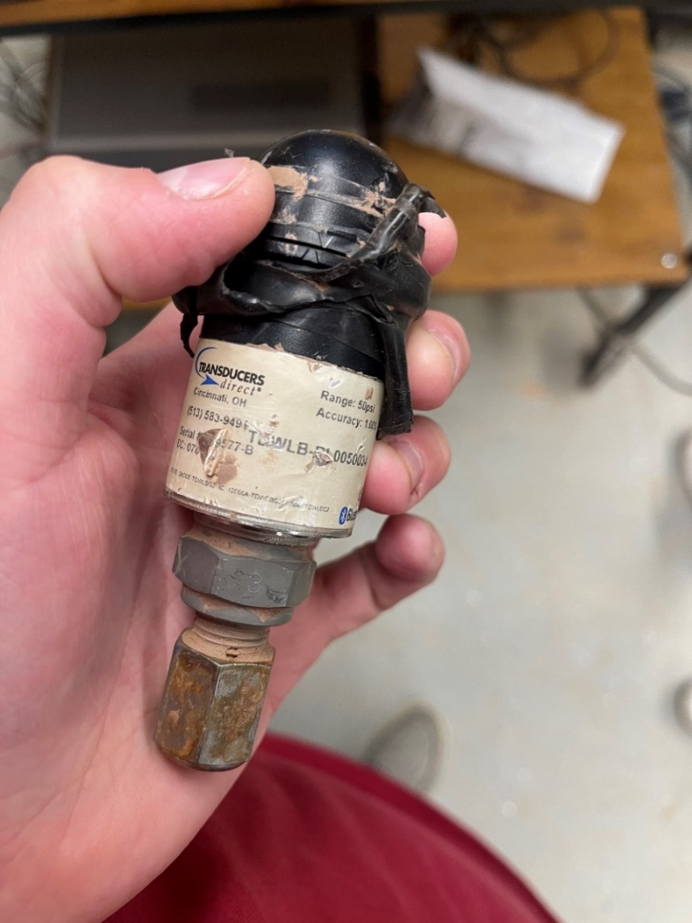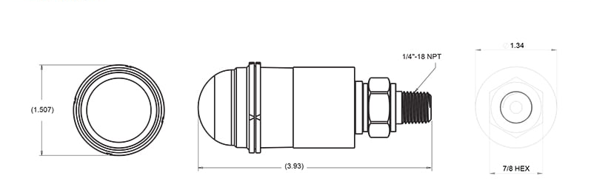

[27]

The primary goal of the sensor will be to transmit the core water pressure data wirelessly from within the middle of the ballast and be small enough so that the ballast still operates as intended. Not only that, but we also need to ensure that once the sensor is placed within the ballast that it will have a long enough lifetime so that it does not need to be replaced frequently. However, the battery life will not be focused on till the end of the project since the primary goal is to first make sure the Brain Ballast Sensor can read water pressure accurately and be able to transmit the voltage readings from the sensor to an external device via a Bluetooth connection using our own application. Like previously stated, the buildup of water pressure within railroad ballast is a large concern for the railroad industry since the pressure buildup has a correlation with ballast becoming fouled. Replacing such ballast is an expensive yet essential task to ensure that the quality of rail lines doesn’t depreciate over time. To replace internally fouled ballast all the exterior ballast must first be dug out. An image of the cross section of a railway can be seen below.

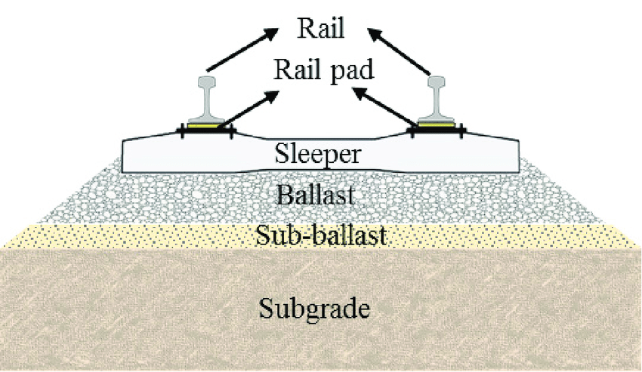

[14]

Currently the TDWLB0050034 device makes use of a proprietary application called the ‘Pressure Pro App’. This application was created by the same company that manufactures the TDWLB0050034 device, Transducers Direct. Although this application has a lot of useful features like cloud-based storage, without being able to make modifications to this application our group will need to create our own application that can connect to the TDWLB0050034 device. Our application needs to be able to run on a smartphone device, connect to the TDWLB0050034 device via Bluetooth, collect the voltage readings from the current TDWLB0050034 device, and display the data that is collected to the application screen when the TDWLB0050034 device is connected to it. The primary focus of this project is to improve upon the TDWLB0050034 device to ensure that it can get accurate core water pressure measurements from within a sample of ballast. Because of this the application we design will have a simple display that will be used to display the collected voltage readings from the device. These voltage readings will be used to prove that the device is able to capture accurate core water pressure data when the device is connected to the application. The TDWLB0050034 device will be transmitting voltage readings through the Bluetooth connection and our device will take these measurements and display them to the application screen. Our sponsors will then use these voltage measurements to calculate the current core water pressure. Since the application will primarily be used to prove that the device is able to detect accurate core water pressure, we will not be storing the data that is collected. The voltage readings collected will be displayed on the application screen then will be updated with new voltage readings from the device but will not be stored within a database. This is something that could be improved on in the future but since our primary goal is to make improvements on the TDWLB0050034 device itself, having an application that can collect this data and display it on the screen will be proficient until we have proven that the device itself can work. To design and implement this application, our group will make use of the Android Studio IDE which uses the Java programming language and test the application that we create using an Android Emulator or Google Pixel that runs the Android operating system. Our application will connect to the Bluetooth module already installed in the TDWLB0050034 device. But to give a simplified idea of how the connection will work a schematic of an Android Studio application connecting to an Arduino Bluetooth module can be seen below.

Once we can extract the voltage readings off the current TDWLB0050034 device and are able to display them onto our own application we will then move into the next phase of our project. The next phase will be adding additional hardware components to the device. The main piece of hardware we intend to add is a BOSCH accelerometer sensor called the BMA400. This piece of hardware will allow us to detect movements from the Brain Ballast Sensor which can further indicate changes in the railroad ballast. Before adding it to sensor we will first need to test the BMA400 component independently to ensure that we know how the component works and how to wire the component to the rest of the device. We will then need to find a location within the current housing of the TDWLB0050034 device that will allow the BMA400 to work properly. Once this location is established, we can move onto installing the component into the Brain Ballast Sensor and get it connected to power along with getting it connected to the current Bluetooth module within the TDWLB0050034. We will then need to make modifications to our current application to collect and display the data from the BMA400 along with the voltage readings from the TDWLB0050034 device. The BMA400 can make use of a condition called the ‘auto-wakeup condition’ [6]. This allows the BMA400 component to switch to its normal mode of operation when it senses a movement in the device. Schematics of the BMA400 can be seen below.

[1] BMA400 device [6] BMA400 pin diagram

[6] BMA400 block diagram [6] BMA400 auto-wakeup condition logic

[15] BMA400 auto-wakeup diagram [15] BMA400 detailed auto-wakeup condition logic

Another section of the project will be redesigning the housing of the core water pressure sensor to better match the average size and shape of a ballast rock. These sensors are typically housed in a metal exterior with all the components held inside. However, we want to design a new housing that will be smaller than the current TDWLB0050034 device and be more asymmetrical in shape. This may prove to be difficult because we do not want to hinder the quality of the device and need to ensure that all the components can still fit inside the new housing. There will still need to be a way for water to enter the device for the components to get a proper reading of the pressure within the ballast. A diagram is shown below that depicts how a general water pressure sensor works and the shape and size of a ballast rock.

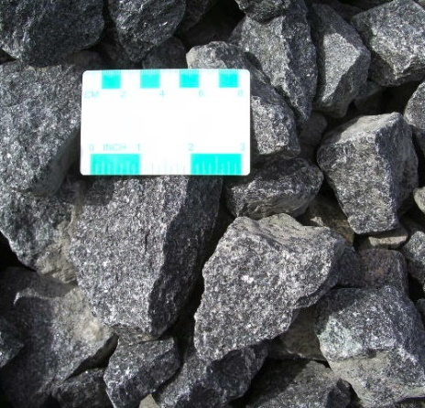

[20] [21]

Our project’s primary goal will first get the voltage readings off the current TDWLB0050034 device and display these voltage readings on our own application. The next step will be to add the new BMA400 accelerometer hardware component. We will then start on the redesign of the current device's housing to be smaller and more organically shaped. If we can accomplish these tasks the focus will then shift to improving battery life and creating a stronger wireless connection from the Brain Ballast Sensor to an external device. The current TDWLB0050034 device uses a Bluetooth connection paired to a smartphone. But when covered in too dense material or submerged in water the Bluetooth connection tends to fail. But there are different modes of wireless connection than Bluetooth. A Wi-Fi connection allows the connection to operate at a higher frequency than Bluetooth (2.4 GHz vs 3.6/5 GHz) and operate at a higher bandwidth (800 Kbps vs 11 Mbps) [5].

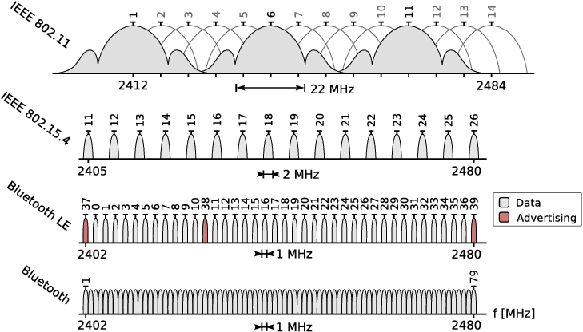

[23]

### Risks

|  |  |
| --- | --- |
| **Risk** | **Risk Reduction** |
| Device will not transmit through water | Test to correctly assess which transmission mode will allow for transference through water with minimum voltage |
| Battery life is insufficient | Ensure components use the minimum voltage necessary, incorporate capacitors, and appropriate battery technology. |
| Components require a housing too large for application | Testing different components to select ones that will fit into a housing that is the size of a typical ballast particle and has all the functionality desired. |

### Tasks

1. Discover how to get voltage readings from the TDWLB0050034 device instead of using the Transducers Direct smartphone application.
2. To do this the group will design and create an Android application through Android Studio that can be used to connect to the TDWLB0050034 device via Bluetooth, receive the voltage readings from the device, and display the voltages on the application.
3. Test the BMA400 accelerometer component independently from the sensor to discover how to properly wire it and ensure the group knows how it is supposed to work.
4. Find a location within the Brain Ballast Sensor that can fit the BMA400 and allow it to work properly.
5. Install the BMA400 into the Brain Ballast Sensor
6. Test the device to ensure the BMA400 still works as intended within the Brain Ballast Sensor housing.
7. Connect the BMA400 component to the application we designed for the TDWLB0050034 device and retrieve its data through the same Bluetooth connection that the TDWLB0050034 device currently uses. Then display the BMA400 data on the application.
8. Document our findings and redesign if not up to standards.
9. Use computer aided design (CAD) software tools to design a new housing for the Brain Ballast Sensor.
10. Research the different ways that we can manufacture the new housing for the device, whether it be from machine milling utilizing CNC or through one of Dr. Barry’s advanced 3-D printers.
11. Use the machinery within BELL and assistance from one of our sponsors, Mr. Davis, to create the new housing.
12. Buildout the Brain Ballast Sensor with the current hardware in the new housing.
13. Test the new housing of the device with the ‘LS-DSS’ machine provided within our sponsor’s laboratory.
14. Document our findings and redesign it if it is not up to standard.
15. Divide the group into two groups where one will focus on extending the battery life of the device and the other will focus on improving the wireless connection that the device makes use of.
16. Implement any of the discoveries that are made into the device.
17. Retest and document the discoveries

### A screenshot of a computer Description automatically generatedSchedule

### Deliverables

* Design Document: Contains a listing of each major hardware and software component and how the hardware is utilized, as well as design specifications and implementation details.
* Transmission protocol that allows for transmission through water and has a sufficiently low voltage to ensure long battery life.
* Android application that can connect to the TDWLB0050034 device, collect voltage readings, and display the voltage data to the application screen.
* Power system that allows the device to function self-sufficiently for up to a year.
* A housing that can fit all necessary components and is small enough to reflect that of a typical ballast particle.
* Final Report: a report detailing the Brain Ballast device and how it fulfilled the objectives set forth in the project.

## Key Personnel

**Students**

**Drew Stull ­**– Stull is a senior computer science major in the Computer Science and Computer Engineering Department at the University of Arkansas. Drew is a member of the Scholarship for Service program at the University of Arkansas. Drew has also been employed by a variety of IT jobs at the University of Arkansas, which ranges from an IT help desk worker to a network technician.

**Clayton Warstler** – Warstler is a senior computer science major in the Computer Science and Computer Engineering Department at the University of Arkansas. Clayton has had an internship at JB Hunt as an Application Development Intern. Clayton has also started up a small business repairing computers and electronics, using his past electronics and programming classes he gained before transferring to the University of Arkansas. Clayton will be working on the key concepts and related work on this project.

**Andrew Murphy** – Murphy is a senior computer science major in the Computer Science and Computer Engineering Department at the University of Arkansas. Andrew has an internship at NCR Corporation as an Information Security Intern.

**Fernanda Caero** – Caero is a senior in Computer Science/Computer Engineering at the University of Arkansas, has experience in diverse programming projects, including an internship at Jalasoft Software Company. As an international student with English as a second language, Fernanda will handle key project components like the presentation, project objectives, and problem analysis, contributing her valuable skills to the team.

**Braeden Morgan** – Morgan is a senior Computer Science major at the University of Arkansas. He is a research assistant for the Computer Vision and Image Processing laboratory under Dr. Khoa Luu. He has worked on RazorFace, an application built to assist researchers at UAMS in the early detection of Autism. His current area of research is the application of machine learning for quantum computing. He will be working on risk assessment and deliverables.

**Project Sponsors**

**Dr. Michelle Lee Barry** – Dr. Barry is professor here at the University of Arkansas in the Civil Engineering (CVEG) department. Dr. Barry has a wide range of work and research interests at the university. But most of it is focused on granular materials and behavior. Her research varies from multi-scale granular material behavior, experimentally validated discrete element method (DEM) models, laboratory testing of granular material, granular soil behavior in multi-directional simple shear, and applications of engineering in Historic Preservation Practice [10]. Dr. Barry also has a PhD student that is an additional sponsor of our project.

**Ben Davis** –Mr. Davisis a PhD student under Dr. Barry andadditionally is the lab manager of the labs where Dr. Barry conducts research. Mr. Davis has been crucial to helping our team with a lot of the hands-on learning of our project. Specifically, how the existing sensors work and how to test them in the laboratory.

**Dr. Matthew** **Patitz** – Dr. Patitz is the class instructor for our senior design class called capstone. Dr. Patitz is an associate professor at the University of Arkansas in the Computer Science and Computer engineering department. He will help answer general questions about the project and set the scope for what needs to be accomplished. Additionally, he will help with resolving communication issues that arise throughout the project and guidance with challenges that occur.

## Facilities and Equipment

To implement and test our sensor Dr. Barry is graciously letting our group make use of one of her lab areas. This lab area is specifically designed to test railroad ballast and has a couple of different devices designed specifically for such. One such device that our group will make the most use of is called ‘LS-DSS’ (Large Scale-Direct Simple Shere). This device was specifically designed to apply different types of pressure to a sample of ballast to study the effects. We will use this device to test our created sensors in a lab environment. In the laboratory environment, there are several different samples of ballast that range from small to large. This will let us test our sensors with various ballast scenarios. The equipment we intend to make use of is the Transducers Direct CirrusSense TDWLB0050034 Wireless pressure transducer [27], the BOSCH BMA400 accelerometer [1], computer aided design (CAD) tools to design the new housing of the device and machinery equipment in BELL to create the new housing. The current device makes use of a Transducers Direct smartphone application called the ‘Pressure Pro app’ [8] but we intend to get away from this application by sending the voltage readings from the TDWLB0050034 through a Bluetooth connection to our own application that we will design using Android Studio. We will write our application in the Java programming language. We will then test our application on an Android emulator or a Google Pixel that runs the android operating system.

## References

1. Acceleration sensor BMA400, <https://www.bosch-sensortec.com/products/motion-sensors/accelerometers/bma400/>
2. Android Studio Tutorial: Create an app to connect the Arduino using Bluetooth and RxAndroid, <https://www.youtube.com/watch?v=aE8EbDmrUfQ&ab_channel=TheFrugalEngineer>
3. Ballast Contamination Mechanisms, <https://encyclopedia.pub/entry/6416>
4. Bluetooth Tool Module, <https://www.boschtools.com/us/en/boschtools-ocs/drill-driver-attachments-gcy42-203552-p/>
5. Bluetooth vs. Wi-Fi, <https://www.diffen.com/difference/Bluetooth_vs_Wifi>
6. BMA400, <https://www.bosch-sensortec.com/media/boschsensortec/downloads/datasheets/bst-bma400-ds000.pdf>
7. Brain Ballast Capstone Barry, <https://uark.app.box.com/v/CSCECapstoneProjects/file/1292164566100>
8. CirrusSense™ TDWLB, TDWLB-DL & TDWLB-LC iOS Application User Guide, <https://transducersdirect.com/wp-content/uploads/2023/07/TDWLB-iOS-App-UserGuide-5.23.pdf>
9. CSCE Faculty Directory, <https://computer-science-and-computer-engineering.uark.edu/directory/index/uid/patitz/name/Matthew-Patitz/>
10. CVEG Faculty Directory, <https://civil-engineering.uark.edu/directory/index/uid/mlbernha/name/Michelle+Lee+Barry/>
11. Federal Railroad Administration Office of Research, Development, and Technology, <https://imlive.s3.amazonaws.com/Federal%20Government/ID83238750918858580289819349035833909191/BAA%202021%20Appendix%20C%20Amended%204_16_2021.pdf>
12. How Bluetooth Works, <https://electronics.howstuffworks.com/bluetooth.htm>
13. Huang, H., Tutumluer, E., & Dombrow, W. (2009). Laboratory Characterization of Fouled Railroad Ballast Behavior. Transportation Research Record, 2117(1), 93-101. <https://doi.org/10.3141/2117-12>
14. Identification of Behavioral Models for Railway Turnouts Monitoring, <https://www.researchgate.net/publication/336552261_Identification_of_Behavioural_Models_for_Railway_Turnouts_Monitoring>
15. Introduction about BMA400 Auto Wakeup and Auto Low Power, <https://community.bosch-sensortec.com/t5/Knowledge-base/Introduction-about-BMA400-Auto-Wakeup-and-Auto-Low-Power/ta-p/8863>
16. Investigation of Ballast Degradation and Fouling Trends using Image Analysis, <https://railtec.illinois.edu/wp/wp-content/uploads/2019/01/Moaveni%20et%20al_2014%20Railways%202014.pdf>
17. Laboratory Characterization of Fouled Railroad Ballast Behavior, <https://railtec.illinois.edu/wp/wp-content/uploads/pdf-archive/Huang-et-al-2009_1.pdf>
18. Michelle L. Bernhardt-Barry, Kathy Scheibel, Richard Coffman, Robert T. Banister, “Development and Assessment of a Pore Water Pressure and Matric Suction Sensor: Laboratory Strength Testing and Field Substructure Monitoring”, Prepared in Response to: FRA BAA-2021 Topic FRA-TR-012 – Substructure Pore Water Pressure and Matric Suction Sensor Development and Assessment, 2021
19. Pre project BMA400, <https://community.bosch-sensortec.com/t5/MEMS-sensors-forum/Pre-project-BMA400/td-p/14102>
20. Pressure sensors for different media types, <https://www.avnet.com/wps/portal/abacus/solutions/technologies/sensors/pressure-sensors/media-types/water/>
21. Railroad Ballast, <https://www.mrtaggregates.com/wp-content/uploads/2015/11/IMGP3225-500x480.jpg>
22. Railway ballast performance: Recent advances in the understanding of geometry, distribution and degradation, <https://www.sciencedirect.com/science/article/pii/S2214391223001150>
23. Troubleshooting Wireless Coexistence Problems in the Industrial Internet of Things, <https://www.researchgate.net/publication/316674860_Troubleshooting_Wireless_Coexistence_Problems_in_the_Industrial_Internet_of_Things>
24. Trung Ngo, Buddhima Indraratna, “Analysis of Deformation and Degradation of Fouled Ballast: Experimental Testing and DEM Modeling”, Internation Journal of Geomechanics, 2020
25. UV or EC? Choosing the right ballast water management system for the environment – and your business profile, <https://www.alfalaval.com/microsites/pureballast/selecting/uv-ec/uv-ec-environment/?utm_source=google&utm_medium=cpc&utm_campaign=environment_uv_ec&utm_source=google&utm_medium=cpc&utm_campaign=global_global_md_wwf_a_pureballast-uv-ec_gcpc_environment-2023&utm_content=environmentsearchad&utm_term=Ballastwatermanagement&utm_matchtype=broad&gad=1&gclid=CjwKCAjwysipBhBXEiwApJOcu5FdxR1mf0414_jU3unH1S20vjQNWX-1ChPpfu2rkOGeJAGnrvfDqhoCZHoQAvD_BwE>
26. WHY ARE THERE CRUSHED STONES ALONGSIDE RAIL TRACKS, <http://www.railroadfastenings.com/blog/functions-of-track-ballast.html>
27. WIRELESS PRESSURE TRANDUSERS, <https://transducersdirect.com/products/pressure-transducers/wireless-pressure-transducers/cirrussense-tdwlb-wireless-pressure-transducer/>