**1. Download the code zip first, then unzip and open it.**

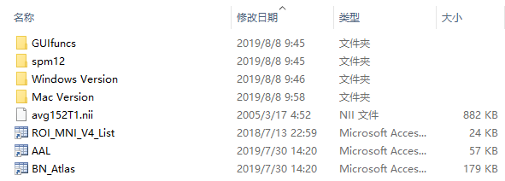

Both the Mac Version folder and Windows Version folder contain the following two files:

(1) m file: ContactSegmentation_SYSU.m;

(2) fig file: ContactSegmentation_SYSU. fig.

The files to be called by the above m files include GUIfuncs, spm12, avg152T1, ROI_MNI_V4_List, AAL, and BN_Atlas. These files are common for both Mac version and Windows version.

**2. Take the use of the Mac version of the GUI as an example.**

Take out the ContactSegmentation_SYSU.m and the ContactSegmentation_SYSU.fig in the Mac Version folder, and put them into the same folder with GUIfuncs, spm12, avg152T1, ROI_MNI_V4_List, AAL and BN_Atlas. As shown below:

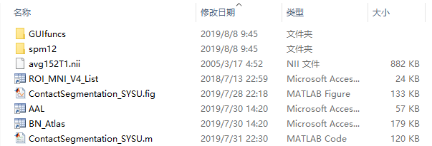Add the above folder to the MATLAB path, or set it to the current folder of MATLAB, then open ContactSegmentation_SYSU.m with MATLAB and run it.