Low-Cost LED Diffusion / Mini Integrating Sphere Ideas
Conversation notes compiled into a Word document.
Scope: A compact, inexpensive approach to diffusing light from LEDs, including a ping-pong ball, fishing bobber, PTFE-lined cap/cavity, and non-sphere alternatives.

Original request
User: I want to make a small very inexpensive integrating sphere, to diffuse light from LEDs. Do you have any good ideas. Maybe starting with coating the inside of a pingpong ball with white matte paint and using straws Or a fishing bobber? Or maybe there are other good ways to diffuse the light - I am not committed to the integrating sphere approach, but I want don't want to spend a lot of money on the solution.

Initial design suggestions
For LED diffusion on a very small budget, it helps to separate the problem into mixing and output diffusion. A tiny integrating sphere can work, but for LEDs it often loses a lot of light, so the best solution depends on whether the goal is uniform luminance, stable spectral mixing, or just less glare / smoother illumination.

1. Better than a ping-pong ball: use a white PTFE/Teflon cavity
For small visible-light integrating cavities, PTFE is excellent. Useful cheap variants include a small PTFE bottle, PTFE plumbing fitting, PTFE tape-lined cap, or a machined/hand-drilled PTFE rod/block. A short white PTFE cylinder with end caps can act as a “poor person’s integrating chamber.” Drill one side hole for the LED input and one output hole, with a small internal baffle so the LED cannot directly see the output.

2. Ping-pong ball: usable, but coat the outside rather than the inside
A ping-pong ball is convenient, but the plastic is thin, glossy, and not very reflective internally. Coating the inside is fiddly. A practical prototype: cut two small ports, put the LED in one port aimed tangentially or at the opposite wall, add a small white baffle between LED and exit port, paint the outside with several coats of matte white paint to stop leakage, and leave the inside unpainted unless you can coat it evenly.

3. Barium sulfate plus binder is the classic DIY coating
Commercial and DIY integrating spheres often use barium sulfate coatings. A simple experimental recipe is barium sulfate powder, white PVA glue or matte acrylic medium, and water to make a brushable slurry. Apply several thin coats and dry between coats. This can work well, but it is fragile and chalky.

4. Fishing bobber: maybe, but only if it is white inside
A fishing bobber is attractive because it opens in halves, but most are glossy colored plastic. If you use one, sand the inside lightly, coat with BaSO4/PVA or very matte white paint, paint the outside black or wrap with black tape to stop light leaks, and use black heat-shrink or tubing around the LED input so no direct light escapes.

Simple geometry for a first sphere/cavity
Use a 25–40 mm white sphere or cylindrical cavity. Put the LED in a side port. Put the output port about 90–120 degrees away. Add a small baffle.
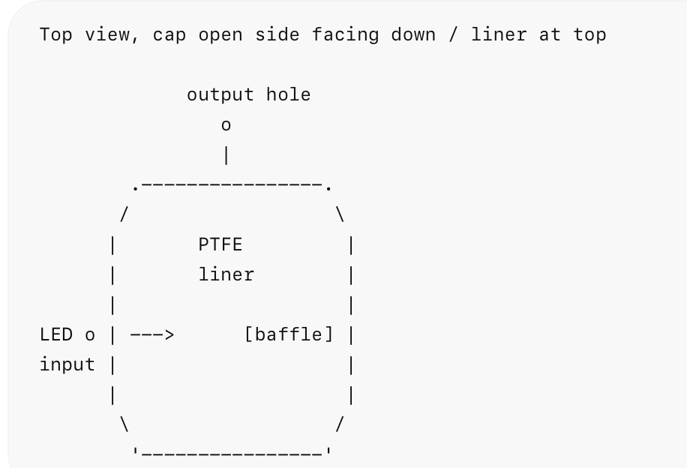
Key rule: the LED die should not have a direct line of sight to the output port. That one detail often matters more than whether the cavity is a perfect sphere.

Alternatives if a true integrating sphere is not required
- Opal acrylic diffuser plus spacing: place an LED-diffusing acrylic sheet some distance from the LEDs. The diffuser distance from the LED should be at least comparable to the LED spacing.
- Mixing box: make a small white foamboard, PTFE sheet, or matte white plastic box. LEDs enter from side or back; output face is opal acrylic, tracing paper, matte Mylar, or thin white polyethylene.
- Translucent polyethylene: milk-jug plastic, white HDPE cutting board, translucent polypropylene sheet, or diffuser film from a broken LCD backlight can be excellent for non-calibrated work.
- Straws: useful as baffles or honeycomb, but ordinary drinking straws tend to channel light directionally rather than randomize it. White paper straws or white plastic tubes may work as a mixing tunnel if the LED is not looking straight through.
Practical first prototypes: build both a ping-pong-ball version and a PTFE/white plastic cap version. For measurement-quality work, move toward PTFE or barium sulfate coating. For simply making LEDs look spatially uniform, a white mixing box plus opal diffuser may beat a miniature sphere in cost, brightness, and ease.

PTFE white cap/cavity: what to buy
User asked: Can you show me a picture of the PTFE white cap/cavity and where I can buy one?
The practical recommendation was not a true solid PTFE cap, but a white plastic screw cap with a PTFE liner, because those are cheap and easy to drill. For a more solid PTFE part, search for PTFE pipe plugs or PTFE NPT plugs. Larger GL45 HPLC caps with PTFE inserts also exist but are typically more expensive.

Suggested searches / sources
- white PTFE lined cap 24-400
- white PTFE lined cap 28-400
- foam PTFE liner bottle cap
- PTFE NPT plug 1/2 inch
- PTFE pipe plug 1 inch
- GL45 PTFE insert cap
- GL45 HPLC cap PTFE insert

Specific PTFE-lined bottle cap source and drill layout
User asked: How about a source for the white PTFE-lined bottle cap, a picture of that one, and a schematic of how you’d drill and arrange it?
A concrete source identified was U.S. Plastic Corp., item 78904: “White Tamper Evident Cap with Foam/PTFE Liner for Chem50 Bottle.” It was described as a white polypropylene cap with a foam/PTFE liner, sold individually. Other possible sources include DWK/WHEATON white polypropylene screw caps with PTFE-faced foamed PE liners and Thermo Scientific PTFE-lined closed caps from Fisher.

Layout
Top view, cap open side facing down / liner at top

Side-section view:
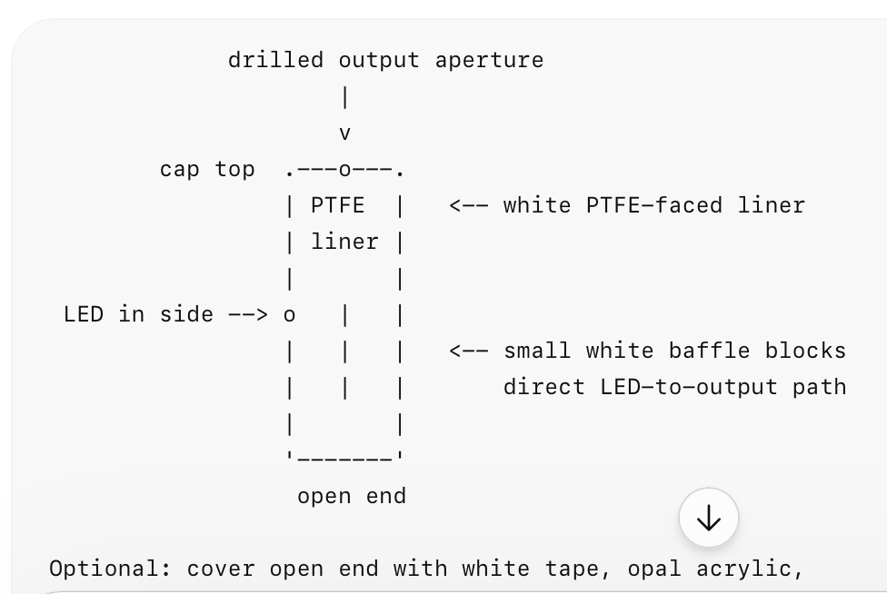
Optional: cover open end with white tape, opal acrylic,
milk-jug plastic, or screw it onto a short white bottle neck.

How to drill it
- Use a larger cap if possible. A 38–45 mm diameter cap is easier to work with than a 20–24 mm cap because it gives more mixing distance and more room for the baffle.
- LED input hole in the side wall. Drill just large enough for the LED body or a short black tube holding the LED. Aim the LED sideways or slightly toward the PTFE liner, not straight at the output.
- Output aperture. Start small, around 1–3 mm. You can always enlarge it. A smaller aperture gives better integration but lower brightness.
- Internal baffle. Glue in a small white tab so the LED die cannot directly see the output hole. A scrap of PTFE sheet, white plastic, matte white card, or a small blob of white epoxy can work.
- Avoid drilling the PTFE liner unless necessary. Let the PTFE liner be the bright diffuse back wall. Put the output hole through the plastic cap top near the edge, or through the side wall 90–120 degrees away from the LED. If drilling through the liner, use a sharp bit and back it with wood so it does not tear.

Search terms for the specific part family
U.S. Plastic 78904 foam PTFE liner cap
white PTFE lined cap 38-400
white polypropylene cap PTFE faced foamed PE liner
WHEATON PTFE faced foamed PE liner cap
Thermo Scientific PTFE-lined closed cap
For the cheapest single-piece experiment, start with the U.S. Plastic item 78904. For a cleaner small optical cavity, look for a 38-400 or 45 mm white polypropylene cap with a PTFE-faced liner, because the larger diameter makes the baffle and ports much easier.

Source links mentioned
- Newport: Integrating sphere fundamentals and applications
- Opsytec integrating sphere PDF
- University of Arizona STAR Lab: Integrating sphere build process
- Hackaday: Cannonball mold makes an integrating sphere
- Simply Plastics: LED light diffusing opal acrylic sheet
- U.S. Plastic item 78904: White tamper evident cap with foam/PTFE liner
- DWK/WHEATON PTFE-faced liner cap
- Fisher Scientific: PTFE-lined closed caps
- McMaster-Carr PTFE caps

