Basic Example
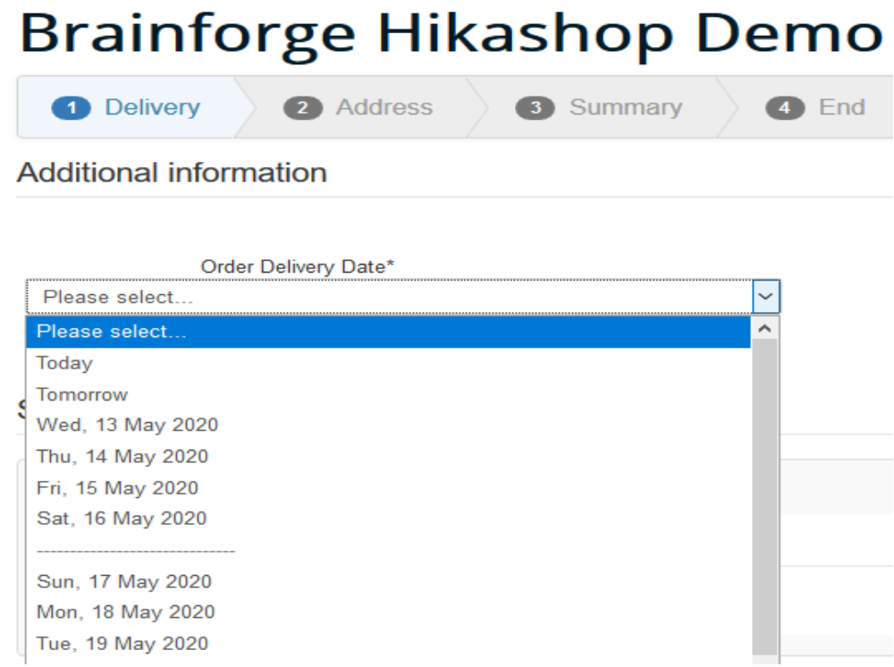

Plugin Configuration
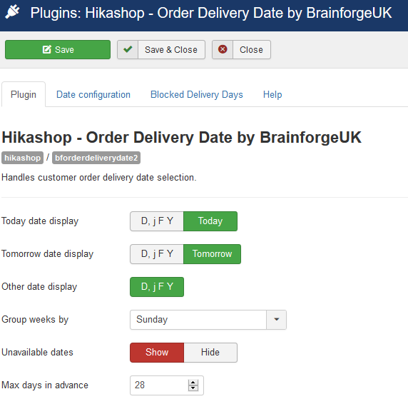
The Plugin tab allows you to configure the date display shown in the Delivery Slot list displayed to the user.

This feature uses Joomla Language Constants so the text displayed can be customised using language overrides in the normal manner.

Optionally weeks can be grouped together with a divider between each week as shown in this example.

Delivery Day Configuration
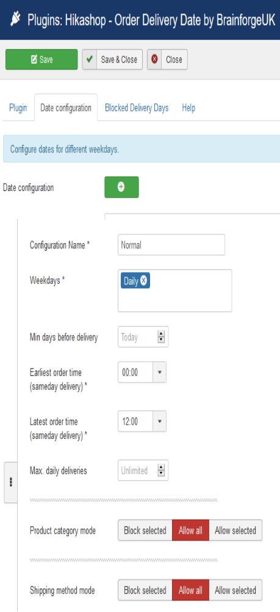
You can configure multiple date scenarios serving different purposes.
The customer is able to select a date a number of days in advance. They can be restricted to same day only deliveries by setting max days in advance to 0 (zero).
The number of deliveries available on any date can be restricted. When the limit reached further orders cannot select that date and, optionally, an email sent to the shop administrator.

Same day deliveries are selected by default. You can increase Min days before delivery as necessary if orders take several days to process.
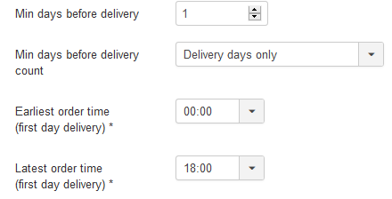
If there are any non-delivery days following the order (e.g. weekends) you can choose whether or not to include these in the Min days delivery count.

Delivery dates can be restricted according to the categories of products in the order.
Delivery dates can be restricted according to the shipping method selected by the customer. As shipping methods can be chargeable this might be one way of charging, say, for Sunday deliveries.

Blocked Product Categories
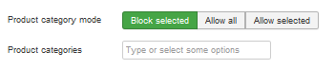
These delivery dates will not be available if the order contains one or more products from the selected product categories.

Allowed Product Categories
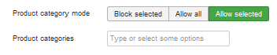
These delivery dates will only be available if the order contains one or more products from the selected product categories.

Blocked Shipping Methods
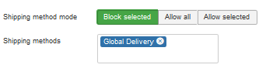
These delivery dates will not be available if the customer chooses one of the selected shipping methods.

Allowed Shipping Methods
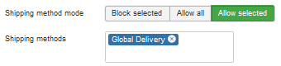
These delivery dates will only be available if the customer chooses one of the selected shipping methods.

Additional Delivery Dates
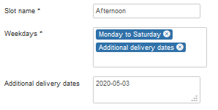
The additional delivery days selection can be used to specify special delivery dates.
For instance a flower shop which does not normally deliver on Sundays may sometimes wish to deliver on a particular Sunday (e.g. for Mothers Day).
This feature can also be used to override blocked delivery dates (e.g. to allow Christmas Day deliveries).

Blocked Delivery Dates
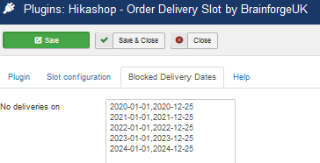
This tab allows you to specify a list of dates when deliveries are never made. This feature is pre-populated automatically with some common examples (e.g. Christmas Day).The additional delivery dates feature, described above, can be used to unblock some of these dates for specific configurations (e.g. to allow morning Christmas Day deliveries).

Different Weekday and Weekend Delivery Rules Example
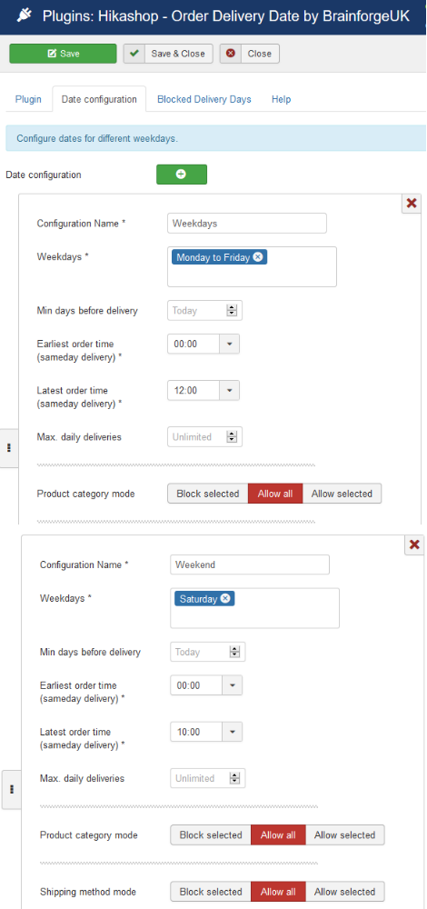
You can setup several delivery day configurations and adjust the order in which they are processed.
Delivery dates always appear in ascending date order (first date at top of select list).

In this example…
- Same day deliveries Monday to Friday must be ordered by 12:00.
- Same day deliveries Saturday must be ordered by 10:00.
You can take this further. For instance: some products cannot be delivered on a Saturday, some delivery methods not available on a Saturday etc..

Slot Status and Access Control
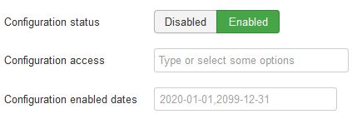
You can individually disable any of the delivery day configurations. This can be useful when making changes in advance – i.e. have the new configurations setup then enable them and disable any redundant ones later.
You can control delivery date access – i.e. limit some days / order times to regular customers. By default, when this field is empty, everyone has access (i.e. equivalent to Public).
Sometimes you may want some delivery days to only be enabled before, after or between certain dates. When enabled you can specify an enabled date range here, again this can be useful when making changes in advance or special events are planned. Note that for this feature to take affect the delivery day configuration must be enabled, a disabled slot will not be automatically enabled.

Hikashop Custom Field
The plugin uses a Hikashop Custom Field type of Brainforge – Delivery Date which must be added to the Order table. The recommended column name is order_delivery_date, although you can use any name convenient. The field type is included with the delivery date plugin.
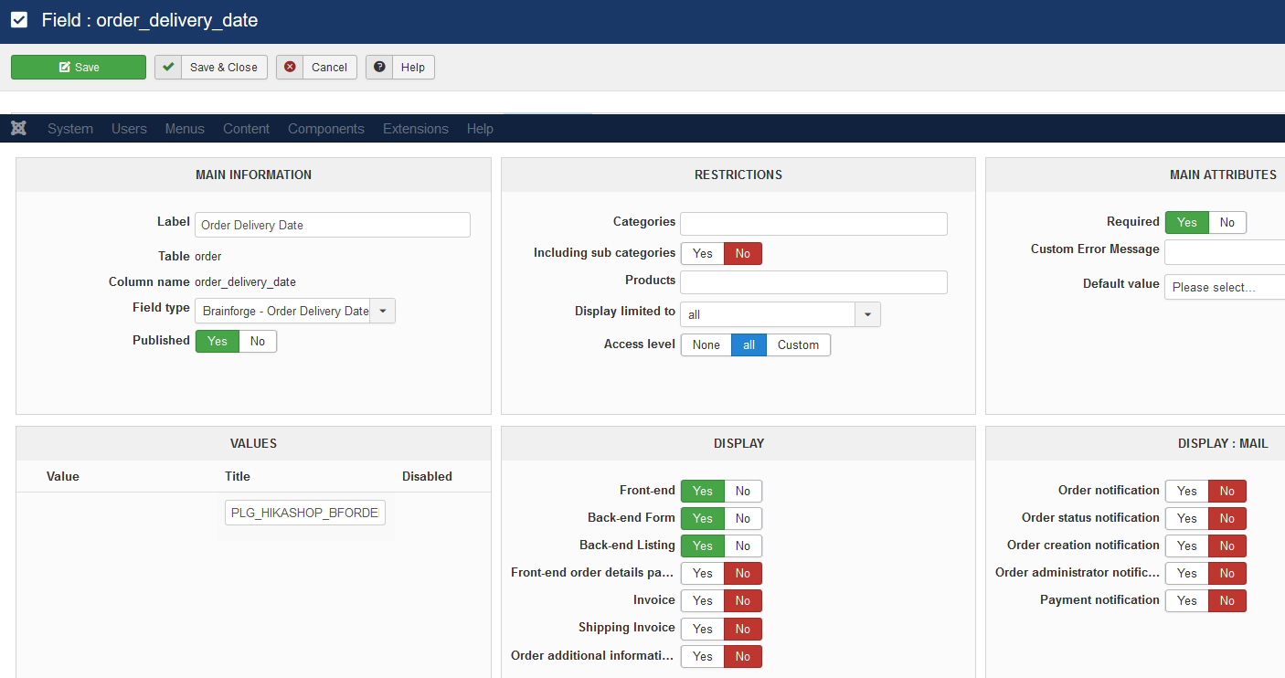
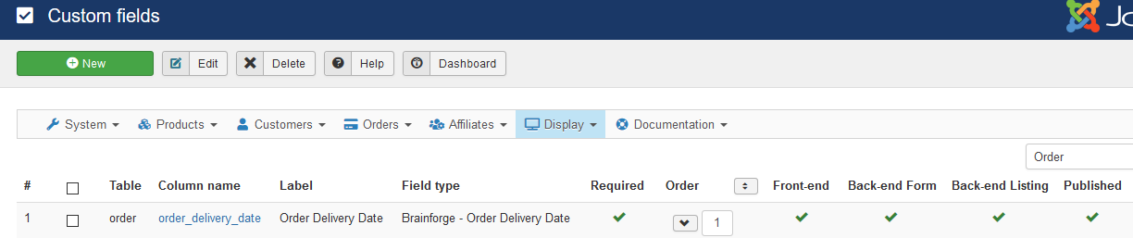
The Please Select title can be changed (normally using Joomla language overrides), but no other values can be entered as these are automatically generated.

Preview Panel – Post Text
Optionally below the delivery date selector you can display additional delivery information to the customer. The value (by default blank) of the Joomla language constant PLG_HIKASHOP_BFORDERDELIVERYDATE_POSTTEXT is shown here. Use the Joomla language override feature to change this to display any text / html you require.
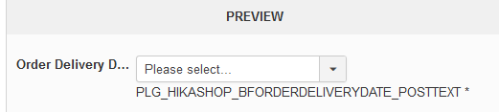

Hikashop Orders
The delivery date information can also be shown in customer emails, invoices and via the user control panel. See the field display options to control the handling of this.
In the order administrator order additional information editor you can edit the delivery date text. The delivery date text is free format, there is no validation.

Joomla Language Constants
If required customise these using Joomla language overrides in the usual manner.
PLG_HIKASHOP_BFORDERDELIVERYDATE_TODAY | Today
PLG_HIKASHOP_BFORDERDELIVERYDATE_TOMORROW | Tomorrow
PLG_HIKASHOP_BFORDERDELIVERYDATE_DATEFORMAT | D, j F Y
PLG_HIKASHOP_BFORDERDELIVERYDATE_ANYDATE | Anyday
PLG_HIKASHOP_BFORDERDELIVERYDATE_OPTION_TEXT | %1$s
PLG_HIKASHOP_BFORDERDELIVERYDATE_POSTTEXT

Language Constant PLG_HIKASHOP_BFORDERDELIVERYDATE_OPTION_TEXT
You can include the configuration name in the delivery date select list presented to the user, as illustrated in these examples.
%1$s | %1$s (%2$s)
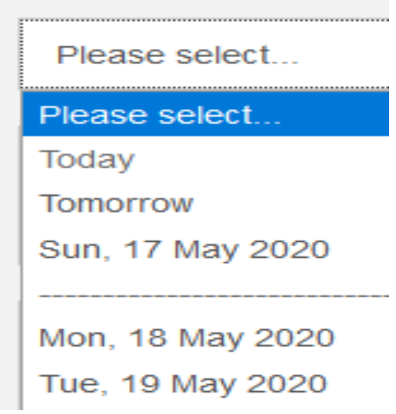 | 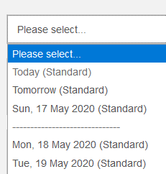

Additional Features

Any Date Handling
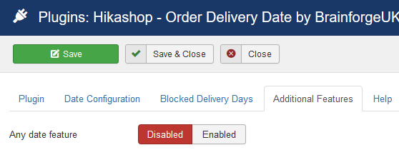
When using the shipping method mode configuration feature there can be circumstances where no delivery date is available for the selected shipping method, for instance, where the shipping method does not permit delivery date selection.
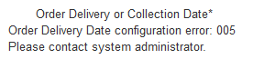
In this situation, by default, the user will see the illustrated error message. This error message can be avoided by using the Any date feature.

Any Date Feature
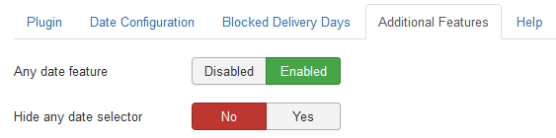
When enabled you can select whether or not the Any Day selector is shown to the user.
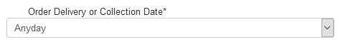
Regardless of the Hide any date setting following order creation the delivery date will show as Anyday in emails and on order administration pages.
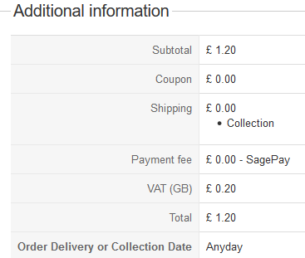

Additional Information
Requires Hikashop Business version 4.2.3 or greater.
Often used with conjunction with the Brainforge.UK Order Delivery Slot plugin.

