1. Introduction
This plugin allows your shop to use PayPal advanced credit and debit card payments with card fields appearing during Hikashop checkout.
Further information can be found here …
https://developer.paypal.com/docs/checkout/advanced/
If required test credit card numbers for use with the PayPal Sandbox can be generated here …
https://developer.paypal.com/developer/creditCardGenerator

1.1 Plugin Configuration
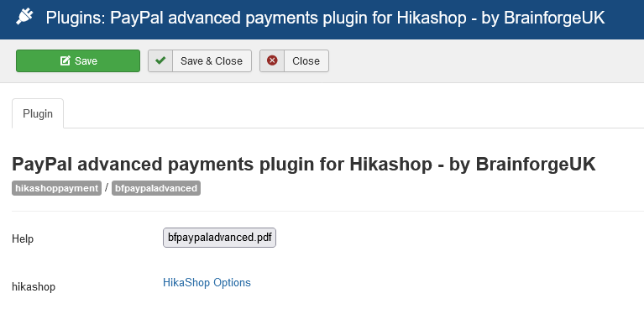

1.2 Example Checkout Display
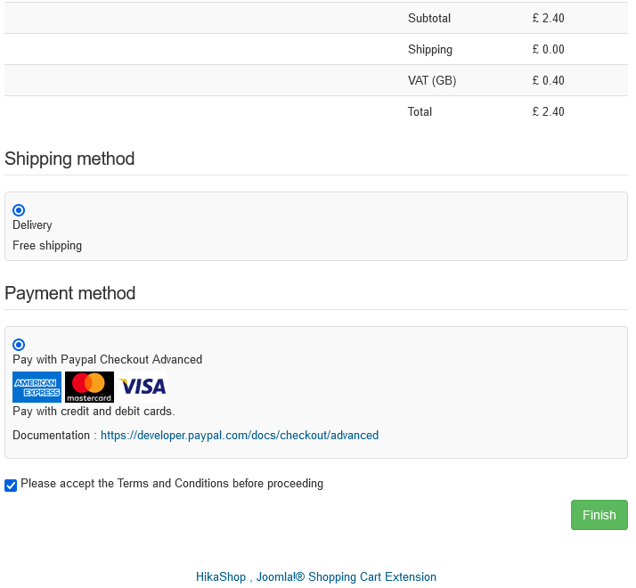

2. Hikashop Configuration Options
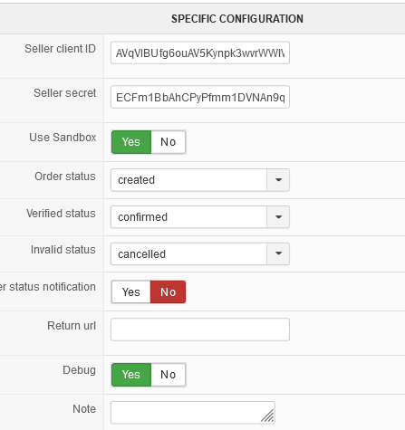
Seller client ID and secret
When using the sandbox these will be found under your REST API apps.
https://developer.paypal.com/developer/applications
Debug
Provides extra information on checkout page and / or in browser console.
Note
Space for notes which might be useful to the site / shop administrator.
When in Sandbox mode these notes appear at checkout below the Cancel Order and Return to Checkout button. This can be handy for recording test card information.

3. Card Payment Form
This appears as a secure area within the Hikashop Checkout page.
The form field placeholder text can be customised using Joomla language overrides.
