1. Introduction
This plugin allows your shop to use PayPal standard payments on Hikashop checkout so your buyers can pay with PayPal, debit and credit cards, Pay Later options, Venmo, and alternative payment methods.
Further information can be found here …
https://developer.paypal.com/docs/checkout/standard/
If required test credit card numbers for use with the PayPal Sandbox can be generated here …
https://developer.paypal.com/developer/creditCardGenerator

1.1 Plugin Configuration
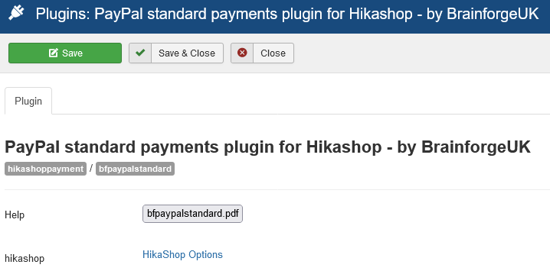

1.2 Example Checkout
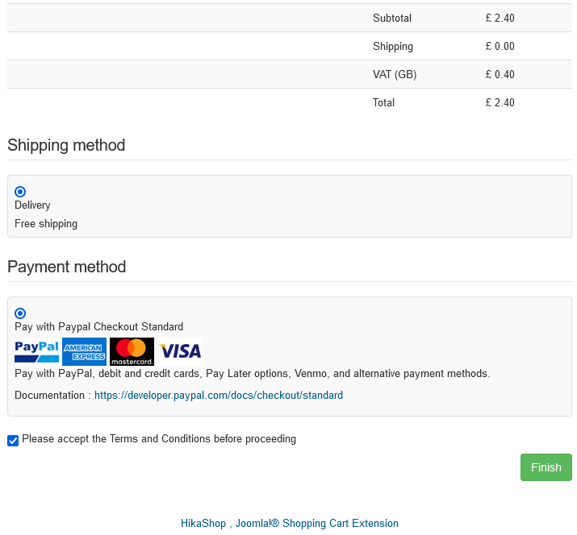

2. Hikashop Configuration Options
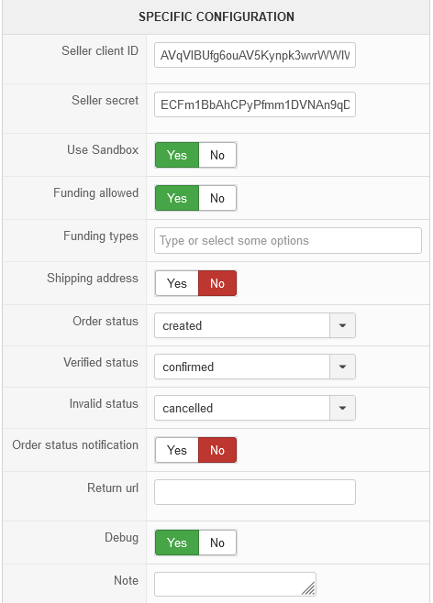
Seller client ID and secret
When using the sandbox these will be found under your REST API apps.
https://developer.paypal.com/developer/applications
Shipping Address
When enabled the shipping address, if any, will be passed to PayPal.
Debug
Provides extra information on checkout page and / or in browser console.
Note
Space for notes which might be useful to the site / shop administrator.
When in Sandbox mode these notes appear at checkout below the Cancel Order and Return to Checkout button. This can be handy for recording test card information.

2.1 Funding Allowed – No
Only the PayPal button will be shown to the buyer.
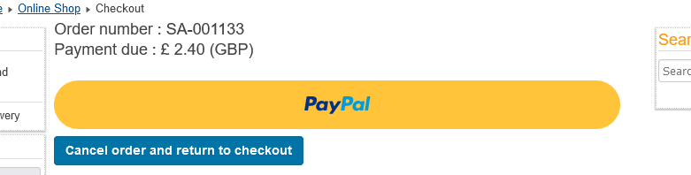
The PayPal screen will appear as a secure PayPal pop-up in front of the shop checkout page.
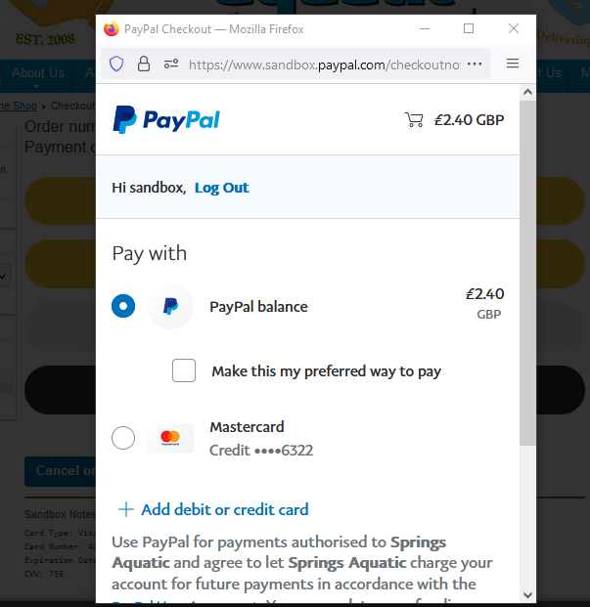

2.2 Funding Allowed – Yes (no funding types selected)
The PayPal button with other buttons, depending on the funding types available to the seller, will be shown to the buyer.
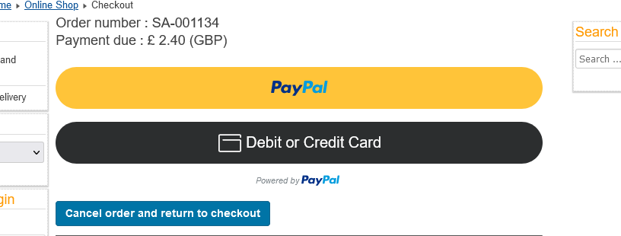
The Debit or Credit Card form will appear in a secure iframe on the Hikashop checkout page
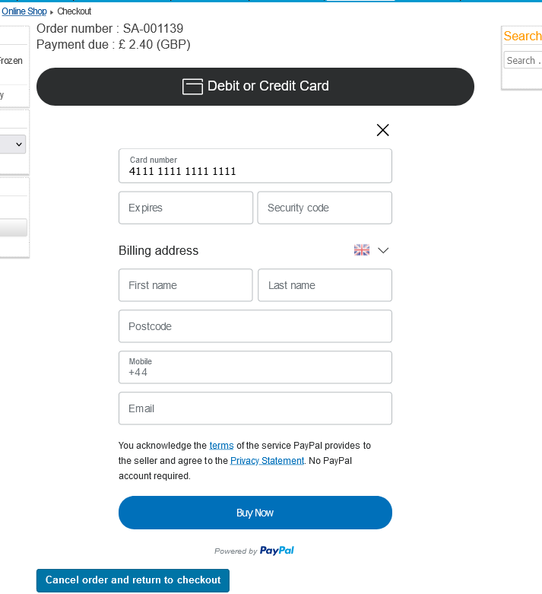

2.3 Funding Allowed – Yes (funding types selected)
The PayPal button together with buttons for the selected funding types will be shown to the buyer.
