Technical Documentation & Analysis:
Remote-Triggered Logic Bomb & Self-Neutralization Mechanics
Coursework Deliverable: Trigger Taxonomies, Payload Execution, Anti-Forensics, and Defensive Engineering
Repository: cns-remote-killswitch-poc | Environment: Controlled Simulation
ACADEMIC RESEARCH & CONTROLLED SIMULATION DISCLAIMER: This project and documentation represent an educational proof-of-concept (PoC) constructed strictly for a Computer Network Security university assignment. The objective is to analyze trigger mechanisms, payload isolation, and evasion dynamics to develop robust defensive controls and incident response strategies. The scenario is executed in an isolated, simulated environment where all network parameters and server states are pre-configured. Crucially, whereas a real-world logic bomb would irreversibly destroy (rm -rf) its artifacts to defeat post-incident forensics, this lab implementation moves components to a .bin/ holding directory to facilitate repeatable testing and academic verification.

DOCUMENT INDEX & TABLE OF CONTENTS
Executive Summary & Academic Disclaimer | Section 1.0
• Definition & Threat Profile of Logic Bombs | Section 1.1
• The Freelance Developer Contract Scenario | Section 1.2
• Feasibility Analysis: Why the Mechanism is Not Foolproof | Section 1.3
Trigger Taxonomy & Architectural Classification | Section 2.0
• Time-Based vs. Event-Based vs. Remote-Polled Triggers | Section 2.1
• Classification of this PoC (Hybrid Temporal-C2) | Section 2.2
• Table 1: Comparative Evaluation Matrix | Section 2.3
System Architecture & Payload Design | Section 3.0
• Structural Isolation (public/ vs. lockdown/ vs. .bin/) | Section 3.1
• The Detonation Barrier (Zero-Flicker SSR & Payment Notice) | Section 3.2
• Cryptographic Passphrase Verification (SHA-256 Digest) | Section 3.3
• Quarantine Mechanics: Real-World rm -rf vs. Lab .bin/ Isolation | Section 3.4
Implementation Walkthrough & Visual Verification | Section 4.0
• Annotated Source Code Listings (Listings 1–5) | Section 4.1
• Visual Verification Placeholders (Figures 1–5) | Section 4.2
Threat Detection, Indicators of Compromise & Forensics | Section 5.0
• Network Traffic Analysis (5s Egress Beaconing, Reputation) | Section 5.1
• Host-Level Indicators (sys_renameat, FIM Discrepancies) | Section 5.2
• Static vs. Dynamic Code Analysis (SAST/DAST, Entropy) | Section 5.3
Findings, Reflection & Defense-in-Depth Controls | Section 6.0
• The Failure of Traditional Signature-Based AV/IDS | Section 6.1
• Technical Mitigations (Egress Filtering, Immutable Containers) | Section 6.2
• Organizational Controls (Four-Eyes Principle, Milestone Escrow) | Section 6.3
Conclusion & Key Research Takeaways | Section 7.0
Alphabetical Subject & Technical Index | Appendix A

LIST OF FIGURES & SOURCE CODE LISTINGS
- Figure 1: Baseline Client Portal Operation (Pre-Activation State)
- Figure 2: External Command-and-Control Flag State (Dontpad Content '0' / '1')
- Figure 3: Detonated Fullscreen Lockout Screen ('Final Amount Not Paid')
- Figure 4: Passphrase Authentication and Unlock Transition
- Figure 5: Terminal Logs & Filesystem Quarantine Proof (.bin/ Verification)
- Listing 1: Stored SHA-256 Digest in Codebase (server.js)
- Listing 2: Remote Polling Loop & Dual Trigger Decision Logic (scripts/toggle-lock.js)
- Listing 3: Dynamic In-Browser Detonation Watcher (public/js/app.js)
- Listing 4: Passphrase Verification & Session Invalidation (server.js)
- Listing 5: Atomic Filesystem Relocation Routine (server.js)
- Table 1: Comparative Evaluation of Logic Bomb Trigger Classes

1. Executive Summary & Scenario Context
A logic bomb is a piece of code intentionally inserted into an application or system that remains dormant until predefined operational conditions are met. Unlike self-propagating threats (such as worms) or directly delivered payloads (such as conventional Trojans), logic bombs leverage existing trust boundaries and normal application flow to hide in plain sight. When detonated, their effects typically range from silent data corruption and intellectual property theft to denial-of-service, financial extortion, and permanent system destruction.
1.1 The Freelance Developer Contract Scenario
The coursework scenario models an insider threat / software supply-chain dilemma: a freelance software developer embeds a dormant trigger mechanism inside a client's deployed production staging gateway. The developer intends to ensure payment settlement by configuring a remote 'dead-man switch'. The mechanism continuously monitors an external, pastebin-style URL on a fixed schedule. If the remote flag remains unset ('0') past a predetermined deadline (a 30-second window in this lab demonstration), the site automatically triggers a restrictive lockdown phase, presenting a fullscreen 'Final Amount Not Paid' modal that halts all client portal operations until released by an administrative passphrase.
1.2 Dual-Action Self-Neutralization Payload
Conversely, if the remote flag changes to '1' before the threshold expires (simulating confirmation of invoice settlement), the trigger activates a self-neutralization payload: it immediately disarms the lockdown, quashes the background polling process, and quarantines its own operational files into a .bin/ folder. If the site has already locked down, entering the correct SHA-256 hashed passphrase in the web UI similarly triggers this self-destruct sequence, moving the lockdown module into quarantine and restoring the portal.
1.3 Feasibility Analysis: Why the Mechanism is Not Foolproof
CRITICAL REALITY CHECK: ENGINEERING & RISK LIMITATIONS: While non-technical clients might find themselves immobilized by such a trigger, from an engineering and security perspective this approach suffers from fatal flaws:
1. Network Fragility & False Positives: Relying on third-party remote endpoints (dontpad.com) is highly error-prone. Transient DNS resolution drops, HTTP 429 rate-limiting, or upstream network congestion will cause the script to misinterpret network errors or delay flag changes, leading to premature, accidental lockouts.
2. High Detection Surface: Periodic outbound polling on a fixed interval generates an unmistakable network beaconing signature that easily triggers EDR, perimeter firewalls, and proxy alerts.
3. Severe Professional & Contractual Risks: Deploying coercive logic into client software constitutes a catastrophic breach of professional ethics, violates service contracts, and exposes the developer to civil lawsuits and criminal liability under unauthorized computer impairment statutes regardless of whether the client defaulted on payment.

2. Trigger Taxonomy & Architectural Classification
In malware analysis and software security taxonomy, logic bombs are categorized based on their activation triggers. Understanding where this proof of concept fits requires analyzing the three primary classes of logic triggers:
- 1. Time-Based Triggers (Cron / Deadlines): The payload relies strictly on the system clock or an internal counter reaching an absolute timestamp (e.g., contract expiration date) or a relative duration. While simple and requiring zero network connectivity, pure time triggers are rigid, incapable of remote cancellation, and vulnerable to system clock manipulation (NTP drift, manual clock rollbacks).
- 2. Event-Based Triggers (Internal State Conditions): Activation occurs following specific internal environmental actions, such as user account deactivation (a classic disgruntled employee scenario where an admin's account being disabled trips a deletion script), a set number of database writes, or specific transaction volumes. These operate completely offline but depend heavily on local environment assumptions.
- 3. Remote-Polled Triggers (C2 / Webhooks / Dead-Man Switches): The dormant code initiates outbound connections to external infrastructure (HTTP APIs, DNS TXT queries, pastebins, or IRC servers) to retrieve an execution directive. This affords the threat actor dynamic control, allowing them to postpone detonation, change payloads, or abort entirely. However, it incurs significant network visibility.
2.2 Classification of this PoC (Hybrid Temporal-C2)
Architectural Position of this PoC: The implementation in cns-remote-killswitch-poc is a Hybrid Temporal-C2 Logic Bomb. It integrates both a temporal deadline and a remote command-and-control polling mechanism. The script maintains a running temporal counter (zeroStartedAt) that continuously evaluates how long an external state (fetched from https://dontpad.com/c2FhaGl0Cg==) has persisted in a dormant state ('0'). Furthermore, it features a dual-action trigger matrix: reaching 30 seconds of persistent '0' triggers payload activation (lockdown), while switching the remote state to '1' triggers premature disarming and self-neutralization.
Trigger Class | Activation Precondition | Detection Footprint | Operational Robustness
Time-Based (Clock) | System time reaches predefined epoch or elapsed timer. | Zero network traffic; easily inspected via static code disassembly or clock manipulation. | Low; susceptible to host clock modifications.
Event-Based (State) | Local internal action occurs (e.g., admin user deletion, record count). | Zero external network traffic; detected via behavioral monitoring or static analysis of triggers. | Moderate; reliant on host application state integrity.
Remote-Polled (C2) | External remote endpoint returns execution or cancel signal. | High network beaconing signature; outbound HTTP/DNS easily logged by firewalls and proxies. | Fragile; fails if external site drops, blocks requests, or changes format.
This PoC (Hybrid) | URL remains '0' for 30s (Lockdown) OR URL changes to '1' (Bypass/Quarantine). | Moderate/High; periodic 5s polling to external unauthenticated domain generates clear telemetry. | Balanced for demonstration: allows dynamic disarm while imposing strict temporal pressure.

3. System Architecture & Payload Design
The cns-remote-killswitch-poc project was designed with a minimal tech-stack philosophy. It operates completely dependency-free using standard Node.js built-ins (node:http, node:crypto, node:fs, node:path) paired with a clean, semantic HTML5, CSS3, and modern vanilla JavaScript frontend. This ensures zero baggage, rapid deployment, and deterministic behavior across any Unix/Windows testbed without requiring npm install.
3.1 Structural Isolation of the Attack Surface
To model realistic software supply-chain embedding and simplify payload targeting, the repository separates the target from the core host:
- Host Application: public/ (Clean Client Infrastructure): Contains the legitimate client website ('Apex Perimeter Defense Infrastructure Gateway'). It incorporates realistic network telemetry, regional node statistics, and operational logs with zero placeholder text. This application code remains untouched during triggers.
- Detonation Target: lockdown/ (Isolated Subsystem): A self-contained directory housing the lockscreen markup (lockscreen.html), high-contrast styling (lockscreen.css), client-side dispatch controller (lockscreen.js), and state manifest (flag.json). This directory is the sole target of the self-destruct mechanism.
- Quarantine Target: .bin/ (Quarantine Holding Area): The destination folder for neutralized components during testing. Only a .gitkeep file is tracked, ensuring the directory structure exists on Git while quarantined artifacts remain ignored.
3.2 The Detonation Barrier (Fullscreen Lockout)
When the 30-second timer expires with the external URL content remaining '0', lockdown/flag.json has its boolean property isLocked set to true. On the web application layer:
- 1. Zero-Flicker Server-Side Injection: When an HTTP GET request hits server.js for '/' while isLocked is true, the server intercepts the request before delivering the standard portal. It dynamically injects lockscreen.html and lockscreen.css directly into the response payload. This guarantees that client-side script blockers or DevTools DOM inspection cannot simply bypass the barrier.
- 2. Contextual Pressure Messaging: The interface explicitly communicates that service is suspended due to an unsettled final invoice: 'Final Amount Not Paid — Demonstration portal access is suspended pending final milestone settlement. Contact developer for release passphrase.' Developer escalation coordinates (hotline, internal extension, email) are rendered dynamically from flag.json.
- 3. Real-Time In-Browser Detonation: If a user is already browsing the portal when the trigger detonates, watchLockdownTransition() in public/js/app.js detects the state transition via periodic status checks and automatically triggers window.location.reload(), locking the interface mid-session.
3.3 Cryptographic Passphrase Verification
To satisfy the requirement that credentials cannot be harvested via static string inspection of source files, the plaintext password ('opensesseme') is never stored in cleartext. Instead, its pre-computed SHA-256 cryptographic digest is stored in the codebase:
Listing 1: Stored SHA-256 Digest in Codebase
const STORED_PASSWORD_HASH = '49b0ea37cc09f0e722207101edf9ba3ee3caebf670ca1b8eb211025a4aaa5be2';

When a user submits a candidate string in the lockout form, the browser transmits it over POST /api/lockdown/unlock. The server computes the candidate's SHA-256 digest and performs a comparison. If identical, authentication succeeds.
3.4 Self-Destruct & Quarantine Mechanics (Real World vs. Lab Simulation)
LABORATORY QUARANTINE VS. REAL-WORLD LOGIC BOMB DELETION: • Real-World Logic Bomb: An authentic malicious logic bomb or dead-man switch operates with absolute finality. Once the neutralization criteria are fulfilled, the script invokes unrecoverable filesystem commands (e.g., rm -rf, shred -u, or direct unlinking of file descriptors) to wipe the locking code, configuration files, and log traces. This prevents security analysts from recovering the code to determine how the mechanism functioned.
• Simulated Educational Environment: For this coursework proof of concept, destroying files permanently would terminate the experiment and prevent repeated evaluation by students and grading instructors. Consequently, executeKillswitch() was engineered to move the isolated lockdown/ directory into a .bin/lockdown/ quarantine repository on disk. Once quarantined, the server dynamically recognizes that lockdown/ no longer exists and restores unobstructed portal access. A companion script (scripts/restore.js) allows the evaluator to reset the codebase for subsequent demonstration runs.

4. Implementation Walkthrough & Visual Verification
The following annotated code snippets demonstrate the primary components of the logic bomb and killswitch pipeline:
Listing 2: Remote Polling Loop & Dual Trigger Decision Logic (scripts/toggle-lock.js)
// Excerpt from scripts/toggle-lock.js
const POLL_INTERVAL_MS = 5000;
const LOCKDOWN_THRESHOLD_MS = 30000; // 30-second window
async function poll() {
const content = await fetchDontpadContent(TARGET_URL);
if (content === '0') {
if (!zeroStartedAt) zeroStartedAt = Date.now();
const elapsedMs = Date.now() - zeroStartedAt;
if (elapsedMs < LOCKDOWN_THRESHOLD_MS) {
console.log(`Content remains '0': ${Math.floor(elapsedMs/1000)}s / 30s elapsed.`);
} else {
// 30s threshold exceeded: Lock down site and KILL SCRIPT (halt polling)
lockDownSite();
process.exit(0);
}
} else if (content === '1') {
// Flag flipped to 1: Disarm, quarantine files to .bin/, and KILL SCRIPT
moveToBinAndUnlock("URL content changed to '1'");
process.exit(0);
}
}

Listing 3: Dynamic In-Browser Detonation Watcher (public/js/app.js)
// Excerpt from public/js/app.js: Auto-Reload Watcher
function watchLockdownTransition() {
setInterval(async () => {
try {
const res = await fetch('/api/status');
if (!res.ok) return;
const data = await res.json();
// If site transitioned to locked while browsing, force instant reload
if (data.isLocked && !document.getElementById('cnd-lockdown-container')) {
window.location.reload();
}
} catch (e) { /* Ignore network drops */ }
}, 2000);
}

Listing 4: Passphrase Verification & Quarantine Execution (server.js)
// Excerpt from server.js: Session Invalidation and Self-Destruct Call
if (pathname === '/api/lockdown/unlock' && req.method === 'POST') {
const body = await parseBody(req);
if (verifyPassphrase(body.password || '')) {
// Quarantine lockdown module into .bin/
const quarantineResult = executeKillswitch();
return sendJson(res, 200, {
success: true,
message: 'Horray! Passphrase authenticated. Lockdown folder moved to .bin.'
});
} else {
return sendJson(res, 401, { success: false, message: 'Fail: Invalid passphrase.' });
}
}

Listing 5: Atomic Filesystem Relocation Routine (server.js)
// Excerpt from server.js: Fault-Tolerant Quarantine Routine
export function executeKillswitch() {
const destination = path.join(BIN_DIR, 'lockdown');
try {
if (fs.existsSync(LOCKDOWN_DIR)) {
if (fs.existsSync(destination)) fs.rmSync(destination, { recursive: true, force: true });
fs.renameSync(LOCKDOWN_DIR, destination);
return { success: true, destination };
}
} catch (err) {
// Fallback copy + unlink for cross-device filesystem boundaries
fs.cpSync(LOCKDOWN_DIR, destination, { recursive: true });
fs.rmSync(LOCKDOWN_DIR, { recursive: true, force: true });
return { success: true, destination };
}
}

The following placeholders indicate where experimental photographic proof should be inserted into the final report:
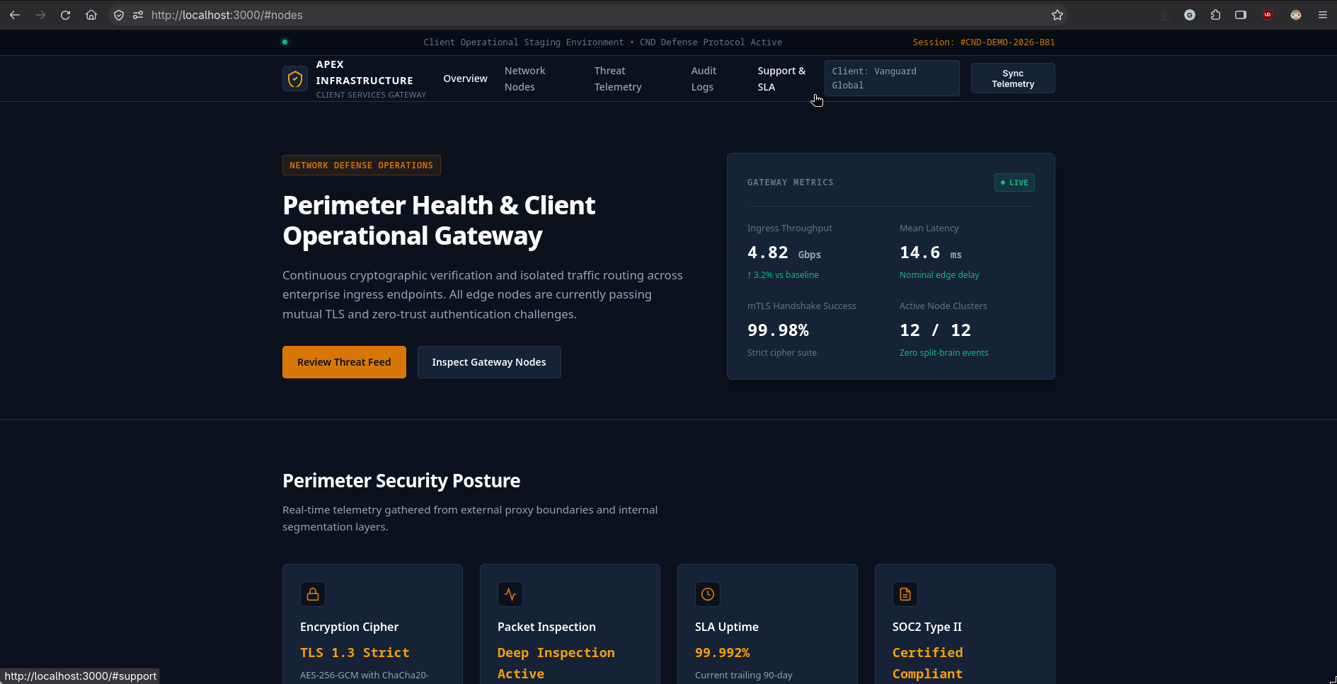
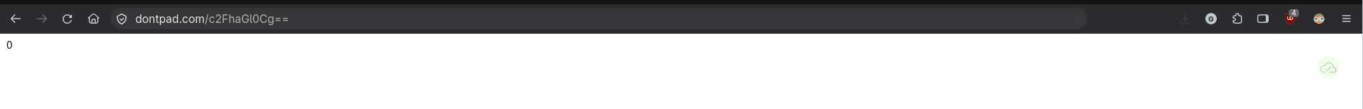
Figure 1: Baseline Client Portal Operation
Figure 2: External Command-and-Control Flag State (Dontpad)
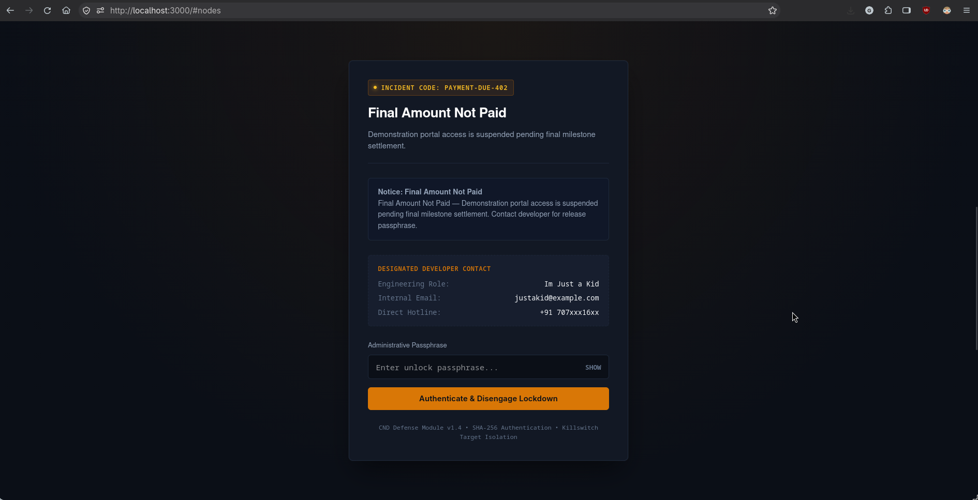
Figure 3: Detonated Fullscreen Lockout Screen ('Final Amount Not Paid')
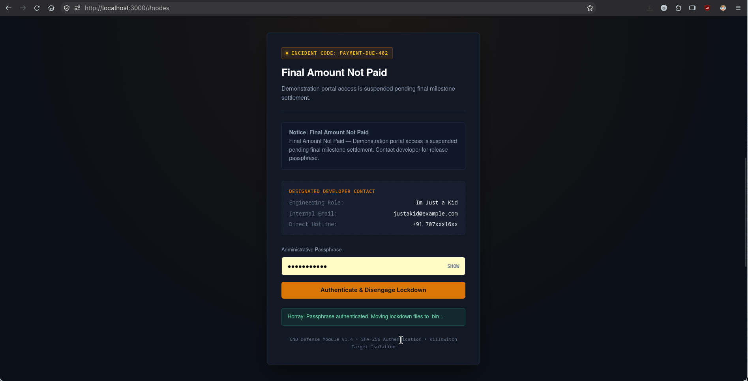
Figure 4: Passphrase Authentication and Unlock Transition
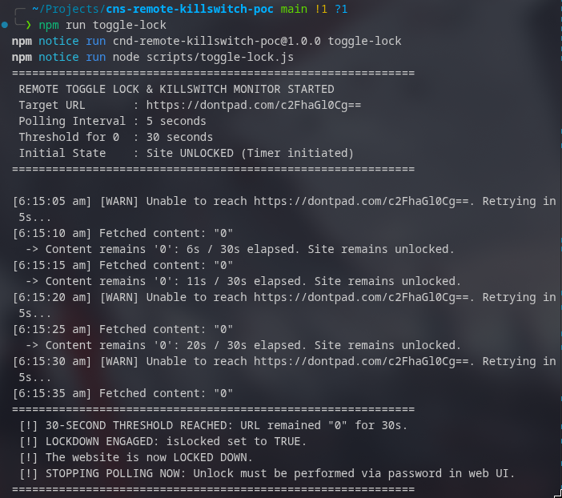

Figure 5: Terminal Logs & Filesystem Quarantine Proof
5. Threat Detection, Indicators of Compromise (IoCs) & Forensics
How would a security operations center (SOC) or forensic investigator expose this mechanism in a real deployment? The proof of concept leaves several critical indicators across network traffic, host behavior, and source code:
5.1 Network Traffic Analysis & Indicators
- Beaconing Patterns: Fixed-Interval Egress Beaconing: An enterprise web server hosting an internal client portal typically serves inbound requests. Outbound HTTP/HTTPS requests every 5000ms to an external domain represent anomalous egress. Statistical analysis of firewall logs will immediately flag periodic beaconing.
- Reputation Scoring: Suspicious Destination Domains: Outbound connections terminating at public scratchpad or pastebin services (api.dontpad.com) violate standard enterprise baseline communications. Enterprise proxies categorize these as unclassified or file-sharing utilities, subjecting them to blocking.
- TLS / Client Mismatches: Static User-Agent & Header Artifacts: The polling script uses a hardcoded desktop browser User-Agent ('Mozilla/5.0 (X11; Linux x86_64)...') dispatched from a Linux server process, creating a protocol mismatch easily detected via Deep Packet Inspection (DPI) or JA3/JA4 TLS fingerprinting.
5.2 Host-Level & Filesystem Indicators
- Runtime Filesystem Alterations: Unusual Filesystem System Calls: A production web application rarely renames or deletes its own source code directories at runtime. Process monitoring tools (e.g., Linux auditd, Falco, Sysmon) auditing sys_renameat or unlinkat system calls would generate high-severity alerts when executeKillswitch() moves lockdown/ to .bin/.
- Hidden Directory Inconsistencies: Anomalous Hidden Directories: The persistence of a hidden .bin/ folder containing quarantined application scripts inside the web root violates standard deployment manifests.
- FIM Alerts: Local State Mutation: The modification of lockdown/flag.json on disk during runtime creates a File Integrity Monitoring (FIM) discrepancy against the Git deployment hash.
5.3 Static vs. Dynamic Code Analysis
- Static Analysis (SAST): Static AST / Dependency Analysis: Abstract Syntax Tree (AST) scanners searching for security policy violations will detect backend HTTP client calls (fetch) targeting hardcoded external domains inside maintenance scripts, as well as arbitrary filesystem manipulation modules (node:fs) outside database/logging layers.
- Entropy Analysis: Obfuscation & Hardcoded Entropy: While opensesseme was stored as an unsalted SHA-256 hash (49b0ea37...), modern SAST tools flag isolated 64-character hexadecimal strings as hardcoded credentials or secret hashes (CWE-259). Furthermore, the Base64-encoded URL path ('c2FhaGl0Cg==' which decodes to 'sahit
') exhibits high entropy compared to regular route names.
- Dynamic Analysis: Dynamic Sandbox Execution (DAST): Running the application in a staging sandbox with network capture accelerates time-based triggers. Fast-forwarding system time or simulating network drops exposes dormant execution paths and reveals the latent lockdown barrier.
6. Findings, Reflection & Defense-in-Depth Controls
Why are logic bombs difficult to prevent using conventional cybersecurity toolsets? Traditional security architectures rely predominantly on signature-based Intrusion Detection Systems (IDS) and Antivirus (AV) scanners. A logic bomb breaks this paradigm because every individual line of code is syntactically benign:
- Benign Components: A timer (setInterval) is standard asynchronous programming.
- Benign Networking: An HTTP request (fetch) is ordinary web communication.
- Benign File Operations: Moving a file (fs.renameSync) is standard filesystem maintenance.
- Benign Cryptography: Comparing a SHA-256 hash is standard user authentication.
It is solely the combination and malicious intent of these benign operations that produces a denial-of-service condition. Because the code was authored by a trusted developer with legitimate commit rights, the logic bomb circumvents perimeter defenses as an insider threat.
6.1 Technical Mitigations (Defense-in-Depth)
- 1. Egress Filtering: Strict Egress Allowlisting: Production web servers must never possess unrestricted outbound Internet access. Perimeter network firewalls and Kubernetes NetworkPolicies should enforce default-deny egress, permitting connections only to vetted upstream payment gateways, databases, and authentication providers. An egress rule blocking unknown domains would completely neutralize the Dontpad polling mechanism.
- 2. Immutable Containers: Read-Only Application Containers: In enterprise cloud deployments, containers should run with an immutable, read-only root filesystem (read_only: true in Docker/Kubernetes). If the web server process cannot write to, delete, or rename directories on disk, the executeKillswitch() payload will fail with EROFS (Read-only file system), neutralizing the self-destruct mechanism and preserving forensic evidence.
- 3. File Integrity Monitoring: Runtime File Integrity Monitoring (FIM): Tools such as OSSEC, Wazuh, or Linux auditd continuously monitor application directories. Any runtime modification to flag.json or the deletion of lockdown/ immediately triggers a high-priority SOC alert and snapshots the process memory.
6.2 Organizational & Governance Controls
- 1. Code Review Discipline: Mandatory Peer Code Reviews & Four-Eyes Principle: No single developer should have the ability to merge uninspected code directly into production branches. A mandatory review policy would flag scripts making outbound calls to pastebins or incorporating time-delayed lockouts.
- 2. Least Privilege: Separation of Duties & Least Privilege: Freelance and external contractors should only deliver tested modules into isolated staging sandboxes; deployment pipelines (CI/CD) and infrastructure configuration must remain under internal DevOps ownership.
- 3. Escrow Structures: Financial & Contractual Escrow: Freelancers resort to logic bombs primarily due to fear of non-payment. Establishing milestone escrow accounts (where funds are verified in escrow before development begins and disbursed upon agreed verification criteria) eliminates the economic motivation for deploying coercive code.
7. Conclusion
This coursework proof-of-concept successfully demonstrates the mechanics of a hybrid temporal/remote-polled logic bomb, illustrating the delicate interplay between activation triggers, payload containment, and self-neutralizing anti-forensics. While technically functional in a controlled sandbox, our analysis demonstrates that such coercive mechanisms are fragile, legally hazardous, and easily unmasked by modern network monitoring and egress controls.
Ultimately, defending against software supply-chain logic bombs requires shifting away from naive signature detection toward architectural defense-in-depth: combining strict network egress allowlisting, immutable container filesystems, automated SAST scanning, and rigorous peer code governance.
Appendix A: Alphabetical Subject & Technical Index
Anti-Forensics & Log Scrubbing | Section 3.4, Section 5.2
Atomic Filesystem Relocation (renameSync) | Section 3.4, Section 4.1
Beaconing Telemetry (5-Second Interval) | Section 2.1, Section 5.1
Command-and-Control (C2) Polling | Section 2.1, Section 5.1
Defense-in-Depth Architecture | Section 6.1, Section 6.2
Dual-Action Trigger Matrix ('0' vs '1') | Section 2.2, Section 4.1
Egress Network Allowlisting | Section 5.1, Section 6.1
File Integrity Monitoring (FIM) | Section 5.2, Section 6.1
Fullscreen Restrictive Detonation Barrier | Section 3.2, Section 4.2
Hybrid Temporal-C2 Logic Bomb Classification | Section 2.2, Table 1
Immutable Root Filesystem (read_only) | Section 6.1
Insider Threat & Supply Chain Compromise | Section 1.1, Section 6.0
JA3/JA4 TLS Fingerprinting | Section 5.1
Minimal Tech Stack Philosophy | Section 3.0
Milestone Escrow Governance | Section 6.2
Payment Overdue Pressure Messaging | Section 3.2, Figure 3
Quarantine Holding Area (.bin/ Subsystem) | Section 3.1, Section 3.4
Rate Limiting (HTTP 429 Anomalies) | Section 1.3, Section 5.1
SHA-256 Digest Verification (opensesseme) | Section 3.3, Listing 1
Static vs. Dynamic Code Analysis (SAST/DAST) | Section 5.3
Subsystem Isolation (public/ vs lockdown/) | Section 3.1
System Call Auditing (sys_renameat) | Section 5.2
Temporal Countdown Trigger (30s Window) | Section 2.1, Section 4.1
Zero-Flicker Server-Side HTML Injection | Section 3.2, Section 4.1

