Updated: November 26, 2020

# nirs.io.loadNIRx

Prevent legacy code from running when one or more short-detector on the active bundles was added to the montage. This was incorrectly reassigning short-detector positions and links.

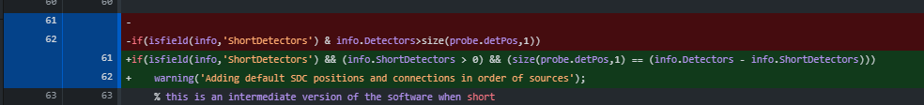

Fix error when loading >2 wavelengths

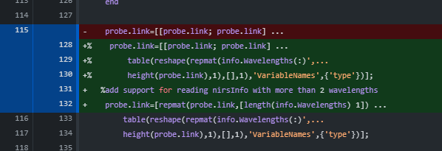

# nirs.util.verify_formula

add check to prevent crash

