MDM-1 LCD SEGMENT ASSIGNMENTS
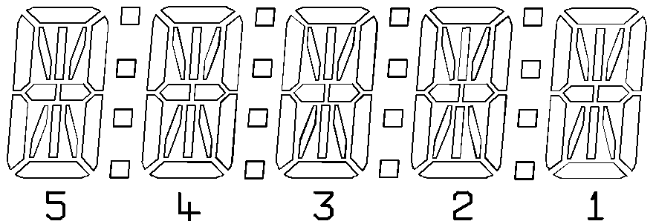
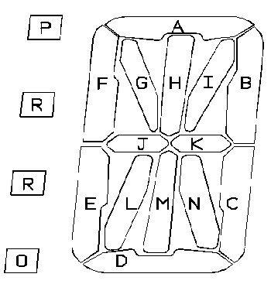

SEGMENT  DRIVER | COM A  SEGMENT | COM B  SEGMENT
S4 | 5J | 5K
S5 | 5E | 5L
S6 | 5D | 5M
S7 | 5C | 5N
S8 | 5F | 5G
S9 | 5A | 5H
S10 | 5B | 5I
S11 | 4O | 4R
S12 | 4J | 4K
S13 | 4E | 4L
S14 | 4D | 4M
S15 | 4C | 4N
S16 | 4F | 4G
S17 | 4A | 4H
S18 | 4B | 4I
S19 | 3O | 3R
S20 | 3J | 3K
S21 | 3E | 3L

S22 | 3D | 3M
S23 | 3C | 3N
S24 | 3F | 3G
S25 | 3A | 3H
S26 | 3B | 3I
S27 | 2O | 2R
S28 | 2J | 2K
S29 | 2E | 2L
S30 | 2D | 2M
S31 | 2C | 2N
S32 | 2F | 2G
S33 | 2A | 2H
S34 | 2B | 2I
S35 | 1O | 1R
S36 | 1J | 1K
S37 | 1E | 1L
S38 | 1D | 1M
S39 | 1C | 1N
S40 | 1F | 1G
S41 | 1A | 1H
S42 | 1B | 1I

Note:- 1P,2P,3P,4P tied to COMA i.e. disabled

