Steps and Results:

1. Created a node.js project with express for routing. And a HTML page for displaying the login form.
2. The service runs on port 3000
3. The project looks like this:

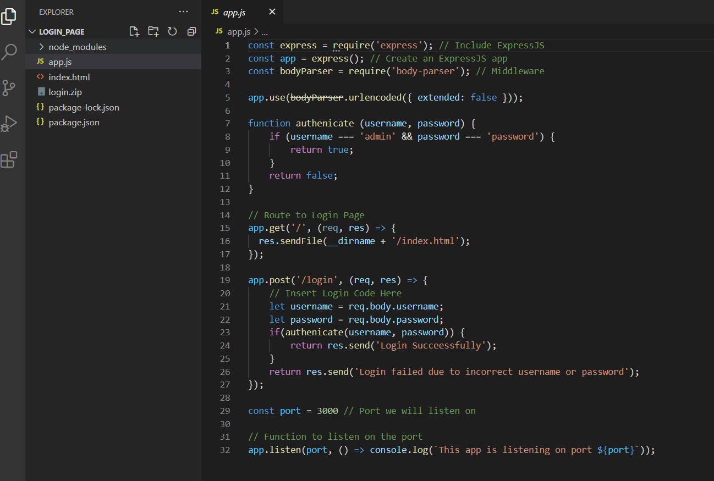

1. The package.json file defines the project dependencies and app.js defines the route. The index.html is the static html page
2. To run the project, we will need node.js environment.

Deploying on the EBS steps:

1. Click on create application.

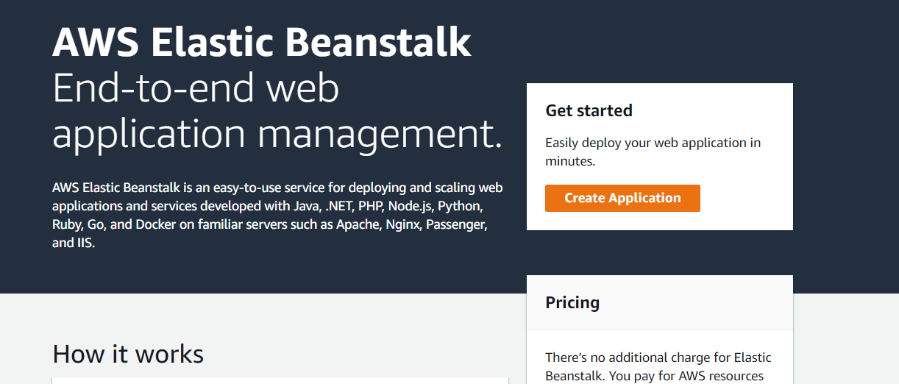

1. Give application name.

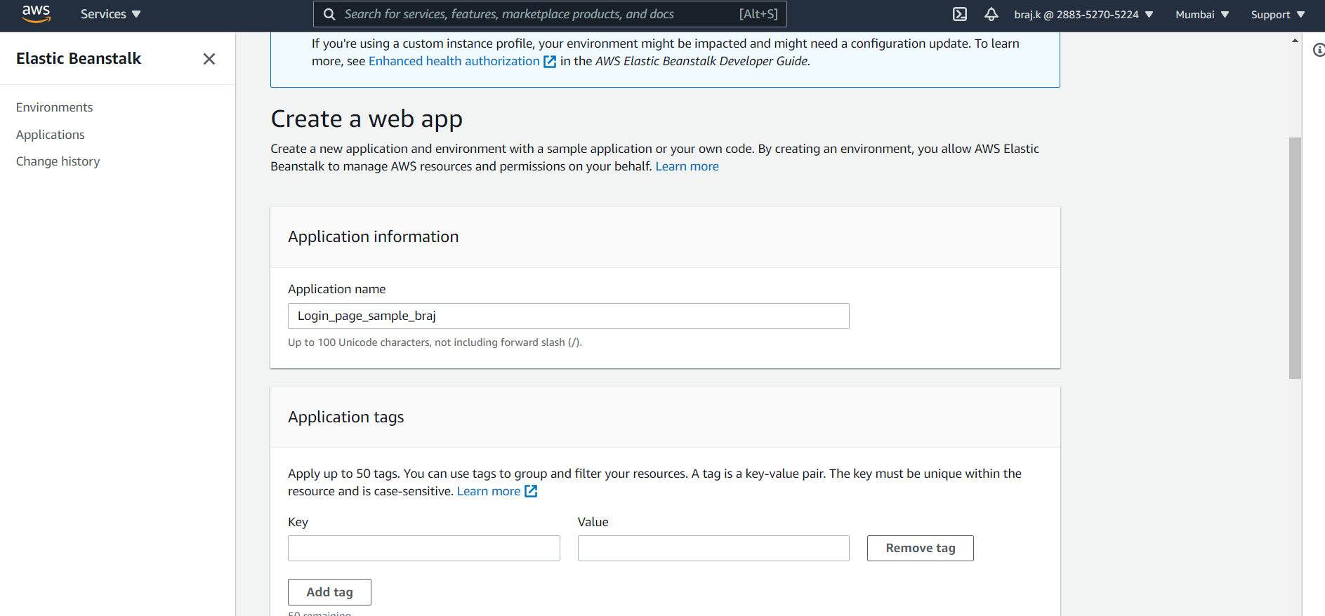

1. Choose platform and then upload your code option.

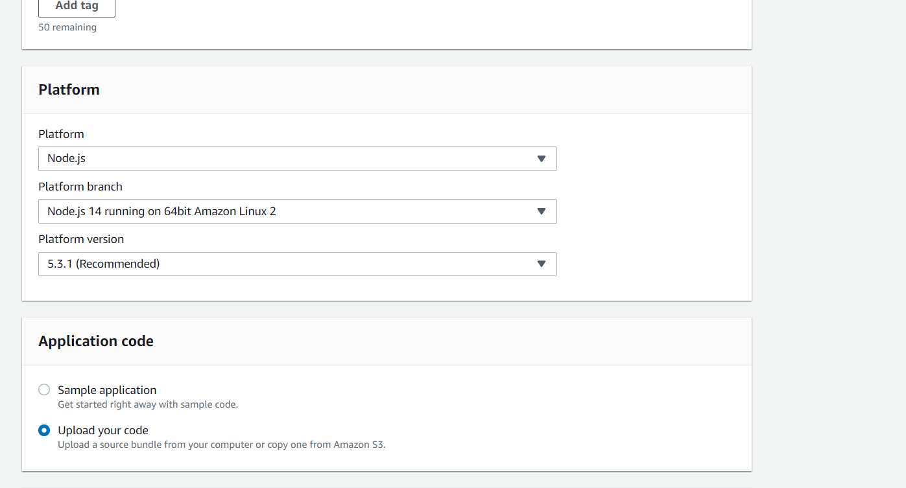

1. Upload the zip file of your code.
2. In additional configuration, software configuration, add environment variable for port mapping.

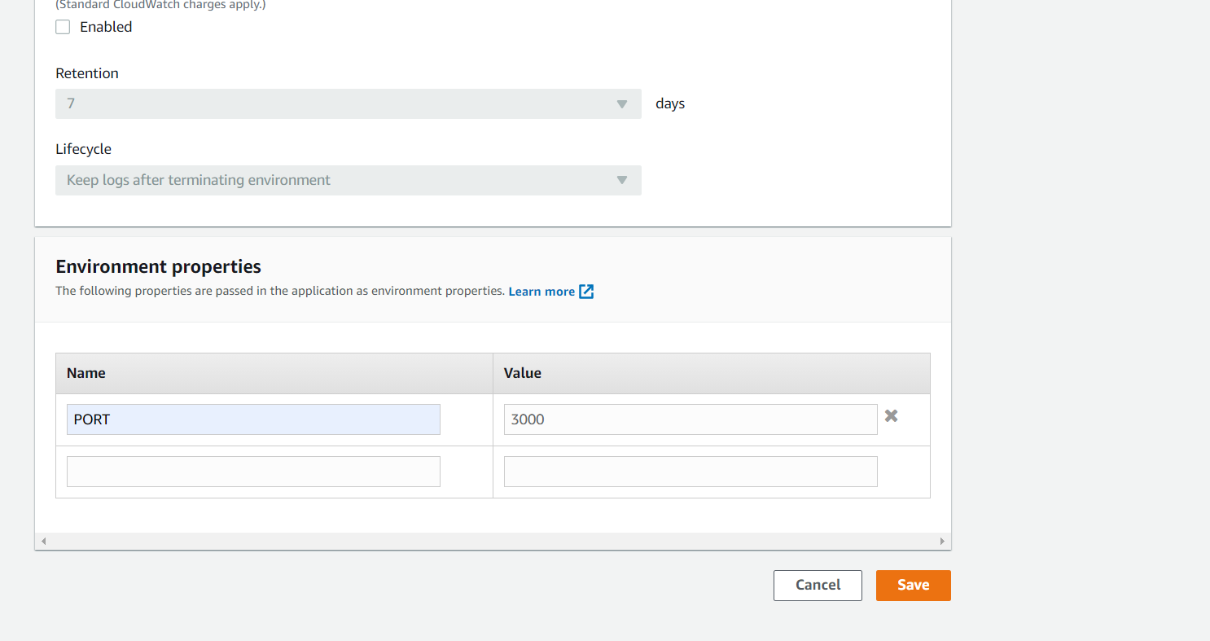

1. This will ensure that ngnix will route the requests to 3000 which by default redirects to 8080.
2. Finally create the application.

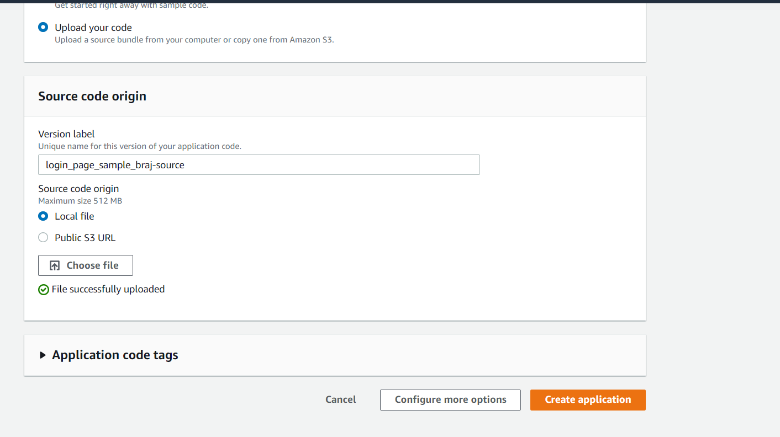

1. It will start the process of the creation of the application.

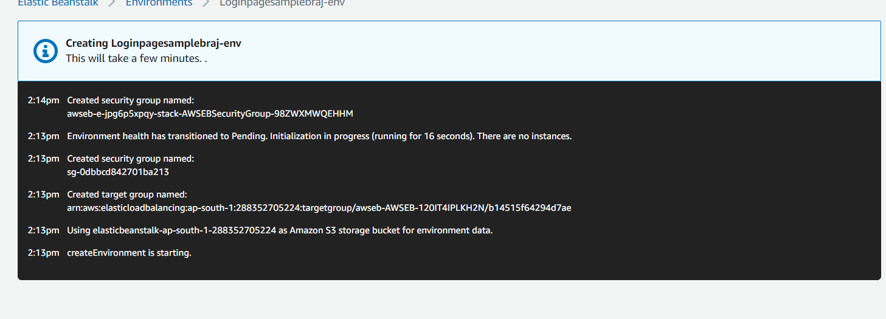

In the process, a new EC2 instance, security group, ngnix, health check, load balancer etc will be automatically created.

1. Once the environment is set, you can see the health status of application.

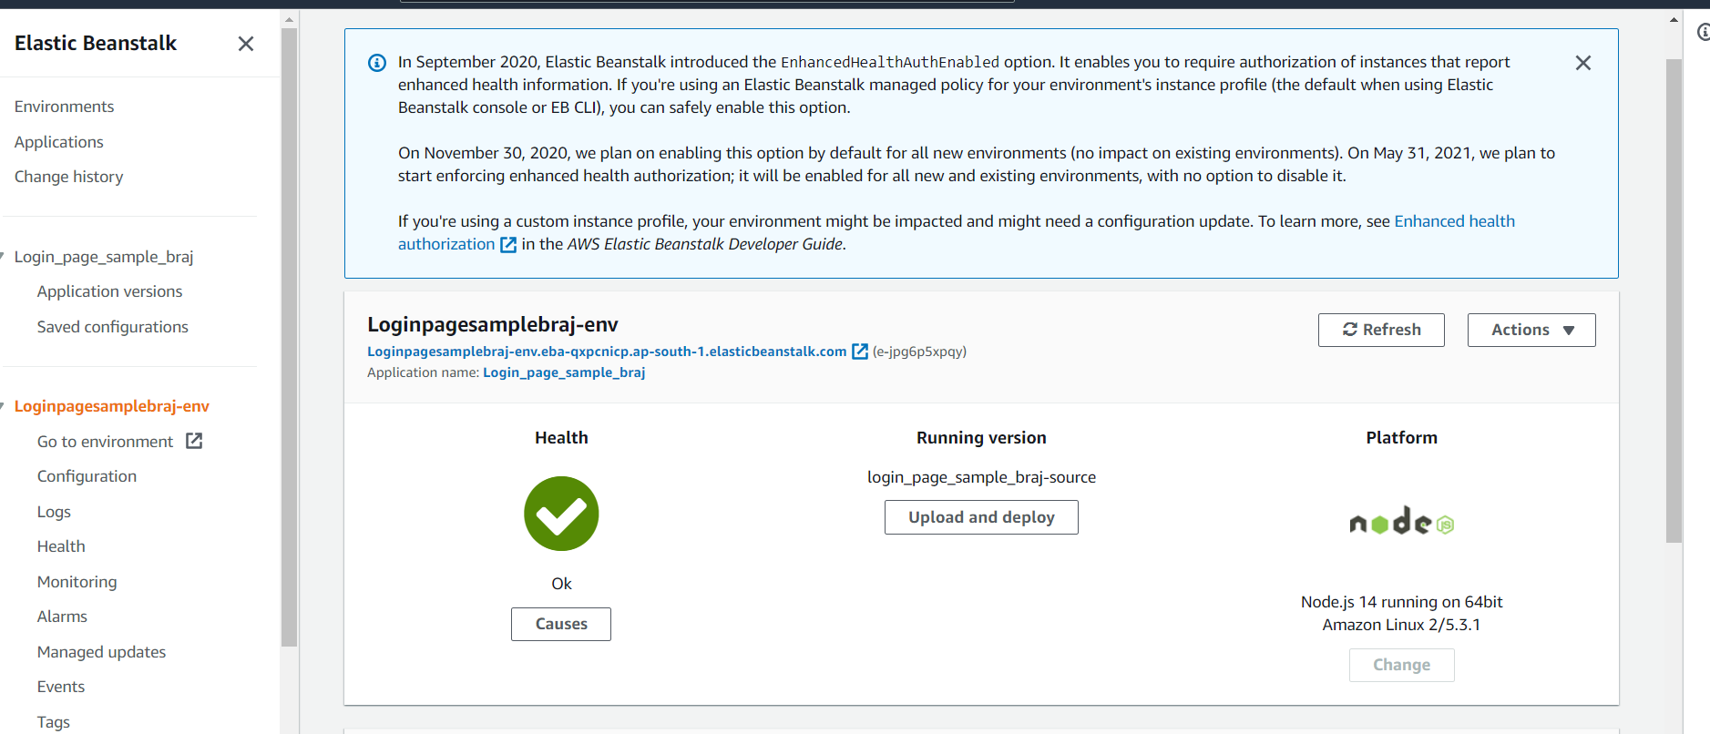

1. Click on go to environment to open the application’s login page.

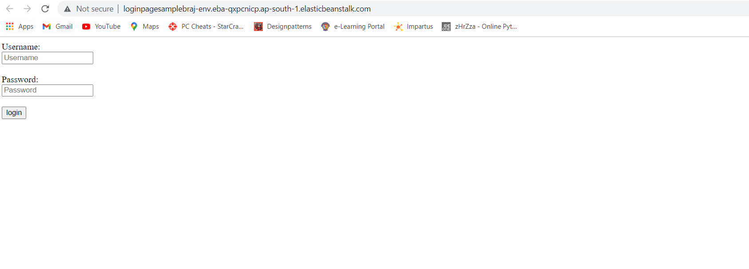

1. Try giving the user name and password correctly, i.e. admin/password. Press login. It gives following message.

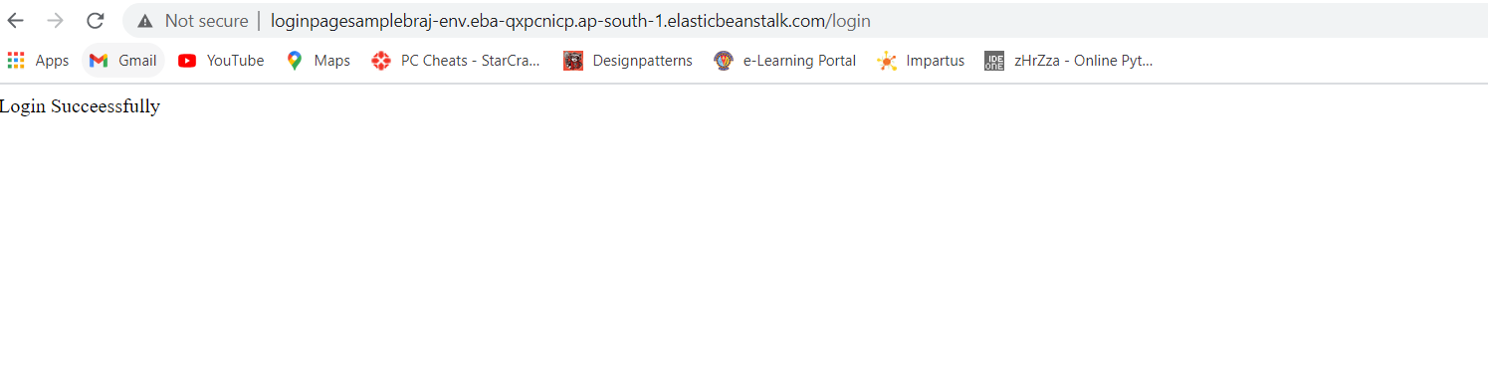

1. Try giving incorrect username/password. It gives the below message.