**Q4**

**ER Diagram for the Airline:** I have used a tool to draw this diagram to ensure clarity**.**

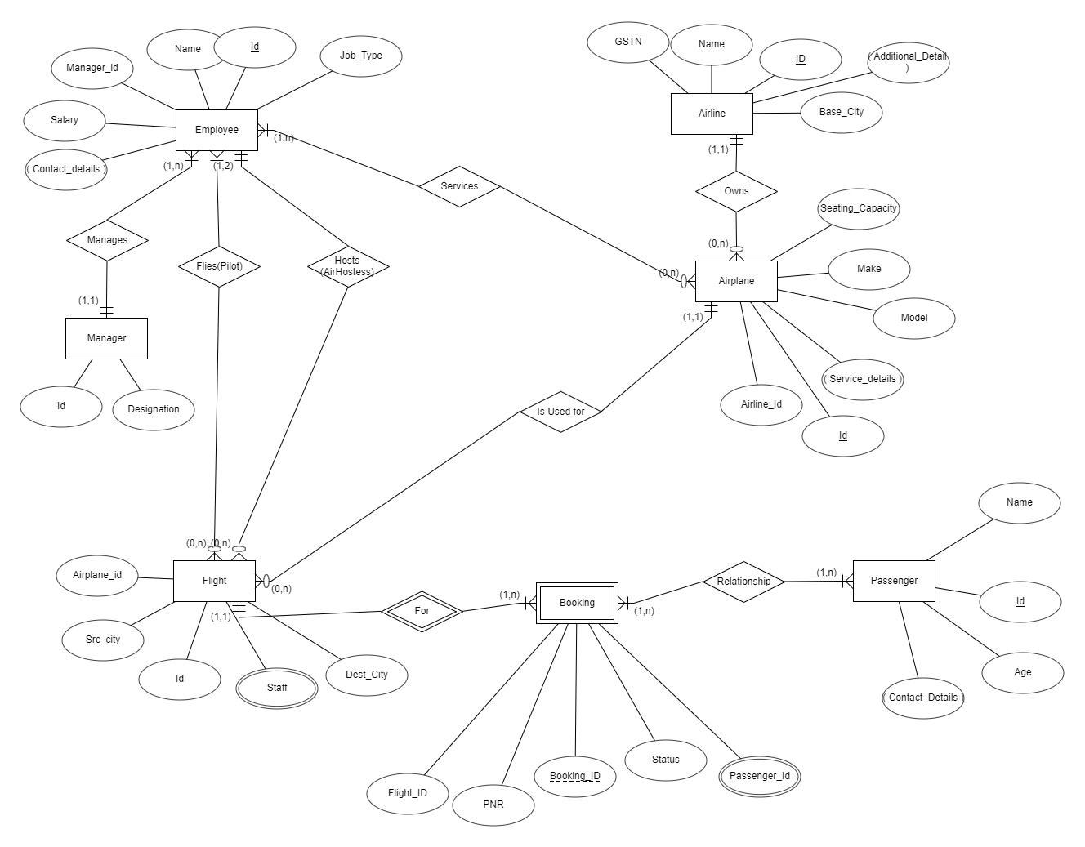

**Relational Model for the diagram:**

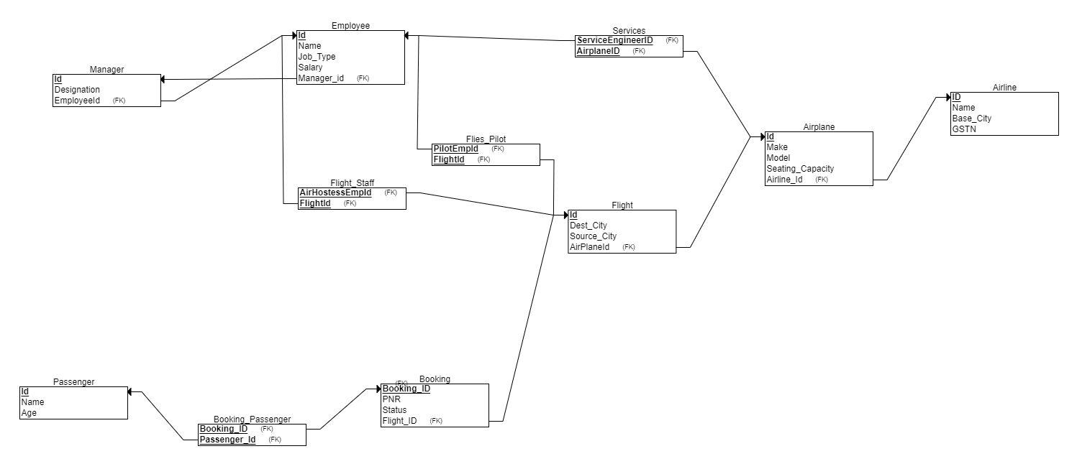

**THE END**