**Q1.**

1. To draw the domain model, firstly we will identify the conceptual classes. Following are the conceptual classes for this Case Study

|  |  |
| --- | --- |
| 1. Users 2. Customer 3. LaundryBag 4. LaundryItem 5. QRCode 6. LaundryServiceCenter | 1. LaundryServiceCenterAdmin 2. Notifications 3. HouseKeeper 4. LaundryStatus 5. SerialNumber |

Using the above classes, following will be the domain model for the same. I have used StarUML tool to draw these diagrams.

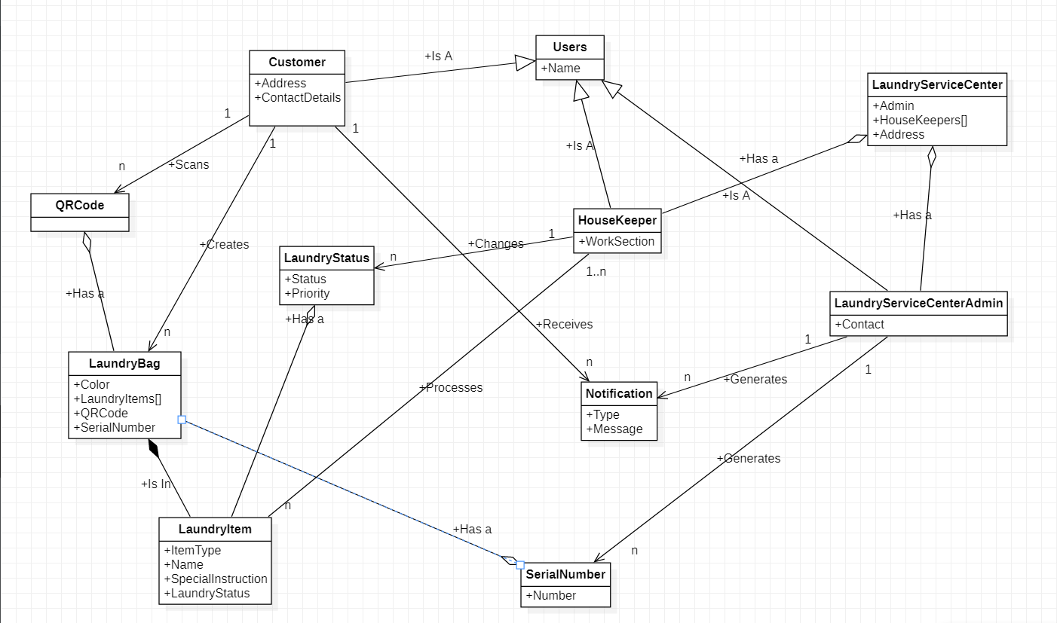

1. Following are the states of the item which arrives for laundry.

|  |  |
| --- | --- |
| 1. Item Received 2. Correction Needed / On Hold 3. Processing Ready 4. Batched 5. Washed 6. Wash Not Satisfactory | 1. Dried 2. Ironed 3. Hanged 4. Folded 5. Special Instruction Met 6. Packed 7. Ready for delivery |

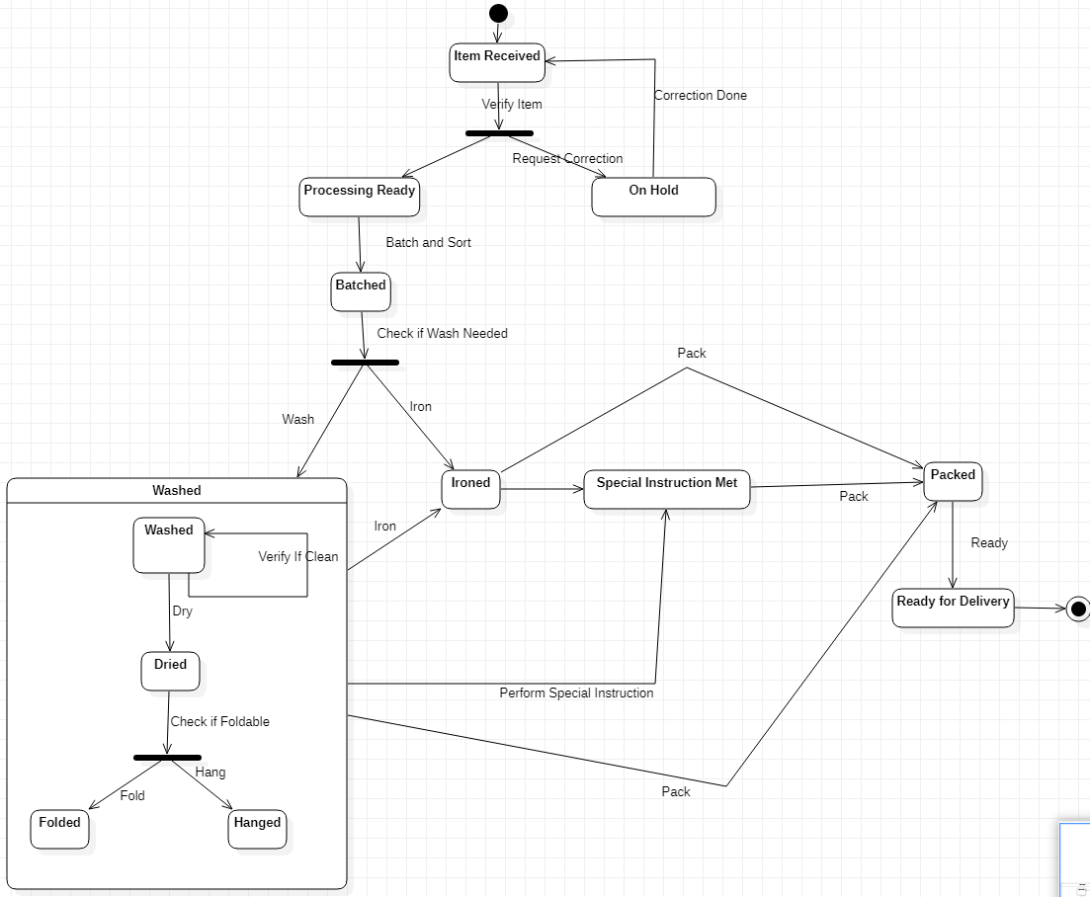State diagram for the same is as follows:

**C)** Sequence diagram for Drop One Laundry Bag for laundry.

