**Q2.**

1. Class Diagram for the bank solution

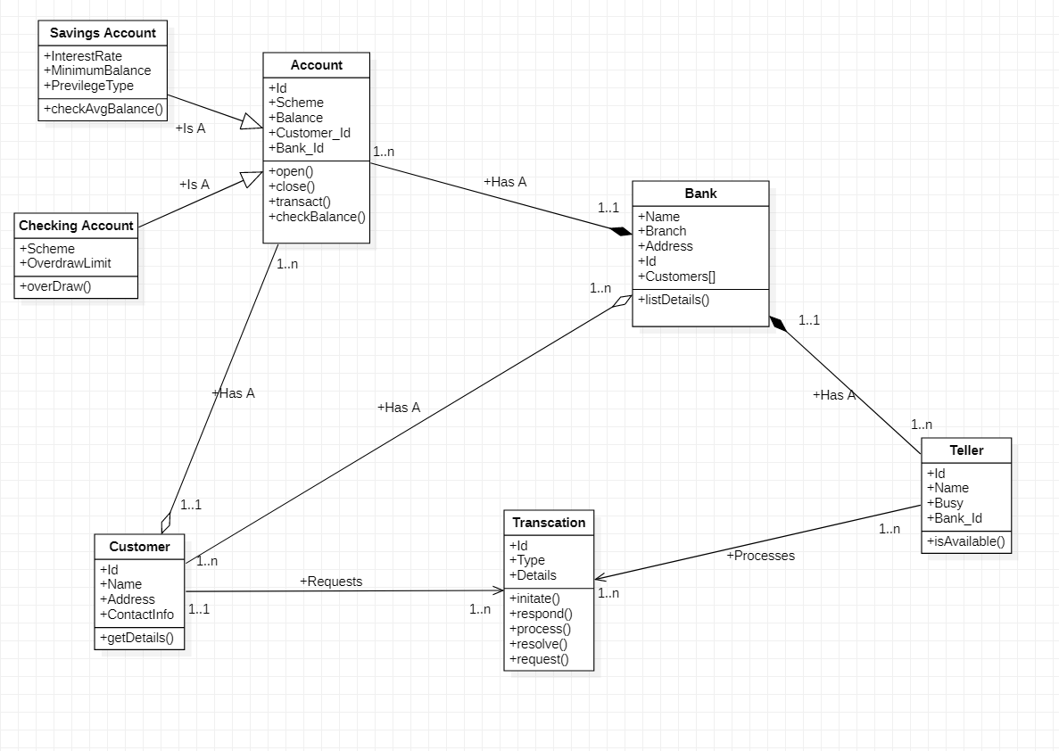

1. **Fully dressed Use case:**

**Use Case**: Customer Queue Management – Manage a socially distanced queuing system

**Level**: User/Customer Level

**Primary Actor**: Bank Customer

**Preconditions**:

1. The customer must have a query/transaction request with the bank.
2. The customer has a media to receive electronic notifications.

**Stakeholders and Their interests**:

Bank: It wants to ensure social distancing and safety inside its premise while serving customers.

Customer: They want to resolve their queries or complete their transactions. They also want to be ensured social distancing.

Tellers: They are required to serve customers efficiently and ensuring their safety.

**Main Success Scenario (or Basic Flow or “Happy Path”):**

1. Customer requests visit to branch by either
   1. Going to bank website
   2. Going to the automated queue teller machine
2. Customer fills details about nature of service required.
3. Customer gets a QR Code.
4. Customer can use this QR Code in following ways to find the current queue position and wait time
   1. Using the bank website
   2. Using a lightweight mobile app which can be downloaded from play store
5. Customer gets a notification message on their registered contact detail 15minutes before their turn.
6. On Receiving the message, customer can go and join the socially distanced queue at the bank premise.
7. On reaching the bank, customer needs to scan his QR code at banks automated entry gate.
8. Then he can go inside the seated waiting area. Only a limited number of customers are allowed inside.
9. Once their turn comes, they can visit the teller and get their request served.

**Post Conditions:**

1. Customer evacuates the bank premise as soon as their query is resolved.
2. Teller updates the status once query of customer is resolved and he leaves the counter.

**Extensions/Alternatives:**

1. Customer misses the allocated queue turn:
   1. In that case, if the turn was within same business day, and currently the queue is empty for the current time slot, the customer can be allowed inside.
   2. Else, he will be asked to request a new visit.
2. Customer does not have any access to smartphone or internet:
   1. The software should have an integrated IVRS or automated SMS system to give the details over call or SMS.
3. The system experiences failure:
   1. Current slots customer who are already in bank premise and who are physically in queue can be allowed to be processed in FIFO sequence.
   2. For others, display an error message for them and ask them to wait till they receive further notice before approaching the bank.
   3. Tellers try to restart the system.
   4. Tellers request fix from the system Admins on priority.
4. Customer query is not resolved with his given timeslot and his presence is needed for the query resolution:
   1. In this case, a revisit queue can be maintained, and a **revisit** request can be raised by the tellers on behalf of customer which will be of higher priority.
5. Customer query is different than what he registered for:
   1. In this case, if the teller who can resolve his query is free and there is no backlog present, then his query can be resolved.
   2. Else, he will be asked to request for revisit.

**Special Requirements:**

1. Language internationalization is needed for making it available for people of all regions.
2. The wait time given to customer should be reasonable and he should be made aware of the possible wait times.

**C) Suggestions to improve the Customer Queue Management Process**

1. An additional priority queue can be maintained to accommodate customers who need to revisit mandatorily as their work was not completed within given timeframe of the day.

2. The queue can also have priority set for high value clients and similarly for old aged, pregnant or differently abled customers. The system should have entry for such type of customers.

3. Apart from the separate lite app for waiting queue, this can also be integrated with the main banking app which the customers already have installed.

4. A separate queue with can be maintained in parallel for customers whose physical presence in not mandatory and can be serviced virtually/online.

5. The request for queue can also be made available over IVRS or SMS.

6. Customer should be able to add multiple queries in one single visit.

**THE END**