WEB SCRAPING -2

Python Virtual Environment
A virtual environment is a tool that helps to keep dependencies required by different projects separate by creating isolated python virtual environments for them. This is one of the most important tools that most Python developers use.

By default, every project on your system will use these same directories to store and retrieve site packages (third-party libraries).

Why do we need a virtual environment?
Imagine a scenario where you are working on two web-based python projects one of them uses Django 4.0 and the other uses Django 4.1 . In such situations virtual environment can be really useful to maintain the dependencies of both projects.

How does a virtual environment work?

Install virtualenv
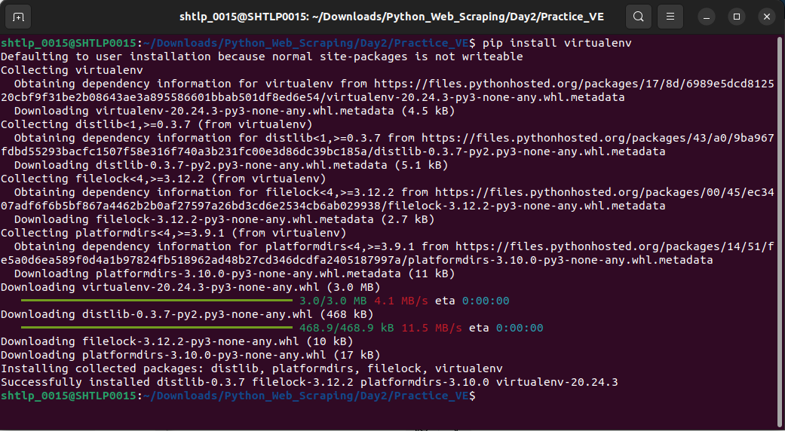
Check version
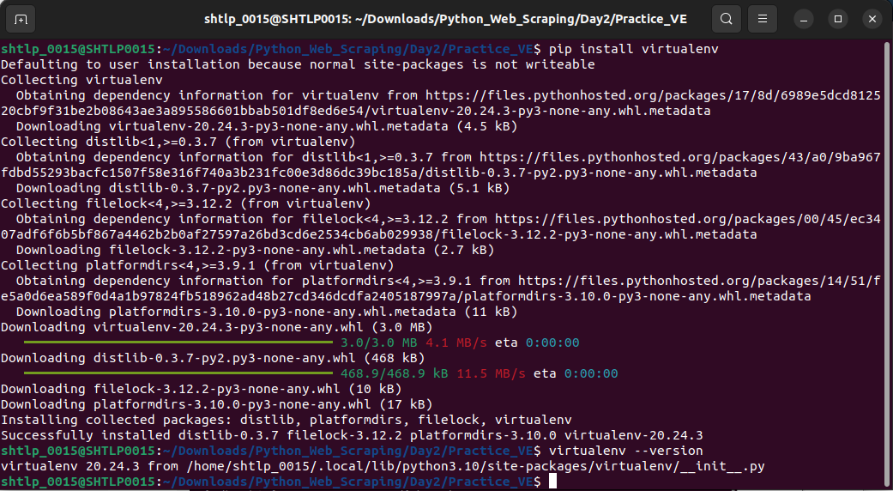
.
Using Virtual Environment:
You can create a virtualenv using the following command:

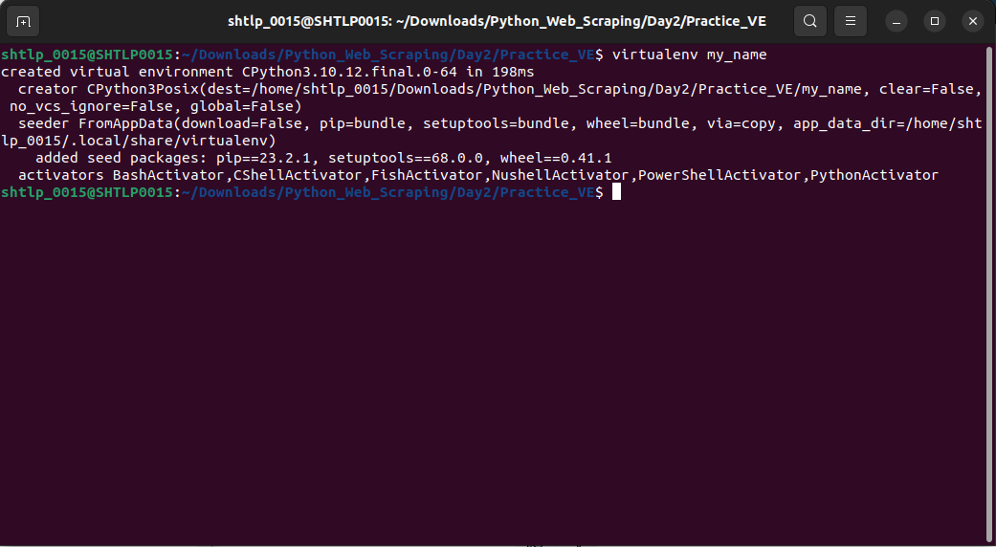
After running this command, a directory named my_name will be created. This is the directory that contains all the necessary executables to use the packages that a Python project would need. This is where Python packages will be installed. If you want to specify the Python interpreter of your choice, for example, Python 3, it can be done using the following command:

$ virtualenv -p /usr/bin/python3 virtualenv_name

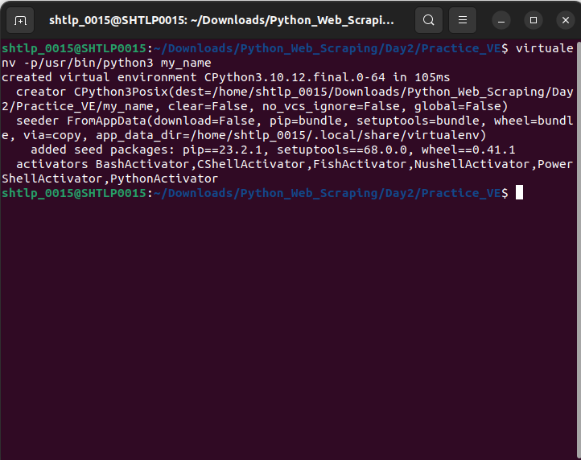
.
To activate virtual environment using windows command prompt
change directory to your virtual env

$ source virtualenv_name/bin/activate

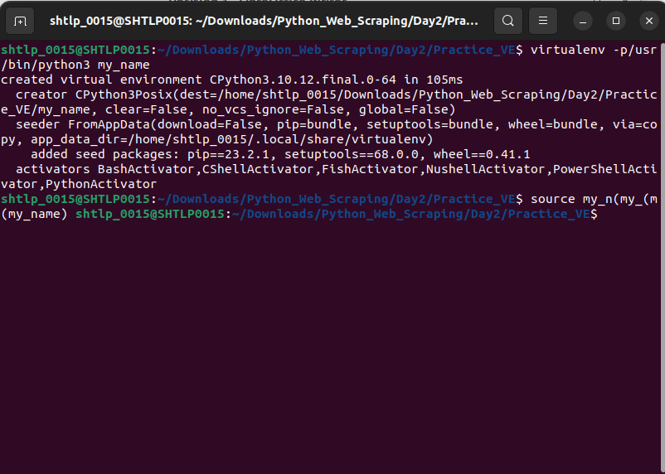
.
Once the virtual environment is activated, the name of your virtual environment will appear on the left side of the terminal. This will let you know that the virtual environment is currently active. In the image below, venv named virtual environment is active. Now you can install dependencies related to the project in this virtual environment.
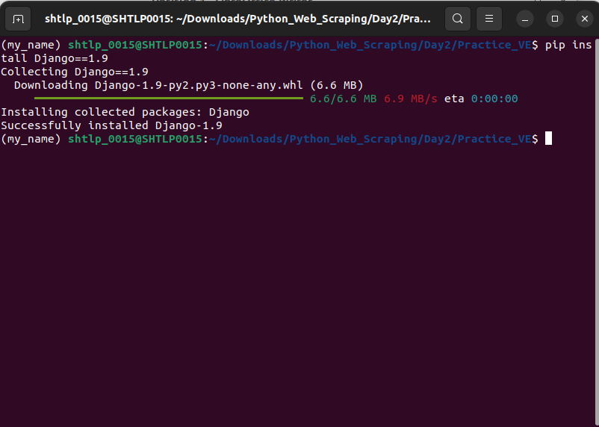
The Django 1.9 package will be placed in virtualenv_name folder and will be isolated from the complete system. Once you are done with the work, you can deactivate the virtual environment by the following command:

(virtualenv_name)$ deactivate
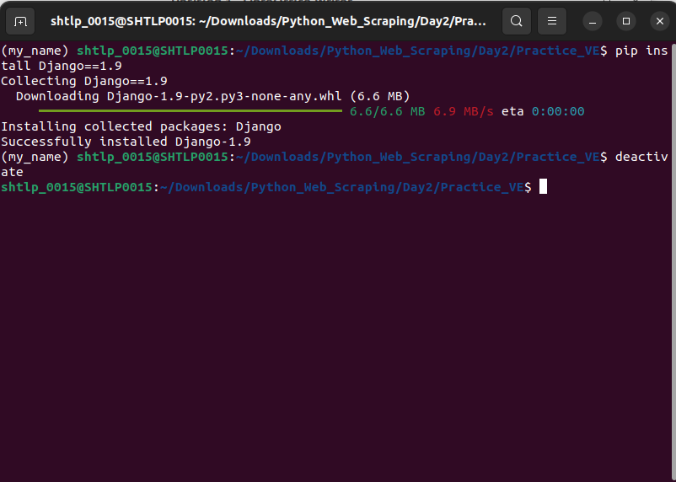

What Is Web Scraping?
Web scraping is the process of gathering information from the Internet. Even copying and pasting the lyrics of your favorite song is a form of web scraping! However, the words “web scraping” usually refer to a process that involves automation.Some websites don’t like it when automatic scrapers gather their data, while others don’t mind.
If you’re scraping a page respectfully for educational purposes, then you’re unlikely to have any problems. Still, it’s a good idea to do some research on your own and make sure that you’re notviolating any Terms of Service before you start a large-scale project.

Reasons for Web Scraping
Absolutely, your description highlights some of the key reasons why web scraping can be incredibly valuable. Here's a breakdown of the points you've mentioned:

1. Time Efficiency:
Web scraping allows you to automate the process of collecting data from websites. In the example of job searching, manually checking a job site daily for new opportunities can be time-consuming and inefficient. With web scraping, you can write a script to automatically retrieve new job listings, saving you time and effort.

2. Repetitive Tasks:
Many online tasks involve repetitive actions like clicking, scrolling, and searching. Web scraping helps you avoid these tedious tasks by letting you program a script to perform these actions automatically. This is especially beneficial when you need to gather information from multiple pages or websites.

3. Frequent Updates:
Websites often update their content regularly, making it challenging to stay up-to-date manually. Automated web scraping can be set to run at specific intervals, ensuring that you always have the latest information without having to check the site constantly.

4. Data Volume:
If you need to collect a significant amount of data from a website, doing it manually can be overwhelming. Web scraping enables you to collect large volumes of data quickly and accurately.

5. Personalization and Filters:
With web scraping, you can tailor your data collection to your specific needs. For instance, you can set up filters to only extract job listings that match your preferences, saving you from sifting through irrelevant information.

6. Real-Time Notifications:
In cases where websites don't offer notification services, web scraping can provide a workaround. You can set up a script to check for new data and send you notifications when specific conditions are met.

7. Efficient Data Analysis:
Once you've gathered the data through web scraping, you can analyze it for insights and trends. This can be especially helpful for making informed decisions, whether it's about job opportunities or any other domain of interest.

8. Accessibility to Public Data:
Much of the data available on the web is publicly accessible. Web scraping allows you to harness this information for your own purposes, whether it's for research, analysis, or personal use.

Remember that while web scraping offers many benefits, it's important to follow ethical guidelines and respect a website's terms of use. Always ensure you're collecting data responsibly and not causing any harm to the website or its users.

Challenges of Web Scraping
You've highlighted some of the key challenges that web scraping practitioners often encounter. Let's break down these challenges in more detail:

1. Website Diversity:
Websites come in all shapes and sizes, built with different technologies, frameworks, and coding practices. This diversity means that you'll need to adapt your scraping approach for each site you target. Even though there might be patterns in the HTML structure, variations can still pose challenges.

2. Dynamic Content:
Many modern websites use JavaScript to load content dynamically. While the initial HTML might look simple, crucial data might be fetched and displayed after the page loads. This requires more advanced techniques, like using browser automation tools (e.g., Selenium) to interact with the page as a user would.

3. Website Changes:
Websites are constantly evolving. Design updates, layout changes, and structural modifications can break your scraping scripts. What worked today might not work tomorrow. Regular maintenance is essential to adapt your scripts to changes in the website's structure.

4. Robots.txt and Ethical Concerns:
Websites often include a `robots.txt` file that instructs web crawlers and scrapers which parts of the site they're allowed to access. It's important to respect these guidelines to avoid legal issues and maintain ethical scraping practices.

5. Anti-Scraping Measures:
Some websites implement anti-scraping measures to deter automated data collection. These measures might include rate limiting, CAPTCHAs, or IP blocking. Overcoming these hurdles requires clever strategies and possibly rotating IP addresses.

6. Data Quality and Cleanup:
Web pages can have inconsistent or messy data formatting. Extracted data might contain HTML tags, unnecessary whitespace, or special characters. Cleaning and formatting the data to make it usable can be a significant task.

7. Performance and Speed:
Scraping many pages or a large amount of data can strain servers and slow down the scraping process. Being respectful of server response times and using appropriate techniques to avoid overloading the server is crucial.

8. Legal and Ethical Considerations:
While much data on the web is publicly accessible, scraping some sites might violate their terms of use or copyright. It's important to ensure that you have the right to access and use the data you're scraping.

9. Maintaining Scrapers:
As you mentioned, maintaining scraping scripts can be time-consuming due to the evolving nature of the web. You might need to adjust your scripts regularly to keep them functional as websites change.

10. Learning Curve:
Web scraping involves a learning curve, especially when dealing with different technologies and troubleshooting issues. However, the effort you invest in learning will pay off in terms of efficiency and data accessibility.

To overcome these challenges, it's essential to stay up-to-date with web scraping best practices, leverage relevant libraries and tools, and be prepared to adapt your strategies as needed. Start small, experiment, and gradually build more complex scraping projects to enhance your skills.

Step 1: Inspect Your Data Source
Before you begin scraping a website, it's crucial to inspect the structure of the webpage you want to extract data from. The "Inspect" option in web browsers, like Chrome or Firefox, is a powerful tool that allows you to view the HTML and CSS code of the page. Here's how you can approach this step:

1. Open the webpage you want to scrape in your web browser.
2. Right-click on the element you want to extract data from (text, images, links, etc.).
3. Select "Inspect" or "Inspect Element" from the context menu. This opens the browser's Developer Tools, where you can see the HTML code corresponding to the selected element.

By inspecting the source code, you can identify the HTML tags, classes, IDs, and attributes associated with the data you want to scrape. This information will be essential for targeting and extracting the data using your scraping script.

Step 2: Scrape HTML Content From a Page
Once you've identified the relevant elements through inspection, you can start scraping the HTML content using a programming language and a web scraping library like Python's BeautifulSoup. Here's a basic example of how this can be done:
Create a virtual environment for your project before you install any external package. Activate your new virtual environment, then type the following command in your terminal to install the external requests library:
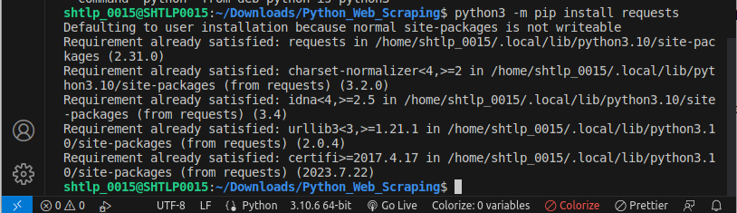
Then open up a new file in your favorite text editor. All you need to retrieve the HTML are a few lines of code:
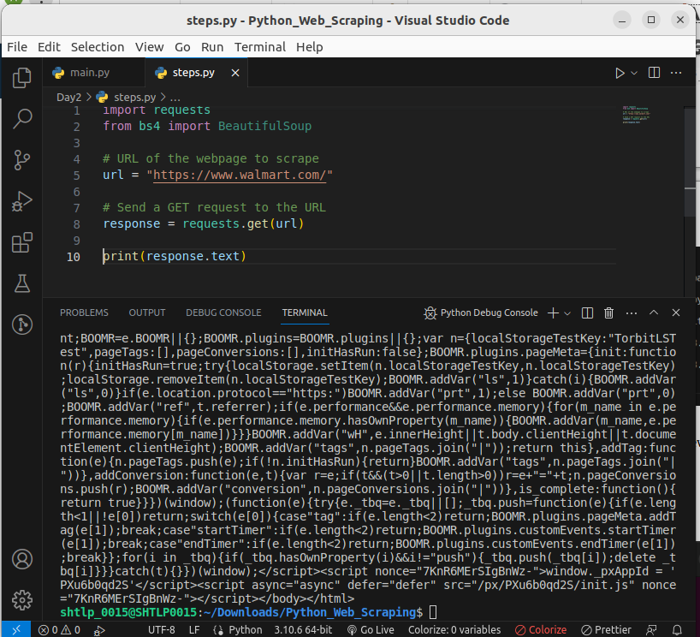
.
If you print the .text attribute of page, then you’ll notice that it looks just like the HTML that you inspected earlier with your browser’s developer tools. You successfully fetched the static site content from the Internet! You now have access to the site’s HTML from within your Python script.

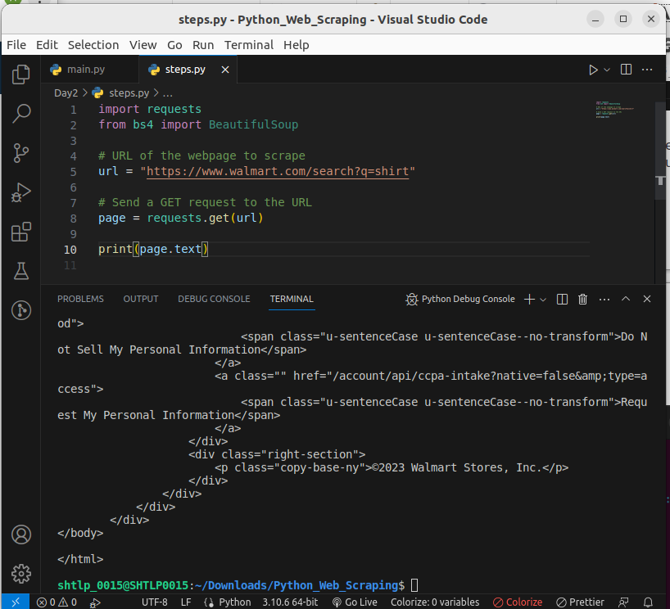

Step 3: Parse HTML Code With Beautiful Soup
Beautiful Soup is a Python library for parsing structured data. It allows you to interact with HTML in a similar way to how you interact with a web page using developer tools. The library exposes a couple of intuitive functions you can use to explore the HTML you received. To get started, use your terminal to install Beautiful Soup:
Installing beautifulsoup4:

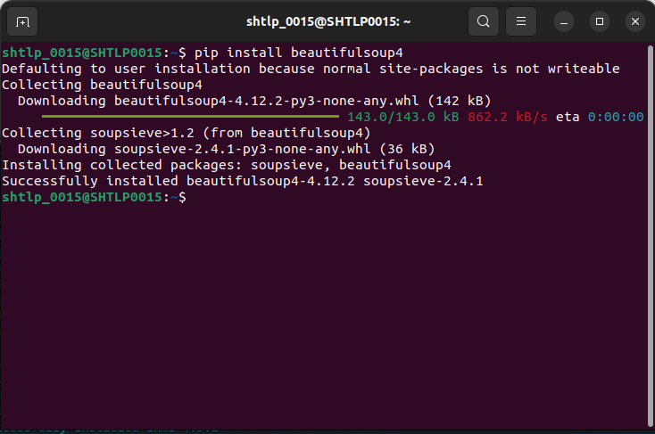
.

Installing lxml
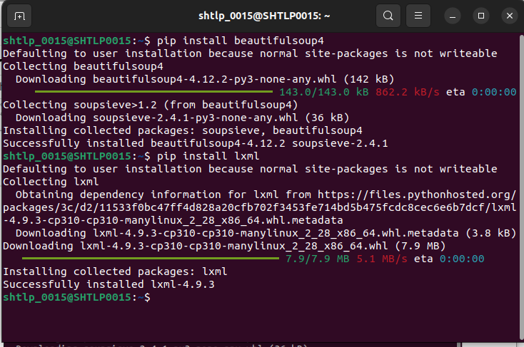
.

.

Installing requests:
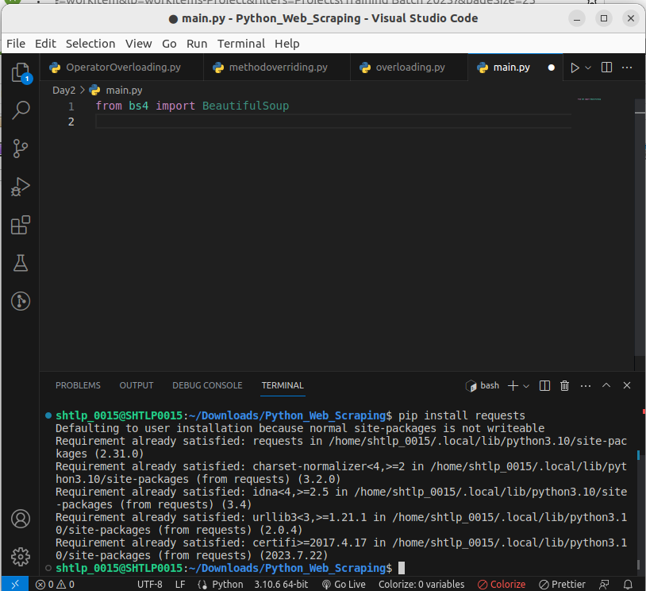
.

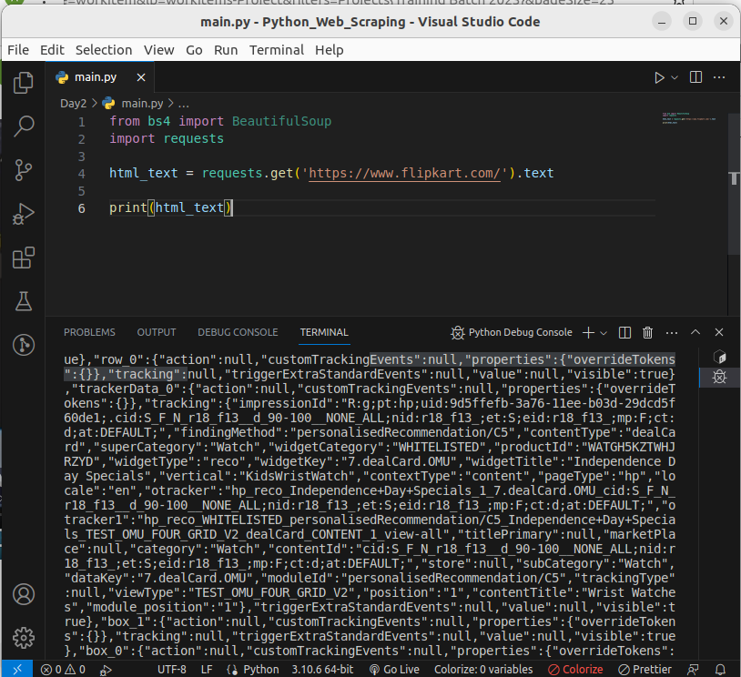
.

Find Elements by ID
In an HTML web page, every element can have an id attribute assigned. As the name already suggests, that id attribute makes the element uniquely identifiable on the page. You can begin to parse your page by selecting a specific element by its ID.
Switch back to developer tools and identify the HTML object that contains all the job postings. Explore by hovering over parts of the page and using right-click to Inspect.
Note: It helps to periodically switch back to your browser and interactively explore the page using developer tools. This helps you learn how to find the exact elements you’re looking for.

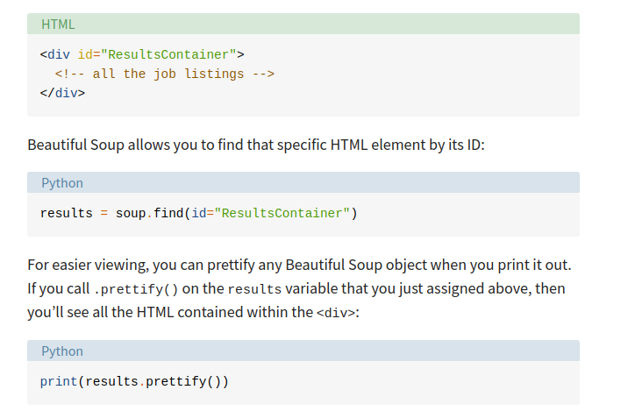

Hidden Websites Some pages contain information that’s hidden behind a login. That means you’ll need an account to be able to scrape anything from the page. The process to make an HTTP request from your Python script is different from how you access a page from your browser. Just because you can log in to the page through your browser doesn’t mean you’ll be able to scrape it with your Python script. However, the requests library comes with the built-in capacity to handle authentication. With these techniques, you can log in to websites when making the HTTP request from your Python script and then scrape information that’s hidden behind a login. You won’t need to log in to access the job board information, which is why this tutorial won’t cover authentication.

Dynamic Websites In this tutorial, you’ll learn how to scrape a static website. Static sites are straightforward to work with because the server sends you an HTML page that already contains all the page information in the response. You can parse that HTML response and immediately begin to pick out the relevant data. On the other hand, with a dynamic website, the server might not send back any HTML at all. Instead, you could receive JavaScript code as a response. This code will look completely different from what you saw when you inspected the page with your browser’s developer tools. Note: In this tutorial, the term dynamic website refers to a website that doesn’t return the same HTML that you see when viewing the page in your browser.

Find Elements by HTML Class Name
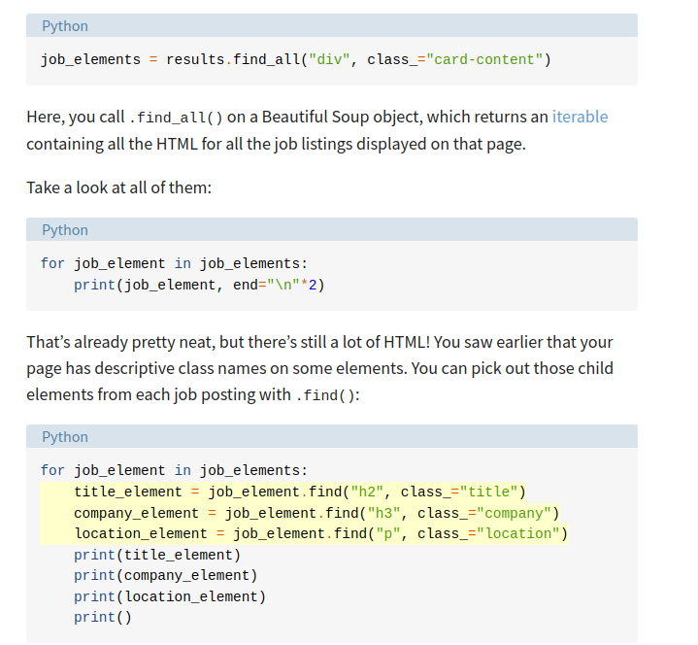
.

Extract Text From HTML Elements
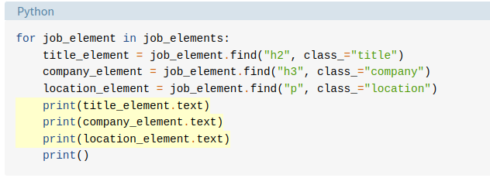
.

Find Elements by Class Name and Text Content
python_jobs = results.find_all("h2", string="Python")
Certainly! Here's a conclusion summarizing the key points covered in your guide to web scraping using Python and Beautiful Soup:

Web scraping is a powerful technique that allows you to extract data from websites for various purposes. Python, along with libraries like Beautiful Soup and requests, provides an effective toolkit for performing web scraping tasks.

The process of web scraping involves several steps:
1. Inspect Your Data Source: Before scraping a website, use browser developer tools to understand the structure of the HTML content you want to extract.

2. Scrape HTML Content: Use the `requests` library to fetch the HTML content of a webpage. This content can then be parsed and manipulated using Beautiful Soup.

3. Parse HTML Code: Beautiful Soup helps you parse and navigate HTML code, making it accessible for further processing. It allows you to search for elements based on tags, classes, and other attributes.

4. Extract Relevant Information: Identify the specific HTML elements containing the data you need. Extract text and attributes from these elements using Beautiful Soup's methods.

5. Handle Dynamic Content: While this guide focuses on static websites, you may encounter dynamic websites that load content using JavaScript. For scraping dynamic content, tools like `requests-html` or Selenium can be used.

Web scraping comes with its own set of challenges:
- Variety: Each website has a unique structure, requiring personalized treatment to extract relevant data.
- Durability: Websites frequently change, which can affect the stability of your scraper. Regular maintenance is needed to adapt to these changes.

Ethical considerations are crucial when engaging in web scraping. Always respect a website's terms of use and consider the legality and ethical implications of scraping its content.

In conclusion, web scraping is a valuable skill for data extraction, research, and automation. With Python and libraries like Beautiful Soup, you can efficiently collect and analyze data from websites, provided you approach it responsibly and ethically. Remember that web scraping is a constantly evolving field, so continuous learning and adaptability are key to success.

