WEB SCRAPING-3

Web scraping is the process of automatically extracting information from websites. It involves using automated scripts or tools to access web pages, retrieve their HTML content, and then parse and extract specific data from that content. Web scraping is commonly used to gather data for various purposes, such as research, analysis, data mining, and more.

Here are some key concepts and steps related to web scraping:

1. HTTP Requests:
Web scraping starts with sending HTTP requests to a website's URL using libraries like `requests` in Python. This request retrieves the HTML content of the webpage.

2. HTML Parsing:
Once the HTML content is retrieved, it needs to be parsed to extract the desired information. The `BeautifulSoup` library in Python is commonly used for this purpose. It creates a parse tree that allows easy traversal and manipulation of HTML elements.

3. Locating Elements:
Web scraping involves identifying and locating specific HTML elements that contain the data you want to extract. These elements are often identified using HTML tags, attributes, and their structure in the page.

4. Data Extraction:
After locating the relevant HTML elements, you extract the desired data from them. This can involve extracting text, attributes, URLs, images, and more.

5. Data Cleaning and Transformation:
Extracted data may need further cleaning and transformation to remove unwanted characters, formatting, or inconsistencies. This ensures that the data is in a usable format.

6. Handling Pagination:
If the data is spread across multiple pages (pagination), you need to navigate through those pages systematically to scrape all the required information.

7. Rate Limiting and Ethical Considerations:
It's important to be respectful of websites' terms of use and to avoid overloading their servers with too many requests in a short period of time. Some websites provide APIs for accessing data in a structured manner, which may be preferable to direct scraping.

8. Legal and Ethical Considerations:
Web scraping should be done ethically and legally. Make sure to review the website's terms of use and robots.txt file to understand whether scraping is allowed. Some websites might have restrictions on scraping, especially for commercial purposes.

9. Dynamic Content:
Some websites load content dynamically using JavaScript. In such cases, you might need to use tools like Selenium that can interact with the webpage as a user would.

10. Data Storage:
Once you have extracted the data, you can store it in various formats, such as CSV, JSON, databases, or other data structures.

It's important to note that websites can change their structure over time, potentially breaking your scraping scripts. Regular maintenance and updates to your scraping scripts may be necessary to ensure they continue to function correctly.

Always ensure that your web scraping activities are respectful, legal, and aligned with the website's terms of use.

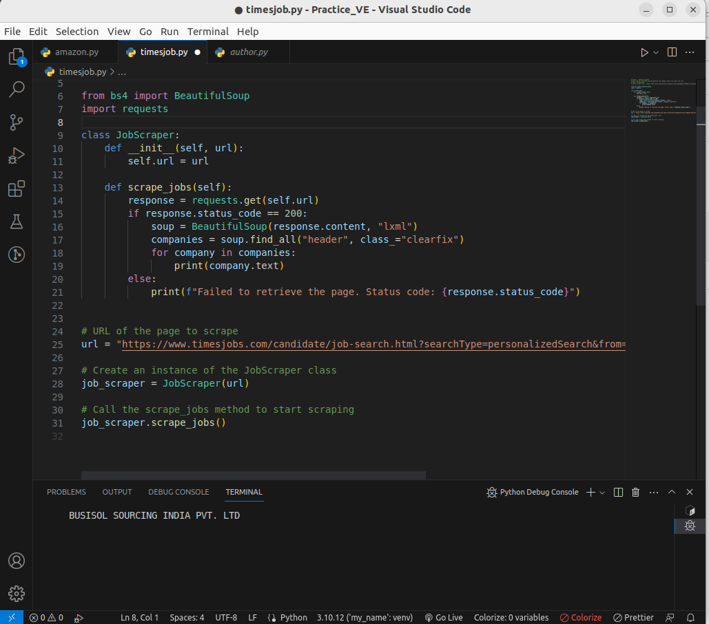
.

1. Import Libraries:
Import the required libraries, including `BeautifulSoup` for parsing HTML content and `requests` for making HTTP requests.

2. Define Class:
Create a class, such as `JobScraper`, to encapsulate the scraping functionality. The class can have an `__init__` method to initialize the URL.

3. Define Scraping Method:
Within the class, define a method like `scrape_jobs()` that performs the actual scraping. This method:
- Uses the `requests.get()` function to retrieve the webpage's content.
- Checks if the response status code is 200 (indicating success).
- Parses the HTML content using `BeautifulSoup`.
- Searches for specific HTML elements (e.g., `header` elements with a certain class).
- Extracts the desired information (text content) from the found elements.

4. Main Code Execution:
- Define the URL of the webpage you want to scrape.
- Create an instance of the scraper class, passing the URL as a parameter.
- Call the scraping method on the instance to initiate the scraping process.

Code
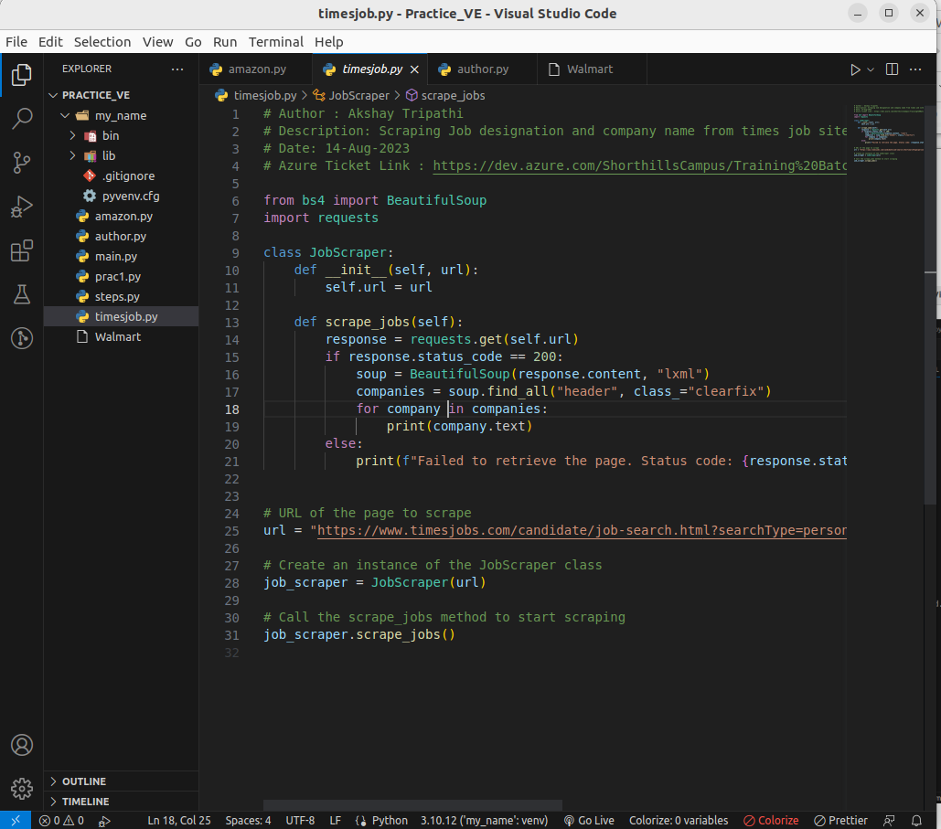
Output:
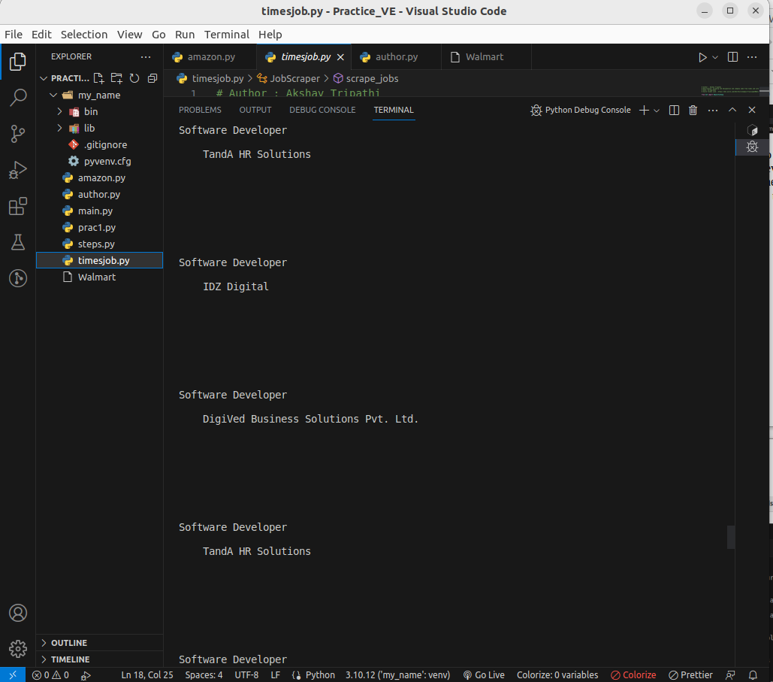

Code:
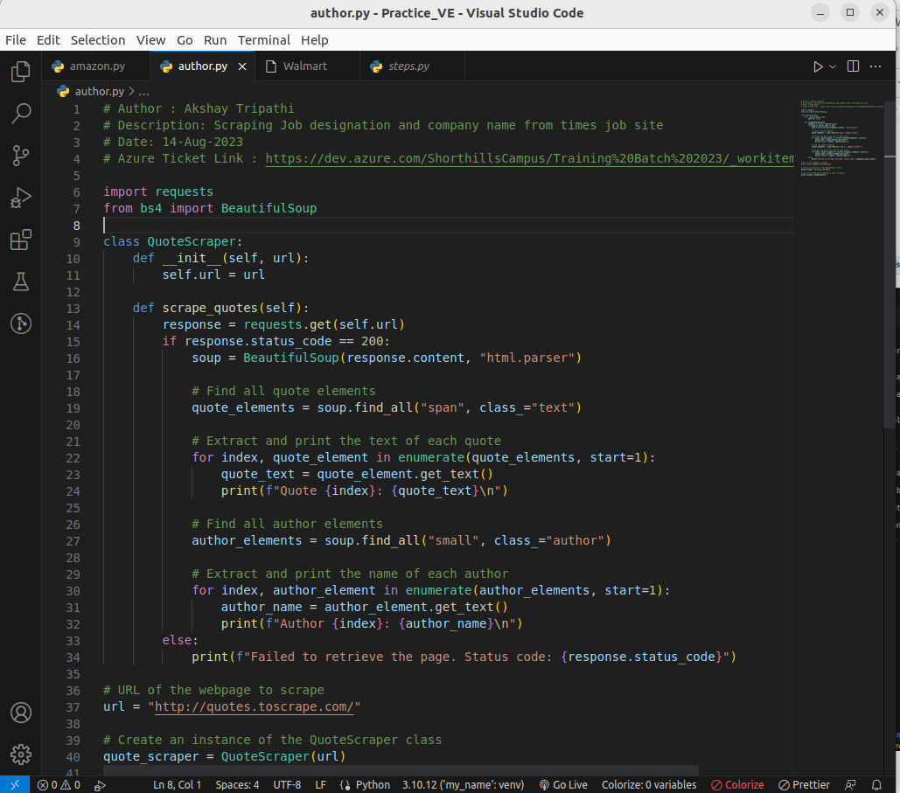
This code defines a class QuoteScraper that is used to scrape quotes and author names from the specified URL. It utilizes the requests library to retrieve the web page content and the BeautifulSoup library to parse the HTML content. The code then finds quote elements and author elements in the parsed HTML and extracts and prints their content.

Output:
