QA-1

Introduction to Quality Assurance (QA):
Quality Assurance, often abbreviated as QA, is a systematic process that ensures the quality of products and services. In various industries, including software development, QA focuses on maintaining high standards and preventing defects from occurring in the first place. QA encompasses strategies, methodologies, and practices that lead to the creation of reliable, consistent, and top-notch products.

Introduction to Software Testing:
Software Testing is a key component of QA. It's the process of evaluating a software application to identify whether it meets specified requirements and functions as intended. Testing helps to uncover defects or issues that might exist in the software, ensuring that it works correctly and reliably.

Why Software Testing is Important:
Software Testing is essential for several reasons:
- Quality Assurance: Testing ensures that the software functions as expected and meets user requirements, leading to high-quality products.
- Risk Reduction: Thorough testing reduces the risk of software failures, data loss, and security breaches.
- Customer Satisfaction: Quality software leads to happy customers who can rely on the product's performance.
- Cost Savings: Identifying and fixing defects early in the development process is more cost-effective than fixing them after deployment.
- Credibility: Rigorous testing enhances the credibility and reputation of the product and the organization.

Testing Throughout the Software Development Lifecycle:
Software testing occurs throughout the development lifecycle:
1. Requirements Phase: Ensuring that requirements are clear, complete, and testable.
2. Design Phase: Checking whether the design meets the requirements and doesn't introduce new issues.
3. Implementation Phase: Testing individual components and functions.
4. Integration Phase: Verifying the interactions between different components.
5. System Testing: Testing the complete application as a whole.
6. User Acceptance Testing (UAT): Evaluating whether the software meets user expectations.
7. Maintenance Phase: Continuously testing to address new changes and updates.

What is Postman?
Postman is a powerful tool designed to simplify the process of developing, testing, and documenting APIs (Application Programming Interfaces). APIs enable different software components to communicate and interact with each other. Postman provides a user-friendly interface for making API requests, testing endpoints, and analyzing responses.

Role of Postman in Software Testing:
Postman plays a crucial role in software testing, especially in the realm of API testing. Here's how it contributes:

1. API Testing: Postman allows testers and developers to send API requests and receive responses, making it a valuable tool for testing the functionality and behavior of APIs.

2. Functional Testing: You can create and execute test scripts to validate whether APIs are performing the expected functions and returning the correct data.

3. Automation: Postman provides automation capabilities, enabling the creation of test suites that can be executed automatically, saving time and effort in repetitive testing.

4. Data Validation: You can validate the data returned by APIs to ensure that it meets specified criteria and is consistent with expectations.

5. Response Analysis: Postman provides a visual representation of API responses, making it easier to identify any anomalies or discrepancies.

6. Collaboration: Teams can collaborate on API testing by sharing Postman collections, which contain request definitions and test scripts.

7. Documentation: Postman allows the creation of API documentation, making it easier for developers to understand how to use APIs effectively.

Getting Started with Postman:
To get started with Postman, you'll need to:
1. Download and Install: Visit the official Postman website, download the application, and install it on your system.
2. Create Requests: Start by creating API requests using the user-friendly interface. Define the HTTP method (GET, POST, etc.), endpoint URL, and any necessary headers or parameters.
3. Send Requests: Execute the requests to interact with the API and receive responses.
4. Validation: Set up assertions and tests to validate the responses, ensuring they meet your expectations.
5. Automation: As you become more comfortable with Postman, explore its automation features to streamline your testing efforts.

Postman's versatility makes it an invaluable tool for both manual and automated testing of APIs. It's particularly useful for verifying API endpoints, testing data integration, and ensuring seamless communication between different software components.

Would you like more information about installing Postman or any specific aspects of its role in testing? If not, we can move on to the next topic.

Installing and setting up postman:

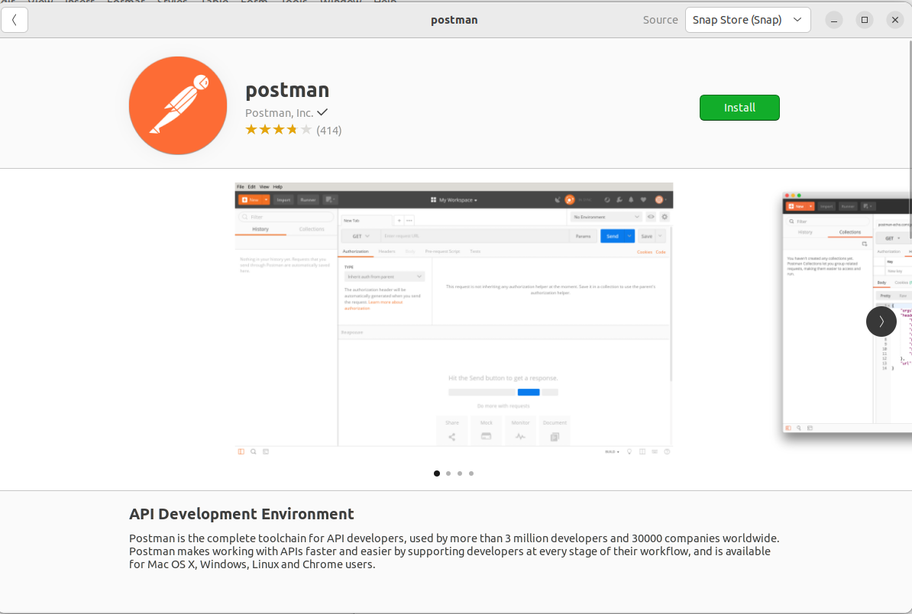
.Create an Account:
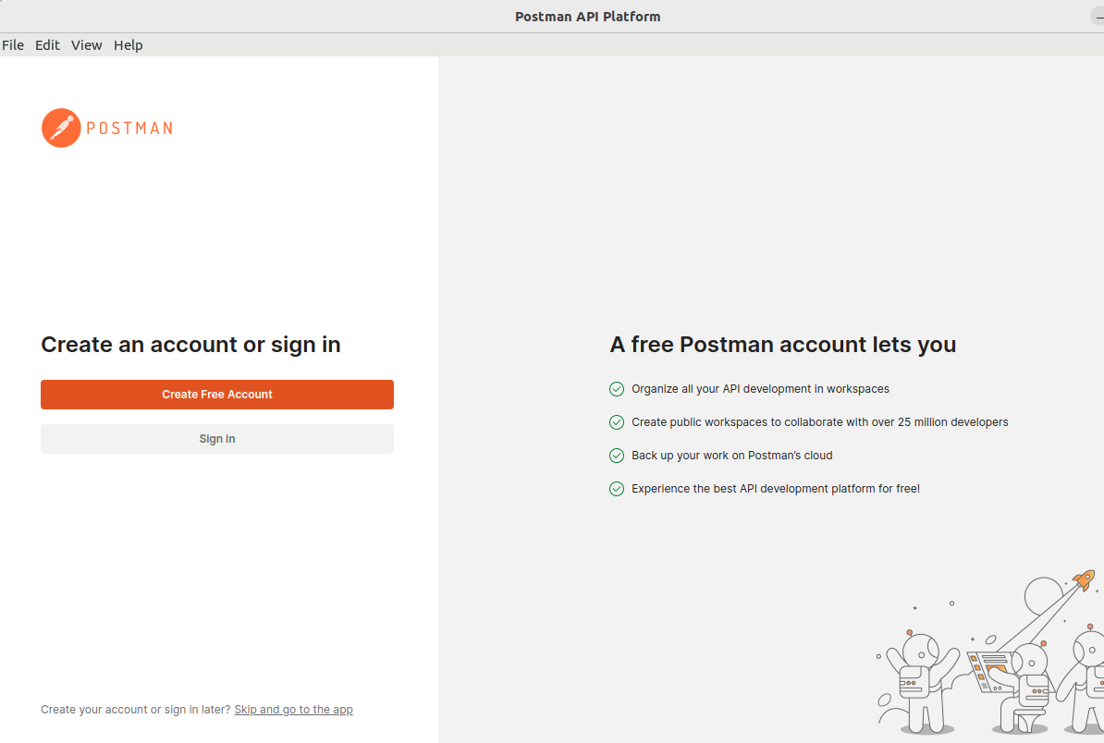
.
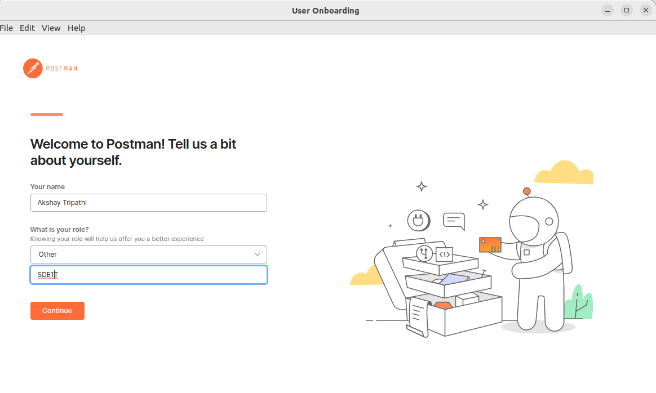
.
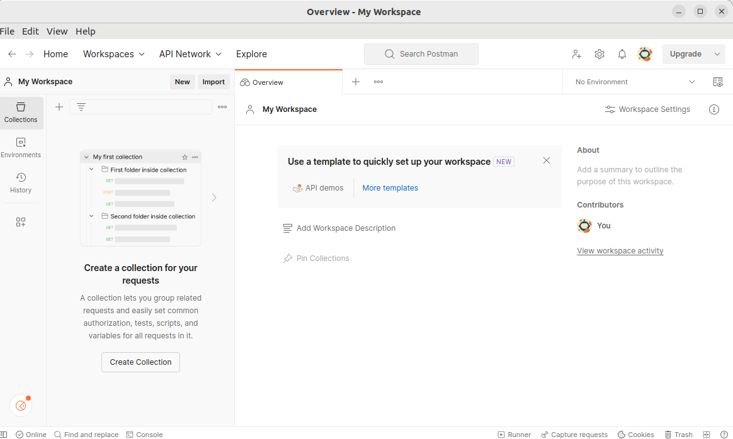
.

Fundamentals of Software Testing.

Effective testing is guided by several principles that contribute to the quality assurance process:

You've provided an organized list of the principles and concepts related to effective software testing. Let's briefly discuss each of these principles:

1. Detecting Defects through Testing:
This principle emphasizes that testing is primarily aimed at identifying defects rather than proving the absence of defects. Successful testing uncovers unknown bugs, and its main purpose is to ensure a reliable and functional software product.

2. Limitations of Exhaustive Testing:
Exhaustive testing, which involves testing all possible combinations of inputs and scenarios, is practically unachievable for complex software. Prioritization is key, focusing on critical areas to achieve comprehensive coverage efficiently.

3. Early Testing Benefits:
Early testing, starting in the initial stages of development, helps identify defects sooner and reduces the cost of fixing them. It also ensures that the software aligns with the correct requirements from the outset.

4. Defect Clustering Concept:
Defects tend to cluster around specific modules or components of software. This concept highlights the importance of focusing testing efforts on these critical areas where most defects are likely to be found.

5. The Pesticide Paradox:
Repeating the same set of tests can lead to overlooking new defects. To overcome this, testing strategies must be periodically reviewed and refreshed to catch different types of defects.

6. Context-Dependent Testing:
Testing approaches are tailored to the specific context of the software application. Different types of applications require varying testing techniques, taking into account their unique features and functionalities.

7. Avoiding the Absence of Error Fallacy:
Identifying and fixing defects doesn't guarantee that the software is free from issues. The software could be bug-free according to known defects but still fail to meet requirements due to incorrect or impractical specifications.

8. Advantages of Thorough Software Testing:
Thorough testing results in higher software quality, reduced risks, and enhanced user satisfaction. It helps identify defects early in the development process, saving time and costs.

9. Recognizing the Limitations of Software Testing:
While testing is crucial, it's not a guarantee of defect-free software. It's impossible to test every scenario exhaustively, and certain defects might remain undetected until deployment.

Advantages of Software Testing:
Thorough software testing offers several benefits:

1. Higher Quality: Testing ensures that the software meets specified standards and functions correctly, enhancing its quality.

2. Risk Reduction: Identifying and addressing defects early minimizes the risk of issues occurring post-deployment.

3. Customer Satisfaction: Quality software leads to satisfied users who can rely on consistent performance.

4. Cost Savings: Fixing defects early in the development cycle is more cost-effective than after deployment.

5. Credibility: Well-tested software builds trust among users and stakeholders.

Limitations of Software Testing:
While testing is essential, it also has limitations:

1. Cannot Prove Absence of Defects: Testing can't prove that there are no defects; it can only uncover the defects present in the tested scenarios.

2. Limited Scope: It's impossible to test all possible combinations of inputs and scenarios.

3. Dependence on Testers: Testing effectiveness relies on the skills and experience of testers.

4. Subjectivity: Some testing decisions can be subjective, leading to variations in testing outcomes.

Understanding these fundamentals provides a solid foundation for approaching software testing effectively.

Is there anything specific within the fundamentals of software testing that you would like to explore further or have questions about? If not, we can proceed to the next topic.

Advantages and Disadvantages of Software Testing.

Advantages of Software Testing:

1. Enhanced Quality: Thorough testing results in higher software quality, meeting user expectations and requirements.

2. Risk Reduction: Early defect identification and mitigation minimize the risk of post-deployment failures.

3. Cost Savings: Addressing issues during development is more cost-effective than fixing them after release.

4. Customer Satisfaction: Reliable software fosters user trust and satisfaction.

5. Credibility: Rigorous testing enhances the organization's reputation for delivering quality products.

Disadvantages of Software Testing:

1. Time-Consuming: Comprehensive testing requires time and resources, potentially delaying project timelines.

2. Complexity: In complex systems, testing all possible scenarios can be challenging.

3. Human Error: Testing outcomes can be influenced by human bias and oversight.

4. Limited Coverage: It's impossible to test every possible combination of inputs and scenarios.

5. False Sense of Security: Passing all tests doesn't guarantee a defect-free product.

Types of Software Testing.

Functional Testing:
Functional testing assesses whether the software functions as intended and meets specified requirements. It ensures that the software performs its intended functions accurately.

Non-Functional Testing:
Non-functional testing focuses on aspects beyond functionality, such as performance, security, usability, and scalability. It ensures that the software meets quality standards beyond basic functionality.

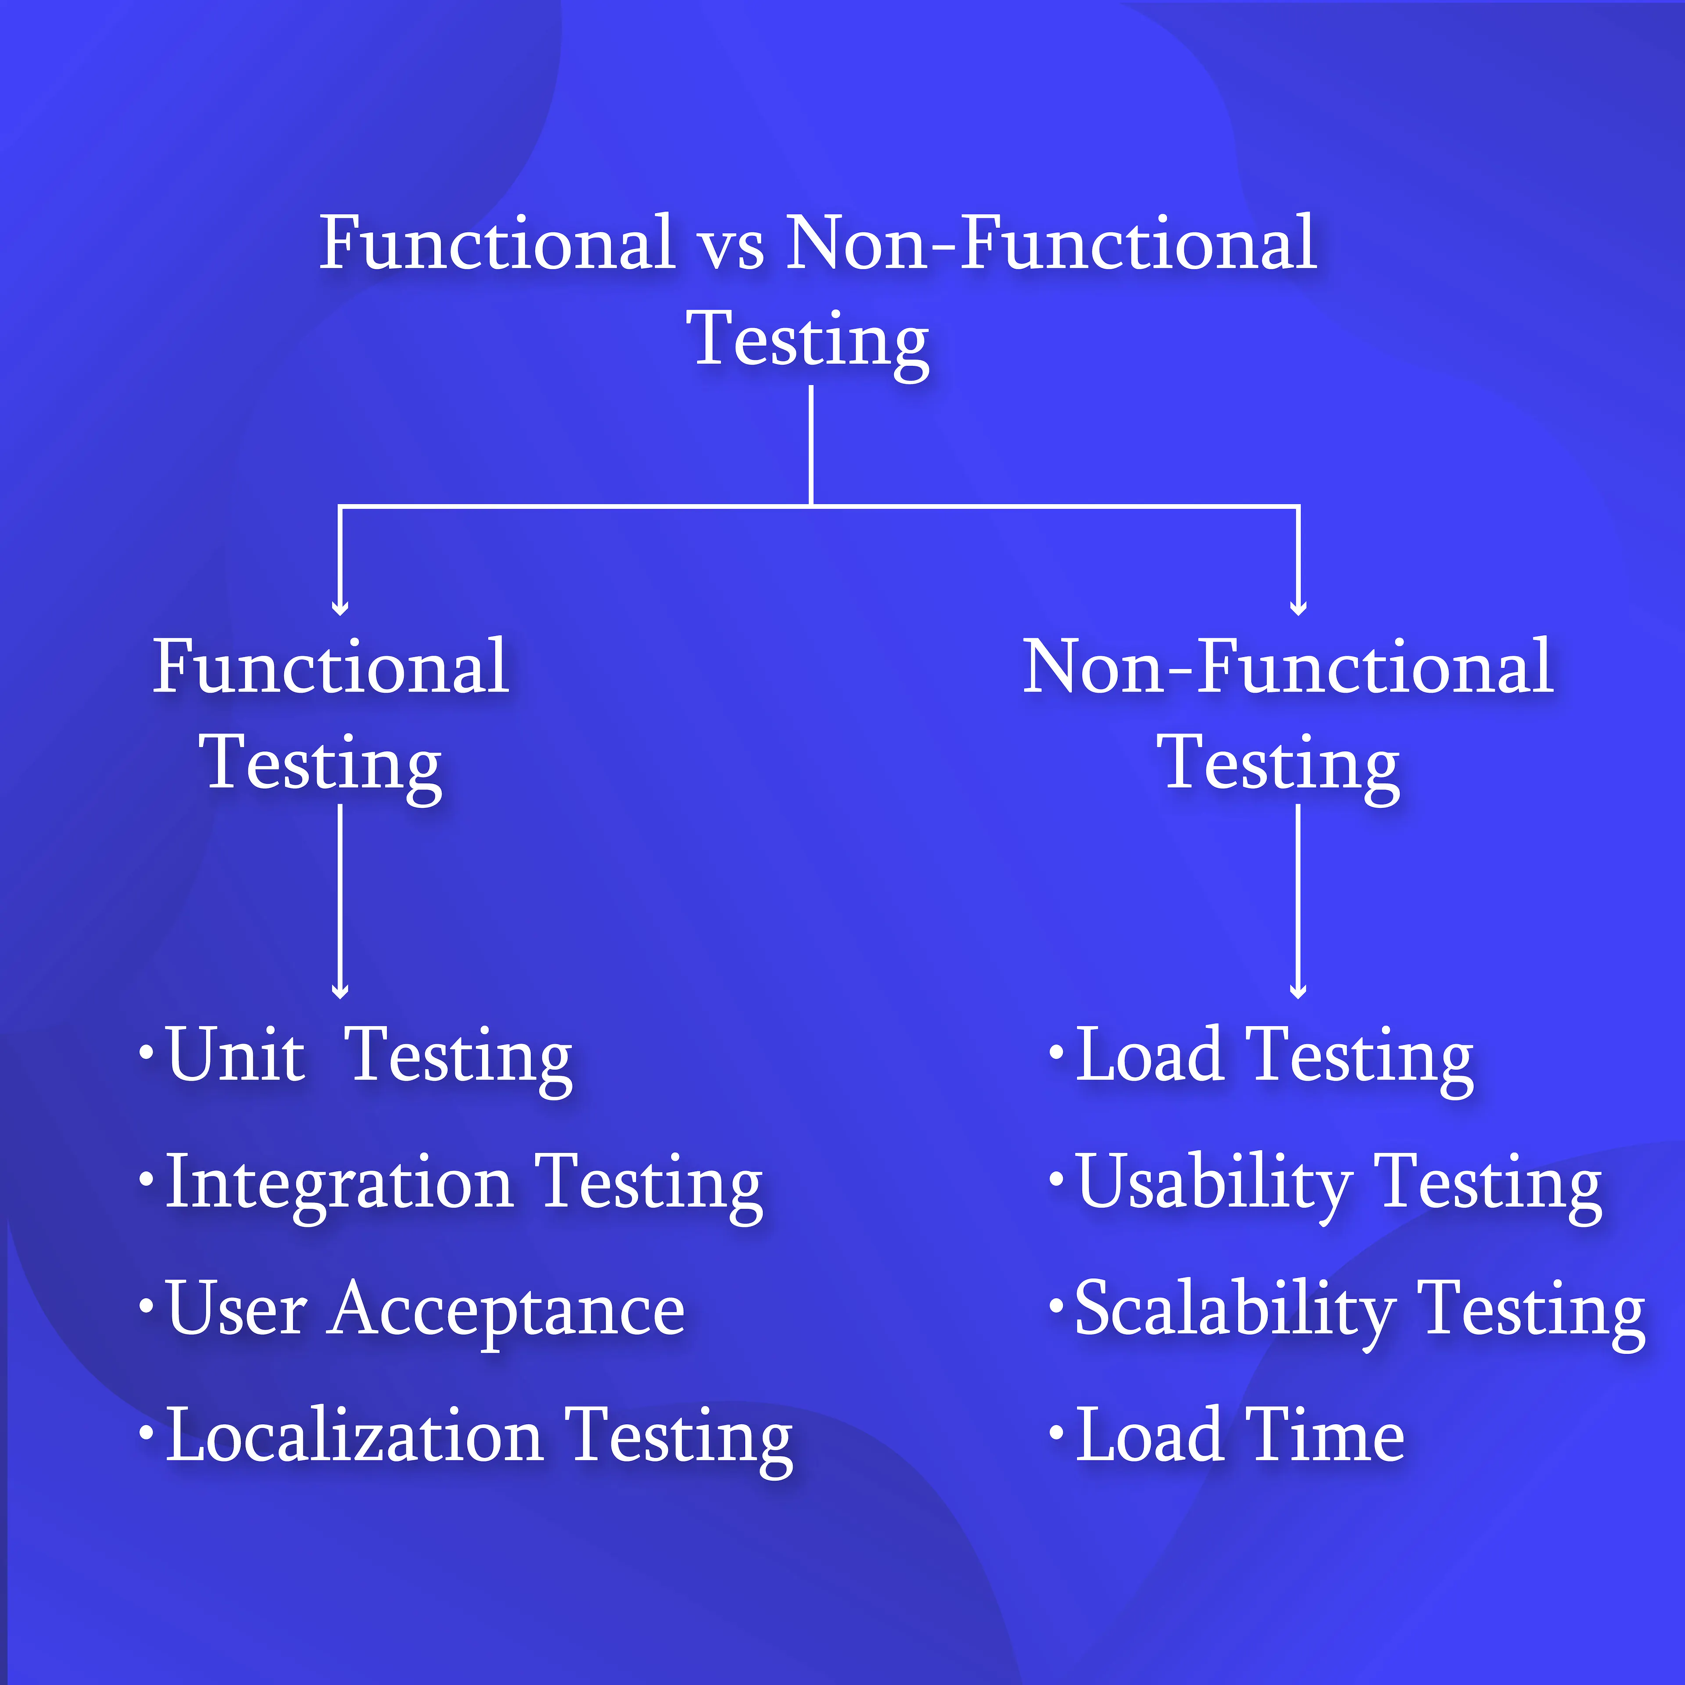
.

Functional Testing:

Goal of Functional Testing:
The primary goal of functional testing is to validate that the software's functions work as expected and deliver the intended outcomes.

Process of Functional Testing:
Functional testing involves several steps:

1. Test Case Creation: Testers create test cases based on the software's requirements and functionalities.

2. Test Execution: The test cases are executed by performing actions in the software, such as inputting data or interacting with user interfaces.

3. Comparison of Results: The actual results are compared with the expected outcomes to identify discrepancies.

4. Defect Reporting: If any differences are found, defects are reported for developers to address.

5. Regression Testing: After defects are fixed, regression testing is performed to ensure that new changes haven't caused unintended issues in existing functionality.

Functional testing ensures that individual components and the software as a whole function cohesively to deliver the desired user experience.

Absolutely, let's delve deeper into functional testing, including its objectives and the steps involved in the process.

Objectives of Functional Testing:
The objectives of functional testing are centered around ensuring that the software's individual components and features operate as intended:

1. Validation of Requirements: Functional testing verifies that the software's functionalities align with the specified requirements.

2. Detection of Defects: By executing various scenarios, functional testing aims to identify defects, errors, and deviations from expected behavior.

3. Ensuring Correct Behavior: It confirms that the software's functions perform accurately and deliver the intended outcomes.

4. Data Integrity: Functional testing assesses the correctness and integrity of data processing within the software.

5. User Experience: It ensures that user interfaces, workflows, and interactions provide a seamless and intuitive experience.

Steps Involved in the Functional Testing Process:
The functional testing process typically consists of the following steps:

1. Requirement Analysis: Understand and analyze the software's requirements and functionalities to formulate effective test cases.

2. Test Case Design: Create detailed test cases based on various scenarios, inputs, and expected outcomes.

3. Test Environment Setup: Set up the necessary test environment, including hardware, software, and configurations.

4. Test Execution: Execute the test cases by interacting with the software's user interfaces and functionalities.

5. Result Comparison: Compare the actual results generated by the software with the expected outcomes defined in the test cases.

6. Defect Reporting: If any discrepancies are identified, report defects to the development team with detailed information for resolution.

7. Defect Verification: After developers address reported defects, verify that the fixes have been successfully implemented.

8. Regression Testing: Re-run functional tests to ensure that newly fixed defects haven't caused unintended issues in other areas.

9. Test Closure: Conclude the functional testing phase by assessing whether the software's functionalities meet the required standards.

Functional testing is integral to the development process as it validates the software's core features and contributes to delivering a high-quality product that aligns with user expectations.

Non-Functional Testing:
Non-functional testing focuses on evaluating the attributes of a software application beyond its basic functionality. It assesses various aspects of the software's performance, security, usability, and more.

Common Types of Non-Functional Testing:

1. Performance Testing:
Load Testing: Measures how the software performs under expected load conditions.
Stress Testing: Evaluates the software's performance under extreme conditions that exceed normal load.
Scalability Testing: Assesses the software's ability to handle increased load and traffic.

2. Security Testing:
Vulnerability Testing: Identifies potential security vulnerabilities and weaknesses.
Penetration Testing: Simulates real-world attacks to uncover vulnerabilities and weaknesses.
Authentication and Authorization Testing: Ensures that access controls and permissions are working as intended.

3. Usability Testing:
User Interface Testing: Assesses the usability and user-friendliness of the software's interface.
User Experience Testing: Evaluates the overall experience of users while interacting with the software.

4. Compatibility Testing:
Device Compatibility Testing: Checks the software's compatibility across different devices and platforms.
Browser Compatibility Testing: Ensures the software functions correctly on various web browsers.

5. Reliability Testing:
Stability Testing: Measures the software's stability over an extended period.
Recovery Testing: Evaluates how well the software recovers from crashes and failures.

6. Availability Testing:
High Availability Testing: Assesses the software's availability and responsiveness under normal and peak conditions.
Failover Testing: Tests the software's ability to switch to backup systems in case of failure.

7. Accessibility Testing:
ADA Compliance Testing: Ensures that the soware is accessible to users with disabilities as per accessibility standards.

Non-functional testing guarantees that the software meets quality standards beyond basic functionality and provides a satisfying user experience while maintaining security and performance.

