QA-2
NON FUNCTIONAL TESTING AND MAINTENANCE

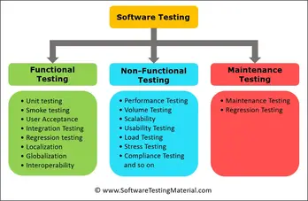

NON FUNCTIONAL TESTING

Non-functional Testing is a method of software testing that examines a software application's non-functional attributes (productivity, compatibility, functionality, and many more). It is intended to assess a system's preparation based on nonfunctional conditions that never get covered by functional tests.

A good example of a non-functional test is seeing how many users would sign into a program at the same time.

1. Performance Testing

Performance testing evaluates the responsiveness, speed, stability, and overall performance of a system under different conditions. It helps identify bottlenecks and performance issues, ensuring that the software can handle expected workloads.

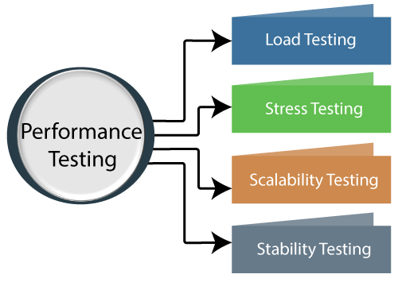
.

Load Testing: Load testing involves simulating a realistic user load on the application to assess how well it performs under expected levels of usage. This helps identify performance bottlenecks and degradation as the load increases.

Stress Testing: Stress testing, as mentioned earlier, evaluates how the application behaves under extreme conditions that go beyond its regular capacity. The goal is to understand breaking points and potential failure scenarios.

Scalability testing is a type of performance testing that assesses how well a software application can handle increased workloads, transactions, or user interactions as demand grows. The primary goal of scalability testing is to determine whether the application can scale up its resources (such as servers, databases, and network capacity) to accommodate higher user loads while maintaining acceptable performance levels.

Stability testing is a type of non-functional testing that assesses the stability and robustness of a software application by subjecting it to various unfavorable conditions. The primary objective is to determine how well the application can handle stress, unexpected inputs, and adverse scenarios without crashing, freezing, or showing abnormal behavior.

2. Endurance Testing

Endurance testing (also known as soak testing) involves subjecting the system to a sustained load over an extended period. The goal is to identify any degradation in performance or potential memory leaks that might occur over time.

3. Load Testing

Load testing assesses how a system performs under various levels of user load or concurrent users. It helps determine the system's maximum capacity and identifies performance issues under heavy loads.

4. Volume Testing

Volume testing verifies how the system performs when dealing with a large amount of data. This type of testing assesses whether the software can handle data growth without performance degradation or data loss.

5. Scalability Testing

Scalability testing assesses the software's ability to scale up or down as the load or demand changes. It ensures that the system can handle increased workloads effectively by adding resources like servers or network capacity.

6. Usability Testing

Usability testing focuses on the user experience and evaluates how easy the software is to use. Testers assess factors such as user interface design, navigation, and user satisfaction. The goal is to ensure that the software is user-friendly and meets user expectations.

MAINTENANCE
1. Regression Testing
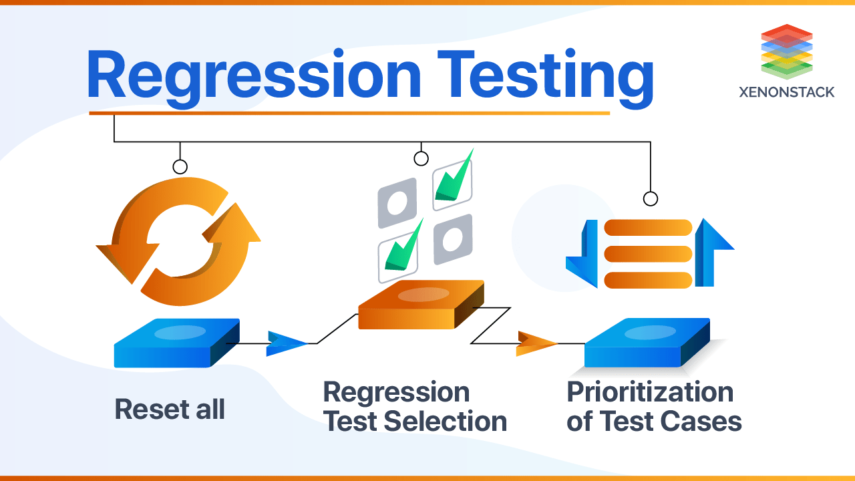
Regression testing is a type of testing that ensures that recent code changes or updates to a software application do not adversely affect its existing functionality. As software evolves through maintenance, bug fixes, feature additions, and other changes, there's a risk that new modifications might unintentionally introduce bugs or regressions in previously working features.

Regression testing involves re-running test cases that cover the core functionalities of the software to verify that everything still works as intended. Automated testing is often used for regression testing because it can quickly and consistently execute a large number of test cases every time there's a code change.

The goal of regression testing is to catch and address any unexpected side effects of code changes early in the development or maintenance process, preventing the introduction of new issues.

2. Maintenace
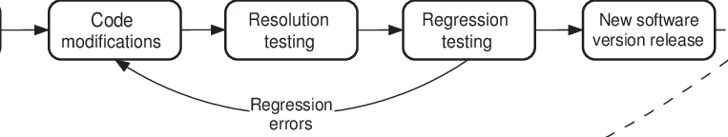
In the context of software, maintenance encompasses ongoing activities to keep the software in good working condition and aligned with changing requirements. While I mentioned different types of maintenance (corrective, adaptive, perfective, and preventive) in my previous response, I'll elaborate further on the concept:

Corrective Maintenance

This involves fixing bugs, defects, and errors in the software that are identified during the software's use. Corrective maintenance ensures that the software remains functional and reliable.
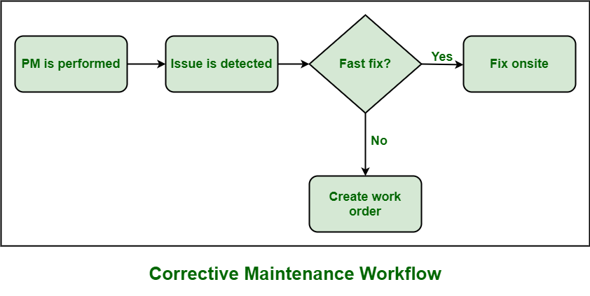
cm is maintenance strategy that is used to correct something in its normal working condition. Whenever any equipment or asset gets failed, one needs to identify main problem and then make decision regarding whether particular equipment should require either repair or replacement. CM is a type of maintenance strategy that is generally required when an asset i.e. equipment, component, part of equipment, etc. gets failed or stops working or gets damaged, simply to bring assets back to their normal working condition.

Advantages of Corrective Maintenance :

- Improves software quality: Corrective maintenance can help improve software quality by identifying and fixing bugs, errors, and defects in the software code. This can lead to a more stable, reliable, and efficient software product.
- Enhances user satisfaction: Corrective maintenance can help enhance user satisfaction by addressing bugs or issues that impact the user experience. This can lead to higher user adoption and better customer feedback.
- Minimizes the risk of downtime: Corrective maintenance can help minimize the risk of downtime by fixing issues that could potentially cause the software to crash or malfunction. This can help improve the overall reliability of the software system.
- Reduces the cost of maintenance: Corrective maintenance can help reduce the cost of maintenance by only addressing issues when they actually occur. This can help save time and resources that would otherwise be spent on unnecessary maintenance activities.

Disadvantages of Corrective Maintenance :

- Increased downtime: Corrective maintenance involves fixing equipment or software after a fault has occurred, which can lead to increased downtime and reduced productivity. This can be especially problematic for critical equipment or systems.
- Higher costs: Corrective maintenance can be more expensive than preventive maintenance or predictive maintenance, it involves repairing or replacing equipment or software that has already failed.
- Reduced safety: Corrective maintenance can increase safety risks if equipment or software malfunctions before the corrective maintenance can be performed. This can be especially problematic in safety-critical systems.
- Difficult to plan: Corrective maintenance can be difficult to plan, as it is based on when failures occur rather than a predetermined maintenance schedule. This can make it challenging to budget for and schedule maintenance activities.

- Adaptive Maintenance: Adaptive maintenance involves modifying the software to accommodate changes in the external environment. This could include updates to support new operating systems, hardware configurations, or third-party integrations.

- Perfective Maintenance: Perfective maintenance focuses on enhancing the software to improve its performance, efficiency, or user experience. This might involve optimizing code, adding new features, or making changes based on user feedback.

- Preventive Maintenance: Preventive maintenance aims to proactively identify and address potential issues before they become major problems. This can involve regular code reviews, refactoring, and keeping the software up to date with security patches.

Maintenance is an ongoing process throughout the software's lifecycle to ensure its longevity, reliability, and alignment with user needs and industry standards.

Both regression testing and maintenance play critical roles in the software development and maintenance processes. Regression testing helps prevent the introduction of new issues, while maintenance activities ensure the software's continued functionality and relevance over time.

