QA-3
Software Testing Methodology

1. SDLC and STLC:

- SDLC (Software Development Life Cycle): SDLC is the process used to design, develop, test, and deploy software applications. It's a systematic approach that involves various phases, such as requirements gathering, design, development, testing, deployment, and maintenance. SDLC provides a framework for teams to follow while building and delivering software.
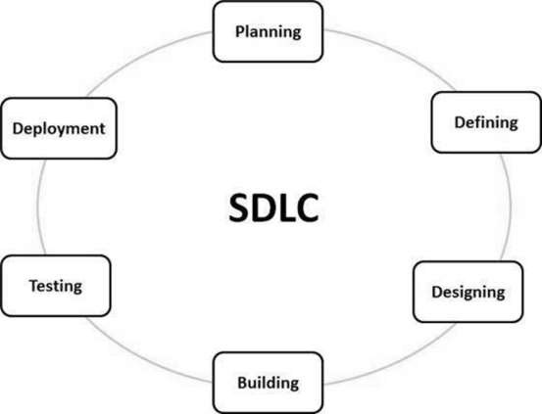
.
Stage 1: Planning and Requirement Analysis
Requirement analysis is the most important and fundamental stage in SDLC. It is performed by the senior members of the team with inputs from the customer, the sales department, market surveys and domain experts in the industry. This information is then used to plan the basic project approach and to conduct product feasibility study in the economical, operational and technical areas.

Stage 2: Defining Requirements
Once the requirement analysis is done the next step is to clearly define and document the product requirements and get them approved from the customer or the market analysts. This is done through an SRS (Software Requirement Specification) document which consists of all the product requirements to be designed and developed during the project life cycle.

Stage 3: Designing the Product Architecture
SRS is the reference for product architects to come out with the best architecture for the product to be developed. Based on the requirements specified in SRS, usually more than one design approach for the product architecture is proposed and documented in a DDS - Design Document Specification.

This DDS is reviewed by all the important stakeholders and based on various parameters as risk assessment, product robustness, design modularity, budget and time constraints, the best design approach is selected for the product.

A design approach clearly defines all the architectural modules of the product along with its communication and data flow representation with the external and third party modules (if any). The internal design of all the modules of the proposed architecture should be clearly defined with the minutest of the details in DDS.

Stage 4: Building or Developing the Product
In this stage of SDLC the actual development starts and the product is built. The programming code is generated as per DDS during this stage. If the design is performed in a detailed and organized manner, code generation can be accomplished without much hassle.

Developers must follow the coding guidelines defined by their organization and programming tools like compilers, interpreters, debuggers, etc. are used to generate the code. Different high level programming languages such as C, C++, Pascal, Java and PHP are used for coding. The programming language is chosen with respect to the type of software being developed.

Stage 5: Testing the Product
This stage is usually a subset of all the stages as in the modern SDLC models, the testing activities are mostly involved in all the stages of SDLC. However, this stage refers to the testing only stage of the product where product defects are reported, tracked, fixed and retested, until the product reaches the quality standards defined in the SRS.

Stage 6: Deployment in the Market and Maintenance
Once the product is tested and ready to be deployed it is released formally in the appropriate market. Sometimes product deployment happens in stages as per the business strategy of that organization. The product may first be released in a limited segment and tested in the real business environment (UAT- User acceptance testing).

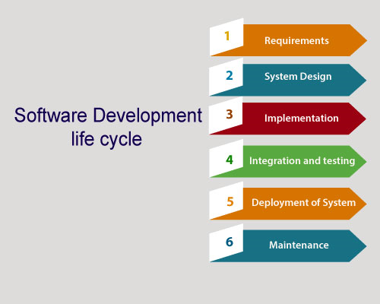
STLC (Software Testing Life Cycle)STLC is a subset of the SDLC and focuses specifically on the testing phases of software development. It outlines the process of planning, designing, executing, and evaluating tests to ensure the quality of the software product.

-STLC is an integral part of Software Development Life Cycle (SDLC). But, STLC deals only with the testing phases.

2. Different STLC Phases and Their Application:

The STLC phases can vary based on the specific methodology or framework being used, but here's a general breakdown:

- Requirement Analysis: Understanding and analyzing the requirements to define testing objectives, scope, and strategy.

- Test Planning: Creating a comprehensive test plan that outlines testing scope, objectives, resources, schedules, and risks.

- Test Case Development: Designing detailed test cases that specify test inputs, expected outcomes, and execution steps.

- Test Environment Setup: Preparing the necessary hardware, software, and test data to create a stable testing environment.

- Test Execution: Executing test cases, recording results, and reporting defects or issues.

- Defect Reporting and Tracking: Documenting and tracking defects found during testing, working with developers to resolve them.

- Regression Testing: Re-executing tests to ensure that new code changes haven't introduced new defects.

- Test Cycle Closure: Summarizing testing activities, evaluating the quality of the software, and preparing testing artifacts for future projects.

3. Requirement Analysis:

In the requirement analysis phase, testers work closely with stakeholders to understand the software requirements, functionalities, and user expectations. This phase helps define the scope of testing and establish testing goals.

4. Test Planning:

Test planning involves creating a detailed test plan that outlines the testing strategy, objectives, scope, resources, schedule, and risks. It ensures that testing activities are organized and aligned with project goals.

5. Test Case Development:

Test case development is the process of designing detailed test cases that describe various scenarios and conditions to be tested. Each test case includes inputs, expected outcomes, and steps to be executed.

6. Test Environment Setup:

Creating a stable and representative test environment is essential for accurate testing. This phase involves setting up the necessary hardware, software, and configurations to mimic the production environment as closely as possible.

7. Test Execution:

In the test execution phase, testers run the prepared test cases, record test results, and report defects. This phase involves actual interaction with the software to validate its functionality.

8. Test Cycle Closure:

After completing the test execution, the test cycle closure phase involves summarizing testing activities, evaluating the quality of the software, and preparing documentation and reports for stakeholders.

9. Entry and Exit Criteria in STLC:

- Entry Criteria: Entry criteria define the conditions that must be satisfied before a testing phase can begin. These conditions include factors like availability of requirements, a stable test environment, necessary test data, and a well-defined test plan.

- Exit Criteria: Exit criteria define the conditions that must be met for a testing phase to be considered complete and for the project to move to the next phase. Exit criteria might include the execution of a certain number of test cases, a certain percentage of defects fixed, and a stable application build.

Both entry and exit criteria ensure that testing activities are well-structured and that testing phases are aligned with the project's progress and goals.

These concepts collectively contribute to a structured and efficient software testing process, ensuring that the software meets quality standards and user expectations.

Agile Methodology

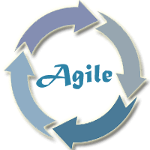

Introduction and Uses:
Agile is a software development methodology that emphasizes flexibility, collaboration, and incremental development. It prioritizes delivering small, functional increments of software quickly, with the ability to adapt to changing requirements and feedback throughout the development process. Agile methodologies promote iterative development cycles, continuous improvement, and close collaboration between development teams and stakeholders.
An agile methodology is an iterative approach to software development. Each iteration of agile methodology takes a short time interval of 1 to 4 weeks. The agile development process is aligned to deliver the changing business requirement. It distributes the software with faster and fewer changes.

The single-phase software development takes 6 to 18 months. In single-phase development, all the requirement gathering and risks management factors are predicted initially.
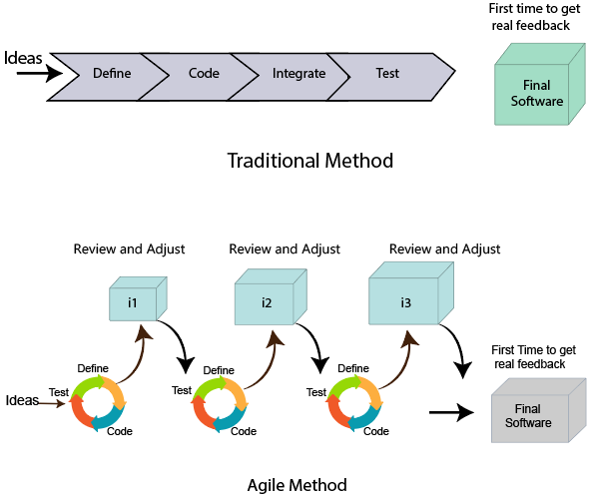
Agile methodologies are particularly useful in situations where requirements are dynamic, customer feedback is essential, and the ability to deliver quickly is important. They are widely used in software development but can also be applied in various other industries where adapting to change is crucial.

Roles in Agile
There are two different roles in a Agile methodology. These are the Scrum Master and Product Owner.

1. Scrum Master
The Scrum Master is a team leader and facility provider who helps the team member to follow agile practices, so that the team member meets their commitments and customers requirements. The scrum master plays the following responsibilities:
- They enable the close co-operation between all the roles and functions.
- They remove all the blocks which occur.
- They safeguard the team from any disturbances.
- They work with the organization to track the progress and processes of the company.
- They ensure that Agile Inspect & Adapt processes are leveraged correctly which includes
  - Planned meetings
  - Daily stand-ups
  - Demo
  - Review
  - Retrospective meetings, and
  - Facilitate team meetings and decision-making process.

2. Product Owner
The Product Owner is one who runs the product from a business perspective. The Product Owner plays the following responsibilities:
- He defines the requirements and prioritizes their values.
- He sets the release date and contents.
- He takes an active role in iteration and releasing planning meetings.
- He ensures that the team is working on the most valued requirement.
- He represents the voice of the customer.
- He accepts the user stories that meet the definition of done and defined acceptance criteria.

Agile vs Waterfall Model:
Agile stands in contrast to the traditional Waterfall model. In the Waterfall model, development progresses linearly through stages like requirements gathering, design, development, testing, and deployment, with each stage completed before moving to the next. In contrast, Agile methods involve shorter development cycles, frequent releases, and the ability to revisit and adjust work throughout the project.

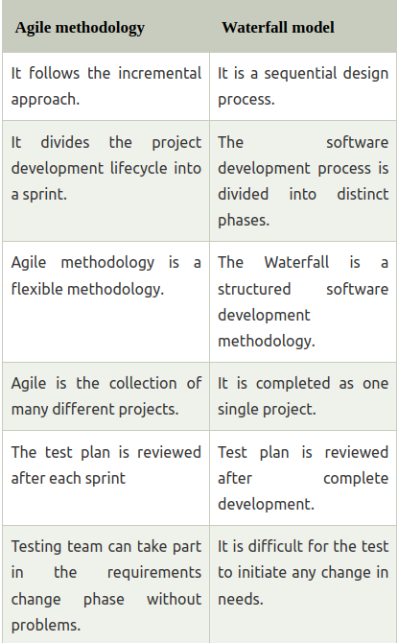

Advantages of Agile Methodology

There are various advantages of using agile methodology over traditional waterfall model or others. Agile development methodology and testing practices have worked wonders for numerous organizations with positive aspects. Its positive aspects are not hidden, it is very much visible in the organization.
Advantages of Agile Methodology

Customer satisfaction is rapid, continuous development and delivery of useful software.
Customer, Developer, and Product Owner interact regularly to emphasize rather than processes and tools.
Product is developed fast and frequently delivered (weeks rather than months.)
A face-to-face conversation is the best form of communication.
It continuously gave attention to technical excellence and good design.
Daily and close cooperation between business people and developers.
Regular adaptation to changing circumstances.
Even late changes in requirements are welcomed.

Advantage of Agile Methodology
Disadvantages of Agile methodology:

It is not useful for small development projects.
There is a lack of intensity on necessary designing and documentation.
It requires an expert project member to take crucial decisions in the meeting.
Cost of Agile development methodology is slightly more as compared to other development methodology.
The project can quickly go out off track if the project manager is not clear about requirements and what outcome he/she wants.

Advantages of the Waterfall Model:

It is one of the easiest and traditional model to manage. Because of its traditional development nature, each phase has specific deliverables and a review process.
It works well in smaller size projects where requirements are easily understandable.
It has a faster product delivery model.
There are well-documented process and results.
Easily adaptable method for shifting teams
This project management methodology is beneficial to manage dependencies.

Scrum vs Kanban Strategies:
Two popular Agile methodologies are Scrum and Kanban:

- Scrum: Scrum is a framework that organizes work into time-boxed iterations called sprints. Each sprint typically lasts two to four weeks and results in a potentially shippable product increment. Scrum involves roles like Scrum Master, Product Owner, and Development Team. It includes ceremonies like Daily Standup, Sprint Planning, Sprint Review, and Sprint Retrospective.

- Kanban: Kanban is a visual framework that focuses on visualizing work in progress and optimizing flow. It doesn't have fixed iterations like Scrum but emphasizes continuous delivery. Work items move through a Kanban board's columns, reflecting their progress. Kanban is flexible and encourages evolutionary change.

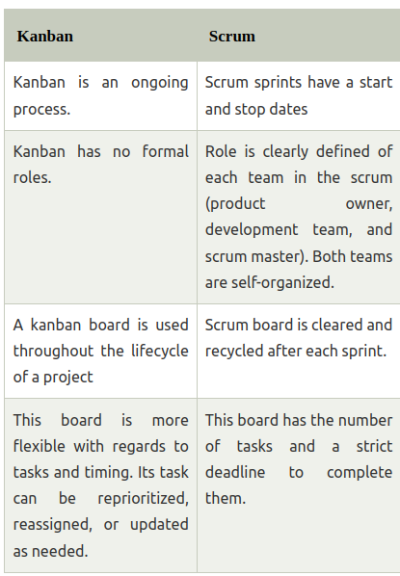

Product Backlog:
The product backlog is a dynamic list of features, enhancements, and fixes that represent the product's requirements. It's maintained by the Product Owner and is prioritized based on value, user needs, and business goals. The backlog evolves as new insights emerge and priorities change.

Agile Product Backlog

The agile product backlog in Scrum is a list of prioritized features. It contains a short description of all the functionalities desired in the product. In usual scenario, items should be broken down into user stories. Commonly, a Scrum team and its product owner write everything that they can think for agile backlog prioritization.
Why Product Backlog is Important?

The backlog is prepared to provide an estimate of each feature.
It helps in the planning of the product's roadmap.
It helps in the re-ranking the features of the product by adding more value to it.
It assists in determining the priority of the product first. The team member works first on the higher prioritize product.

Characteristics of Product Backlog

Each product should have its own product backlog. It can be a set of large to very large features.

Multiple team members can work on a single product backlog.

Ranking of product is based on the technical value, business value, risk management, or strategic fitness.

Highest priorities items are decomposed into smaller stories during release planning. This is because they can be completed in future iterations.
The Product Backlog comprises the following different types of items:

Features
Bugs
Technical work
Knowledge acquisition

Scrum Practices:

1. Sprint Planning:
Sprint Planning is a collaborative meeting that marks the beginning of a sprint. During this meeting, the Scrum Team, including the Product Owner, Scrum Master, and Development Team, comes together to decide which items from the Product Backlog will be worked on during the upcoming sprint.

The main objectives of Sprint Planning include:

- Discussing and clarifying the sprint goal and its scope.
- Selecting user stories or backlog items to be included in the sprint.
- Breaking down the selected items into smaller tasks.
- Estimating the effort required for each task.
- Determining how the work will be accomplished and identifying potential obstacles.

By the end of the Sprint Planning meeting, the Development Team should have a clear understanding of what they will work on during the sprint, and the work items should be well-defined and estimated.

2. Daily Standup (Daily Scrum):
The Daily Standup is a short, time-boxed daily meeting where the Development Team comes together to provide a brief update on their progress. This meeting aims to enhance communication, collaboration, and transparency within the team.

Key aspects of the Daily Standup include:

- Each team member shares:
- What they accomplished since the last standup.
- What they plan to work on until the next standup.
- Any obstacles or impediments they're facing.

- The meeting is kept brief (usually 15 minutes) to maintain focus and prevent lengthy discussions.

The Daily Standup helps the team stay aligned, identify and address issues quickly, and make necessary adjustments to achieve the sprint goal.

3. Sprint Review:
The Sprint Review is held at the end of each sprint and serves as an opportunity for the Development Team to showcase the work they've completed during the sprint. This meeting involves the Scrum Team, stakeholders, and sometimes customers.

Key elements of the Sprint Review include:

- The Development Team presents the completed user stories or backlog items.
- Stakeholders provide feedback on the presented work.
- The Product Owner discusses the product backlog items that were completed and those that remain.

The Sprint Review fosters collaboration, allows stakeholders to provide input, and helps ensure that the product is meeting customer needs and expectations.

4. Sprint Retrospective:
The Sprint Retrospective takes place after the Sprint Review and before the start of the next sprint. This meeting allows the Scrum Team to reflect on their processes and identify opportunities for improvement.

The goals of the Sprint Retrospective include:

- Identifying what went well during the sprint (to continue doing).
- Identifying what could be improved (to start doing or stop doing).
- Discussing potential action items for the next sprint to enhance team effectiveness.

The Sprint Retrospective promotes a culture of continuous improvement and learning, allowing the team to adapt and refine their practices over time.

These Scrum practices are integral to the framework's success, as they promote communication, transparency, collaboration, and adaptability within the Scrum Team and with stakeholders.

