QA-4
Testing Case Development

Test Case Development and Documentation:

Test Cases:
Test cases are detailed instructions or scenarios that outline the steps, data, and conditions required to execute a specific test on a software application. They serve as a guide for testers to validate whether the software behaves as expected under various circumstances.

How to Write Test Cases:
To write effective test cases, follow these steps:

1. Understand the Requirements: Fully comprehend the software's functional requirements or user stories.

2. Identify Test Scenarios: Break down the application into different functionalities or modules, and then identify the scenarios that need to be tested.

3. Define Test Steps: Outline the sequential steps to be followed during the test. Be specific and concise in describing each step.

4. Specify Input Data: Specify the inputs or data required for each step of the test case.

5. Expected Output: Clearly state the expected outcome or result for each step.

6. Preconditions: Mention any prerequisites that must be met before executing the test case.

7. Postconditions: Indicate the state the system should be in after the test case is executed.

8. Notes and Comments: Add any relevant notes, comments, or additional information to enhance understanding.

Test Scenario:
A test scenario is a broader category that encompasses a set of related test cases. It represents a particular functionality or behavior of the software. A test scenario outlines the general aspects to be tested, and individual test cases within that scenario provide specific details.

Enumerate possible users, their actions and objectives.

Evaluate users with hacker's mindset and list possible scenarios of system abuse.

List the system events and how does the system handle such requests.

List benefits and create end-to-end tasks to check them.

Read about similar systems and their behavior.

Studying complaints about competitor's products and their predecessor.

Requirement Traceability Matrix (RTM):
RTM stands for Requirement Traceability matrix. RTM maps all the requirements with the test cases. By using this document one can verify test cases cover all functionality of the application as per the requirements of the customer.

Requirements: Requirements of a particular project from the client.
Traceability: The ability to trace the tests.
Matrix: The data which can be stored in rows and columns form.
The main purpose of the requirement traceability matrix is to verify that the all requirements of clients are covered in the test cases designed by the testers.
In simple words, one can say it is a pen and pencil approach i.e. to analyze the two data information but here just we are using an excel sheet to verify the data in a requirement traceability matrix.
Traceability Matrix
Traceability matrix is a table type document that is used in the development of software application to trace requirements. It can be used for both forward (from Requirements to Design or Coding) and backward (from Coding to Requirements) tracing. It is also known as Requirement Traceability Matrix (RTM) or Cross Reference Matrix (CRM).

It is prepared before the test execution process to make sure that every requirement is covered in the form of a Test case so that we don't miss out any testing. In the RTM document, we map all the requirements and corresponding test cases to ensure that we have written all the test cases for each condition.

The test engineer will prepare RTM for their respective assign modules, and then it will be sent to the Test Lead. The Test Lead will go repository to check whether the Test Case is there or not and finally Test Lead consolidate and prepare one necessary RTM document.

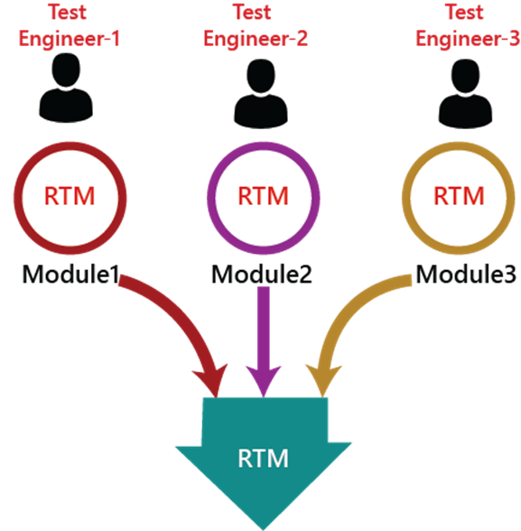
.
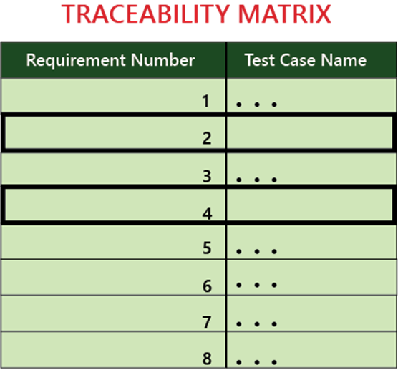

Note:

We go for RTM after approval and before execution so that we don't miss out on any Test Case for any requirement.

We don't write RTM while writing the testing because it can be incomplete, and after writing the test case, we don't go here because the test case can be rejected.

RTM document ensures that at least there is one test case written in each requirement, whereas it does not talk about all possible test cases written for the particular requirement.

RTM Template
Below is the sample template of requirement traceability matrix (RTM):
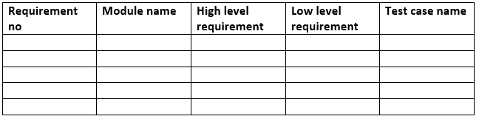
Advantage of RTM
Following are the benefits of requirement traceability matrix:

With the help of the RTM document, we can display the complete test execution and bugs status based on requirements.
It is used to show the missing requirements or conflicts in documents.
In this, we can ensure the complete test coverage, which means all the modules are tested.
It will also consider the efforts of the testing teamwork towards reworking or reconsidering on the test cases.

How to Create a Traceability Matrix in Excel

Creating a traceability matrix in Excel is going to take some time and sleuthing. If you’ve already tracked down the details of which artifacts you want to trace, the process will go much more smoothly.
1. Copy and Paste Requirements From Your Requirements Document

Now it’s time to open up your requirements document and start copying and pasting your requirement IDs into your first column of the traceability matrix template.

This may take a while, depending on how many requirements you have.
2. Copy and Paste Test Cases From Your Test Case Document

Next, you’ll enter your test case IDs into the second column. Test cases should be in the same row as the requirements they are tied to.

This may take a while — especially if your test cases aren’t stored in a central spot.

3. Copy and Paste Test Results and Issues (If You Have Them)

A test implies that a requirement was implemented. So, you’ll also need to have the results of your test runs in your traceability matrix, as well as any issues that may have come up.

You might have test run results tracked in a spreadsheet. And you might have issues in Jira. Both of those will need to be copied over to the traceability matrix — and put in the same row as their related test cases and requirements.

You can indicate whether a test run passed or failed by changing the background color of the cell (e.g., green for passed and red for failed).
4. Update the Traceability Matrix — Constantly

It’s one effort to create a traceability matrix. But it’s a full-time job to keep it updated and do it right.

If a requirement changes, you’ll need to update the traceability matrix. Or there might be requirements you decided not to fulfill — you’ll need a way to indicate that, too. If someone adds a test case, you’ll need to update the matrix. When a test run passes or fails, you’ll need to update it again. If an issue found in testing is resolved, you’ll need to update it yet again.

Remember to keep a close eye on your requirement IDs. Those should stay the same, even if you reorder your requirements list or reuse a requirement.

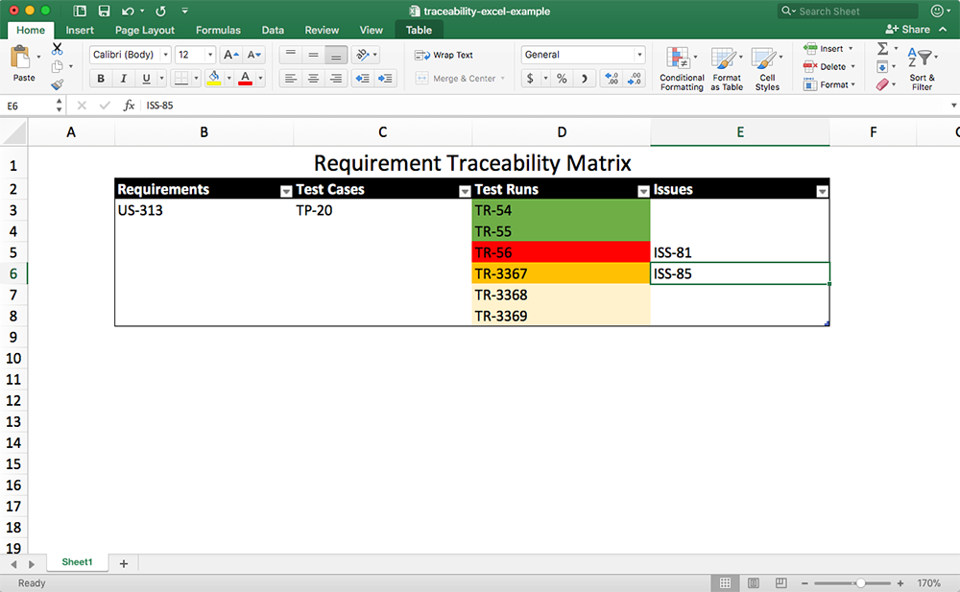
.

Setting Up a Test Bed:
Setting up a test bed involves preparing the environment, tools, configurations, and resources necessary for testing. It's essential to create a controlled environment that closely mimics the production setup.

A test bed configuration refers to the setup and configuration of the environment in which software testing will be conducted. It involves preparing the necessary hardware, software, network connections, and other components to create a controlled and representative testing environment. The goal of test bed configuration is to mimic the real-world conditions as closely as possible to ensure accurate and reliable testing results.

Exercise : RTM of Amazon

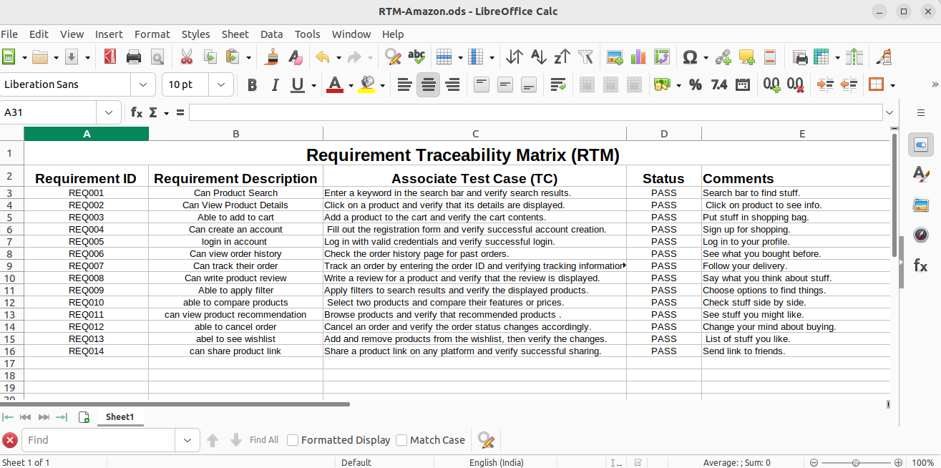
https://shorthillstech-my.sharepoint.com/:x:/g/personal/akshay_tripathi_shorthills_ai/EV5wMvqyzcNNquUqkRG8-7UB81jXebNLzIoQKytz0G7sLA?e=Cvg65X

BASIC API TESTING

API Testing:

API Testing is a software testing type that validates Application Programming Interfaces (APIs). The purpose of API Testing is to check the functionality, reliability, performance, and security of the programming interfaces.

In API Testing, instead of using standard user inputs(keyboard) and outputs, you use software to send calls to the API, get output, and note down the system’s response. API tests are very different from GUI Tests and won’t concentrate on the look and feel of an application. It mainly concentrates on the business logic layer of the software architecture.

API (Application Programming Interface) testing is a type of testing that focuses on testing the interactions and integration points between different software components, often at the code level. It ensures that APIs function as intended, exchange data correctly, and provide expected responses to different inputs.

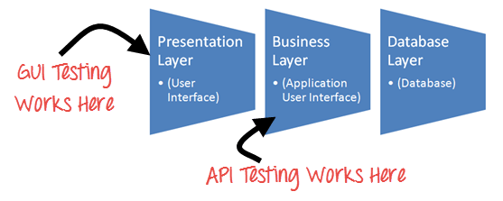
.

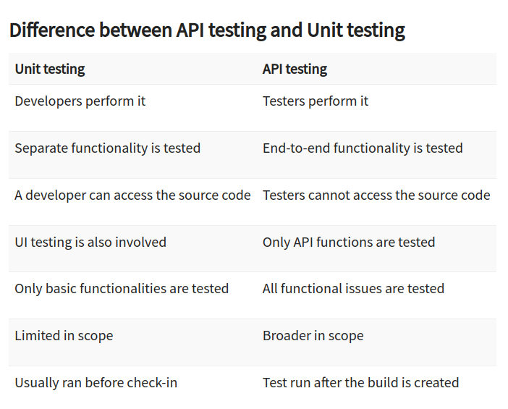
.

HTTP Methods:
HTTP (Hypertext Transfer Protocol) methods define the actions that a client (such as a browser or application) can perform on a server. Some common HTTP methods used in API testing include:
- GET: Retrieve data from the server.
- POST: Send data to the server to create a new resource.
- PUT: Update an existing resource on the server.
- DELETE: Remove a resource from the server.
- PATCH: Partially update an existing resource.
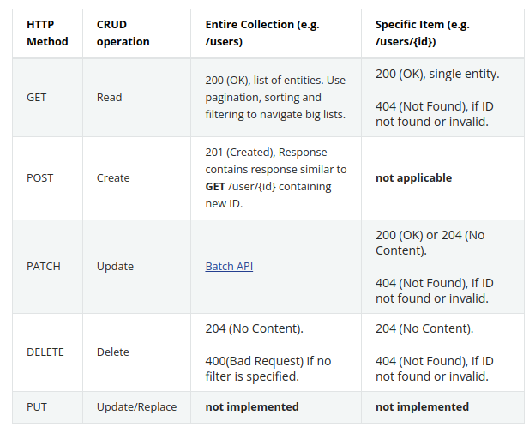
Endpoint and Payload:
- Endpoint: An endpoint is a specific URL or URI (Uniform Resource Identifier) that an API exposes to provide access to its resources. Each endpoint represents a specific function or resource on the server.

Each endpoint represents a specific function, action, or resource on the server that clients (applications, websites, or other systems) can interact with.

In simpler terms, an endpoint is like a door that leads to a particular room or service within a building (the server). Each room or service (resource) has its own unique door (endpoint) that allows authorized users (clients) to enter and access that room's functionalities or information.

Endpoints are used to specify the exact location and operation a client wants to perform on the server. For example, in an e-commerce API:

The endpoint for retrieving product information might be: /api/products/{product_id}

Payload

The payload, also known as the request body, is the data sent by the client to the server as part of an API request. It contains the data required to perform a specific operation on the server.

In the world of computer programming and APIs, when data is transmitted over the internet, each piece of data has two main parts: the header (used for identification) and the payload (actual information). The header identifies the source and destination of the data but is stripped off once the data reaches its destination. The payload carries the real message that an app or system needs to act upon.

In APIs, the payload is the essential data sent with a GET request. It's the information you submit to the server for an API request. This payload can be in different formats, like JSON, and is denoted using "{}" in a query string.

Payload Formats:

1.API Request Payload Format:

Interface Type
Method Name
Parameters

2.API OK Response Payload Format:

Response Type
Data (zero or more parameters)

3.API FAILED Response Payload Format:

Response Type
Messages (array of zero or multiple error messages)

Importance of Payload:
The payload is the part of a query string that carries the essential message or information required by the server to generate a response or for the user to make a decision.

In simpler terms, the payload is like the cargo in a truck - it's the core data that matters. It's what APIs handle to perform actions, send responses, and interact with other systems.

This understanding of payloads is essential in API testing and development, as it ensures that the right data is being sent and received accurately, contributing to the proper functioning of applications and services.

Using Postman as a Tool:
Postman is a popular tool used for API testing and development. It provides a user-friendly interface for creating, sending, and receiving API requests. With Postman, you can define request parameters, headers, authentication, and test various scenarios easily.

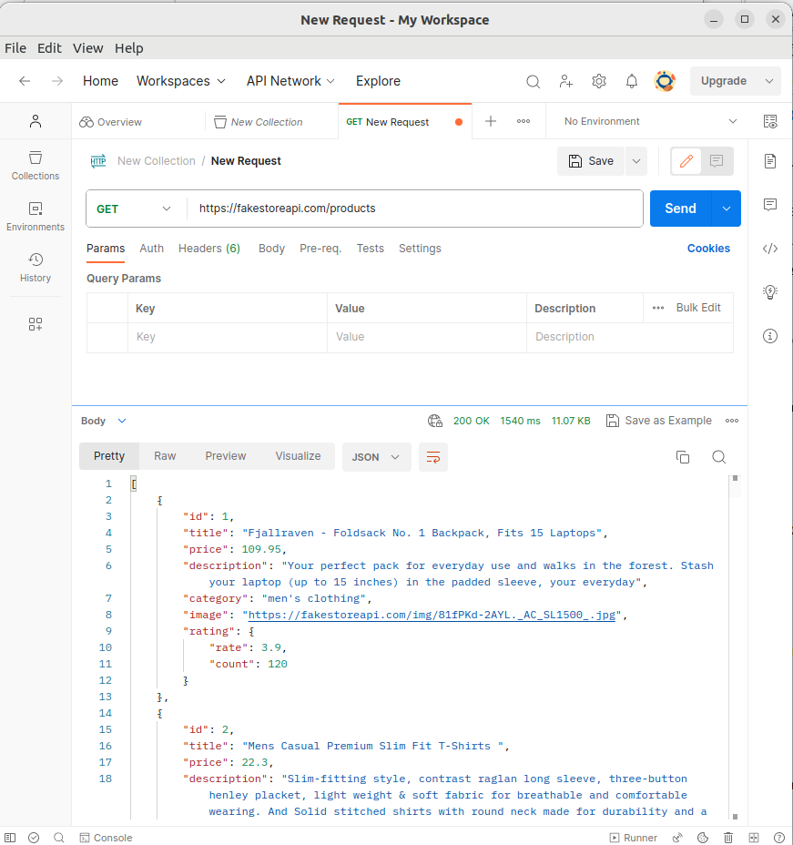

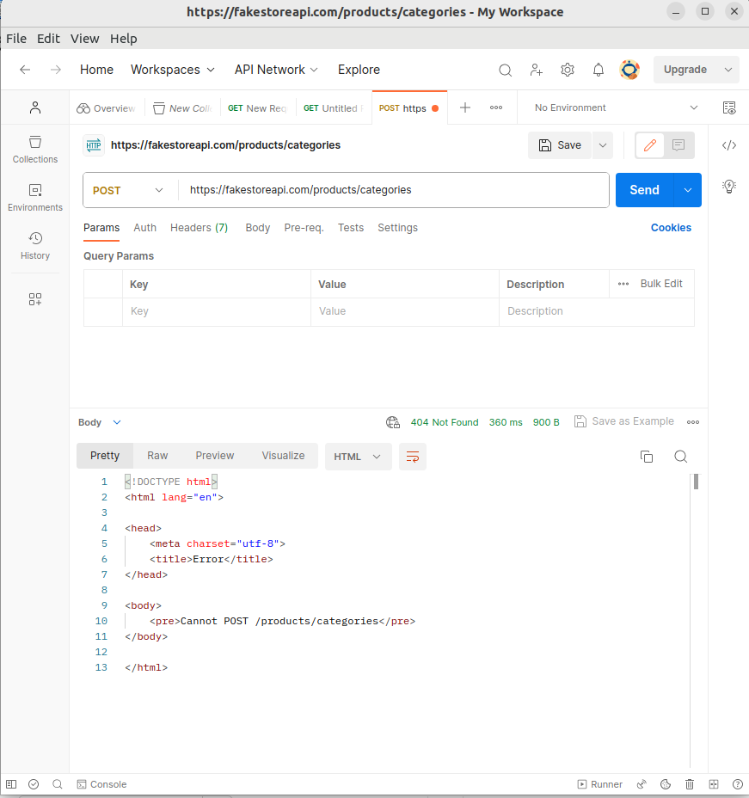

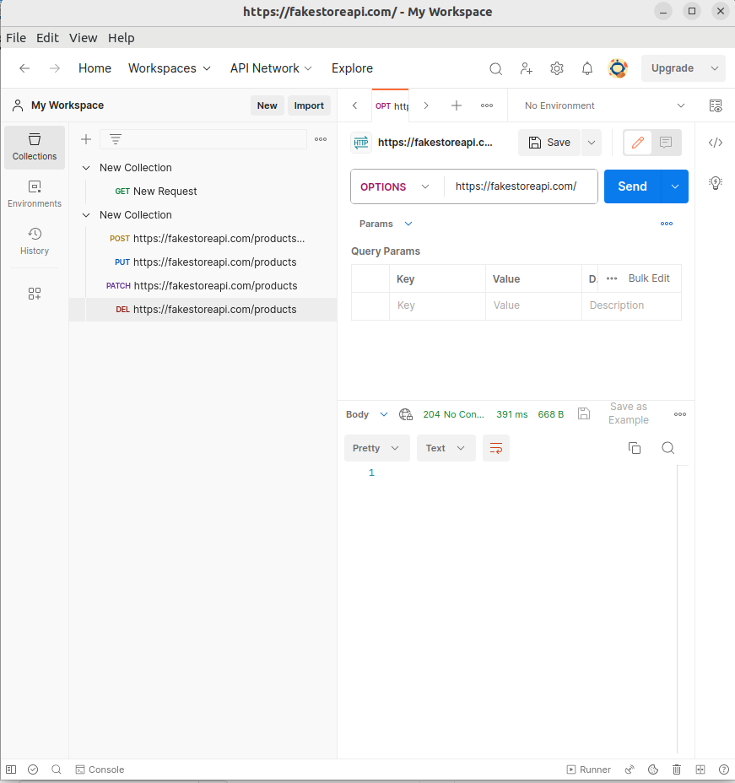

Response Code and Error Code:
- Response Code: Every API request results in a response from the server. The response typically includes a status code that indicates the outcome of the request. For example, a status code of 200 signifies a successful request, while a code starting with 4 or 5 indicates an error.
- Error Code: Error codes are specific status codes used to indicate errors that occur during API requests. These codes provide information about the type of error that occurred, helping developers diagnose and resolve issues.

In API testing, you'll focus on sending requests to different API endpoints using various HTTP methods, examining the responses and status codes, and verifying that the API behaves as expected. Tools like Postman make it easier to craft and execute these requests, as well as analyze the responses and error codes for effective testing and troubleshooting.

It seems like you've provided a detailed explanation of HTTP response status codes. These codes are used by servers to indicate the outcome of an HTTP request. Each code represents a different situation or result of the request. Here's a summary of the different classes of response status codes:

Informational Responses (100 - 199):
- These are informational codes indicating that the request is continuing and the server is still processing it.

Successful Responses (200 - 299):
- These codes indicate that the request was successful. The specific meaning can vary depending on the HTTP method used.

Redirection Messages (300 - 399):
- These codes indicate that further action needs to be taken by the client to fulfill the request. It often involves redirecting to a different URL.

Client Error Responses (400 - 499):
- These codes indicate that the client's request was invalid or cannot be fulfilled. They often result from issues on the client's end.

Server Error Responses (500 - 599):
- These codes indicate that the server failed to fulfill a valid request due to an error on the server's end.

Each code within these ranges serves a specific purpose in indicating the outcome of an HTTP request. They provide useful information for developers and systems to understand the status of their requests and responses.

Exercise :
