SELENIUM-1

What is Selenium?

Selenium is an open-source testing tool, which means it can be downloaded from the internet without spending anything. Selenium is a functional testing tool and also compatible with non-functional testing tools as well.



Why we use Selenium for automation testing?
Selenium is one of the most popular automation testing tools. Here automation testing is a process of converting any manual test case into the test scripts using automation tools such as Selenium.

Following are some aspects that, why we prefer Selenium for automation testing:

- The Selenium test scripts can be written in any programming languages like Java, Python, C#, Ruby, Perl, as so on.
- The Selenium test scripts can be executed in many operating system platforms such as Windows, Mac, Linux, etc.
- And the test scripts can be implemented on different browsers like Google Chrome, Mozilla Firefox, Internet Explorer, Safari, etc.
- The Selenium testing tool can be associated with other testing tools such as TestNG, Junit for managing the test cases, and generating test reports.
- To achieve continuous testing, Selenium is integrated with Maven, Jenkins, and Docker testing tools.

Why is Python useful for automation testing?
- Python is very useful for automation testing because it supports multiple programming patterns.
- Python has many built-in testing frameworks such as Pytest and Robot, which covers the debugging and faster workflow.
- It is an interpreted language means the interpreter implements the code line by line at a time that's makes debugging easy.
- Python is Cross-platform Language; that's why it can run on different platforms like Windows, Linux, UNIX, and Macintosh,
- Python can be easily implemented with other programming languages such as C, C++, JAVA, etc.

SELENIUM WEB DRIVER

What is WebDriver ?

-> WebDriver is one of the component in selenium.
-> WebDriver is module

firefox brower -----> Firefox()
Chrome Browser------------> Chrome()
Edge-------->Edge()

WebDriver is an API(Application Programming Interface)

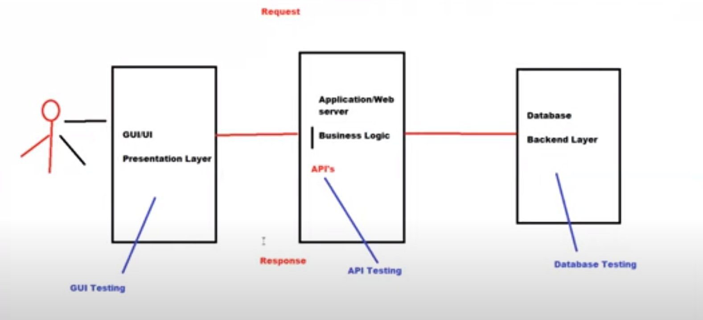
.

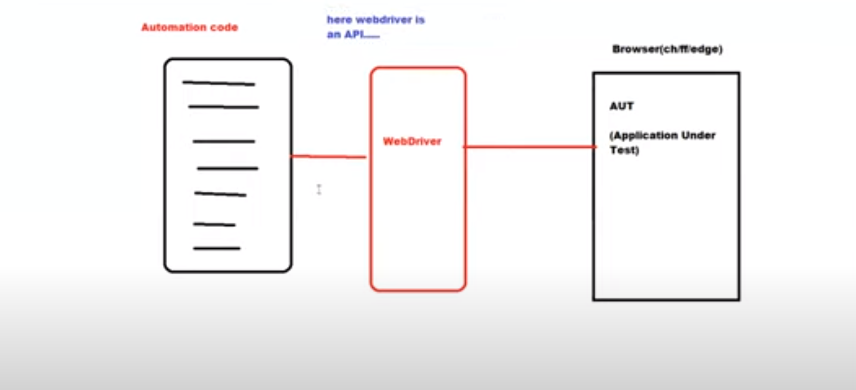
.

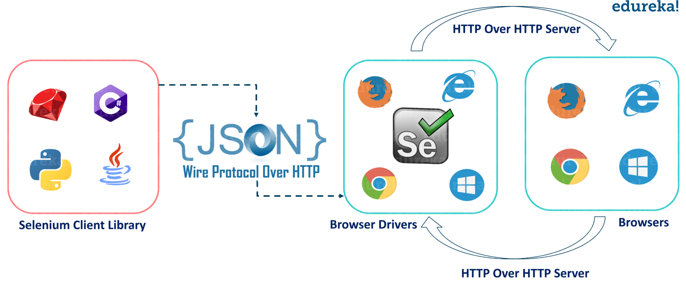
.
Architectural Difference between Selenium3 and Selenium4

Selenium3
Selenium Language bindings—JSON Wire Protocol ---> Browser drivers ---w3c --> Browsers

Selenium4
Selenium Language bindings—w3c----> Browser drivers –w3c --> Browsers

Selenium 4, also known as Selenium WebDriver 4, brought about several architectural changes and improvements over Selenium 3. Here are the key architectural differences between Selenium 3 and Selenium 4:

1. W3C WebDriver Protocol :
- Selenium 3 used the JSON Wire Protocol for communication between the client library and browser drivers.
- Selenium 4 adopted the W3C WebDriver Protocol, a more standardized and modern communication protocol. This change improves cross-browser consistency and allows for better compatibility with evolving browser features.

2. Relative Locators :
- Selenium 4 introduced "Relative Locators" or "Friendly Locators," which simplify locating elements by their relationship to other elements on the page. This feature makes it easier to perform actions on nearby elements without relying solely on complex XPath or CSS selectors.

3. Improved WebDriver APIs :
- Selenium 4 provides enhanced APIs for WebDriver instances. The API design is more consistent, making it easier to interact with different browser drivers.
- Asynchronous JavaScript execution has been improved, allowing more efficient interaction with web pages that heavily rely on JavaScript.

4. New Browser Drivers :
- Selenium 4 included updated and improved browser drivers for popular browsers like Chrome, Firefox, Safari, and Edge. These drivers offer better performance, stability, and compatibility with the latest browser versions.

5. DevTools Integration :
- Selenium 4 introduced better integration with browser DevTools. This allows developers and testers to leverage browser DevTools capabilities directly from their Selenium scripts, enabling deeper insights and more advanced debugging.

6. Improved Error Messages and Diagnostics :
- Selenium 4 provides more informative error messages and diagnostics, aiding in quicker issue resolution during script development and troubleshooting.

7. Grid Improvements :
- Selenium 4 improved the Selenium Grid, making it more stable and scalable for distributed test execution. The new Grid supports Docker containers, allowing for easier deployment and management.

8. Extended Element Interaction Methods :
- Selenium 4 expanded the methods available for interacting with web elements, making scripting more intuitive and enabling complex interactions without relying on external libraries.

9. Better Support for Headless Browsers :
- While Selenium 3 had limited support for headless browsers, Selenium 4 offers more robust and consistent support for running browser tests in headless mode, enhancing testing efficiency.

10. Parallel Execution Enhancements :
- Selenium 4 improved support for parallel test execution, making it easier to run tests concurrently and reduce overall testing time.

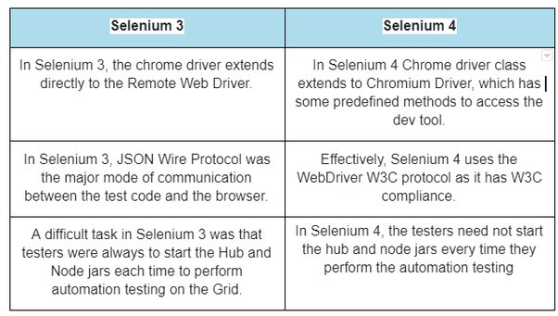
Setup & configure WebDriver in VSCode

1) install selenium
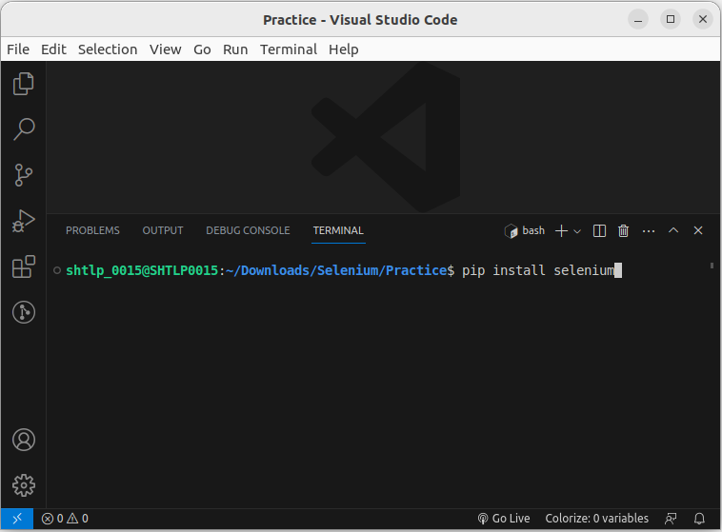
.
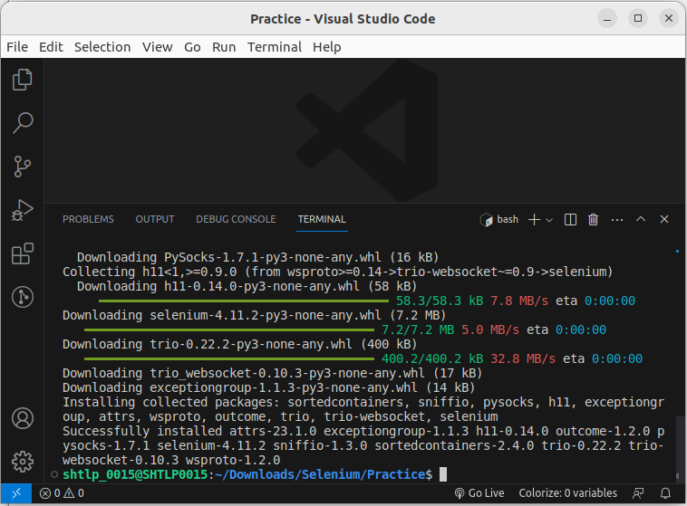
.

2) Download browser specific driver using below links:

chrome driver:

https://chromedriver.storage.googleapis.com/114.0.5735.90/chromedriver_linux64.zip

edge driver:
https://developer.microsoft.com/en-us/microsoft-edge/tools/webdriver/

firefox driver:
https://github.com/mozilla/geckodriver/releases/download/v0.33.0/geckodriver-v0.33.0-linux-aarch64.tar.gz

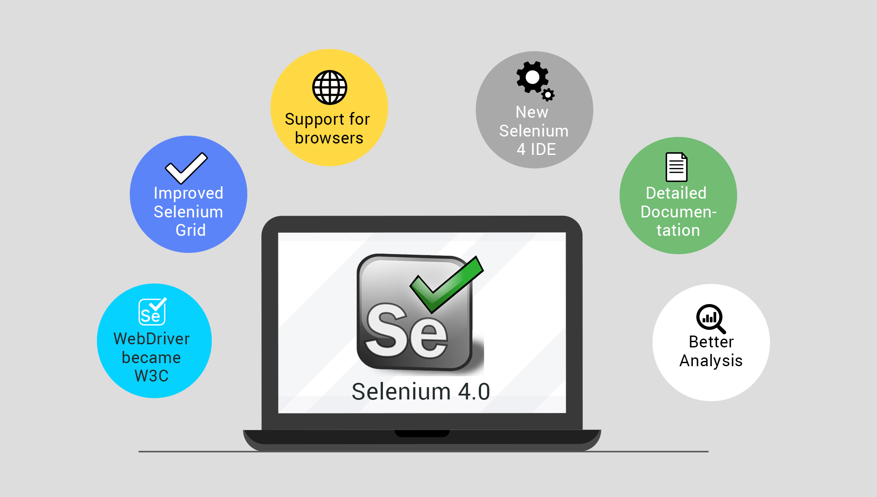

Writing the Selenium test script:
- Import WebDriver from selenium.

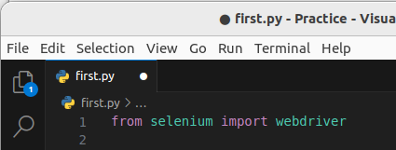

- Open the Google Chrome browser.
After that, we will open the Google Chrome browser.

As we can see in the below screenshot, we have multiple types of browsers options available, and we can select any browser from the list like Chrome, Edge, firefox, Internet Explorer, opera, safari, etc.

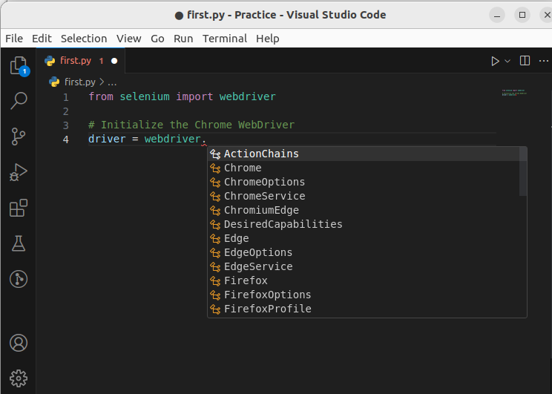

- Maximize the browser window.
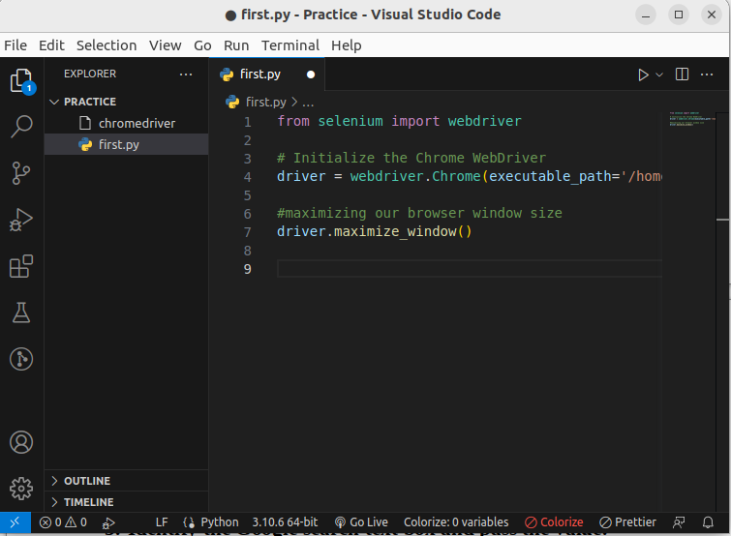
- Navigate to the Google home page.

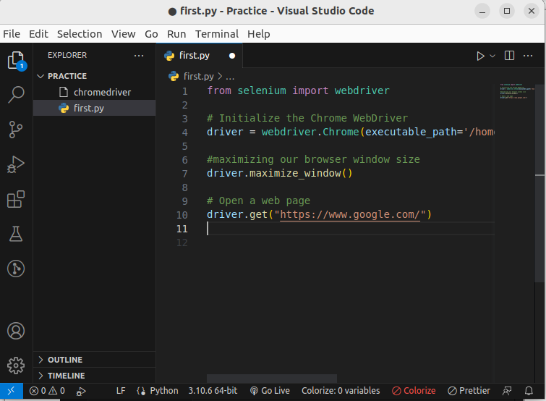
- Identify the Google search text box and pass the value.

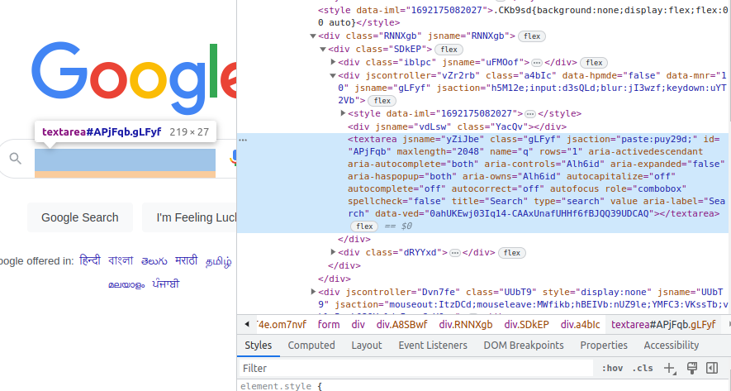
.
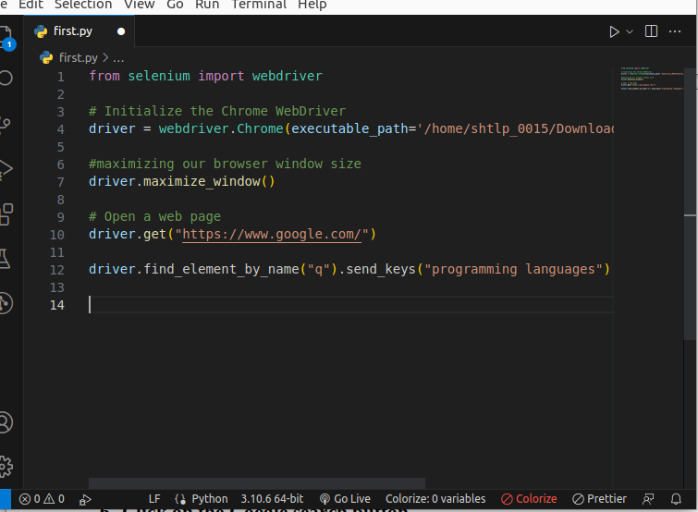

- Close the Browser.
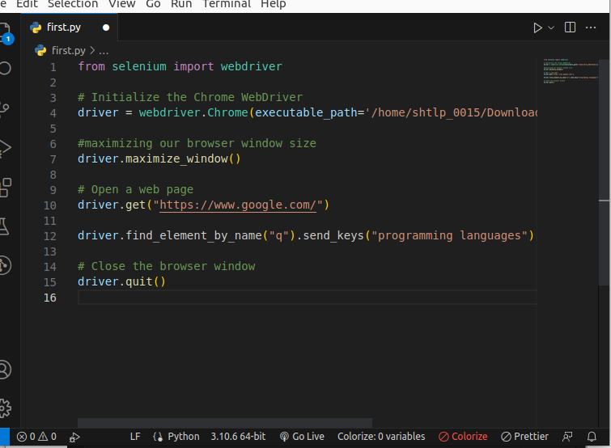
.

Automated Google Homepage Opening with Selenium

This code is a Python script that demonstrates the use of Selenium, a web automation framework, to perform automated actions on a web browser, specifically Google Chrome.

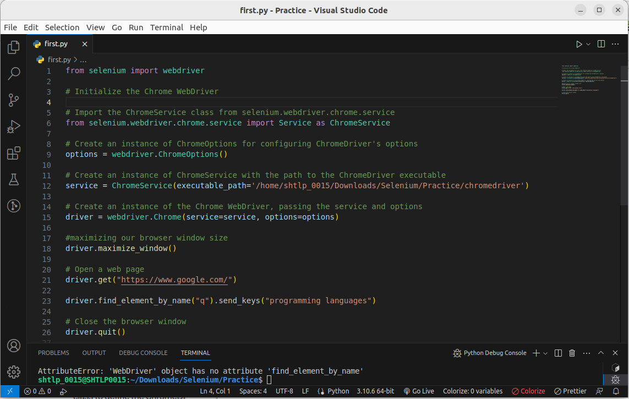
.

1. Importing Required Libraries:
The code imports necessary modules from the Selenium library, including `webdriver` and `ChromeService`.

2. Setting Up Chrome WebDriver:
- An instance of `ChromeOptions` is created to configure options for the ChromeDriver.
- An instance of `ChromeService` is created, specifying the path to the ChromeDriver executable.
- The Chrome WebDriver is initialized by passing the `service` and `options` instances to `webdriver.Chrome()`.

3. Maximizing Browser Window:
The browser window is maximized to ensure better visibility during automation.

4. Opening Google Homepage:
The WebDriver navigates to the Google homepage (https://www.google.com/).

5. Performing a Search:
- The script identifies the search input element on the page using its "name" attribute ("q").
- The `send_keys()` method is used to simulate typing "programming languages" into the search input.

6. Closing the Browser:
The browser window is closed using the `quit()` method, which releases any resources associated with the WebDriver.

Automation Testing Using Selenium

