SELENIUM-2

Practice Automation using Selenium
1. Automated Google Search Test using Selenium 4

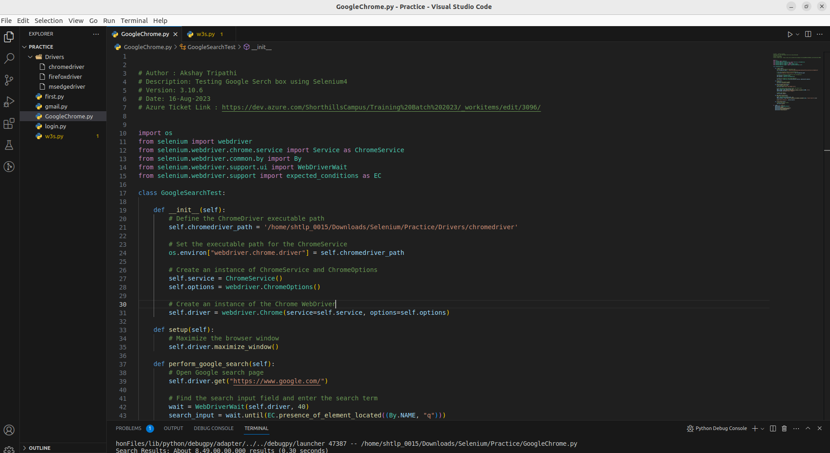
.
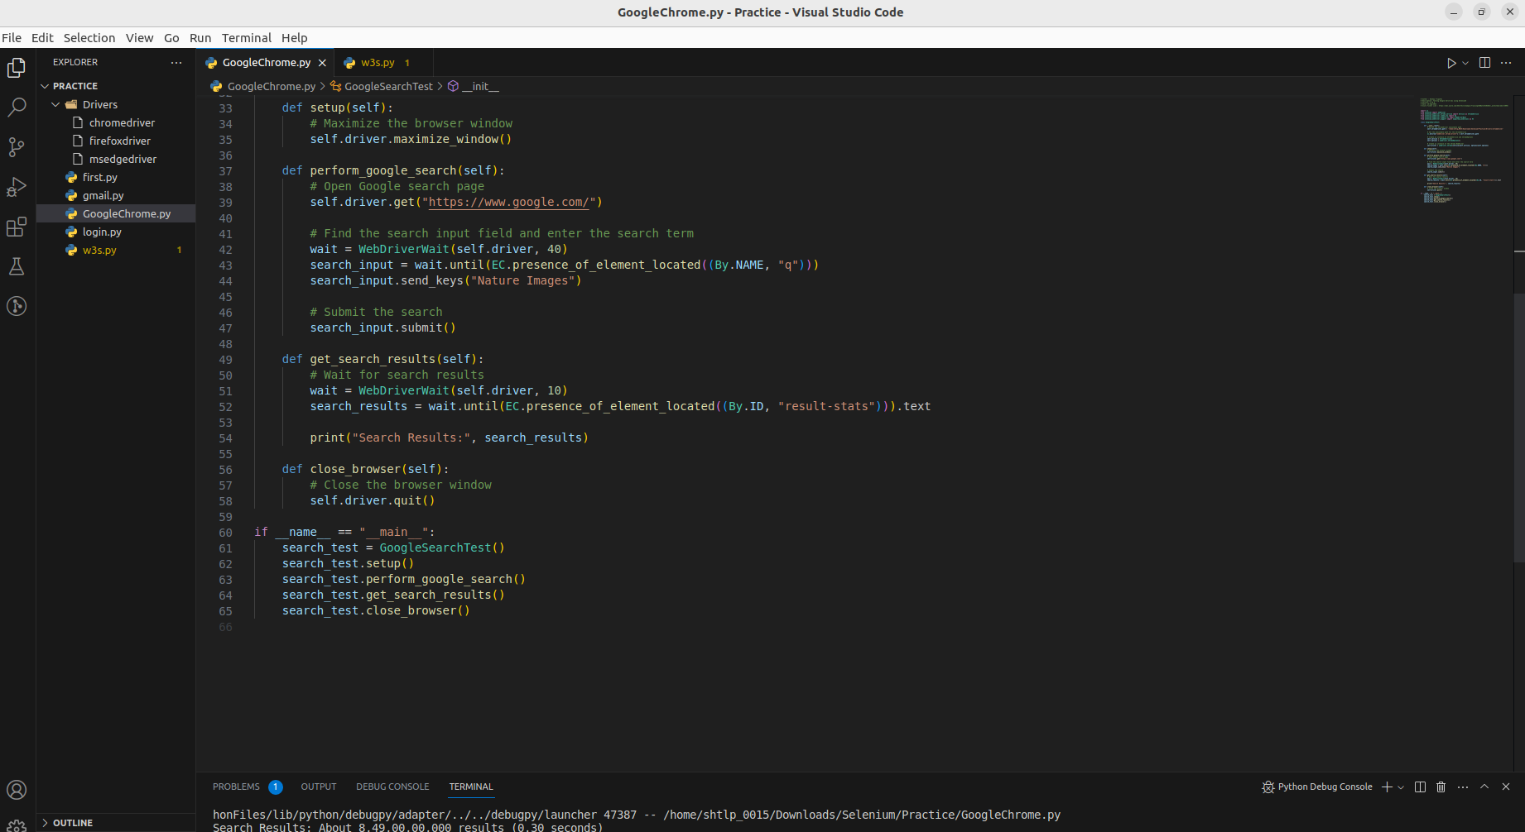
.

2. Automating Amazon Shopping Cart with Selenium

Automating Amazon Shopping Cart with Selenium

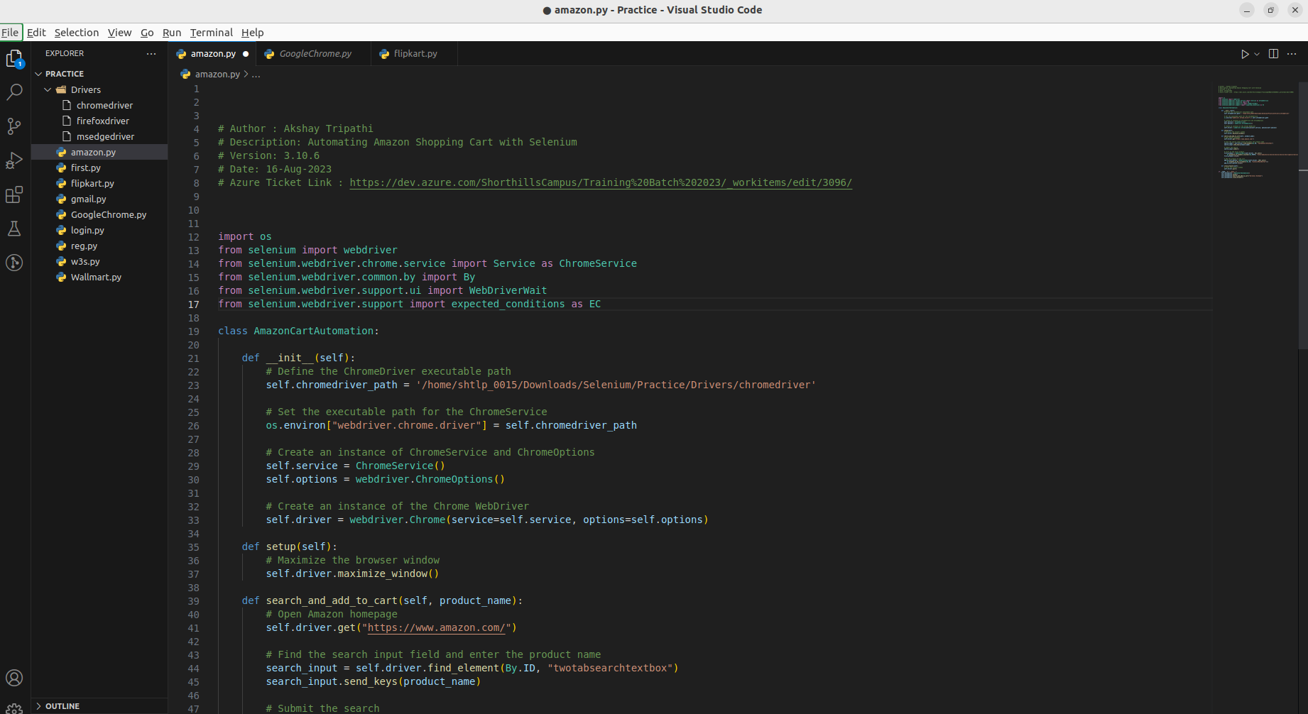

.

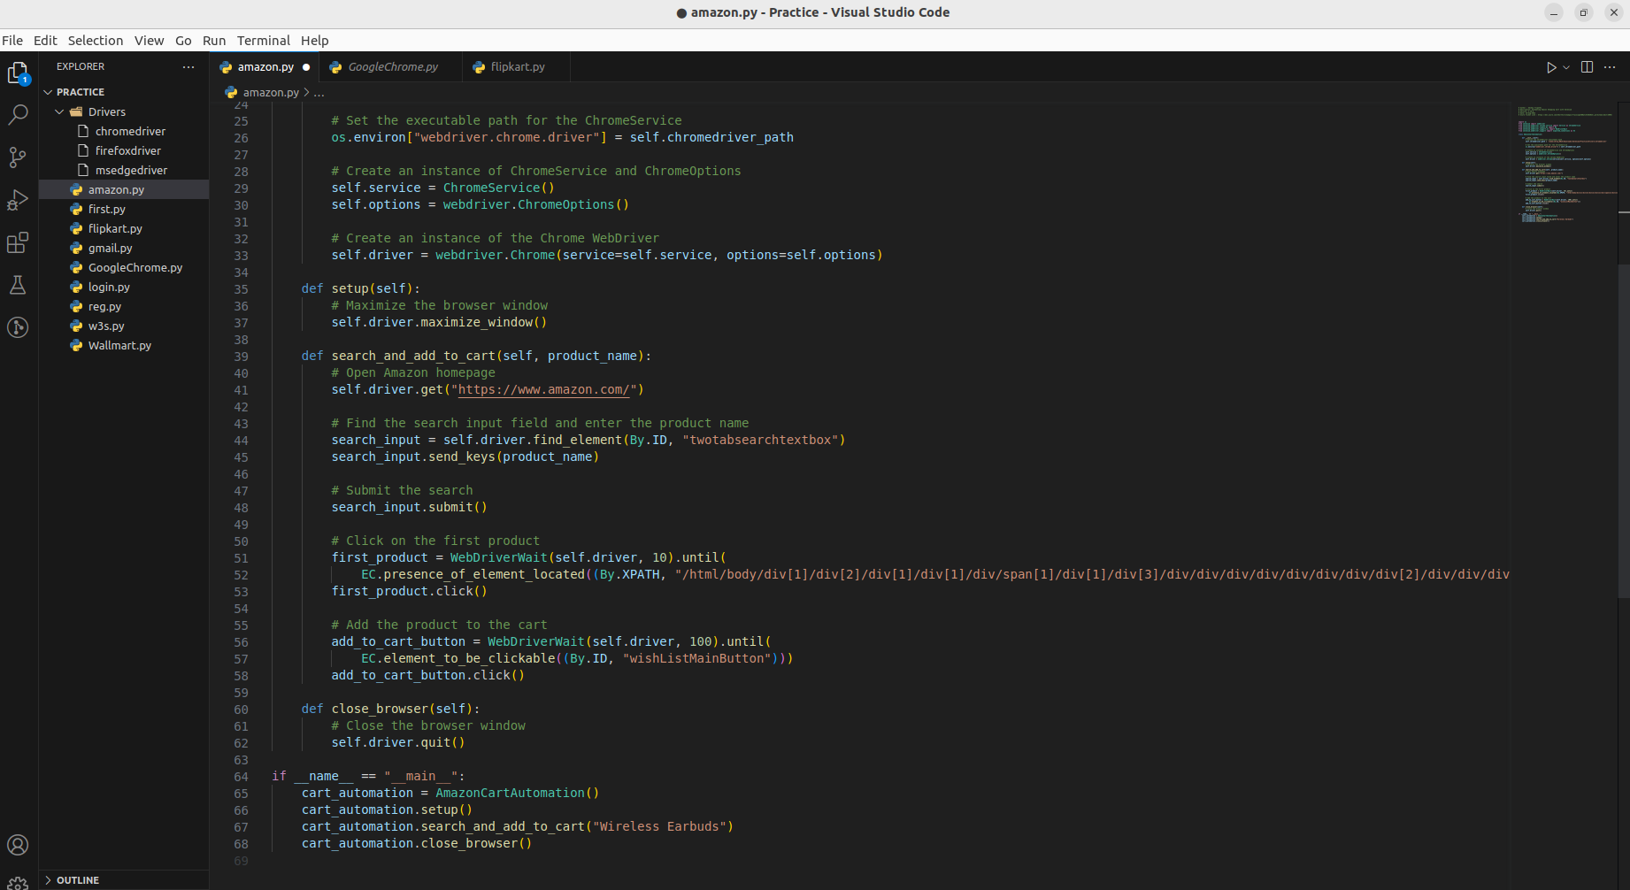

Sure! The provided code is using the Selenium library to automate the process of adding a product to the Amazon shopping cart. Here's a brief overview of what the code is doing:

1. The code starts by importing necessary libraries and setting up some initial configuration, including the ChromeDriver executable path.

2. It defines a class named `AmazonCartAutomation` that encapsulates the automation process.

3. The `__init__` method initializes the Chrome WebDriver by setting up the ChromeService and ChromeOptions. It also creates an instance of the Chrome WebDriver.

4. The `setup` method maximizes the browser window.

5. The `search_and_add_to_cart` method automates the following steps:
- Opens the Amazon homepage.
- Locates the search input field and enters the desired product name (in this case, "Wireless Earbuds").
- Submits the search.
- Waits for the first product to become clickable, clicks on it, and opens the product page.
- Waits for the "Add to Cart" button to become clickable and clicks on it.

6. The `close_browser` method closes the browser window.

7. In the `__main__` block, an instance of the `AmazonCartAutomation` class is created.
- The `setup` method maximizes the browser window.
- The `search_and_add_to_cart` method is called with the product name "Wireless Earbuds" to initiate the automation.
- The `close_browser` method is called to close the browser window.

Overall, this code demonstrates how Selenium can be used to automate the process of searching for a product on Amazon and adding it to the shopping cart.

