Selenium-3
Automating Amazon

Exploring Techniques to Interact with CAPTCHA-Protected Websites Responsibly

1. Deleting Cookies:

Deleting cookies in Selenium could potentially be a strategy to avoid CAPTCHA challenges, as some CAPTCHAs might be triggered by suspicious or repetitive behavior associated with specific cookies. However, keep in mind that deleting cookies might not always guarantee success, and it can have unintended consequences on the functionality of the website you're automating. Here's how you could approach it:

1. Identify Relevant Cookies : Analyze the website's behavior and CAPTCHA triggers to identify if specific cookies are associated with the CAPTCHA challenge. Some CAPTCHAs might be tied to cookies related to session tracking, user behavior, or previous failed attempts.

2. Delete Cookies : In Selenium, you can delete cookies using the `delete_cookie` method for a specific cookie, or the `delete_all_cookies` method to remove all cookies associated with the current session.

1. driver.delete_cookie("cookie_name")

2. driver.delete_all_cookies()

3. Reset State : After deleting cookies, you might need to reset the state of your automation. This could involve refreshing the page, navigating back to a specific starting point, or re-authenticating if necessary.

4. Implement Delays : To mimic human behavior, introduce realistic delays before and after deleting cookies. This can help prevent immediate detection as a bot.

5. Use Wisely : Deleting cookies should be used as a last resort and with caution. It might not work for all CAPTCHAs, and excessive cookie deletion could trigger additional security measures on the website.

CAPTCHA mechanisms are designed to detect unusual behavior, and websites might employ various techniques beyond just cookies to identify and block automated bots. Additionally, frequent cookie deletion could negatively impact the user experience and functionality of the website, which goes against the principles of responsible web automation. Always ensure that your automation activities are aligned with the website's terms of use and policies.

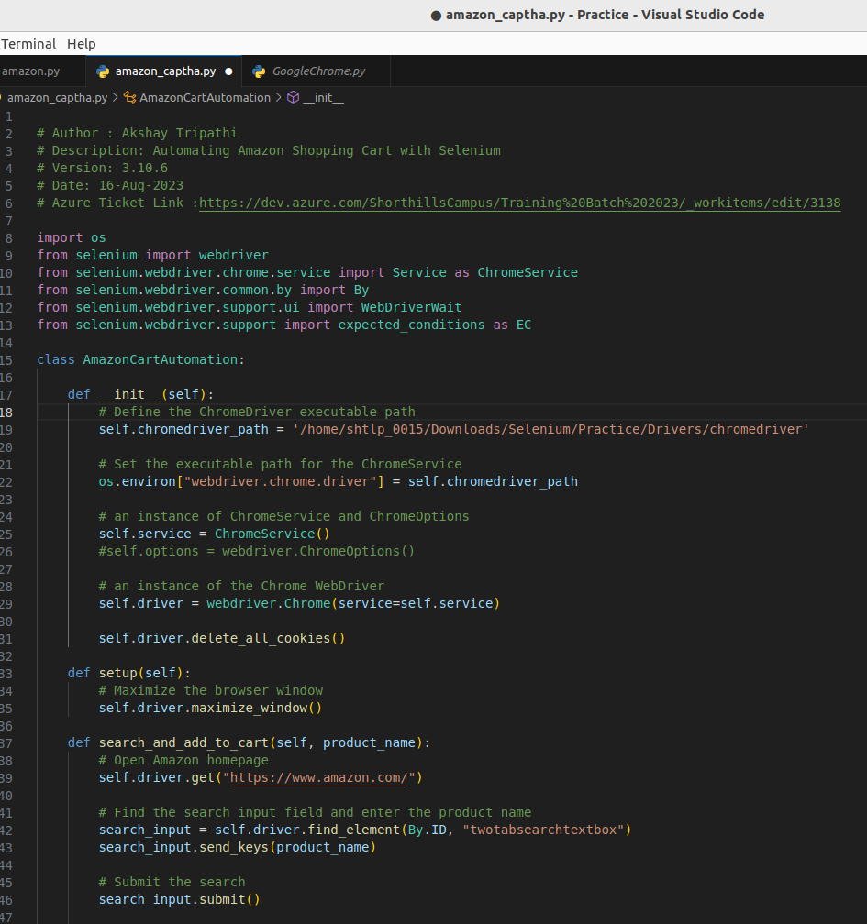
.

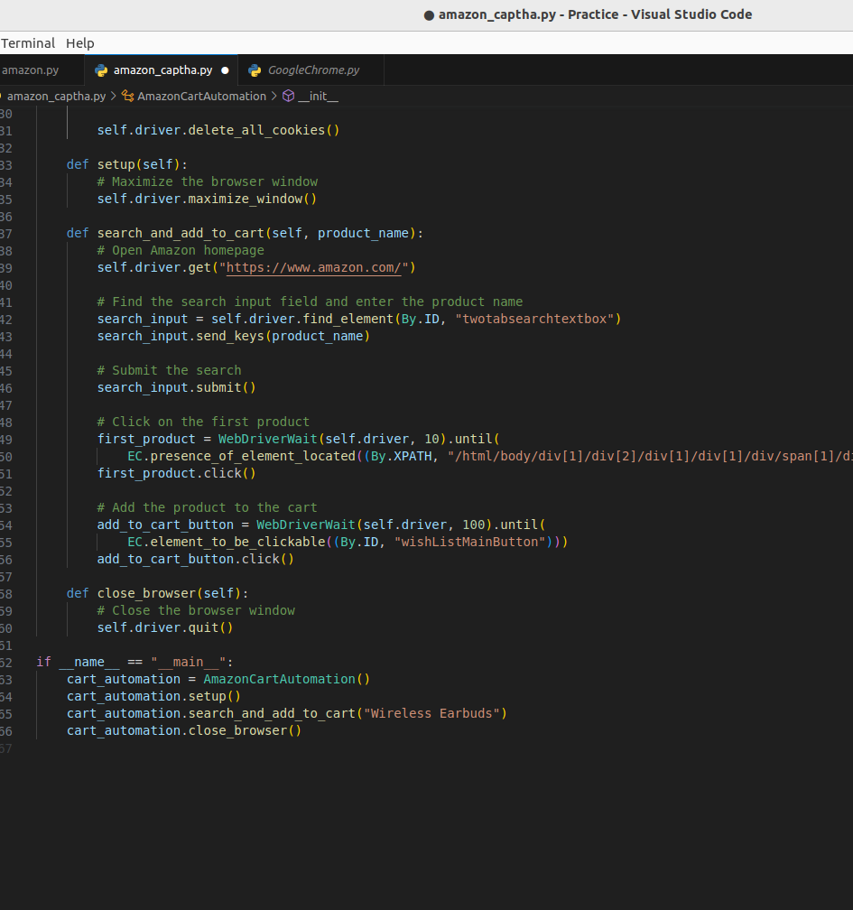
.

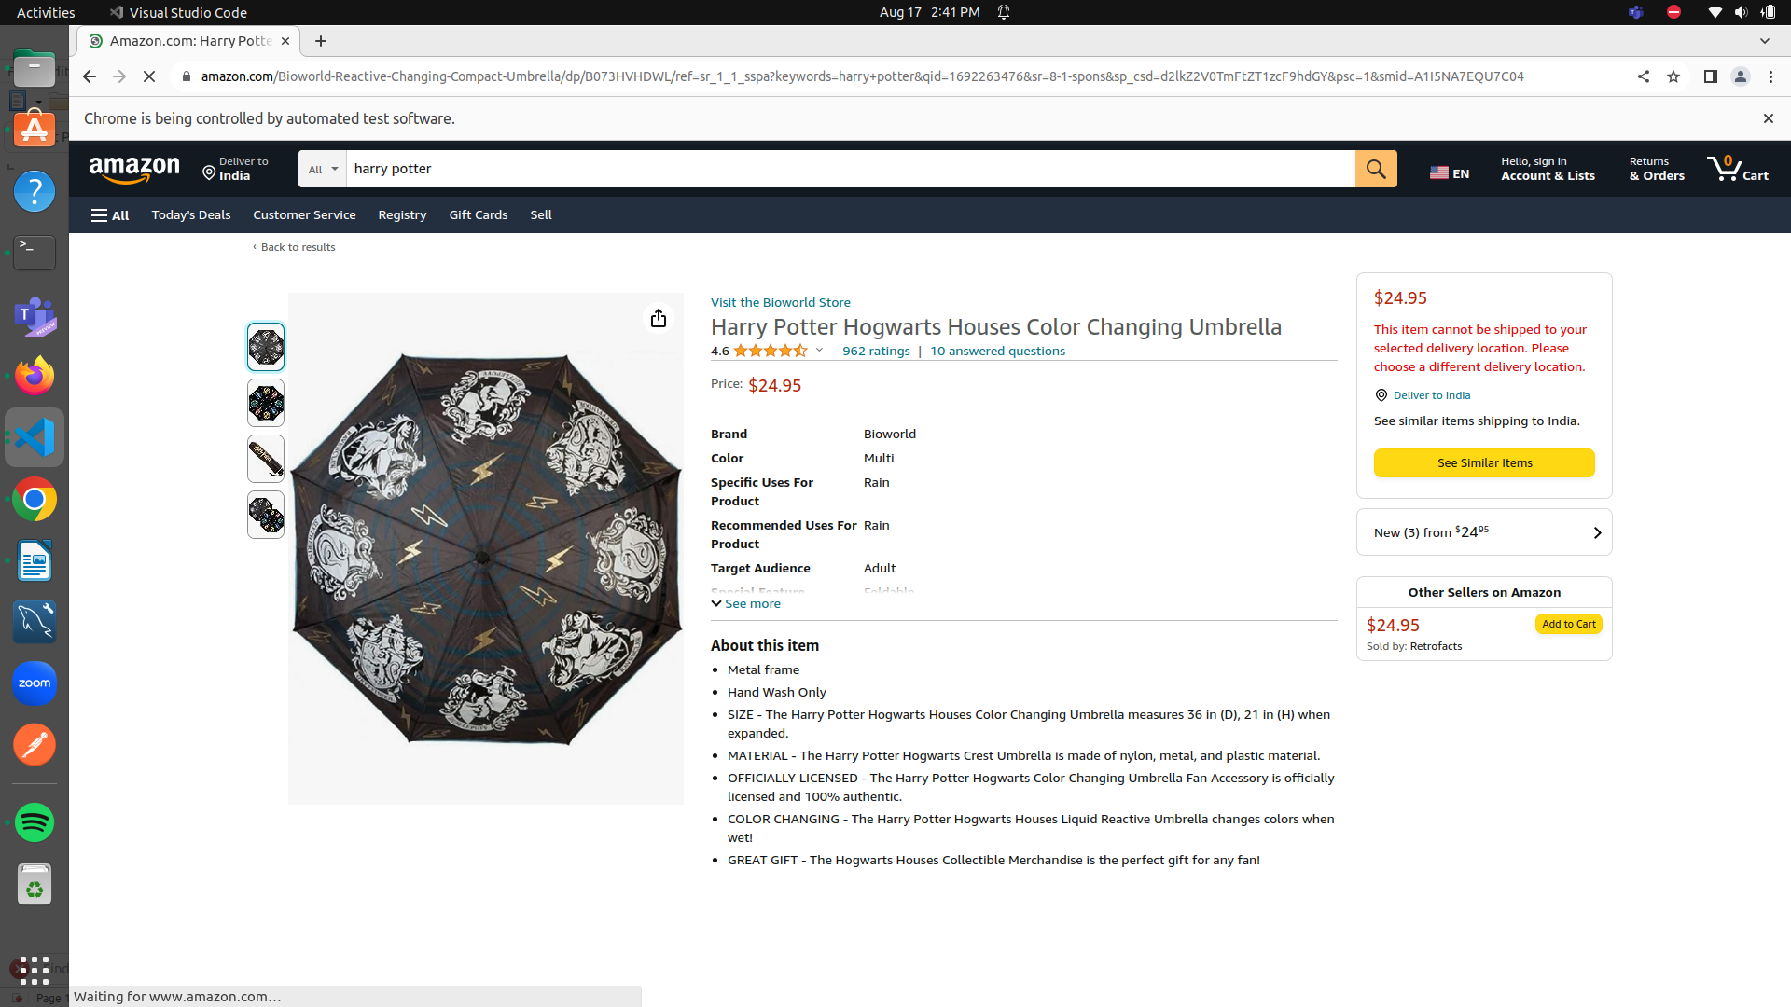

Exploring Techniques to Interact with CAPTCHA-Protected Websites Responsibly

OPENING PRODUCTS ON LOOP :
Automating Amazon Product Exploration with Selenium

Description:
This Python script demonstrates how to automate the process of exploring different products on Amazon using Selenium, a web automation framework. The script utilizes Selenium to interact with the Amazon website, perform searches, open product pages, and then navigate back to the search results.

Features:
- Uses Selenium to automate web interactions with the Amazon website.
- Allows seamless exploration of multiple products in a loop.
- Efficiently manages browser sessions and interactions.

Instructions:
1. Ensure you have the appropriate ChromeDriver executable at the specified path.
2. Replace the product names in the 'products' list with the desired products.
3. Set the desired delay times between opening and closing products.
4. Execute the script and watch as it automatically opens and closes product pages.

- The script includes exception handling to allow manual interruption using Ctrl+C.
- Adjust the delays as needed to control the pacing of the automation.

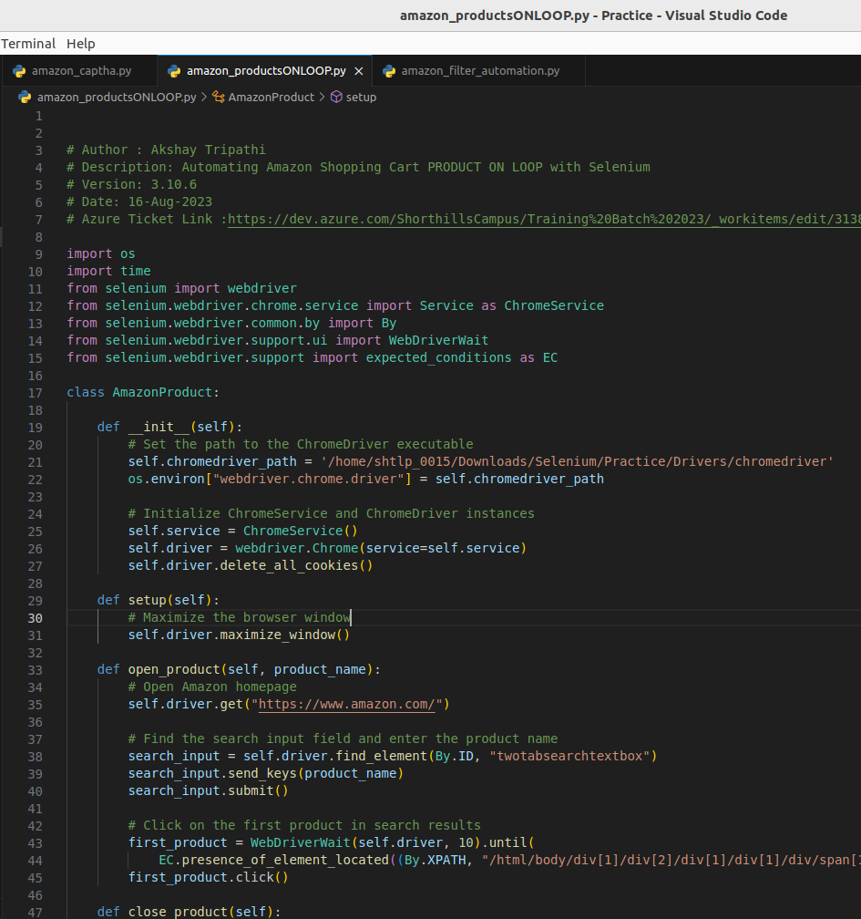
.
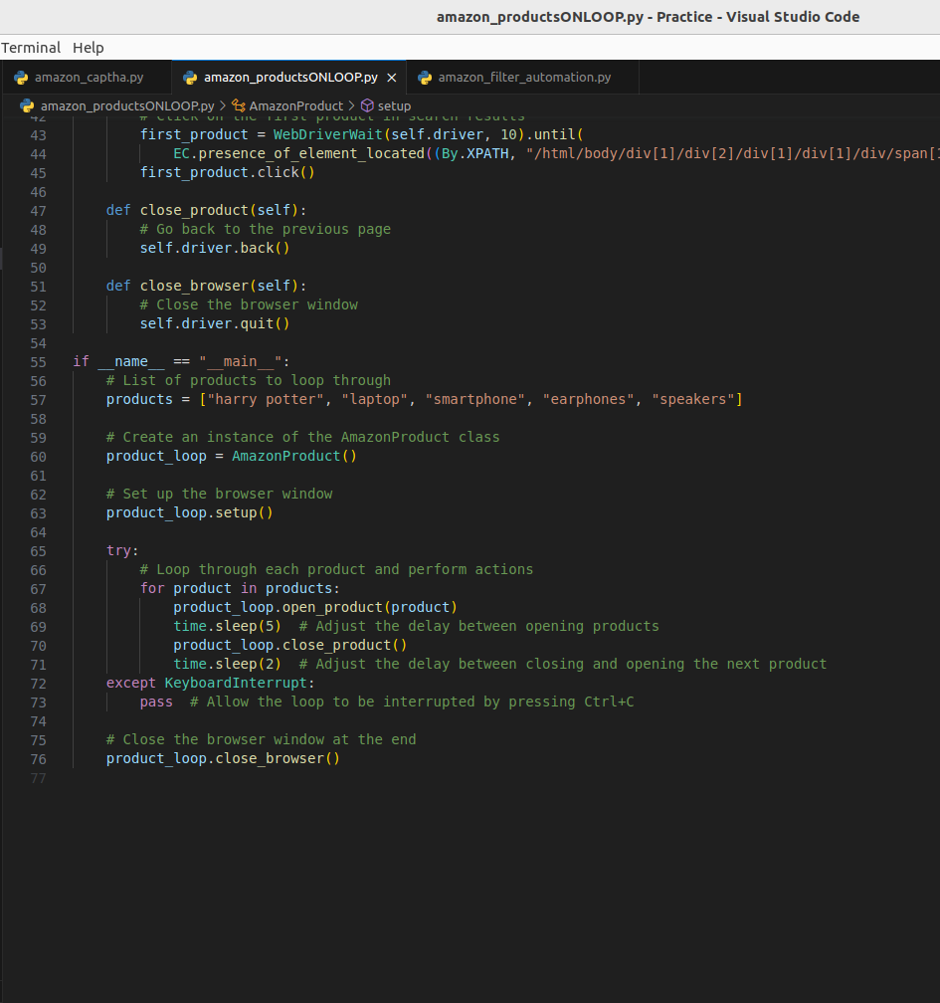
.

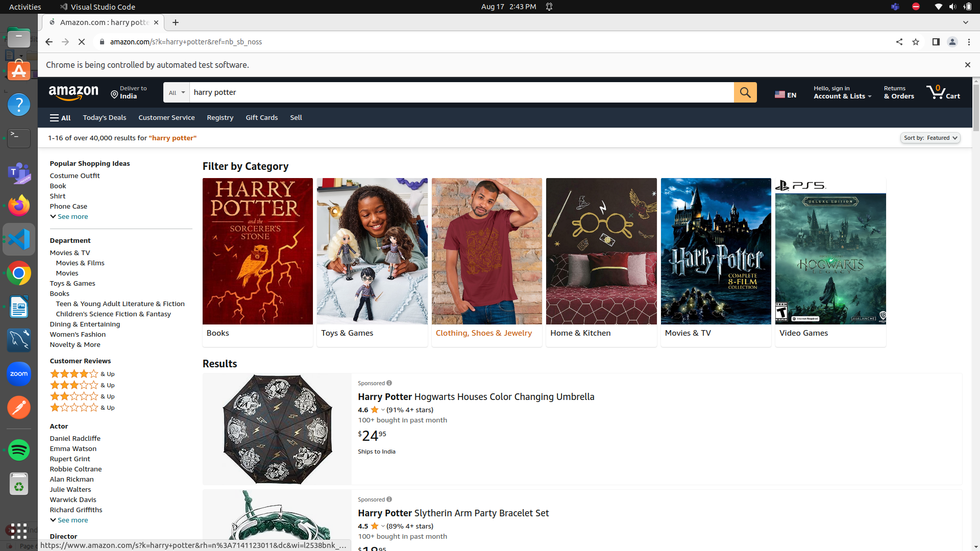
.

Deleting cookies might not completely avoid CAPTCHA issues on its own. While clearing cookies can help with certain types of CAPTCHA challenges, many CAPTCHA mechanisms are more complex and rely on multiple factors to determine if a user is a bot. These factors can include browsing behavior, IP address history, mouse movements, and more. Simply clearing cookies might not be sufficient to bypass these mechanisms.

CAPTCHAs are designed to detect and prevent automated bot behavior, and website security systems often use a combination of techniques to identify and mitigate such activity. Clearing cookies might reset some tracking data, but it's likely that other tracking methods will still be in place to detect unusual or non-human-like behavior.

If you're facing CAPTCHA challenges during automation, it's important to explore multiple strategies to mitigate the issue. This might include implementing delays between actions, mimicking human-like interaction (such as mouse movements and scrolling), and structuring your automation script to closely resemble typical user behavior. Additionally, periodically clearing cookies might be a part of your strategy, but it's unlikely to be a standalone solution.

Always keep in mind that using automation on websites, especially when dealing with CAPTCHAs, should be done ethically and in compliance with the website's terms of use and applicable laws.

