Git -1

Git is a distributed version control system used to manage and track changes in code and other files. It enables collaboration among developers by allowing them to work on separate branches and merge changes.

With Git, you can create repositories to store your code, track changes over time, and revert to previous versions if needed.

It's widely used in software development to maintain code quality, facilitate teamwork, and streamline the development process.

Git's commands include adding files to a staging area, committing changes with messages, branching for parallel development, and syncing with remote repositories. Learning Git empowers developers to collaborate effectively, experiment with new features, and manage complex projects with ease.

Git is a powerful version control system that helps you track changes to your code and collaborate with others effectively.

1. Installation:
Start by installing Git .

Sudo app-get install Git
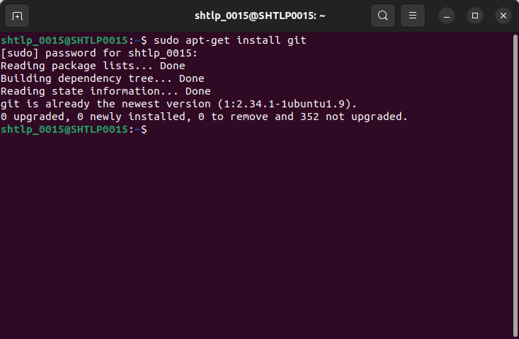

2. Configuration:
After installation, you need to configure your Git identity:

git config --global user.name "Akshay Tripathi"
git config --global user.email "Akshay.tripathi@shorthills.ai"

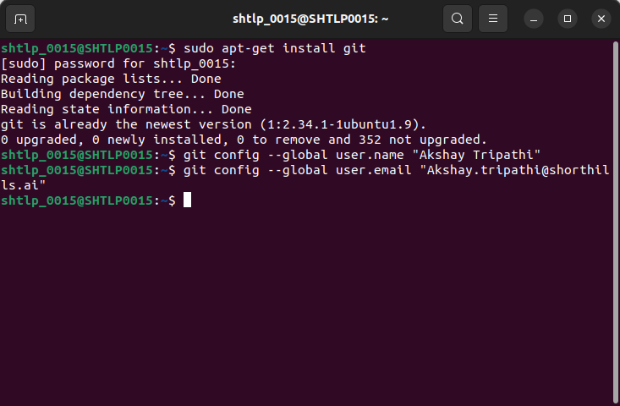

3. Creating a Repository:
Navigate to the directory where you want to start version controlling your project and run:

git init
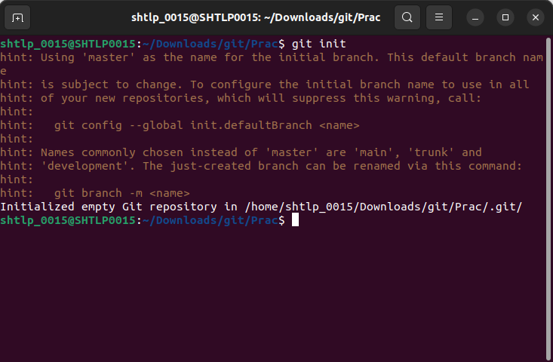

4. Basic Commands:
- `git status`: Check the status of your repository.

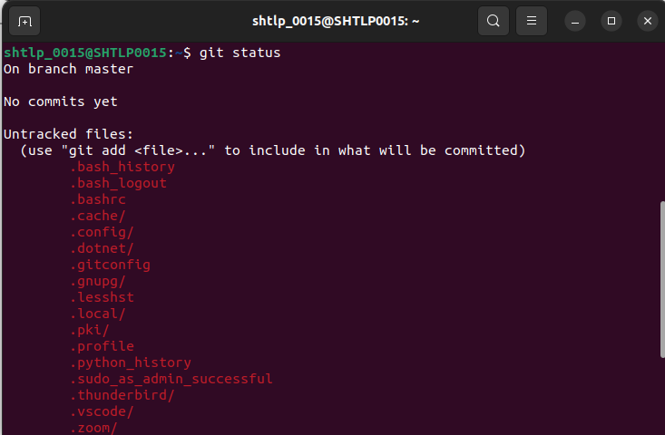
- `git add <filename>`: Add files to the staging area.

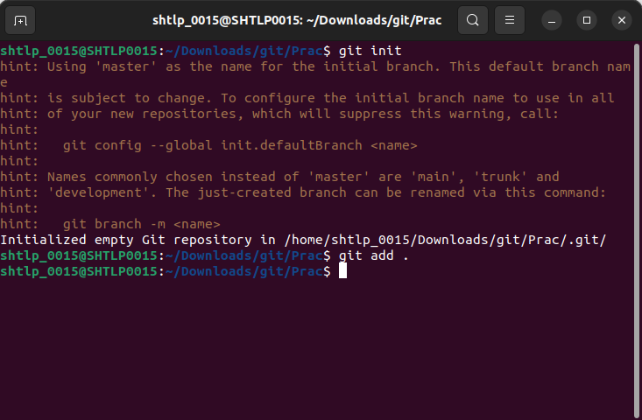

- `git commit -m "Commit message"`: Commit your changes to the repository.

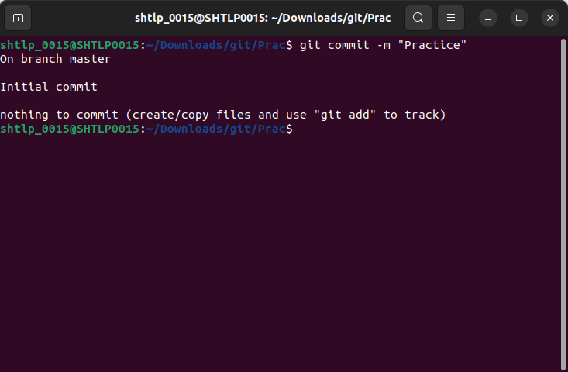
- `git log`: View the commit history.

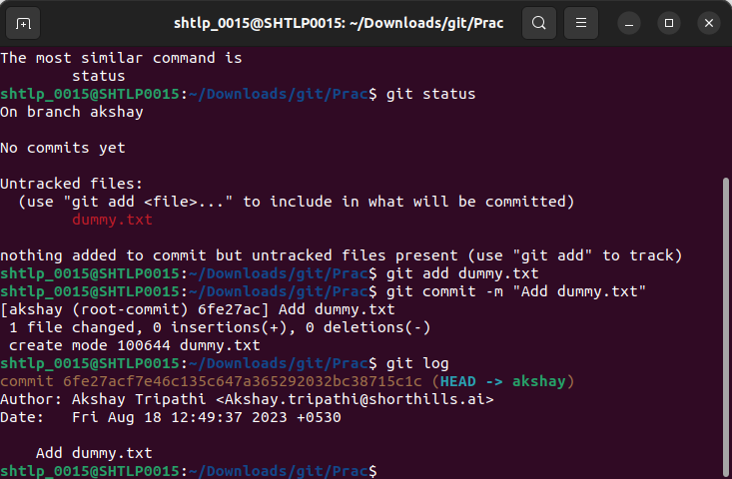
5. Branches:
- `git branch`: List all branches.
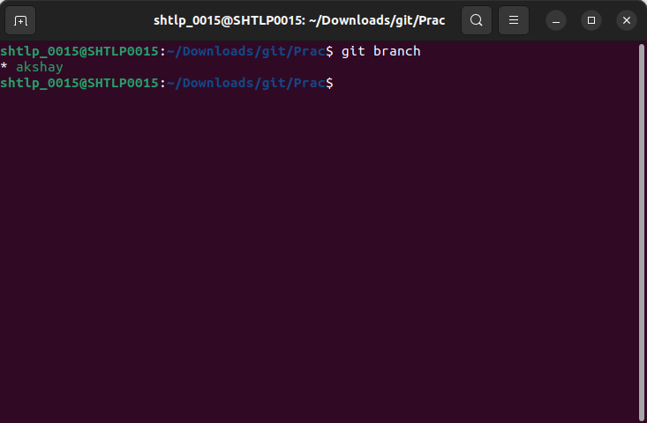

- `git branch <branchname>`: Create a new branch.
- `git checkout <branchname>`: Switch to a different branch.

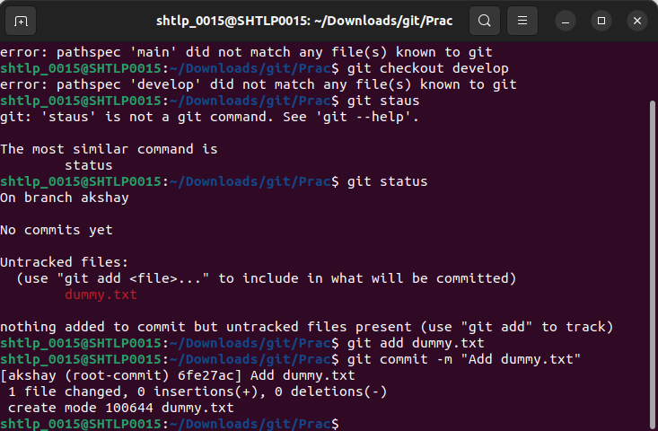
- `git merge <branchname>`: Merge changes from one branch into another.

1. Switch to the Target Branch:
Make sure you're on the branch where you want to integrate changes. This is typically the branch where you want to apply the changes from another branch.

git checkout <target_branch>

2. Initiate the Merge:
Use the `git merge` command followed by the name of the branch you want to merge. This will integrate the changes from the specified branch into the current branch.

git merge <source_branch>

3. Resolve Conflicts (if any):
If there are conflicting changes between the branches being merged, Git will pause and notify you about the conflicts. You'll need to manually resolve these conflicts by editing the conflicting files, saving the changes, and then marking them as resolved using `git add`.

4. Commit the Merge:
After resolving any conflicts, you need to commit the merge. Git automatically creates a merge commit that has multiple parents (one for each branch being merged).

git commit -m "Merge changes from <source_branch>"

5. Push the Merged Changes:
Once the merge commit is created and you've tested the merged code, you can push the merged changes to a remote repository.

git push origin <target_branch>

6. Remote Repositories:
- Create a GitHub (or any other Git hosting service) account.
- Create a new repository on GitHub.
- Link your local repository to the remote:

git remote add origin <repository_url>

- Push your local commits to the remote:

git push -u origin <branchname>

7. Collaboration:
- Share your repository URL with collaborators.
- They can clone your repository using `git clone <repository_url>`.
- Collaborators can create their branches, make changes, and push them to the repository.

8. Pull Requests (GitHub flow):
- Collaborators can create a pull request (PR) to propose changes.
- Code changes are reviewed, discussed, and potentially modified.
- Once approved, the changes can be merged into the main branch.

9. Handling Conflicts:
- Conflicts can occur when merging or pulling changes.
- Git will highlight conflicting lines in your code.
- You need to manually resolve conflicts, commit the changes, and then complete the merge or pull.

10. Advanced Topics:
- Rebasing: Alter the history of your branch before merging.
- Cherry-picking: Apply specific commits from one branch to another.
- Gitignore: Ignore specific files or directories from being tracked.
- Submodules: Include other repositories within your repository.

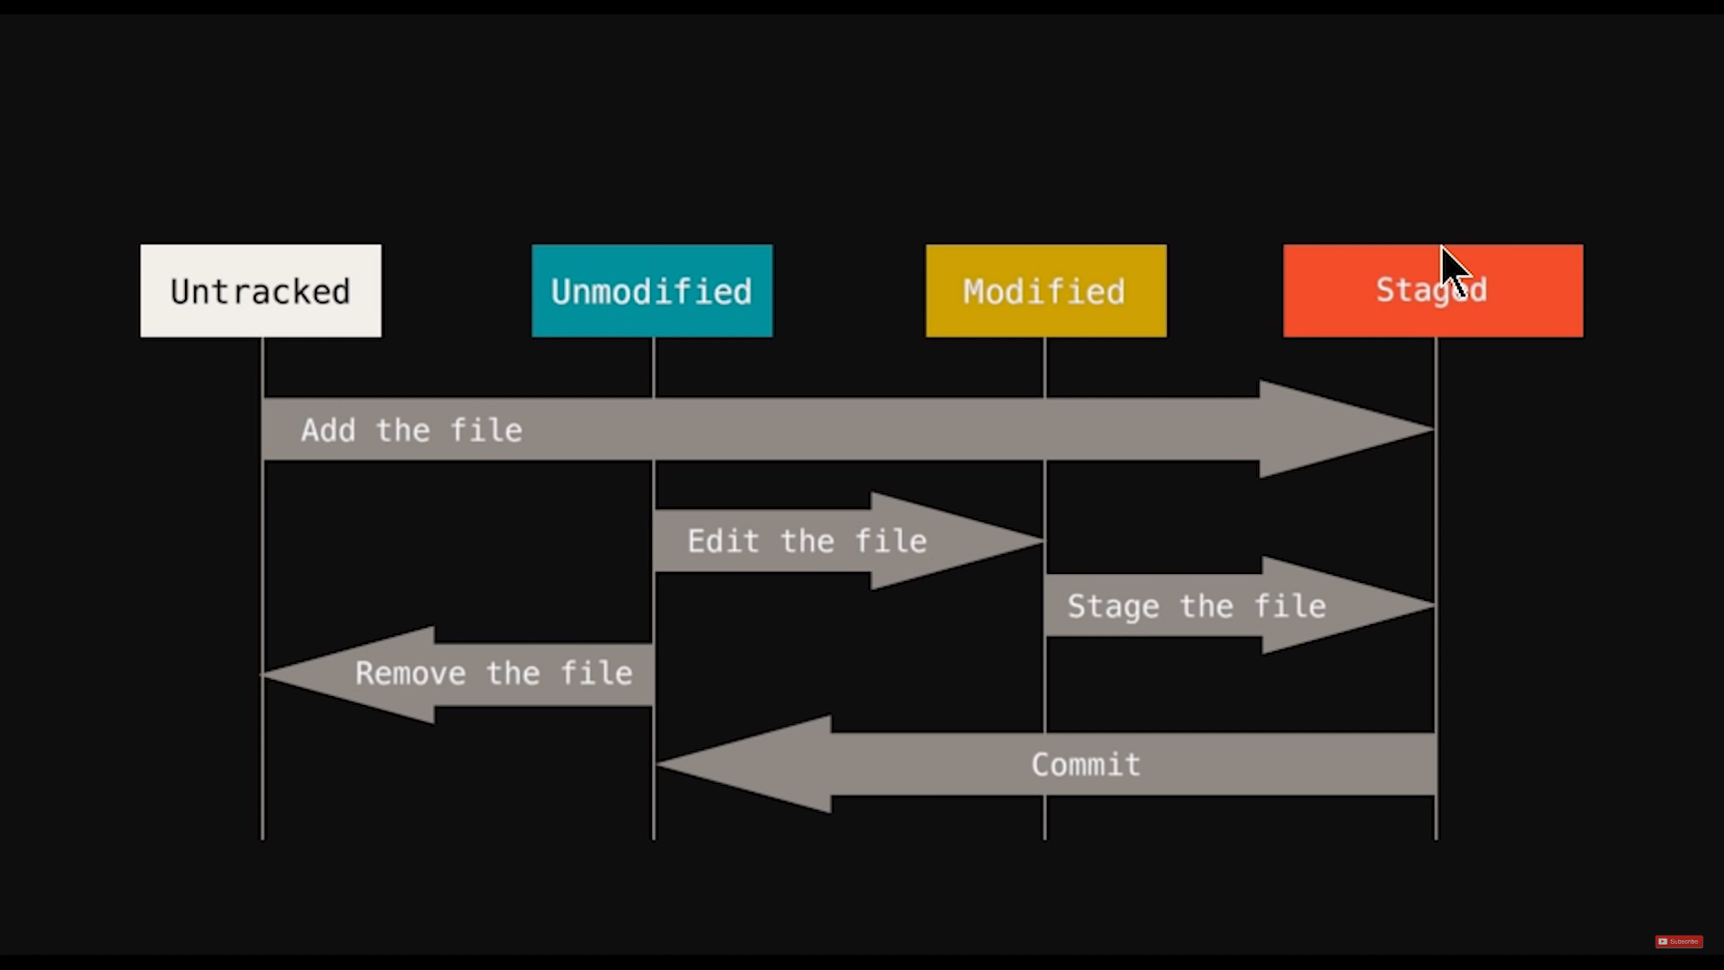

1. Branching Strategies:
Learn about different branching strategies like Git Flow, GitHub Flow, and Feature Branching. These strategies provide guidelines for managing branches in larger projects and teams.

Git Flow:

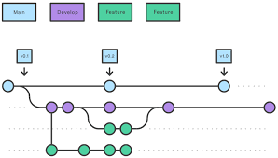

Git Flow is a branching model designed for managing larger projects with more complex development and release cycles. It defines specific branches for different purposes:

Master Branch (main):
The master branch holds stable, production-ready code. It only receives updates from release and hotfix branches.

Develop Branch:
The develop branch is the integration branch where ongoing development takes place. Feature branches are merged into this branch for testing.

Feature Branches:
Developers create feature branches for individual features or tasks. These branches are based on develop and merged back when the feature is complete.

Release Branches:
release branches are created to prepare for a new release. Final testing and last-minute adjustments take place here before merging into master and develop.

Hotfix Branches:
hotfix branches are used to quickly address critical issues in the production codebase. They're based on master, fixed, and merged back into both master and develop.

GitHub Flow:

GitHub Flow simplifies the development process, emphasizing a more continuous deployment strategy:

1. Main Branch (`main` or `master`):
The main branch (GitHub suggests `main`) holds the production-ready code.

2. Feature Branches:
Developers create a new branch for each feature or task. These branches are based on `main`.

3. Pull Requests:
Once a feature is complete, developers create a pull request (PR) to merge their branch into `main`.

4. Code Review:
PRs undergo code review and testing. Feedback and adjustments are made directly on the feature branch.

5. Merge to Main:
Once the PR is approved, the changes are merged into the main branch. This triggers deployment.

Feature Branching:

Feature branching is a more flexible strategy that revolves around creating branches for individual features or tasks. It's a bit less prescriptive compared to Git Flow and GitHub Flow:

1. Main Branch (`main` or `master`):
The main branch holds the stable, production-ready code.

2. Feature Branches:
Developers create a new branch for each feature or task. These branches are based on `main`.

3. Development and Testing:
Developers work on the feature branch, committing changes and testing.

4. Code Review and Integration:
Once the feature is ready, the code is reviewed and tested. If approved, the changes are merged back into the main branch.

Each of these branching strategies has its own strengths and weaknesses, and the choice often depends on the development team's workflow, project requirements, and the team's familiarity with the process. It's important to find the strategy that best fits your team's needs.

2. Merging and Rebasing:
Understand the differences between merging and rebasing. Rebasing can help keep your commit history cleaner by integrating changes from one branch into another.

3. Resolving Conflicts:
Study how to resolve merge conflicts that can arise when Git can't automatically merge changes. Learn how to manually edit conflicting areas in files.

4. Git Reset and Revert:
Explore how to use `git reset` to undo commits and `git revert` to create a new commit that undoes the changes introduced by a previous commit.

5. Git Stash:
Learn how to use `git stash` to temporarily save changes that you're not ready to commit yet, allowing you to switch branches or perform other tasks.

6. Remote Repositories and Collaboration:
Dive into remote repositories, learn how to clone, fetch, pull, and push changes to remote servers like GitHub or GitLab. Explore collaboration workflows with pull requests.

7. Git Ignore:
Understand how to use `.gitignore` files to specify files or directories that Git should ignore when tracking changes. This is useful for ignoring build artifacts, temporary files, and sensitive information.

8. Submodules and Subtrees:
Explore how to include other repositories within your repository using submodules or subtrees. This can be useful for including external libraries or dependencies.

9. Git Hooks:
Learn about Git hooks, which are scripts that can be executed before or after certain Git actions like committing, pushing, or merging.

10. Interactive Rebasing:
Discover how to interactively rebase your commits using `git rebase -i`, allowing you to reorder, squash, edit, and even drop commits.

