PYTHON-2

1. Expressions in Python
An expression is a combination of operators and operands that is interpreted to produce some other value. In any programming language, an expression is evaluated as per the precedence of its operators. So that if there is more than one operator in an expression, their precedence decides which operation will be performed first. We have many different types of expressions in Python. Let’s discuss all types along with some exemplar codes :
1. Constant Expressions: These are the expressions that have constant values only.
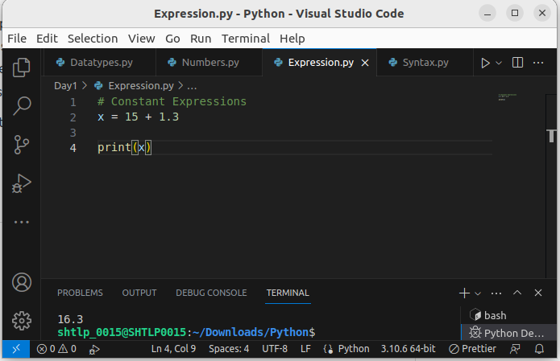
2. Arithmetic Expressions: An arithmetic expression is a combination of numeric values, operators, and sometimes parenthesis. The result of this type of expression is also a numeric value. The operators used in these expressions are arithmetic operators like addition, subtraction, etc. Here are some arithmetic operators in Python:
Operators | Syntax | Functioning
+ | x + y | Addition
– | x – y | Subtraction
* | x * y | Multiplication
/ | x / y | Division
// | x // y | Quotient
% | x % y | Remainder
** | x ** y | Exponentiation
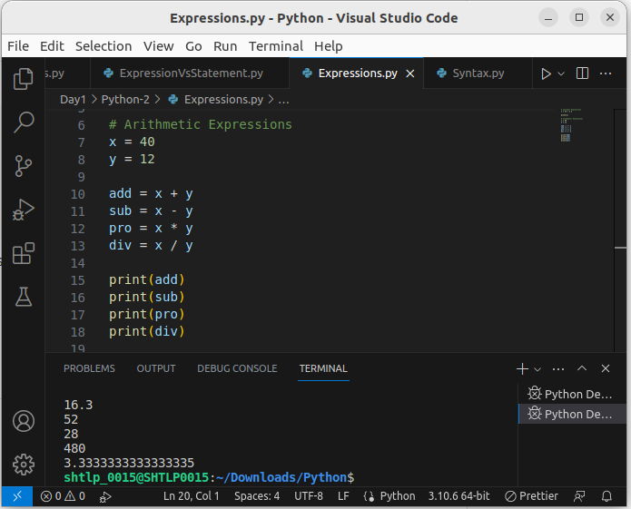
.
3. Integral Expressions: These are the kind of expressions that produce only integer results after all computations and type conversions.
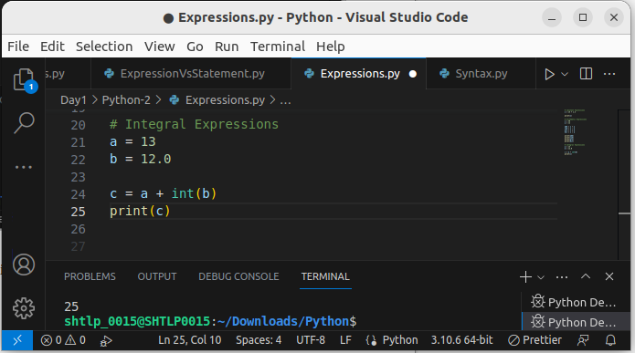
4. Floating Expressions: These are the kind of expressions which produce floating point numbers as result after all computations and type conversions.
Example:
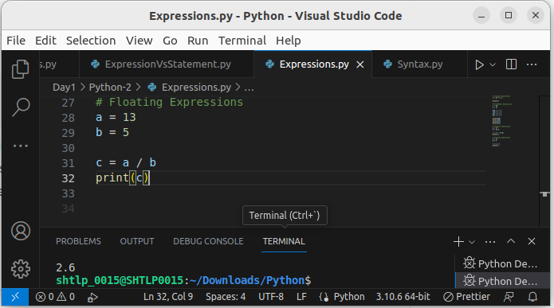
.
5. Relational Expressions: In these types of expressions, arithmetic expressions are written on both sides of relational operator (> , < , >= , <=). Those arithmetic expressions are evaluated first, and then compared as per relational operator and produce a boolean output in the end. These expressions are also called Boolean expressions.
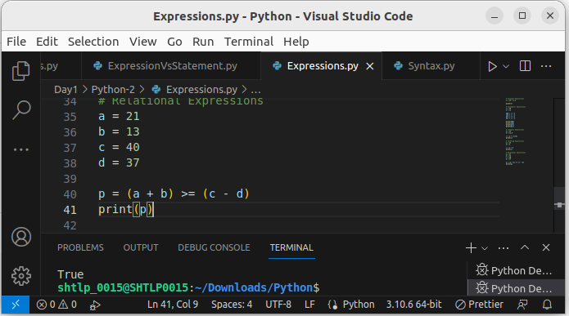
.
6. Logical Expressions: These are kinds of expressions that result in either True or False. It basically specifies one or more conditions. For example, (10 == 9) is a condition if 10 is equal to 9. As we know it is not correct, so it will return False. Studying logical expressions, we also come across some logical operators which can be seen in logical expressions most often. Here are some logical operators in Python:
Operator | Syntax | Functioning
and | P and Q | It returns true if both P and Q are true otherwise returns false
or | P or Q | It returns true if at least one of P and Q is true
not | not P | It returns true if condition P is false
Example:
Let’s have a look at an examplar code :
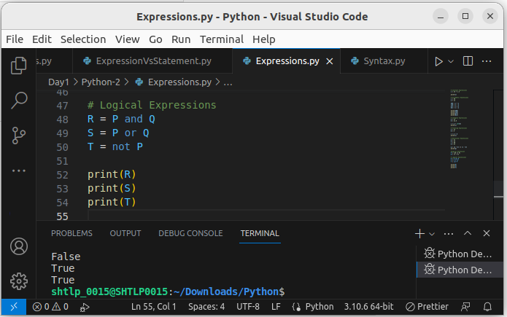
.

7. Bitwise Expressions: These are the kind of expressions in which computations are performed at bit level.
Example:
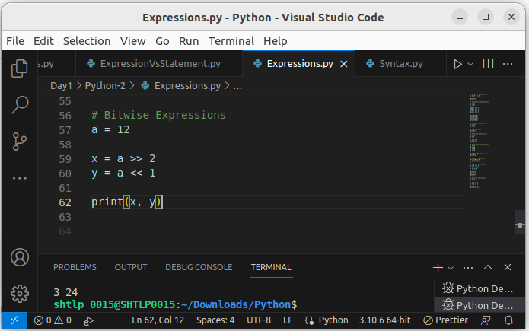
.
8. Combinational Expressions: We can also use different types of expressions in a single expression, and that will be termed as combinational expressions.
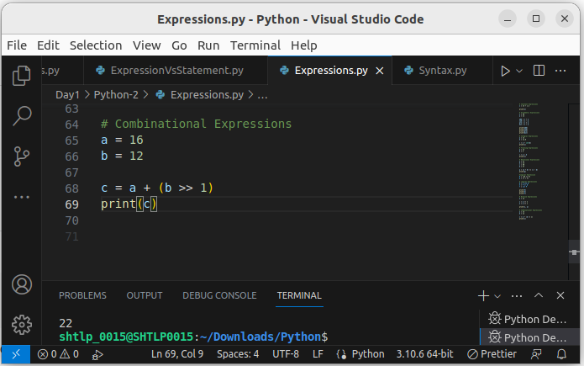
.

2. Multiple operators in expression (Operator Precedence)
It’s a quite simple process to get the result of an expression if there is only one operator in an expression. But if there is more than one operator in an expression, it may give different results on basis of the order of operators executed. To sort out these confusions, the operator precedence is defined. Operator Precedence simply defines the priority of operators that which operator is to be executed first. Here we see the operator precedence in Python, where the operator higher in the list has more precedence or priority:
Precedence | Name | Operator
1 | Parenthesis | ( ) [ ] { }
2 | Exponentiation | **
3 | Unary plus or minus, complement | -a , +a , ~a
4 | Multiply, Divide, Modulo | / * // %
5 | Addition & Subtraction | + –
6 | Shift Operators | >> <<
7 | Bitwise AND | &
8 | Bitwise XOR | ^
9 | Bitwise OR | |
10 | Comparison Operators | >= <= > <
11 | Equality Operators | == !=
12 | Assignment Operators | = += -= /= *=
13 | Identity and membership operators | is, is not, in, not in
14 | Logical Operators | and, or, not
.
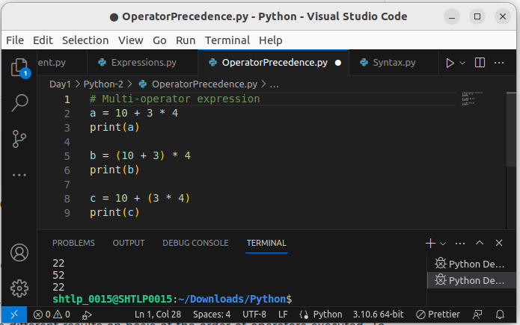
.

3.Math Functions
Python has a set of built-in math functions, including an extensive math module, that allows you to perform mathematical tasks on numbers.

Built-in Math Functions
The min() and max() functions can be used to find the lowest or highest value in an iterable:
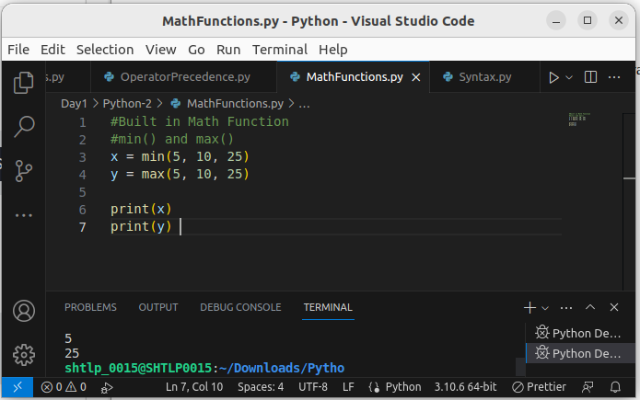
.
The abs() function returns the absolute (positive) value of the specified number:
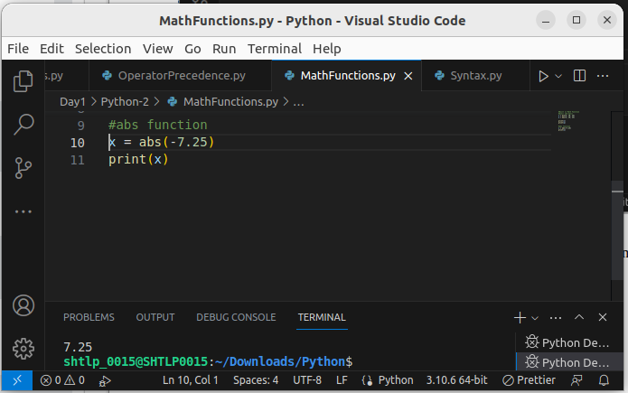
.
The pow(x, y) function returns the value of x to the power of y (xy).
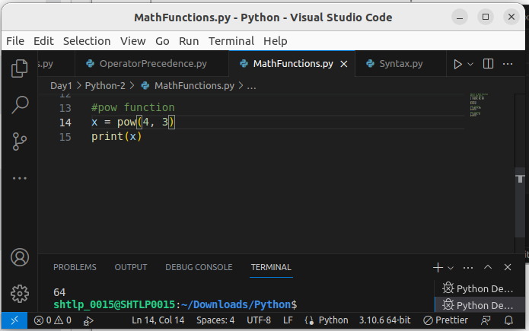
.

4. The Math Module
Python has also a built-in module called math, which extends the list of mathematical functions.
To use it, you must import the math module:
import math

When you have imported the math module, you can start using methods and constants of the module.
The math.sqrt() method for example, returns the square root of a number:
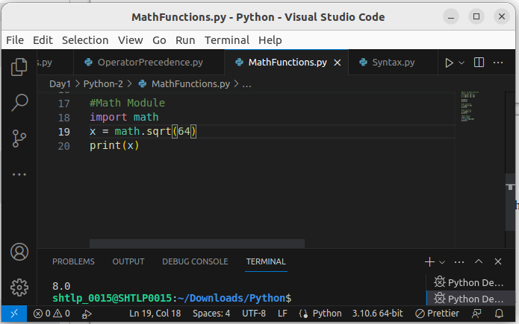
.
The math.ceil() method rounds a number upwards to its nearest integer, and the math.floor() method rounds a number downwards to its nearest integer, and returns the result:
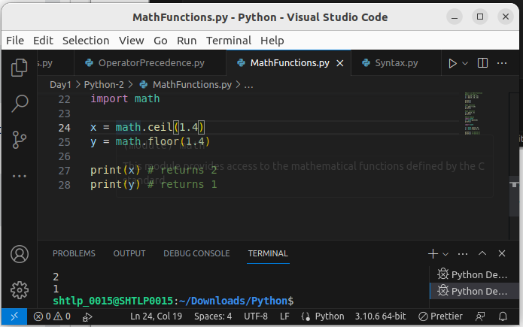
.
The math.pi constant, returns the value of PI (3.14...):
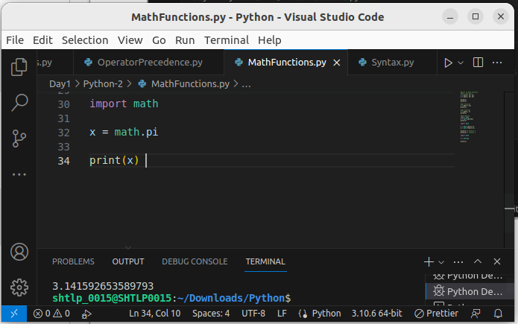
.

5. Python Operator

1.Python Arithmetic Operators
Arithmetic operators are used with numeric values to perform common mathematical operations:

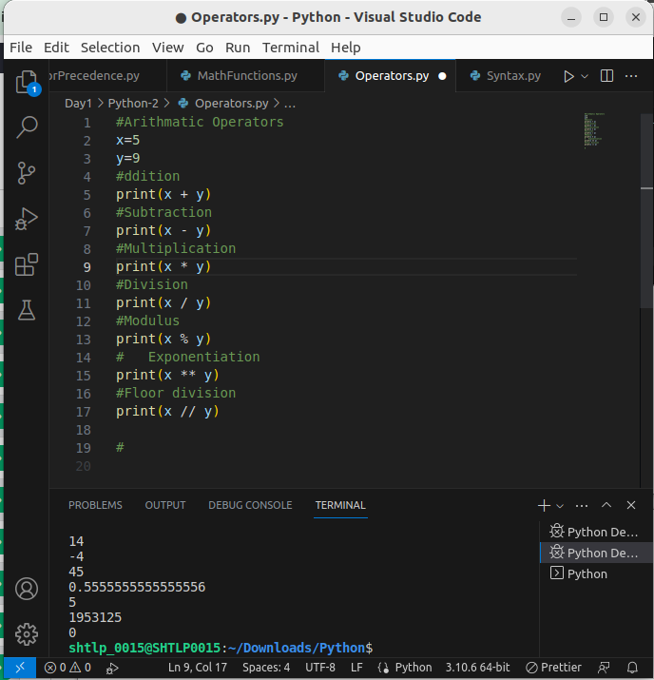
.

2. Python Assignment Operators
Assignment operators are used to assign values to variables:
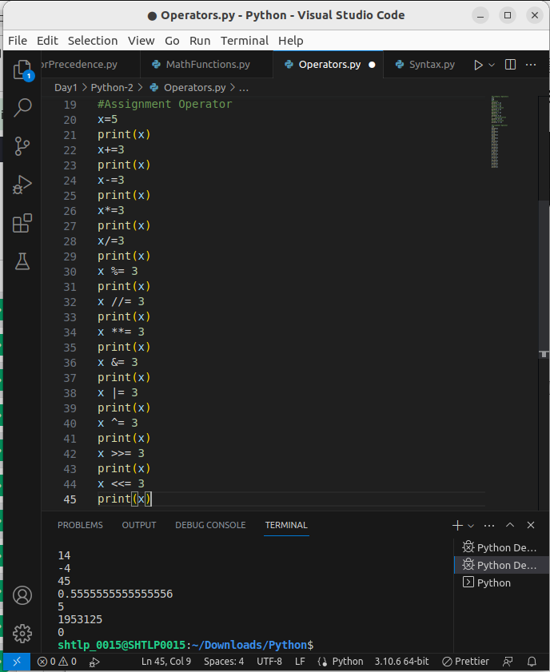
.

3.Python Comparison Operators
Comparison operators are used to compare two values:
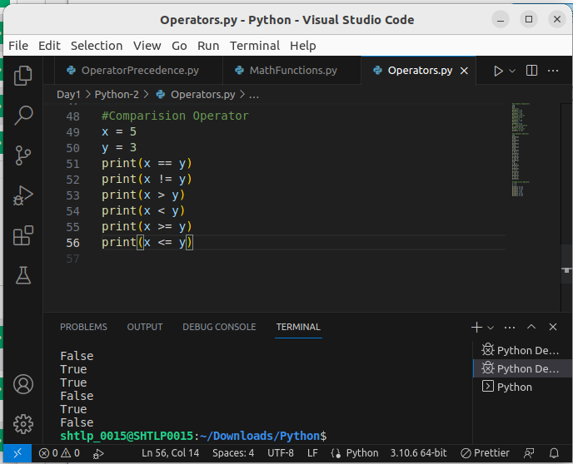
.

4. Logical Operators
Logical operators are used to combine conditional statements:

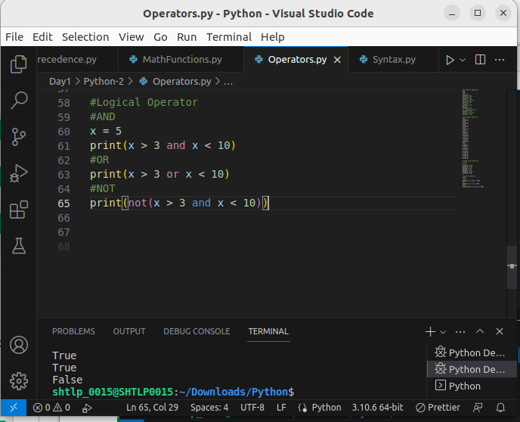
.

5. Python Identity Operators
Identity operators are used to compare the objects, not if they are equal, but if they are actually the same object, with the same memory location:
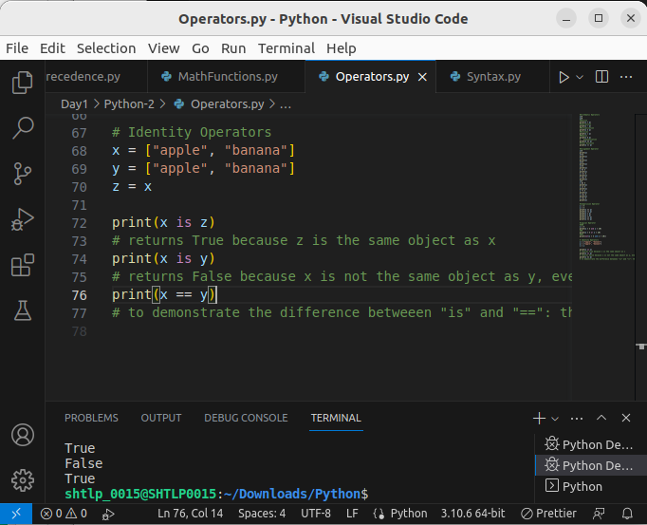
.
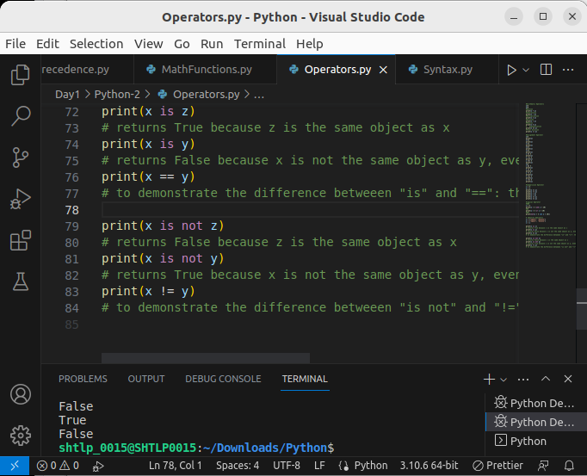

6.Python Membership Operators
Membership operators are used to test if a sequence is presented in an object:
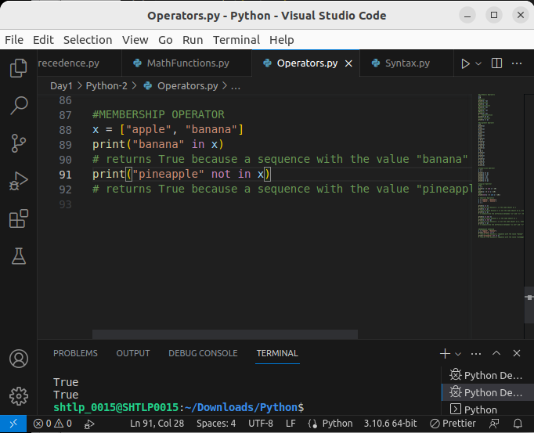
.

6.Python Casting
Casting in python is therefore done using constructor functions:
- int() - constructs an integer number from an integer literal, a float literal (by removing all decimals), or a string literal (providing the string represents a whole number)
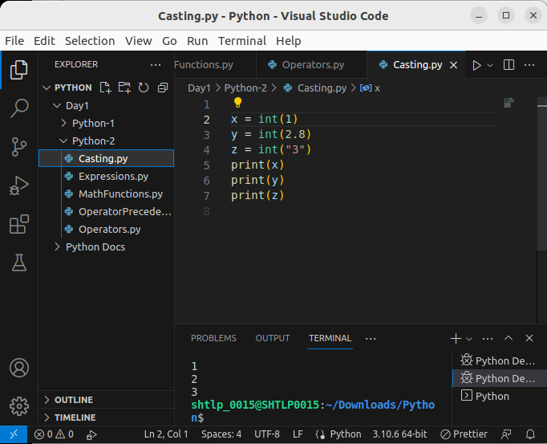
- float() - constructs a float number from an integer literal, a float literal or a string literal (providing the string represents a float or an integer)
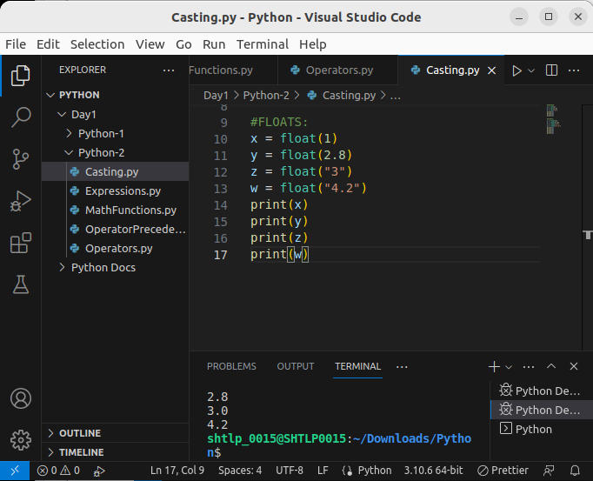
- str() - constructs a string from a wide variety of data types, including strings, integer literals and float literals
.
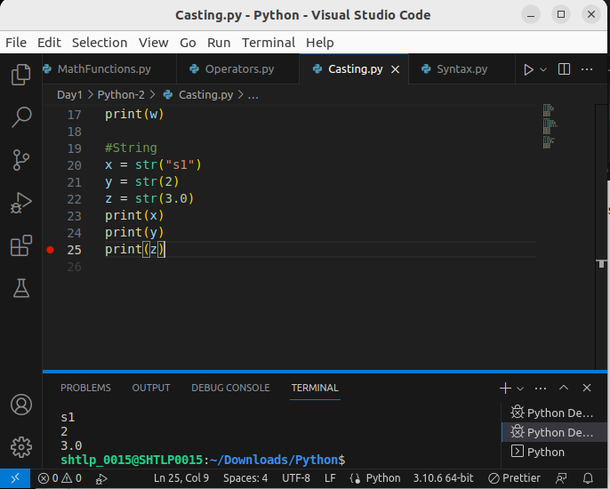

7. Python Strings

1.Strings
Strings in python are surrounded by either single quotation marks, or double quotation marks.
'hello' is the same as "hello".
You can display a string literal with the print() function:
String can assign a multiline string to a variable by using three quotes:
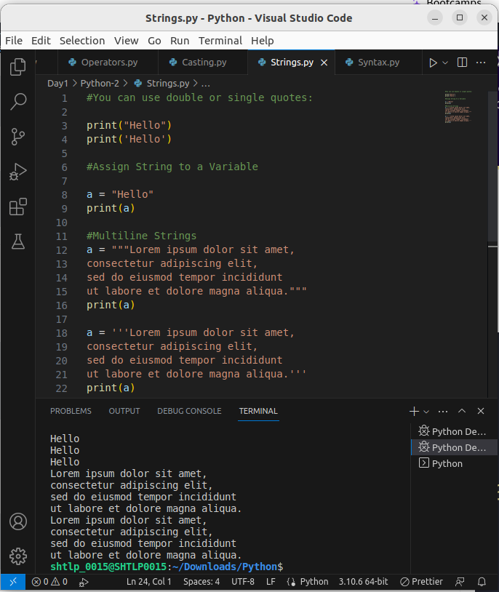
.

Strings are Arrays
Like many other popular programming languages, strings in Python are arrays of bytes representing unicode characters.
However, Python does not have a character data type, a single character is simply a string with a length of 1.
Square brackets can be used to access elements of the string.

Example
Get the character at position 1 (remember that the first character has the position 0):
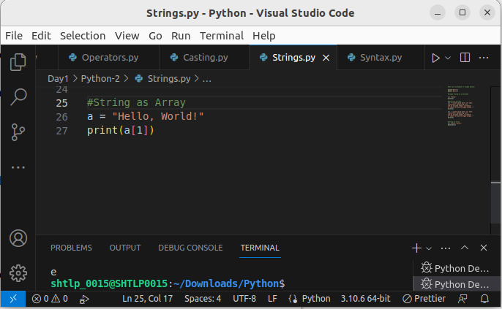

Looping Through a String
Since strings are arrays, we can loop through the characters in a string, with a for loop.

Example
Loop through the letters in the word "banana":
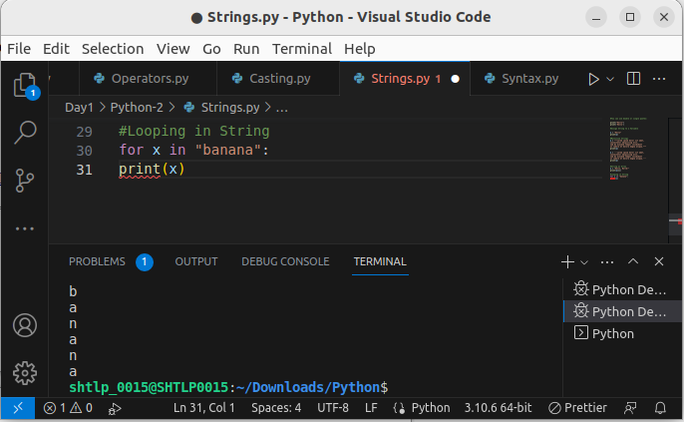

String Length
To get the length of a string, use the len() function.

Example
The len() function returns the length of a string:
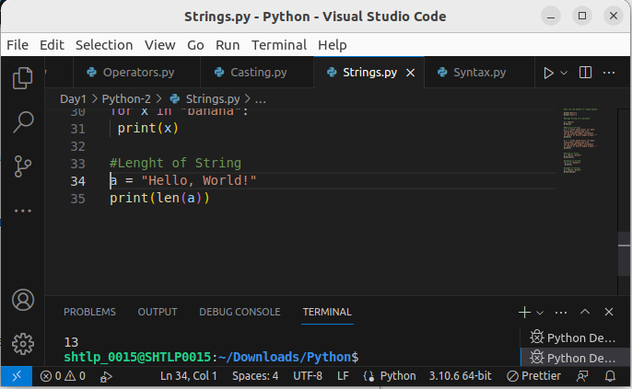

Check String
To check if a certain phrase or character is present in a string, we can use the keyword in.

Example
Check if "free" is present in the following text:
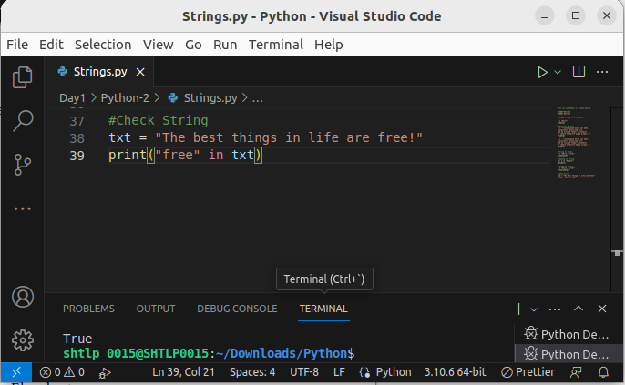
Use it in an if statement:

Example
Print only if "free" is present:
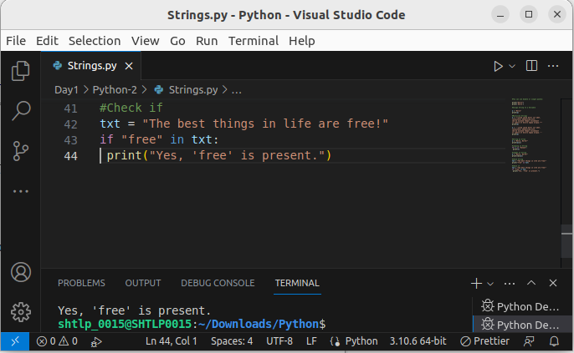

Check if NOT
To check if a certain phrase or character is NOT present in a string, we can use the keyword not in.

Example
Check if "expensive" is NOT present in the following text:
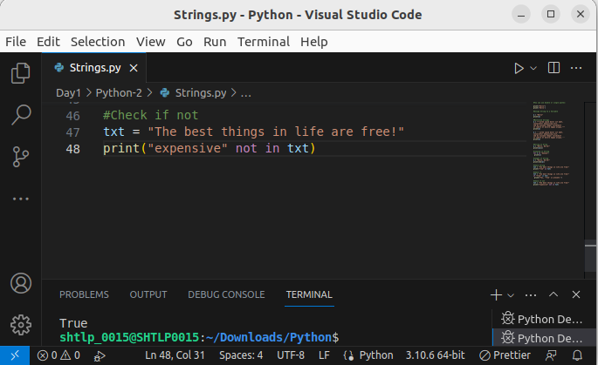
Use it in an if statement:

Example
print only if "expensive" is NOT present:
