SQL
INTRODUCTION TO SQL

What is SQL?
- SQL stands for Structured Query Language
- SQL lets you access and manipulate databases
- SQL became a standard of the American National Standards Institute (ANSI) in 1986, and of the International Organization for Standardization (ISO) in 1987

RDBMS
RDBMS stands for Relational Database Management System.
RDBMS is the basis for SQL, and for all modern database systems such as MS SQL Server, IBM DB2, Oracle, MySQL, and Microsoft Access.
The data in RDBMS is stored in database objects called tables. A table is a collection of related data entries and it consists of columns and rows.

What is Database?
A database is an application that stores the organized collection of records. It can be accessed and manage by the user very easily. It allows us to organize data into tables, rows, columns, and indexes to find the relevant information very quickly. Each database contains distinct API for performing database operations such as creating, managing, accessing, and searching the data it stores. Today, many databases available like MySQL, Sybase, Oracle, MongoDB, PostgreSQL, SQL Server, etc. In this section, we are going to focus on MySQL mainly.

What is MySQL?
MySQL is currently the most popular database management system software used for managing the relational database. It is open-source database software, which is supported by Oracle Company. It is fast, scalable, and easy to use database management system in comparison with Microsoft SQL Server and Oracle Database. It is commonly used in conjunction with PHP scripts for creating powerful and dynamic server-side or web-based enterprise applications.

INSTALLING MYSQL

1. sudo apt update:
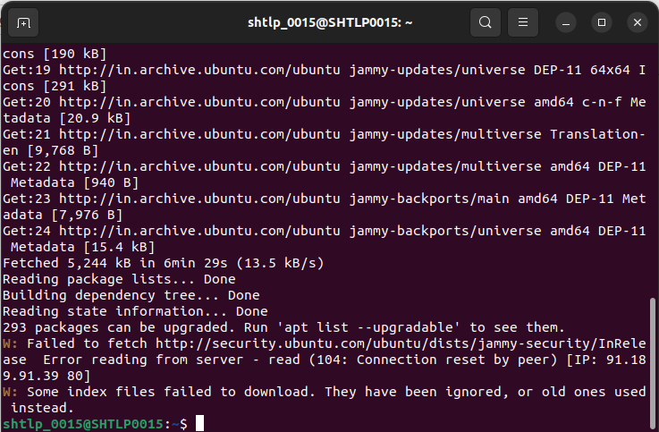
.
2.sudo apt install mysql-server
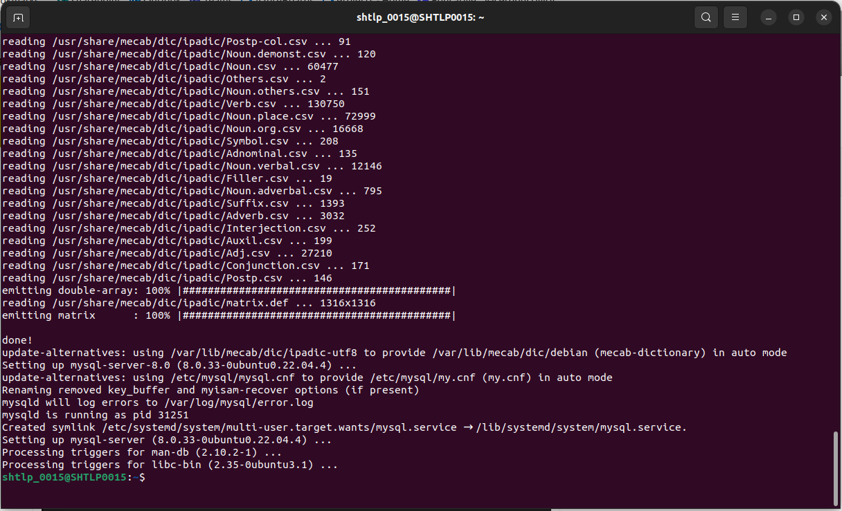
.
3. mysql –version

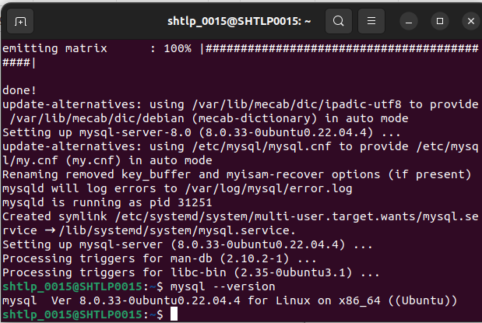
.
4.sudo mysql_secure_installation
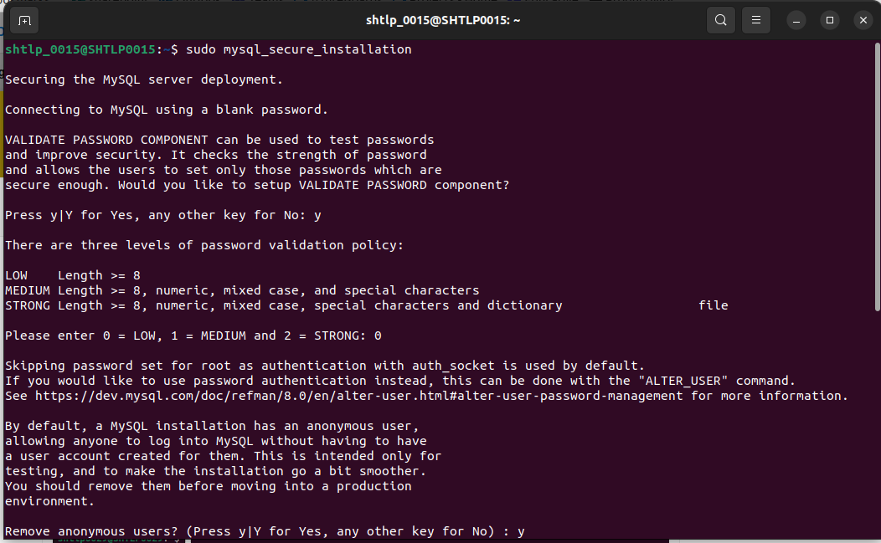
.
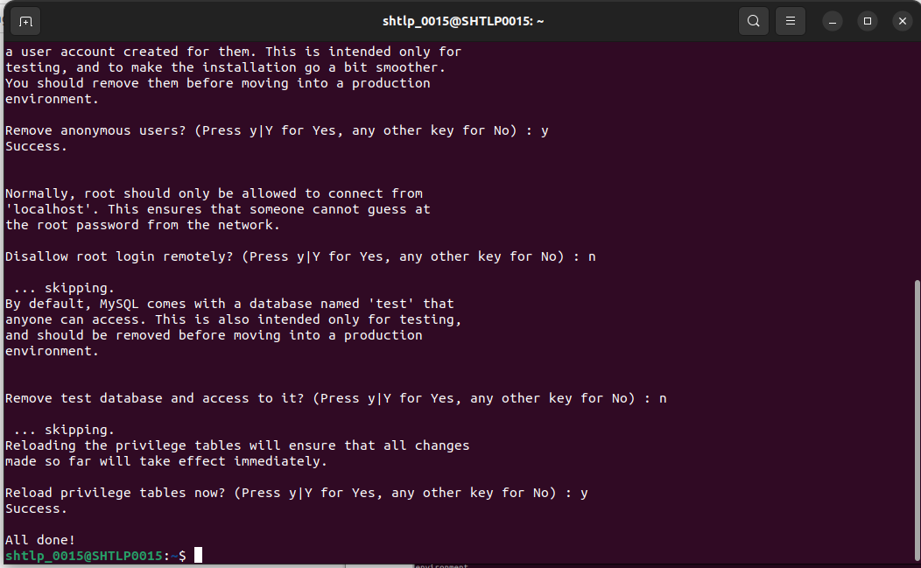
5. sudo mysql : to enter into sql environment
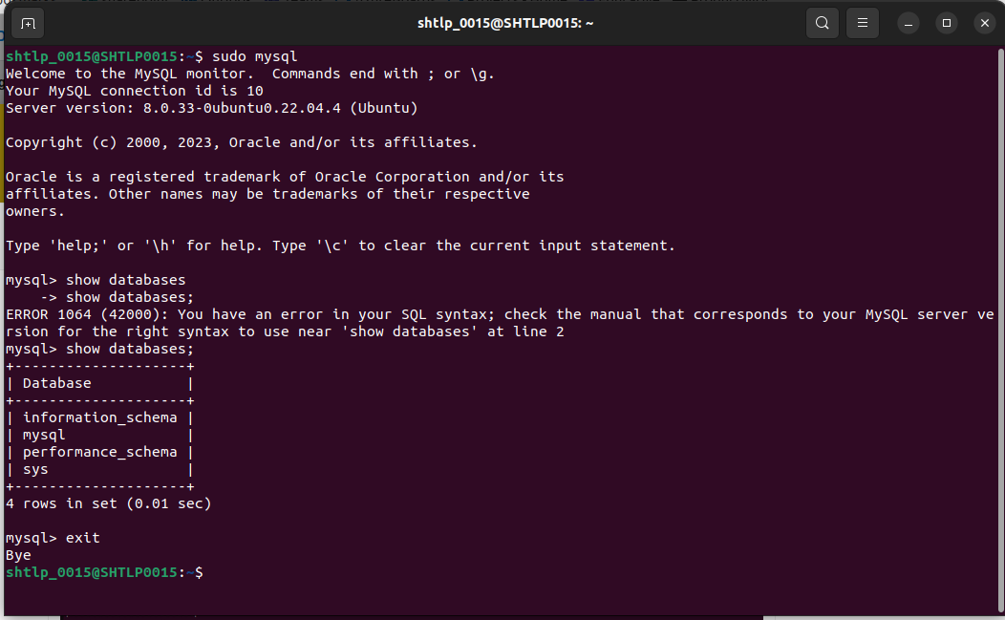
.

6. setting up the password for root user.

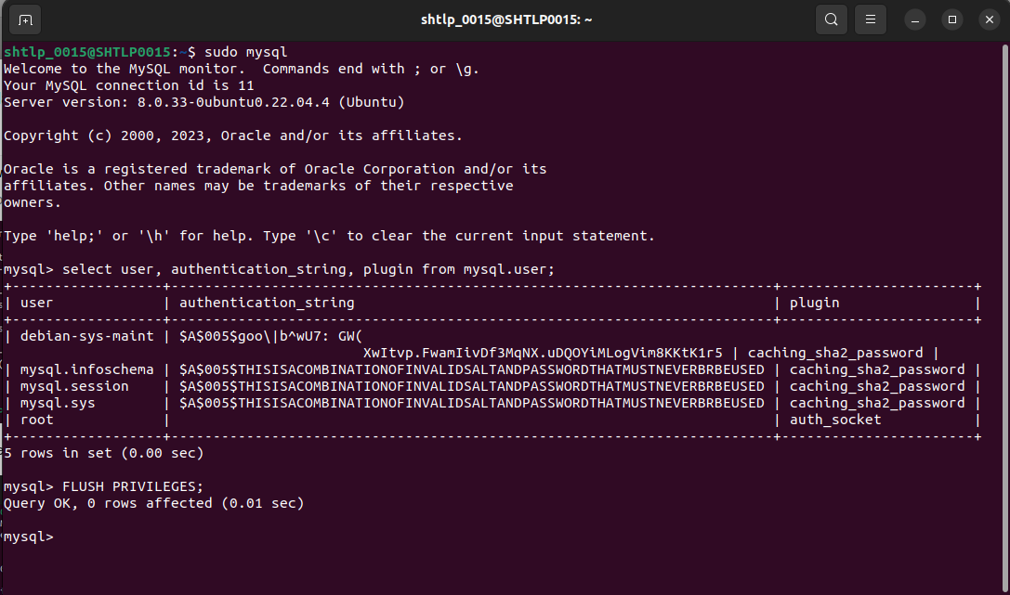
.
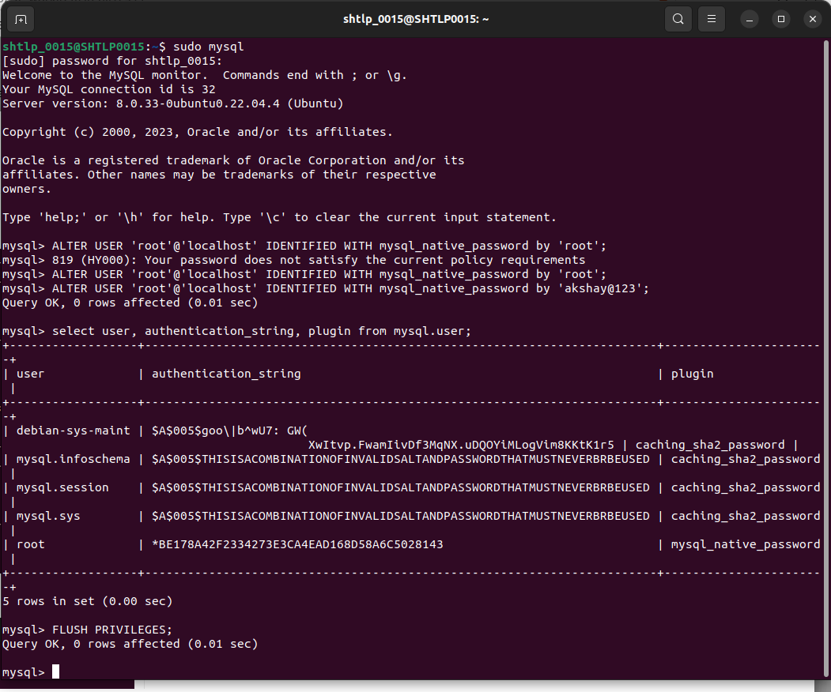
7.Logging in using password.
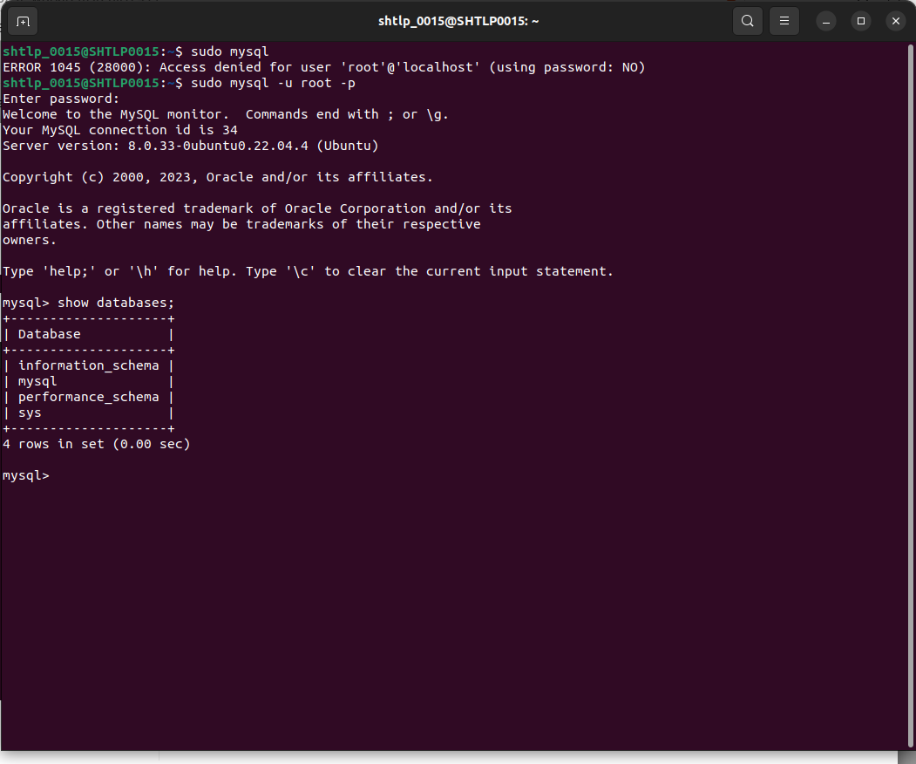
.

SET UP MYSQL WORKBENCH

8. Installing mysql workbench from ubuntu software.

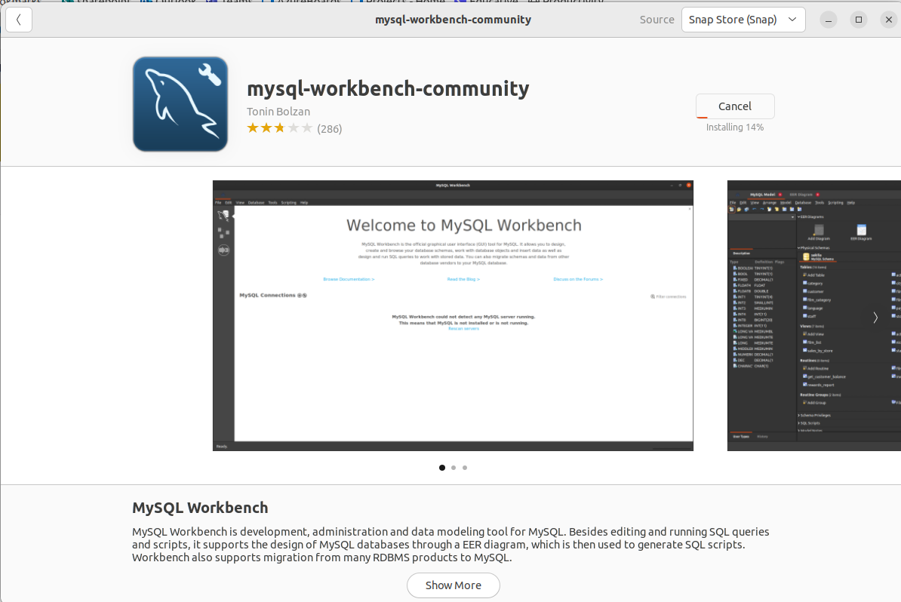
.

9. opening mysql workbench software.

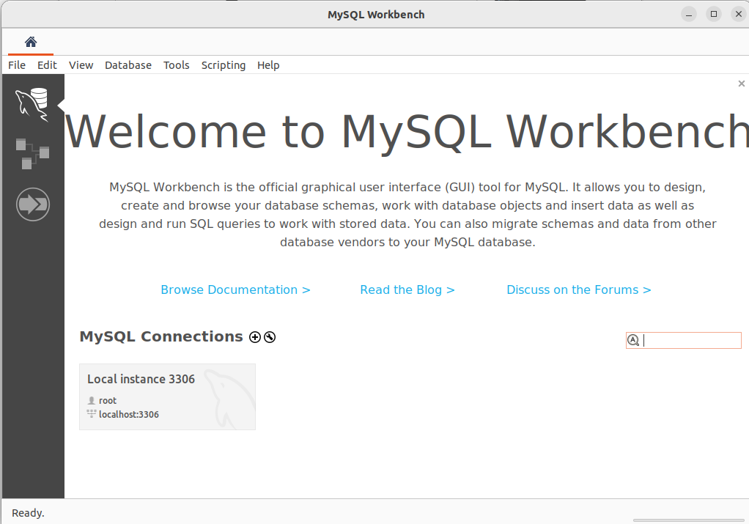
.

10. creating a new connection as LOCAL_MYSQL

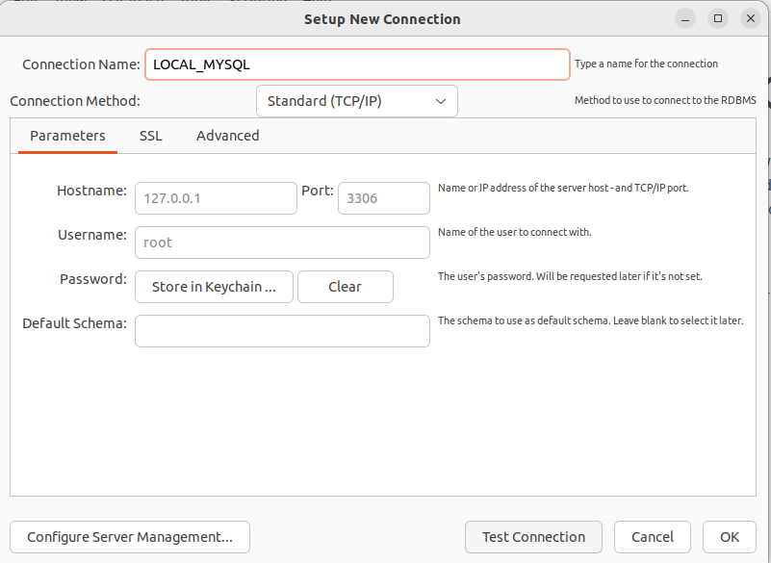
.

11. Test Connection :

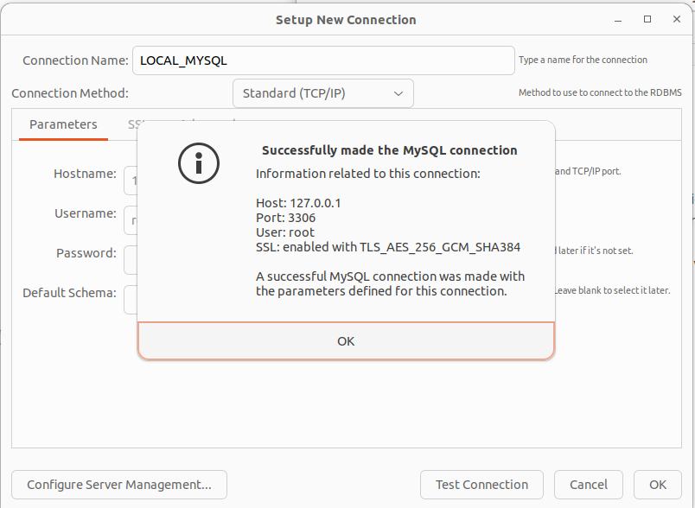
.

12. Executing queries on MYSQL WORKBENCH.

