SQL-2

1. SQL:
Structured Query Language, used to access and manipulate data.SQL is a standard language for storing, manipulating and retrieving data in databases.
Our SQL tutorial will teach you how to use SQL in: MySQL, SQL Server, MS Access, Oracle, Sybase, Informix, Postgres, and other database systems.

2. Creating temporary database:
The CREATE DATABASE statement is used to create a new SQL database.

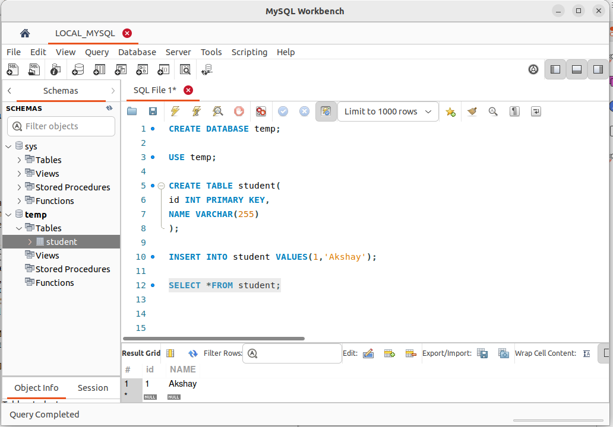

3. SQL used CRUD operations to communicate with DB.
1. CREATE - execute INSERT statements to insert new tuple into the relation.

2. READ - Read data already in the relations.

3. UPDATE - Modify already inserted data in the relation.

4. DELETE - Delete specific data point/tuple/row or multiple rows.

4. SQL is not DB, is a query language.

Actually, SQL (Structured Query Language) is both a query language and a database management system (DBMS) language. It is primarily used for managing and manipulating relational databases. Let me clarify the two main aspects of SQL:
1. Query Language: As you correctly stated, SQL is a query language. It is used to retrieve, insert, update, and delete data from a database. With SQL, you can write specific commands known as queries that interact with the database to perform various operations on the data.
For example, some common SQL queries include:
- SELECT: Retrieve data from the database.
- INSERT: Insert new records into a table.
- UPDATE: Modify existing records in a table.
- DELETE: Remove records from a table.
2. Database Management System (DBMS) Language: SQL is also the standard language used by most relational database management systems. These systems use SQL as the interface through which users can interact with the database, manage its structure, and perform various operations.
Some popular relational database management systems that use SQL as their language include MySQL, PostgreSQL, Oracle, Microsoft SQL Server, and SQLite.
In summary, SQL is a query language used to interact with relational databases, and it is the standard language for managing data in most relational database management systems.

5. What is RDBMS? (Relational Database Management System)
1. Software that enable us to implement designed relational model.
2. e.g., MySQL, MS SQL, Oracle, IBM etc.
3. Table/Relation is the simplest form of data storage object in R-DB.
4. MySQL is open-source RDBMS, and it uses SQL for all CRUD operations
5. MySQL used client-server model, where client is CLI or frontend that used services provided by MySQL server.

6. Difference between SQL and MySQL

SQL and MySQL are related but distinct concepts:
1. SQL (Structured Query Language):
SQL is a standardized programming language used for managing relational databases. It is used to perform various operations on data, such as querying, inserting, updating, and deleting records in a database. SQL is not a specific database management system, but rather a language that is used across many different database systems.
SQL provides a standard syntax and set of commands that can be used with different database management systems, allowing users to interact with the databases in a consistent manner. The same SQL commands can be used with different database systems like MySQL, PostgreSQL, Oracle, SQL Server, etc.
2. MySQL:
MySQL, on the other hand, is a specific relational database management system (RDBMS) that uses SQL as its query language. It was developed by MySQL AB, which was later acquired by Oracle Corporation. MySQL is open-source software and is widely used for various applications, including web development, content management systems, and data-driven applications.
Key differences:
- SQL is a language, while MySQL is a specific database management system that uses SQL.
- SQL is a standard language used by multiple database management systems, whereas MySQL is just one of those systems.
- MySQL is an open-source RDBMS, meaning it is freely available for use and can be modified, while some other database systems may be commercial or have different licensing models.
- SQL syntax is consistent across different database systems, but each database system (including MySQL) may have its own extensions and additional features beyond the standard SQL commands.
In summary, SQL is a query language used across multiple database systems, and MySQL is a specific open-source relational database management system that uses SQL for data manipulation and management.

7. Types of SQL commands:

1. DDL (data definition language): defining relation schema.

- CREATE: create table, DB, view.
- ALTER TABLE: modification in table structure. e.g, change column datatype or add/remove columns
- DROP: delete table, DB, view.
- TRUNCATE: remove all the tuples from the table.
- RENAME: rename DB name, table name, column name etc.

2. DRL/DQL (data retrieval language / data query language): retrieve data from the tables.

- SELECT

3.DML (data modification language): use to perform modifications in the DB

- INSERT: insert data into a relation
- UPDATE: update relation data.
- DELETE: delete row(s) from the relation.

4. DCL (Data Control language): grant or revoke authorities from user.

- GRANT: access privileges to the DB
- REVOKE: revoke user access privileges.

5. TCL (Transaction control language): to manage transactions done in the DB

- START TRANSACTION: begin a transaction
- COMMIT: apply all the changes and end transaction
- ROLLBACK: discard changes and end transaction
- SAVEPOINT: checkout within the group of transactions in which to rollback.

Managing Database (DDL)

- CREATION OF DATABASE IF NOT EXIST temp;
- USE temp
- CREATE TABLE
- INSERT INTO table_name VALUES ();// To insert row into a table
- SHOW DATABASES// list tables in the selected database

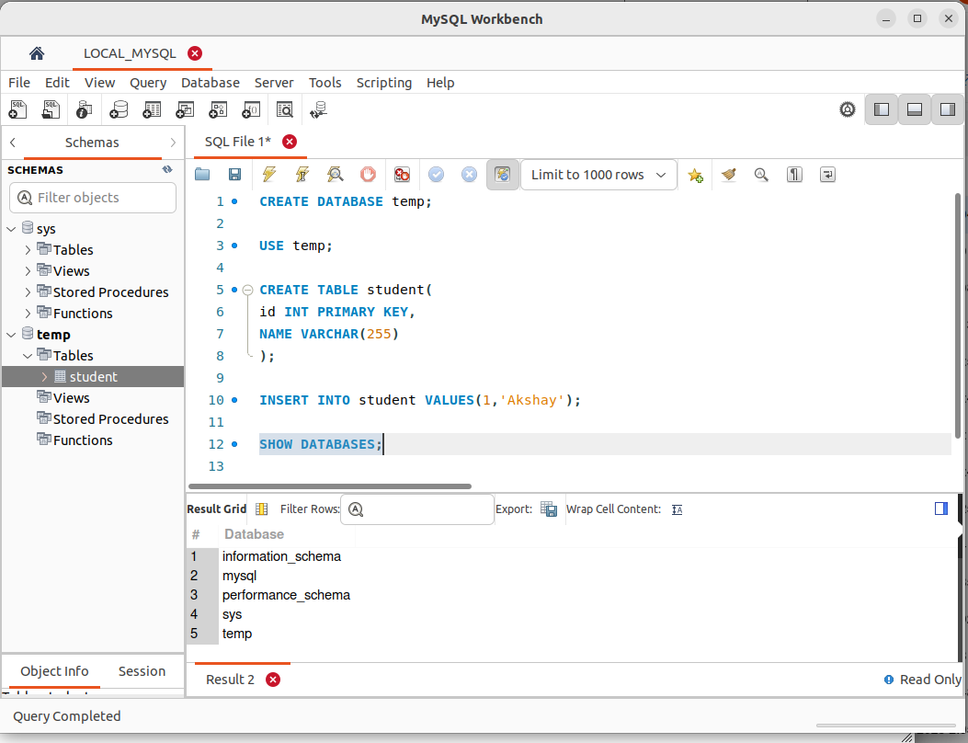
.

- SHOW TABLES: list table in the selected database
