SQL-3

1.Introduction to DRL/DSL
- DRL/DSL stands for Data Retrieval Language/Data Selection Language.
- It is a set commands which are used to retrieve data from database server.
- It manipulates the data in database for display purpose like aggregate function.
- In DRL/DSL, for accessing the data it uses the DML command that is SELECT.
- The SELECT command allows database users to retrieve the specific information they desire from an operational database.

CREATING DATABASE ORG:
ORG DATABASE have three TABLES Worker, Bonus , Title . Following are the screenshots :

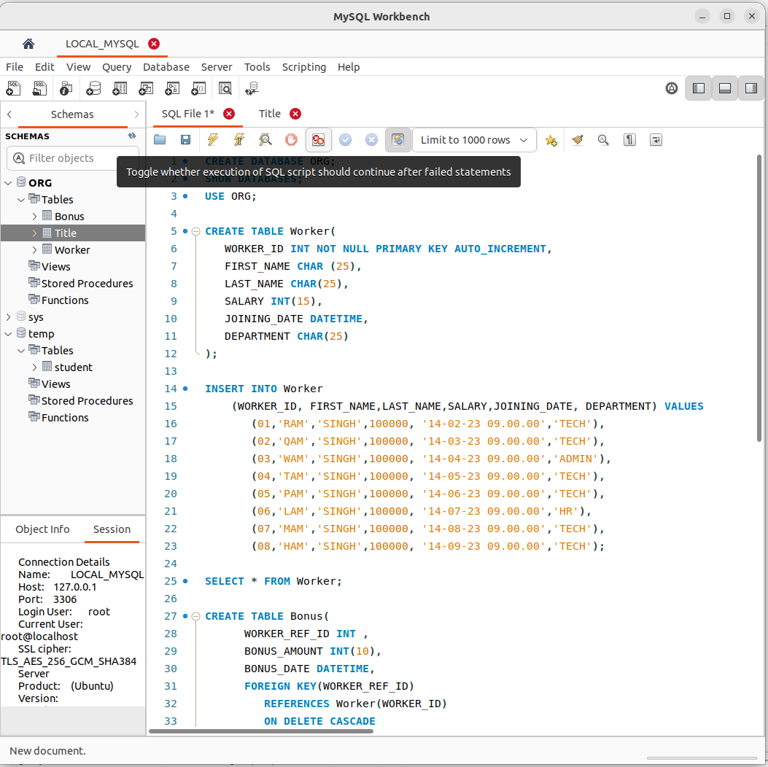
.
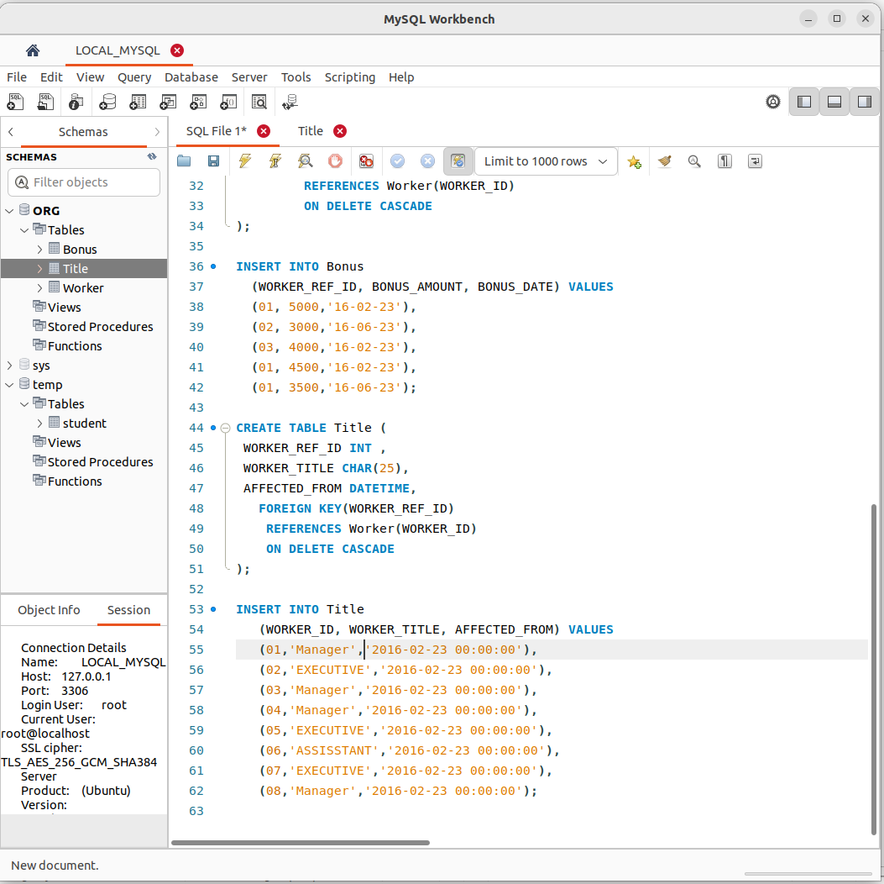

What is ER Diagram?
ER Diagram stands for Entity Relationship Diagram, also known as ERD is a diagram that displays the relationship of entity sets stored in a database. In other words, ER diagrams help to explain the logical structure of databases. ER diagrams are created based on three basic concepts: entities, attributes and relationships.
ER Diagrams contain different symbols that use rectangles to represent entities, ovals to define attributes and diamond shapes to represent relationships.
At first look, an ER diagram looks very similar to the flowchart. However, ER Diagram includes many specialized symbols, and its meanings make this model unique. The purpose of ER Diagram is to represent the entity framework infrastructure.

2.What is an EER diagram?
Enhanced entity-relationship (EER) diagrams are basically a more expansive version of ER diagrams. EER models are helpful tools for designing databases with high-level models. With their enhanced features, you can plan databases more thoroughly by delving into the properties and constraints with greater precision.
An EER diagram provides you with all the elements of an ER diagram while adding:
- Attribute or relationship inheritances
- Category or union types
- Specialization and generalization
- Subclasses and superclasses
Overall, an EER diagram builds off of an ER diagram by including elements that allow for aggregation, generalization, and specialization.

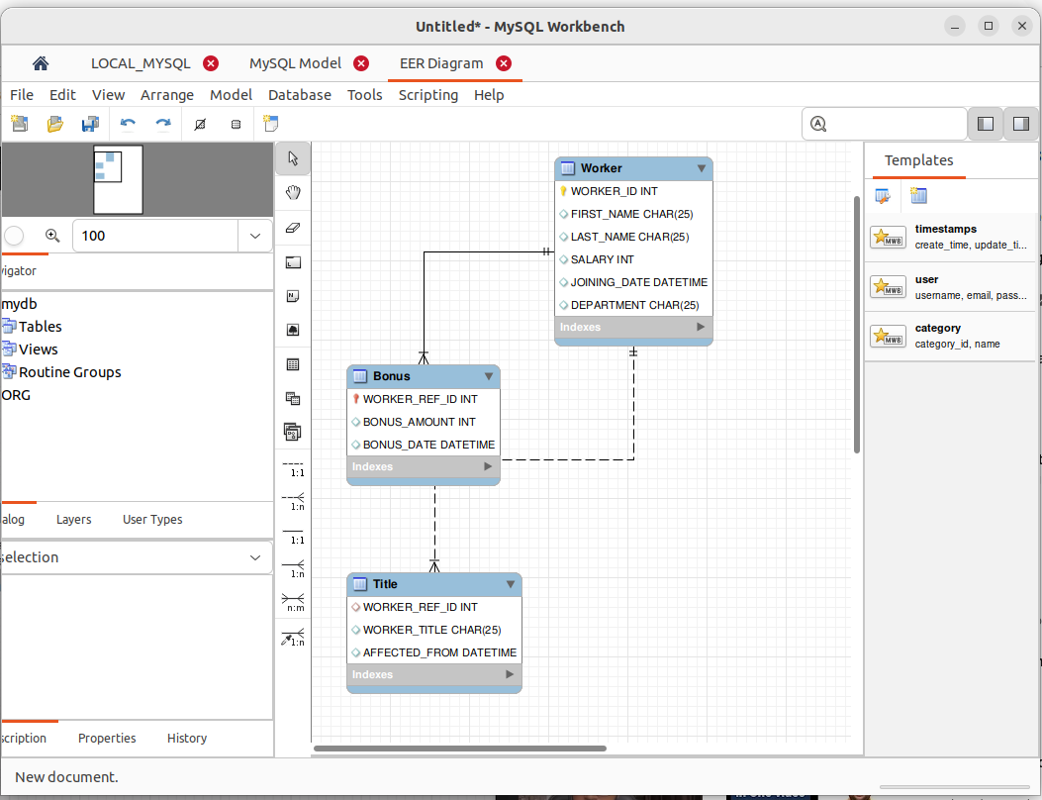
.

3.What is DUAL table?
The DUAL is special one row, one column table present by default in all Oracle databases. The owner of DUAL is SYS (SYS owns the data dictionary, therefore DUAL is part of the data dictionary.) but DUAL can be accessed by every user. The table has a single VARCHAR2(1) column called DUMMY that has a value of 'X'. MySQL allows DUAL to be specified as a table in queries that do not need data from any tables. In SQL Server DUAL table does not exist, but you could create one.
The DUAL table was created by Charles Weiss of Oracle corporation to provide a table for joining in internal views.

DUAL : It is a table that is automatically created by Oracle Database along with the data dictionary. DUAL is in the schema of the user SYS but is accessible by the name DUAL to all users. It has one column, DUMMY, defined to be VARCHAR2(1), and contains one row with a value X.

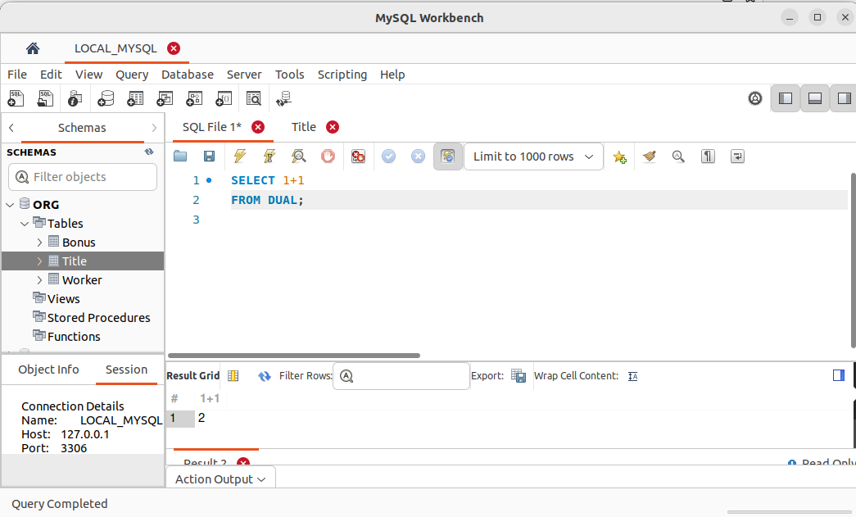
.

4.USE STATEMENT
The USE statement in SQL is used to specify the name of the database we want to select. After selecting the database, we can perform various operations on it such as creating tables, inserting data, updating data, and deleting data.
To retrieve the data from the database, we can use the SELECT statement in SQL, which is used to retrieve data from one or more tables.

Syntax
Following is the syntax of the USE statement in SQL −
USE DatabaseName;
Here, the “DatabaseName” is the name of the database that we want to create.
Always the database name should be unique within the RDBMS.
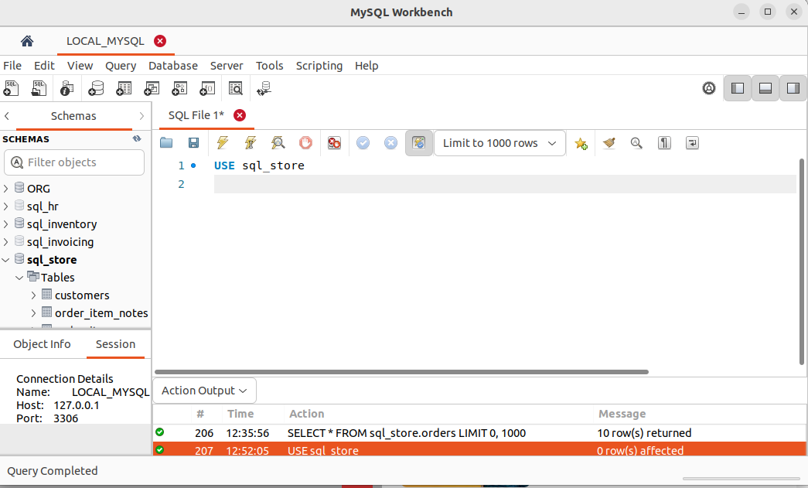
.

5.THE SELECT STATEMENT
A SELECT statement in SQL is used to retrieve data from one or more tables in a database. It allows you to specify the columns you want to retrieve, the table from which to retrieve the data, and optional conditions to filter the data. The basic syntax of a SELECT statement is as follows:
```sql
SELECT column1, column2, ..., columnN
FROM table_name;
```
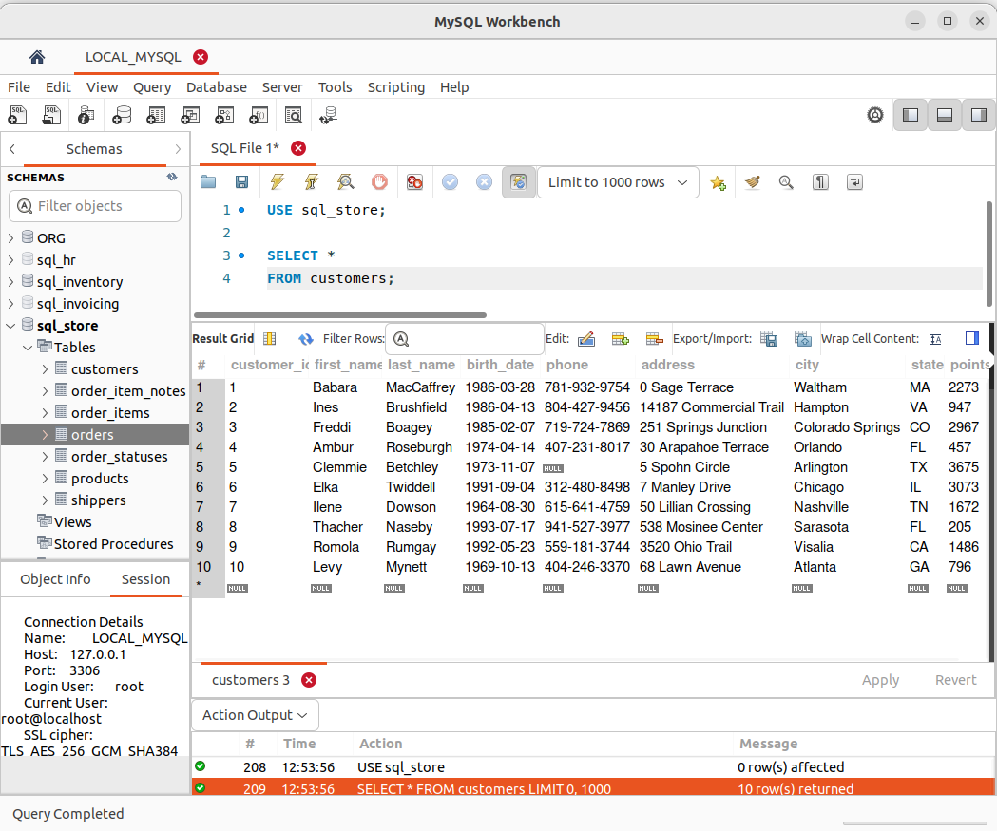
.

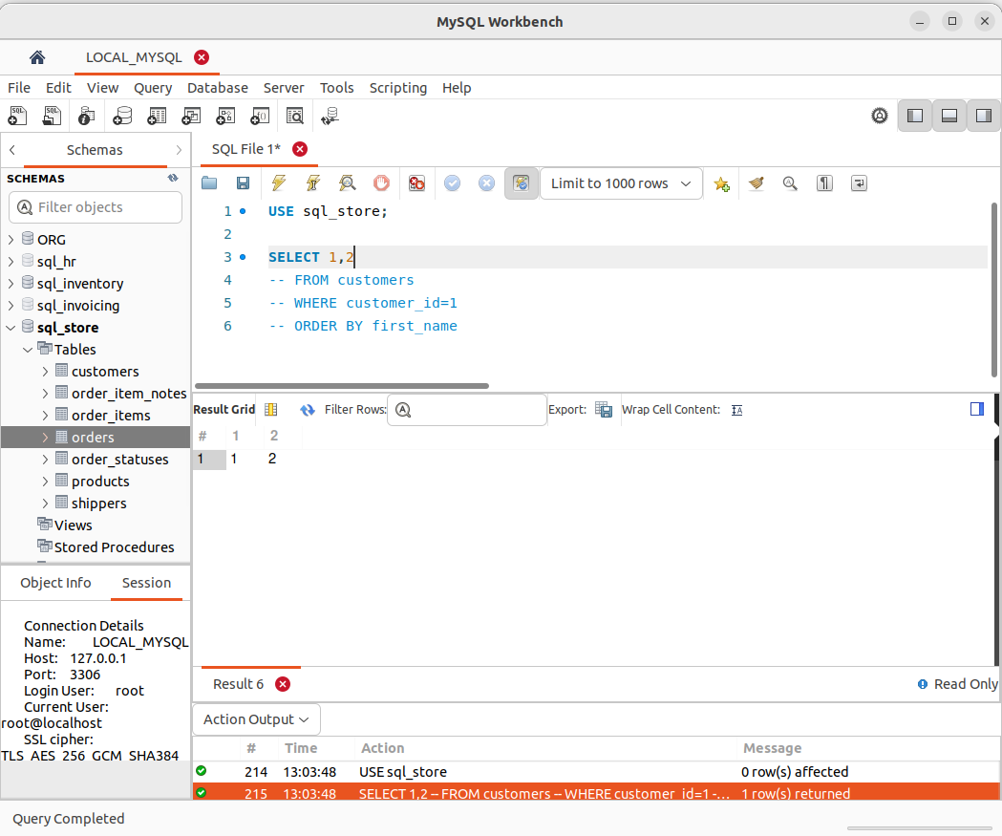

5.THE SELECT CLAUSE

SELECT clause has many optional clauses are as follow:

Clause | Description
FROM | It is used for selecting a table name in a database.
WHERE | It specifies which rows to retrieve.
GROUP BY | It is used to arrange the data into groups.
HAVING | It selects among the groups defined by the GROUP BY clause.
ORDER BY | It specifies an order in which to return the rows.
AS | It provides an alias which can be used to temporarily rename tables or columns.
Syntax:
SELECT {* | column_name1, column_name2, . . . , column_name_n}
FROM <list_of_tablename>
WHERE <condition>;

WHERE CLAUSE:

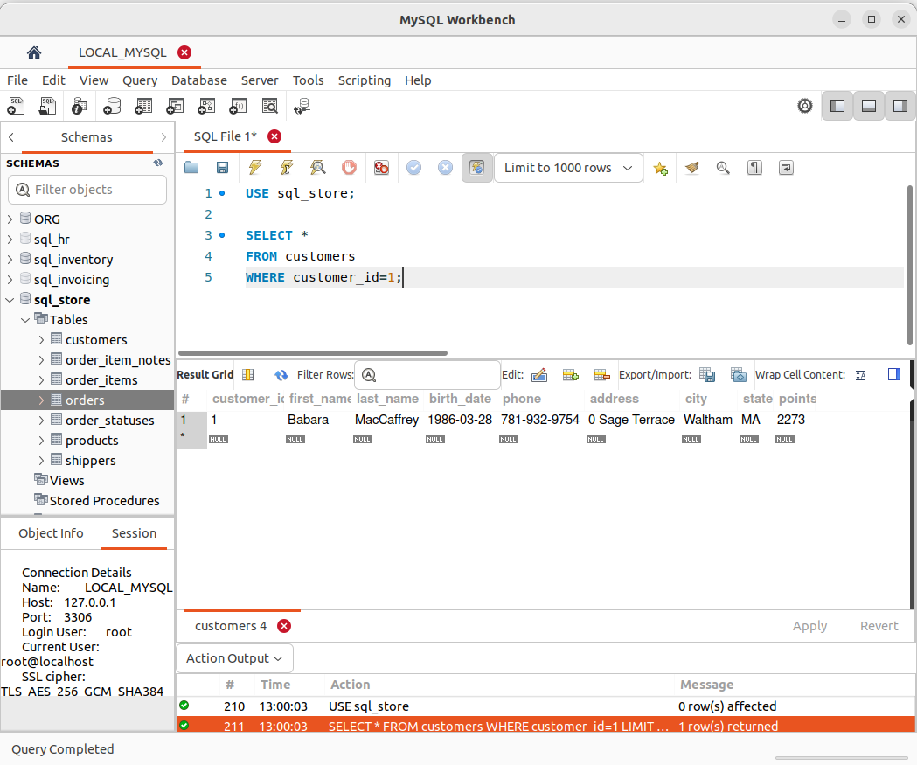
.

ORDER BY:

The SQL ORDER BY Keyword
The ORDER BY keyword is used to sort the result-set in ascending or descending order.
The ORDER BY keyword sorts the records in ascending order by default. To sort the records in descending order, use the DESC keyword.

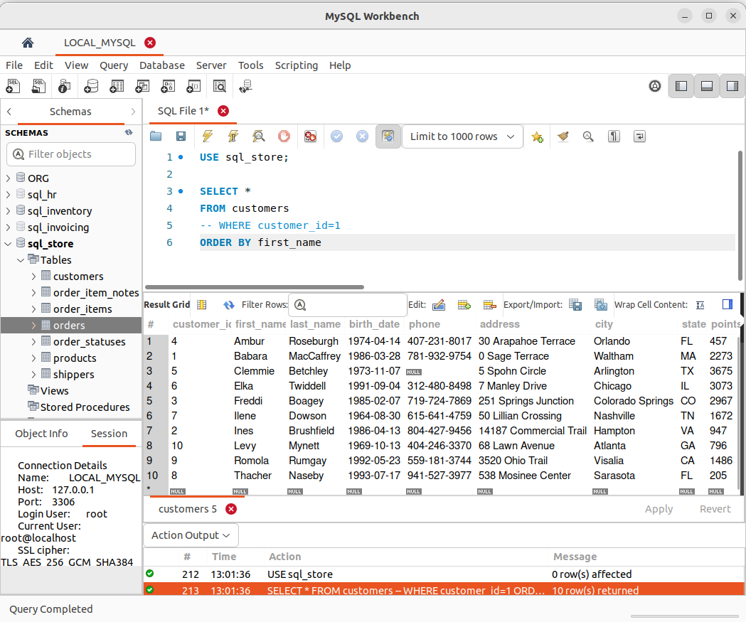
.

DISTINCT :

The SELECT DISTINCT statement is used to return only distinct (different) values.
Inside a table, a column often contains many duplicate values; and sometimes you only want to list the different (distinct) values.

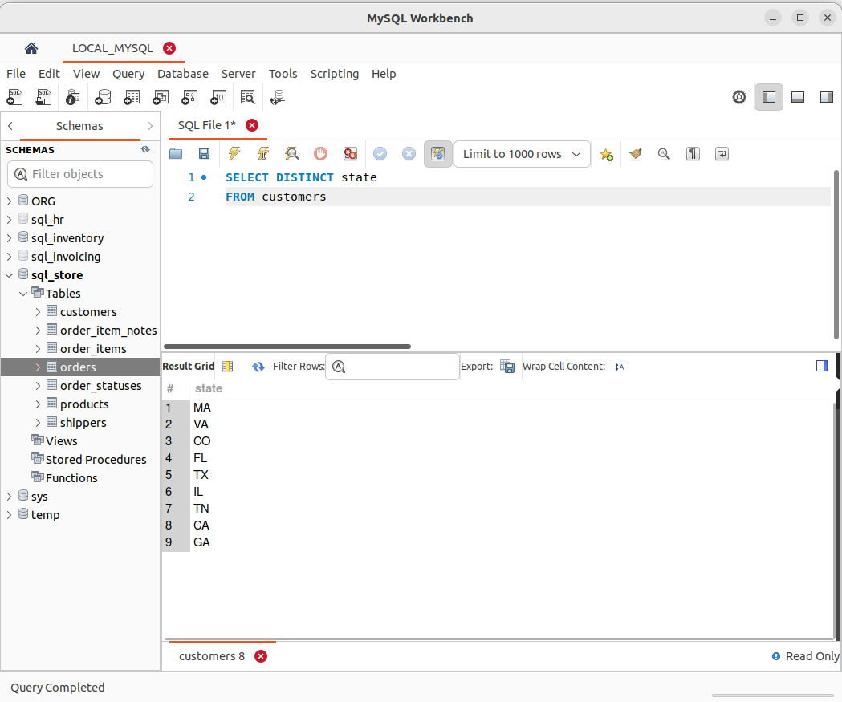
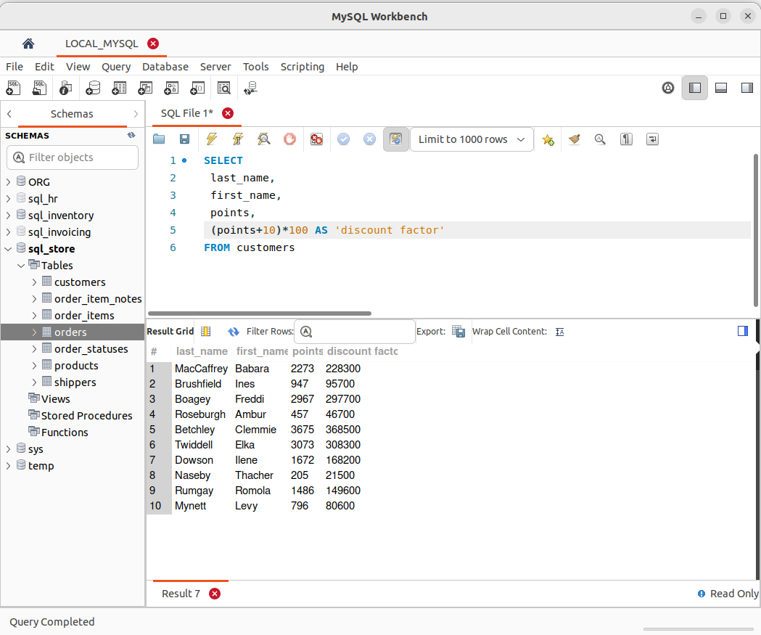
.

7. WHERE CLAUSE:

The WHERE clause is used to filter records.
It is used to extract only those records that fulfill a specified condition.

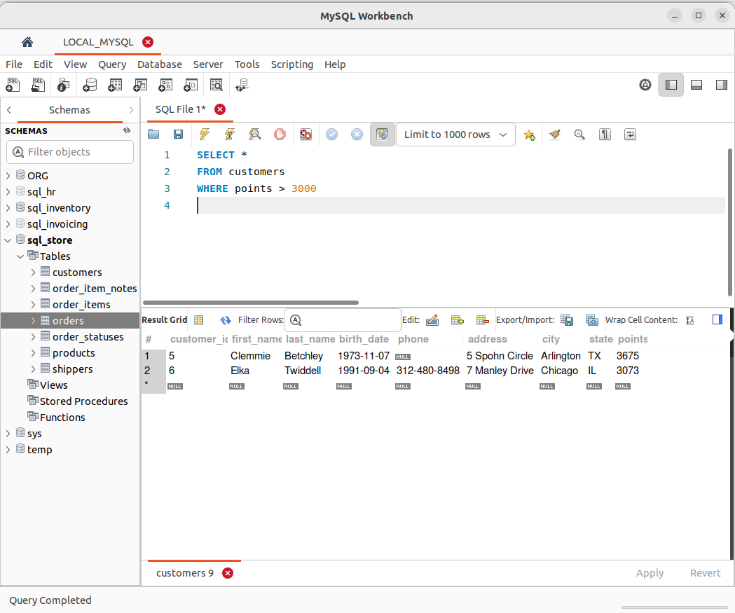
.

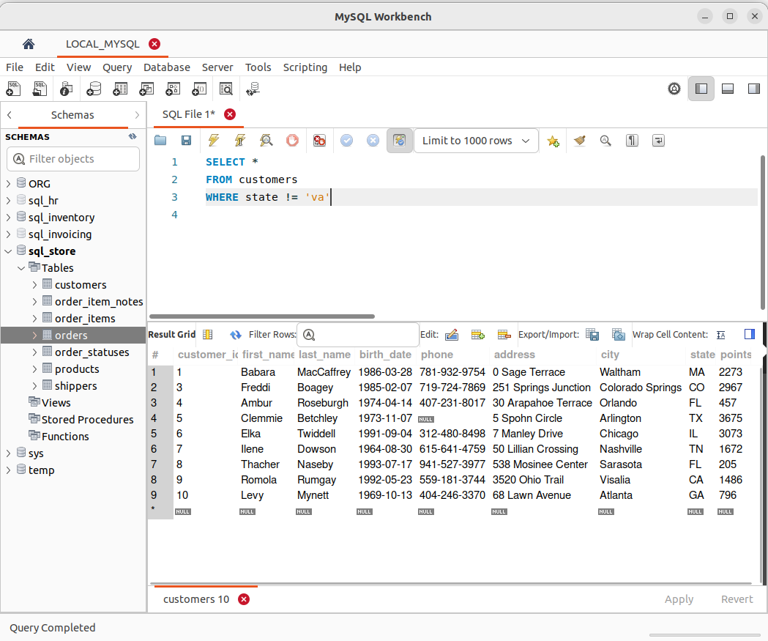
.

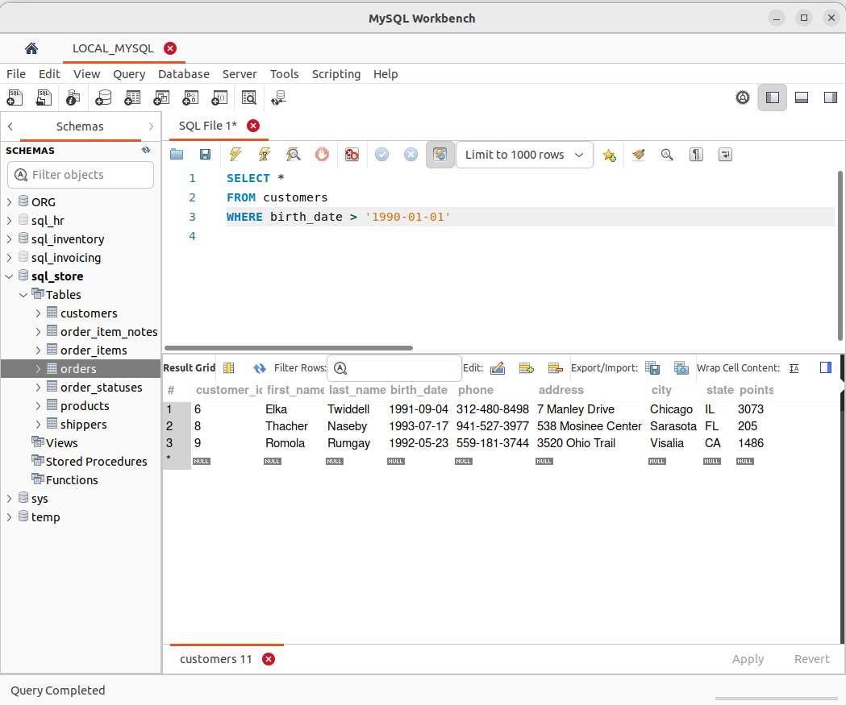
.

7 . The AND, OR, and NOT Operators

The WHERE clause can be combined with AND, OR, and NOT operators.
The AND and OR operators are used to filter records based on more than one condition:
- The AND operator displays a record if all the conditions separated by AND are TRUE.
- The OR operator displays a record if any of the conditions separated by OR is TRUE.
The NOT operator displays a record if the condition(s) is NOT TRUE.

AND :

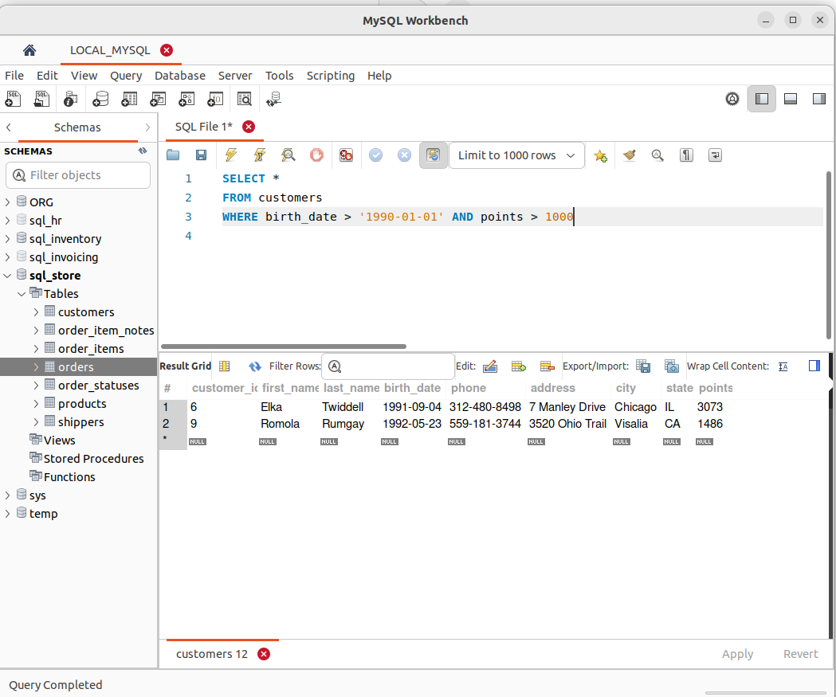
..

OR:

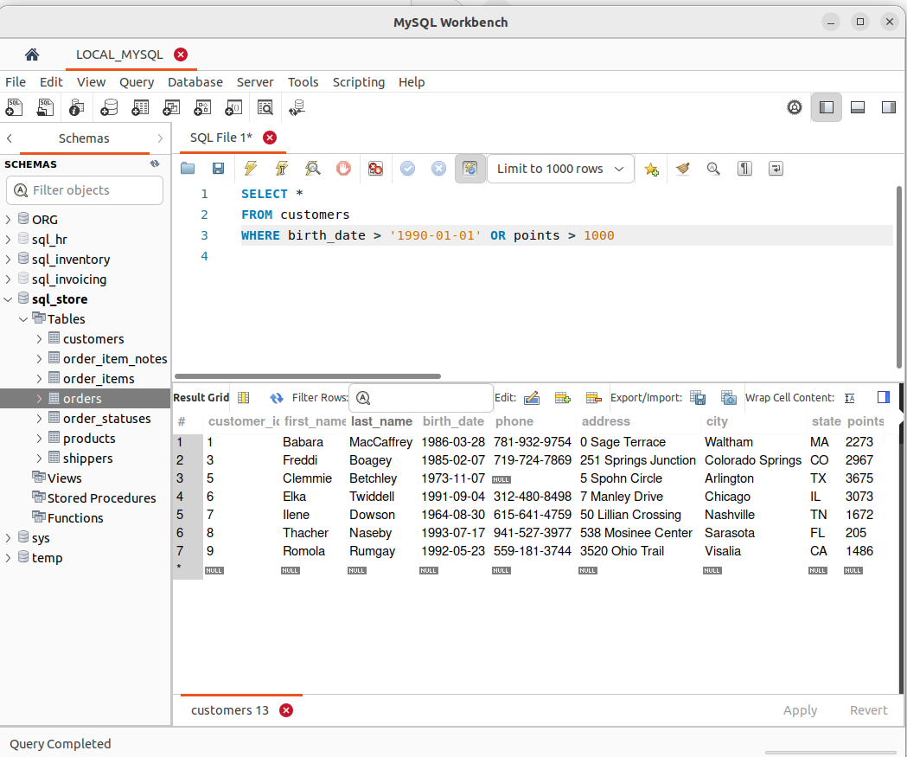
.

AND OPERATOR HAS PRIOROTY OVER OR OPERATOR

NOT :

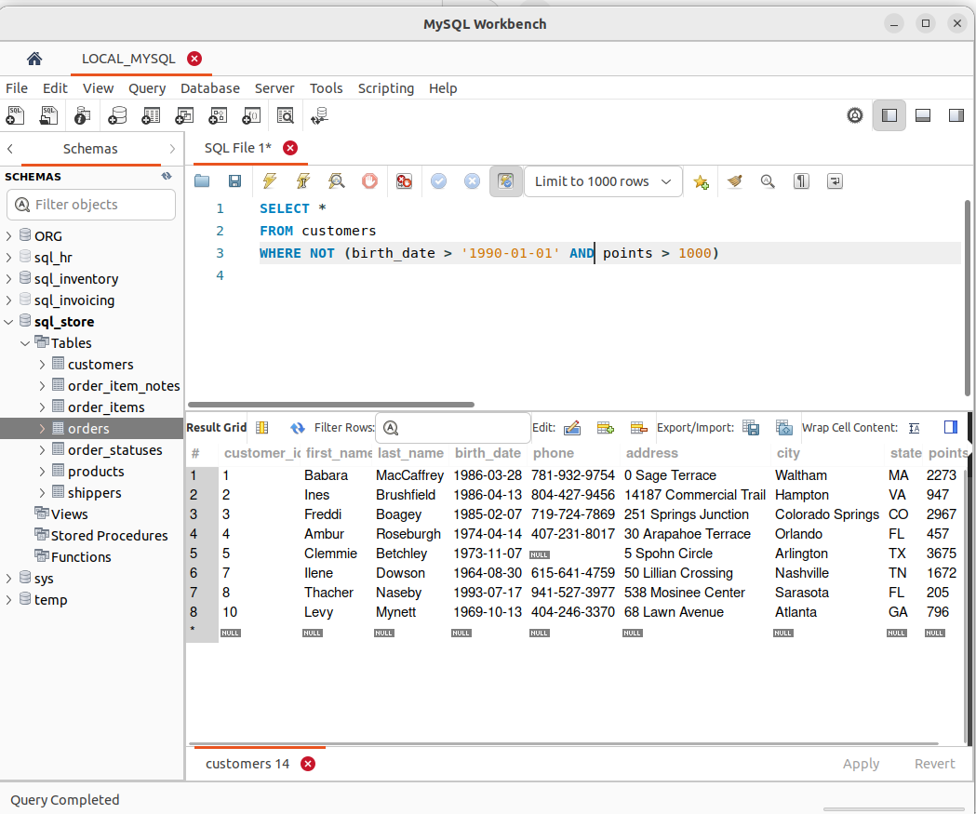
.

9. The IN Operator
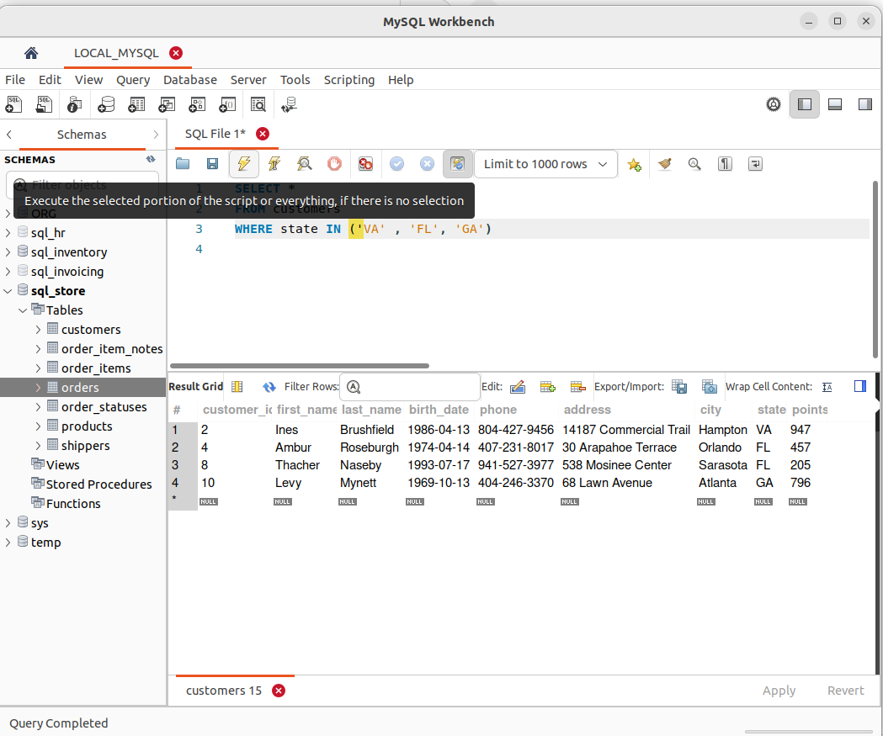
.

10. The BETWEEN Operator
The BETWEEN operator selects values within a given range. The values can be numbers, text, or dates.
The BETWEEN operator is inclusive: begin and end values are included.

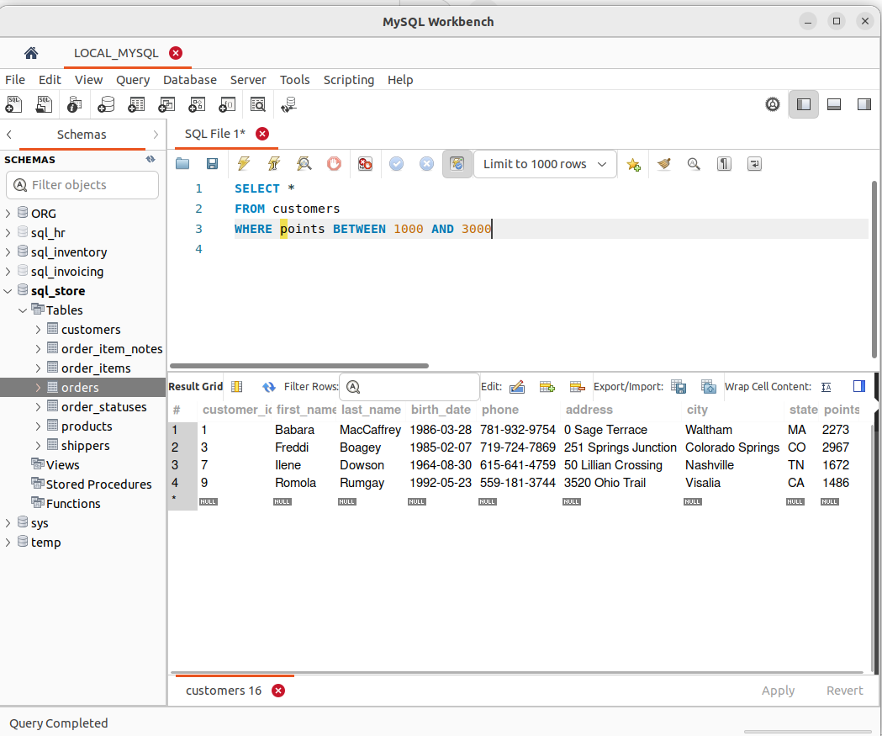
.

11. The LIKE Operator

The LIKE operator is used in a WHERE clause to search for a specified pattern in a column.
There are two wildcards often used in conjunction with the LIKE operator:
- The percent sign (%) represents zero, one, or multiple characters
- The underscore sign (_) represents one, single character

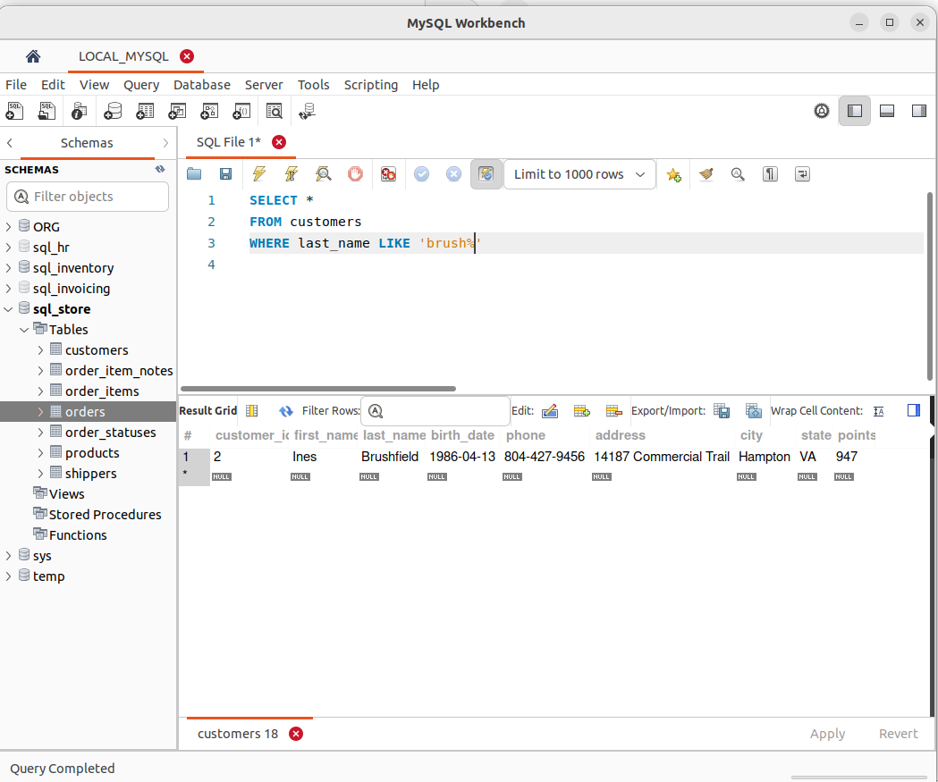

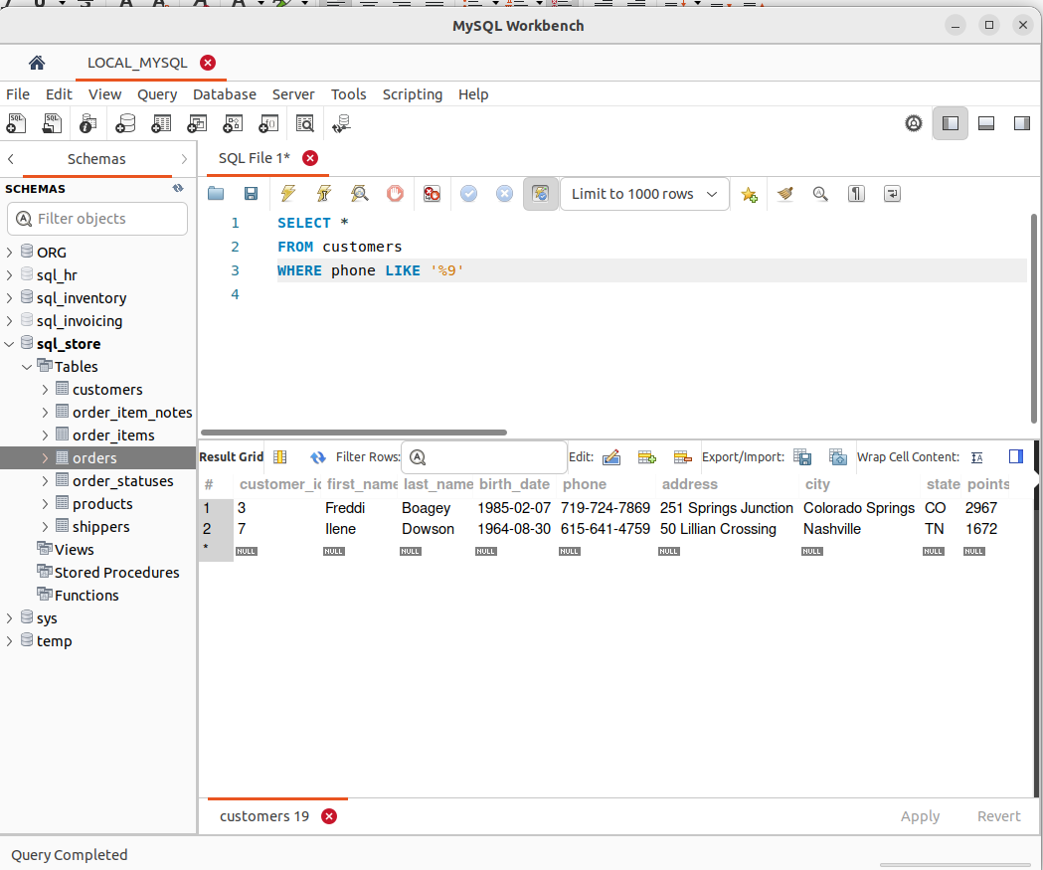
.

12. The REGEXP Operator
MySQL supports another type of pattern matching operation based on the regular expressions and the REGEXP operator.
- It provide a powerful and flexible pattern match that can help us implement power search utilities for our database systems.
- REGEXP is the operator used when performing regular expression pattern matches. RLIKE is the synonym.
- It also supports a number of metacharacters which allow more flexibility and control when performing pattern matching.
- The backslash is used as an escape character. It’s only considered in the pattern match if double backslashes have used.
- Not case sensitive.




