SQL-4

- The IS NULL Operator

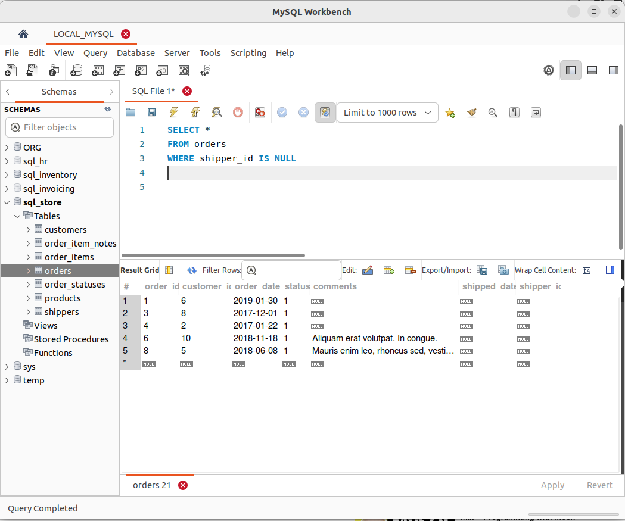
.

- The ORDER BY Operator

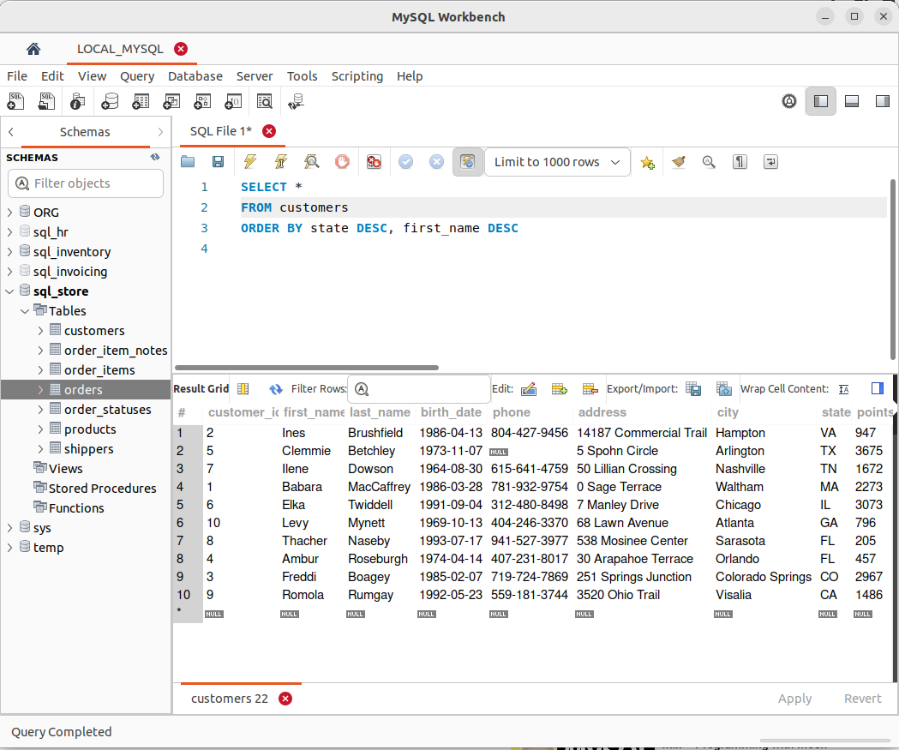
.
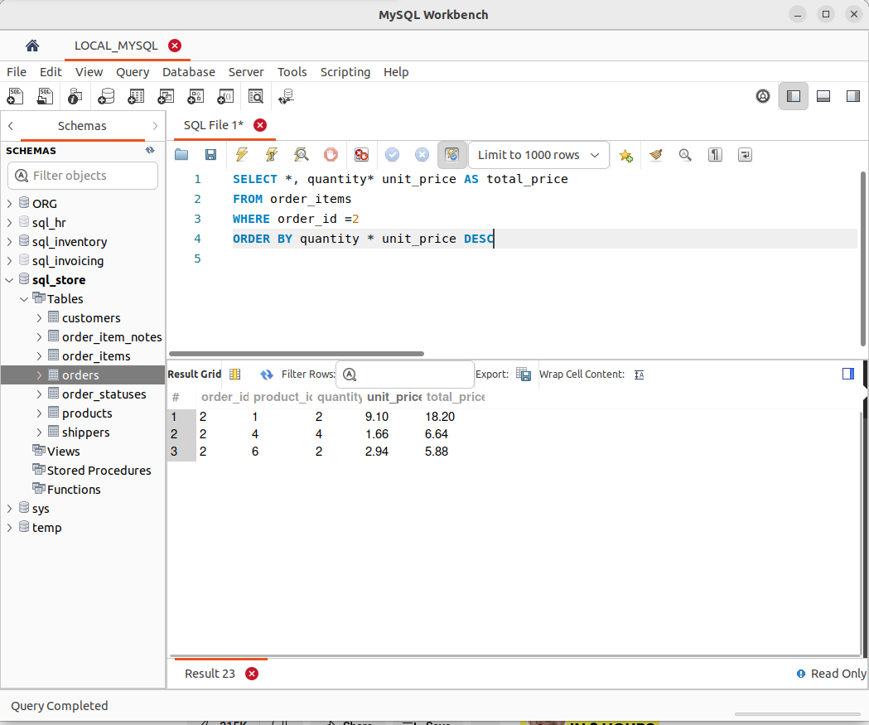
.

- The LIMIT Operator
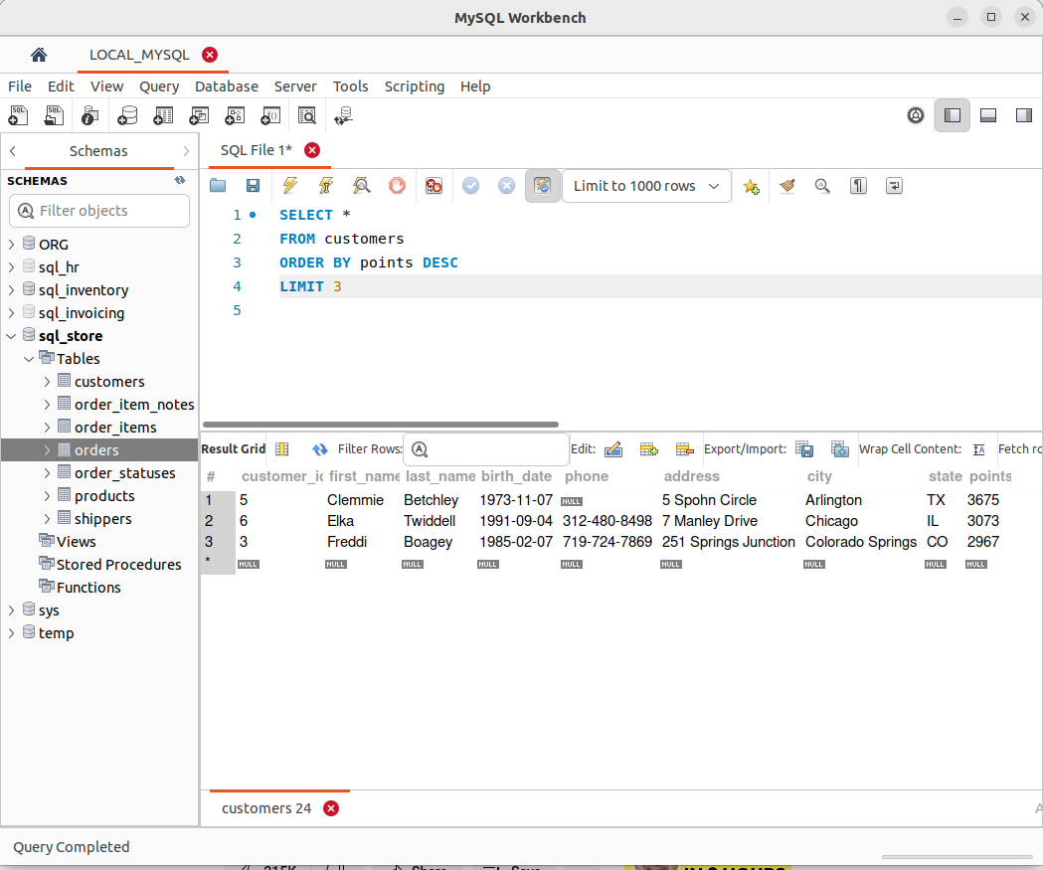
- WILDCARD CHARACTERS
A wildcard character is used to substitute one or more characters in a string.
Wildcard characters are used with the LIKE operator. The LIKE operator is used in a WHERE clause to search for a specified pattern in a column.

Wildcard Characters in SQL Server
Symbol | Description | Example
% | Represents zero or more characters | bl% finds bl, black, blue, and blob
_ | Represents a single character | h_t finds hot, hat, and hit
[] | Represents any single character within the brackets | h[oa]t finds hot and hat, but not hit
^ | Represents any character not in the brackets | h[^oa]t finds hit, but not hot and hat
- | Represents any single character within the specified range | c[a-b]t finds cat and cbt
All the wildcards can also be used in combinations!
Here are some examples showing different LIKE operators with '%' and '_' wildcards:
LIKE Operator | Description
WHERE CustomerName LIKE 'a%' | Finds any values that starts with "a"
WHERE CustomerName LIKE '%a' | Finds any values that ends with "a"
WHERE CustomerName LIKE '%or%' | Finds any values that have "or" in any position
WHERE CustomerName LIKE '_r%' | Finds any values that have "r" in the second position
WHERE CustomerName LIKE 'a__%' | Finds any values that starts with "a" and are at least 3 characters in length
WHERE ContactName LIKE 'a%o' | Finds any values that starts with "a" and ends with "o"

- Inner Joins
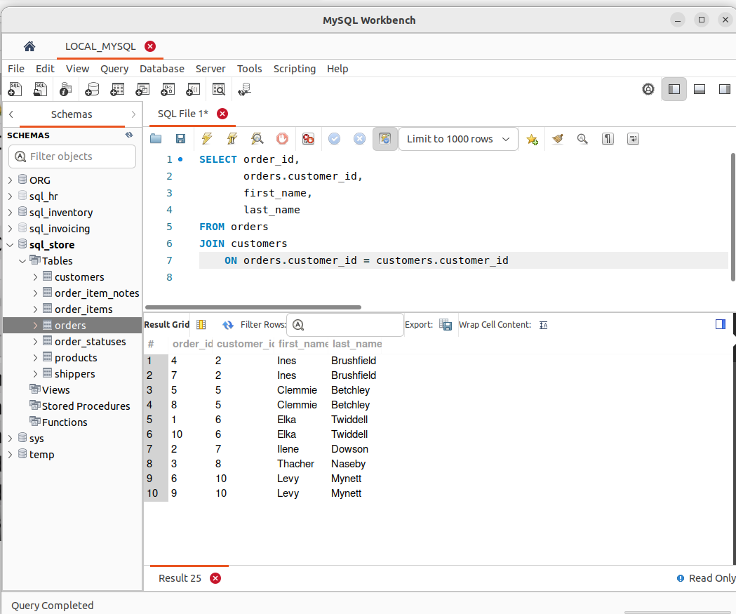
.

- Joining Across Databases
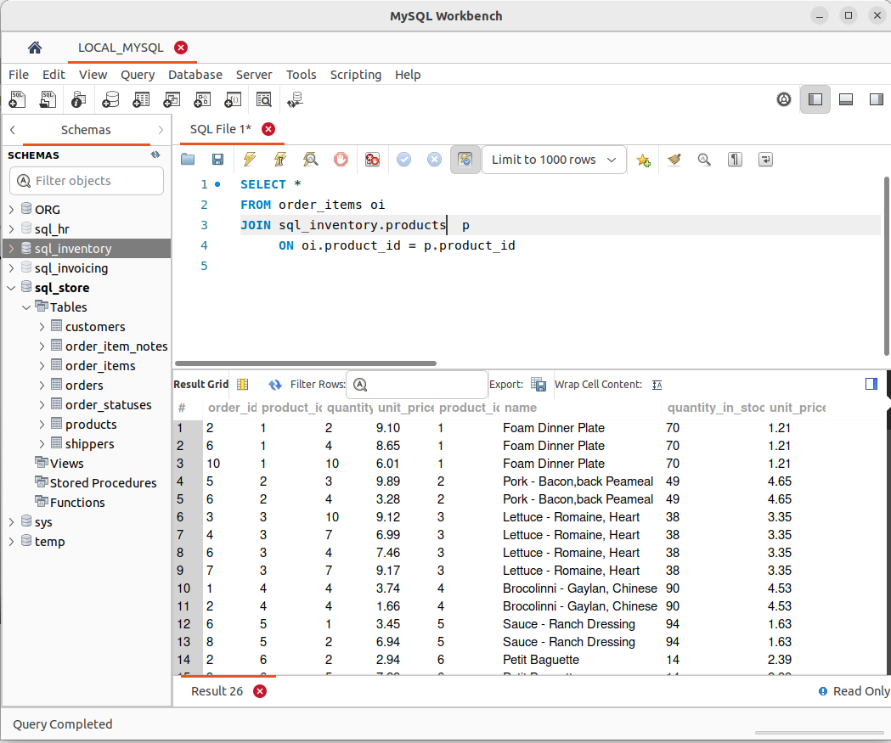
.

- Self Joins

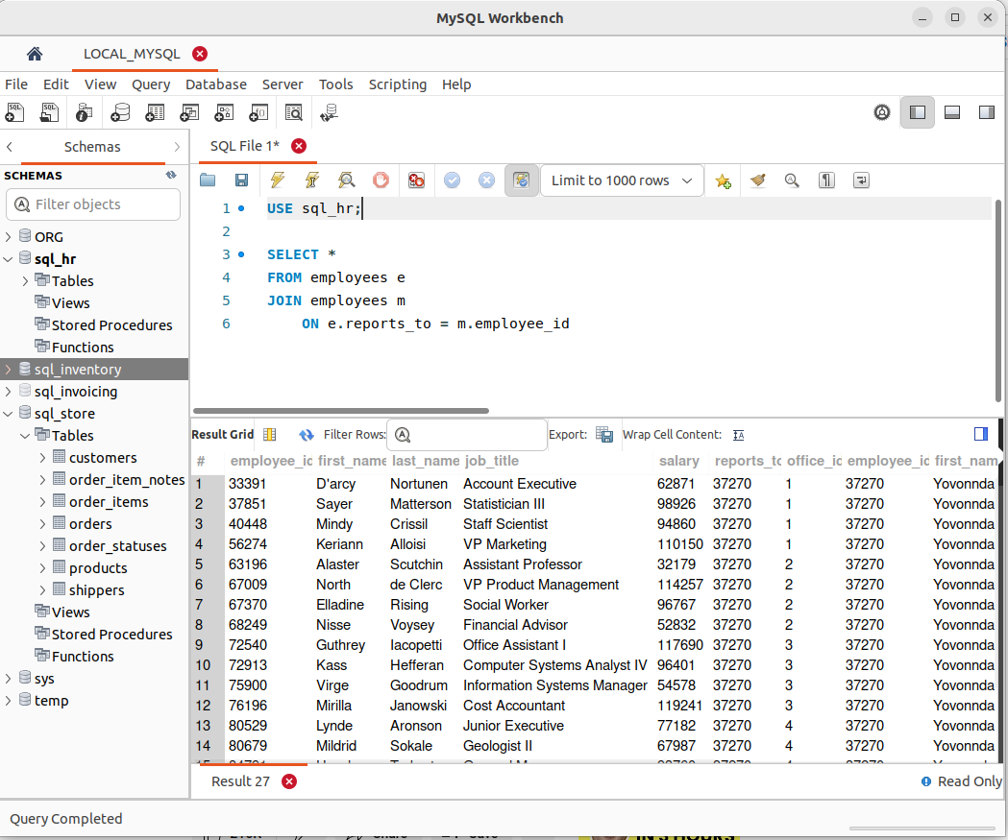
.

- Joining Multiple Tables
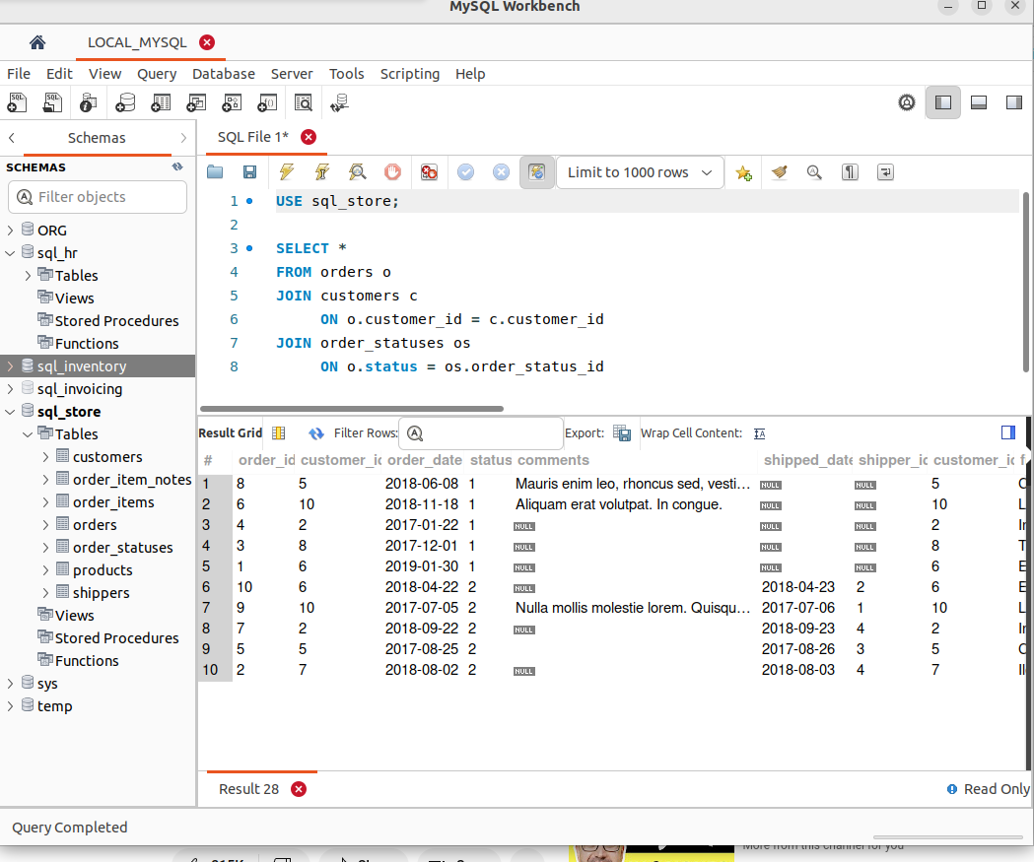
.

- Compound Join Conditions
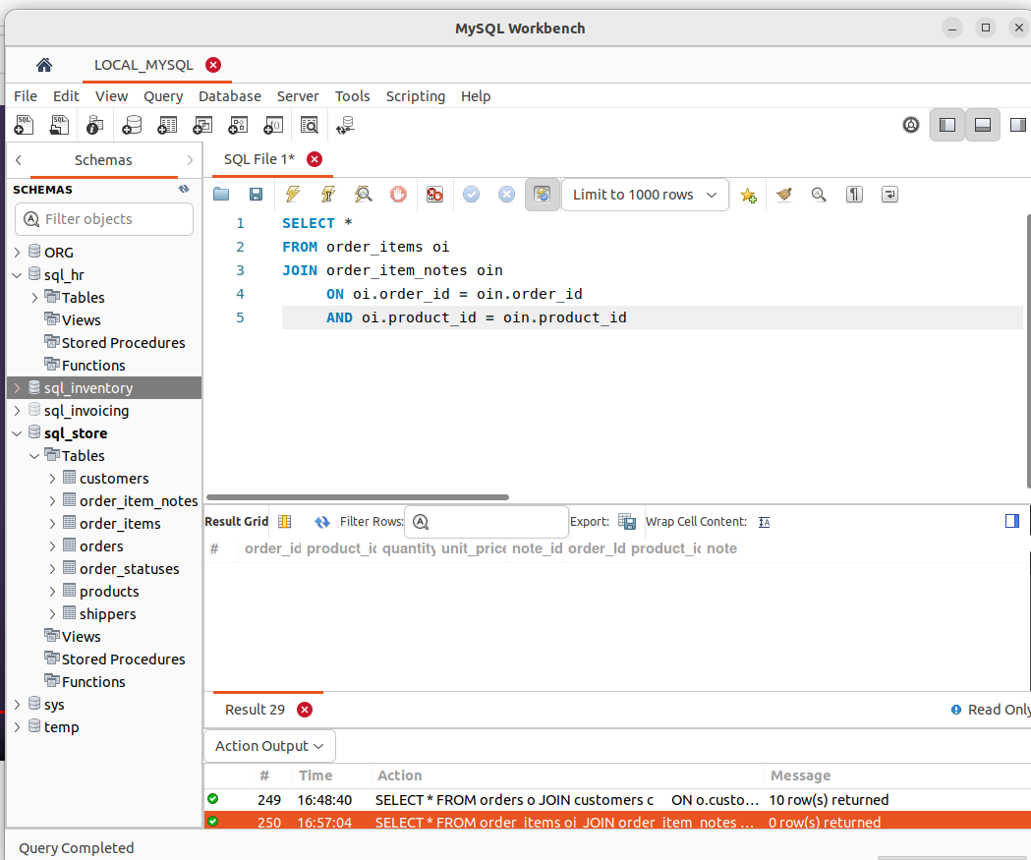
.

- Implicit Join Syntax
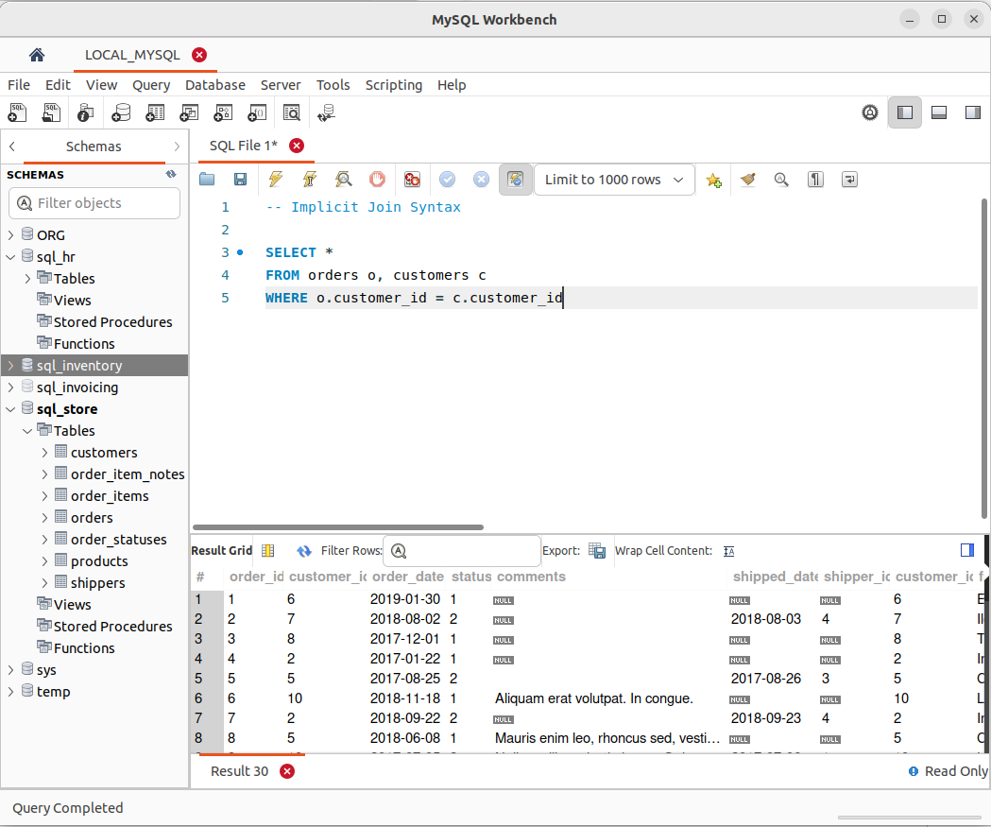
.

- Outer Joins

RIGHT JOIN:
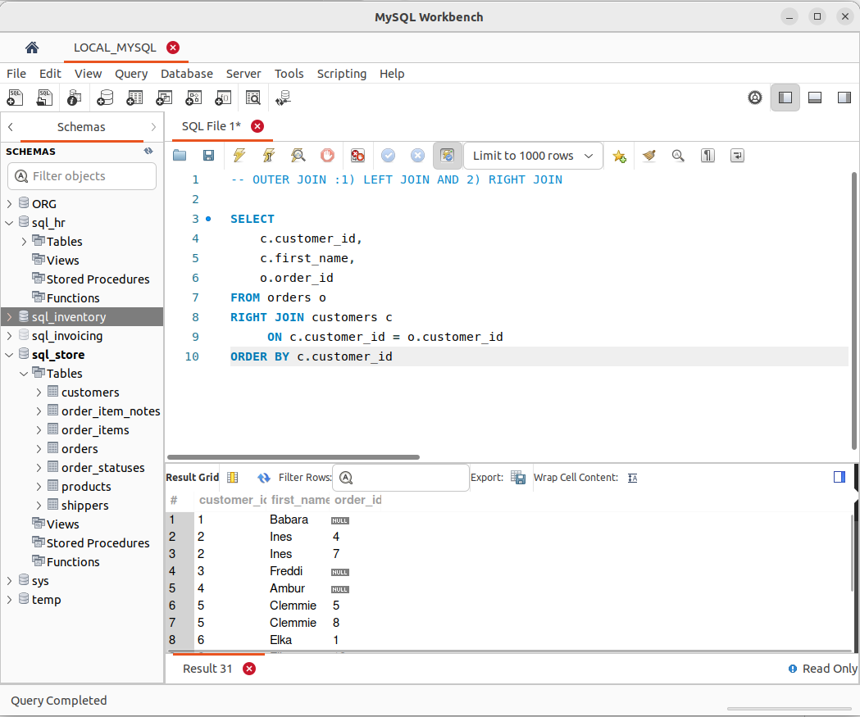
.

LEFT JOIN :
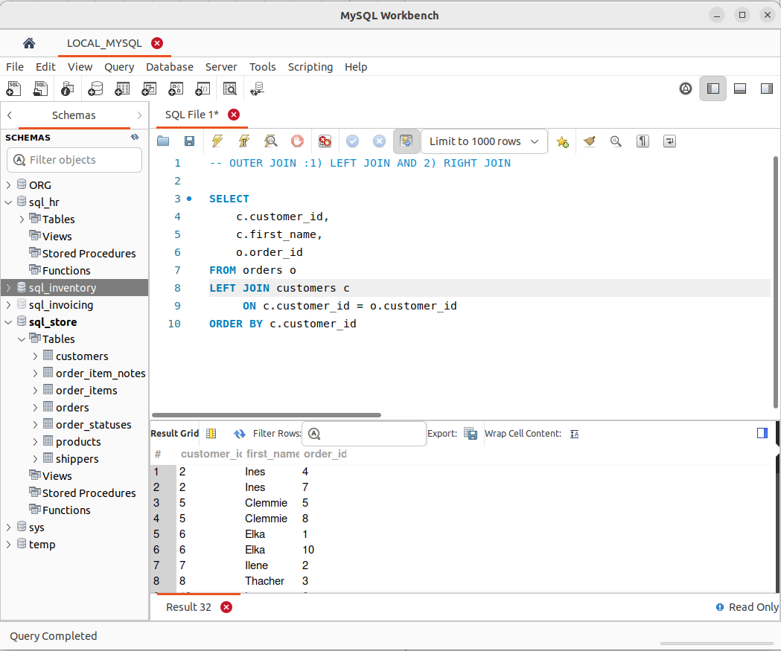
.

- Outer Join Between Multiple Tables
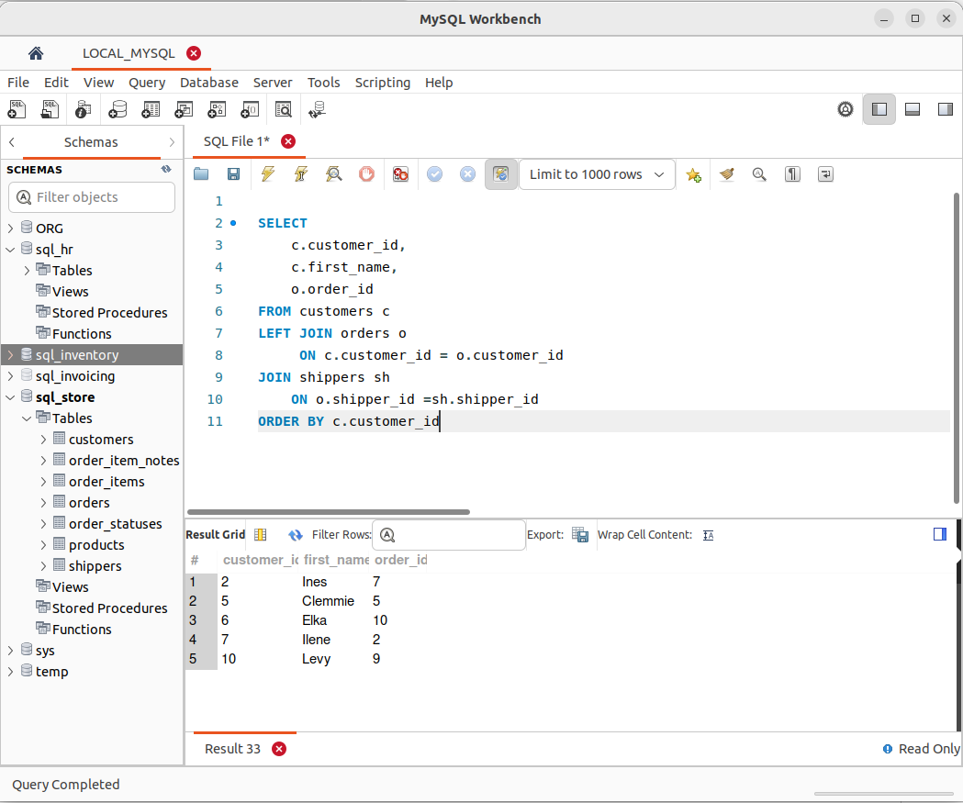
.

- Self Outer Joins
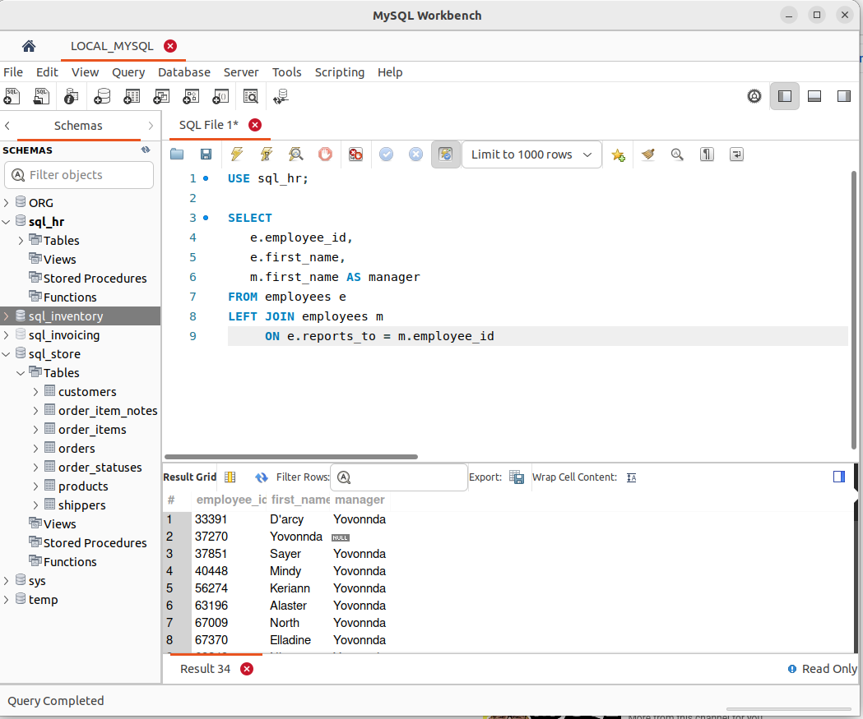
.

- The USING Clause
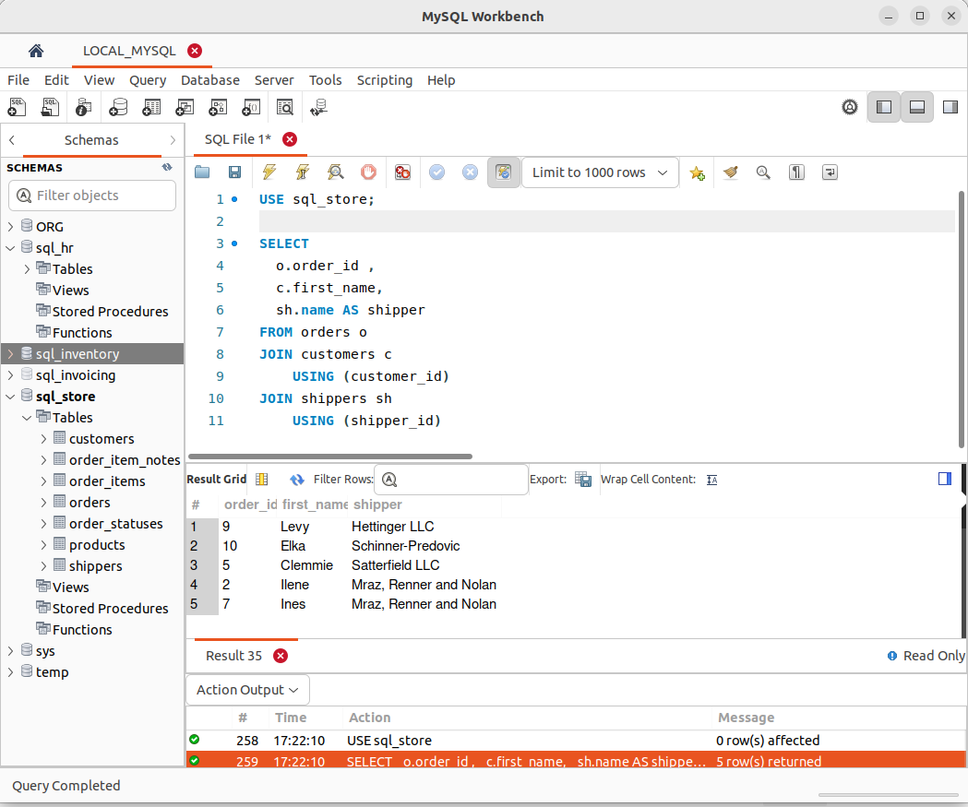
.

- Natural Joins

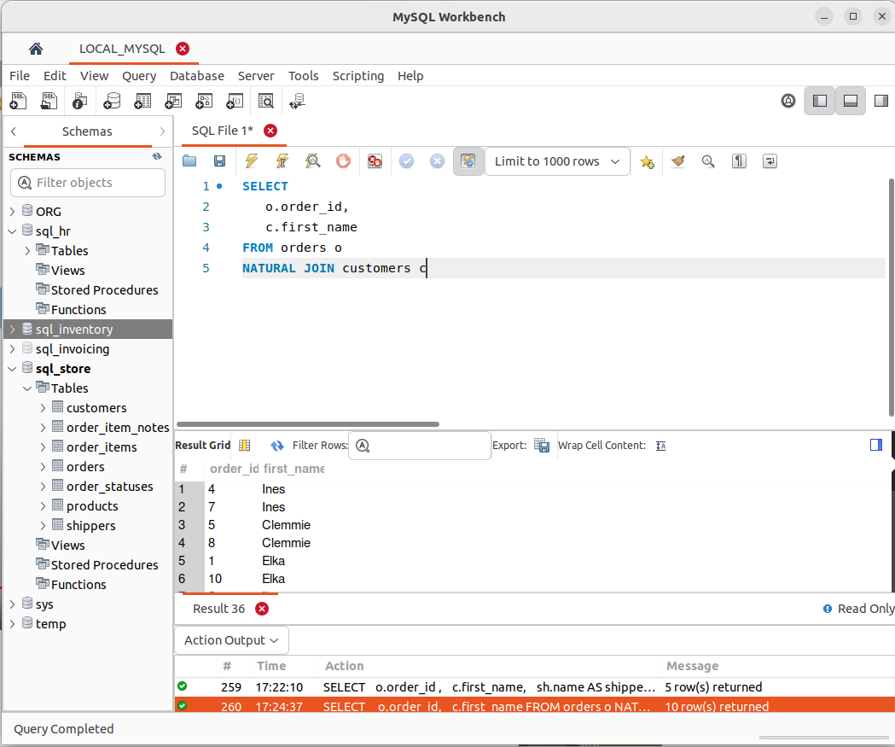
.

- Cross Joins
