SQL -5

- Unions
Combines the result sets of two or more SELECT queries into a single result set. Example:
```
SELECT name FROM employees
UNION
SELECT name FROM contractors;
```

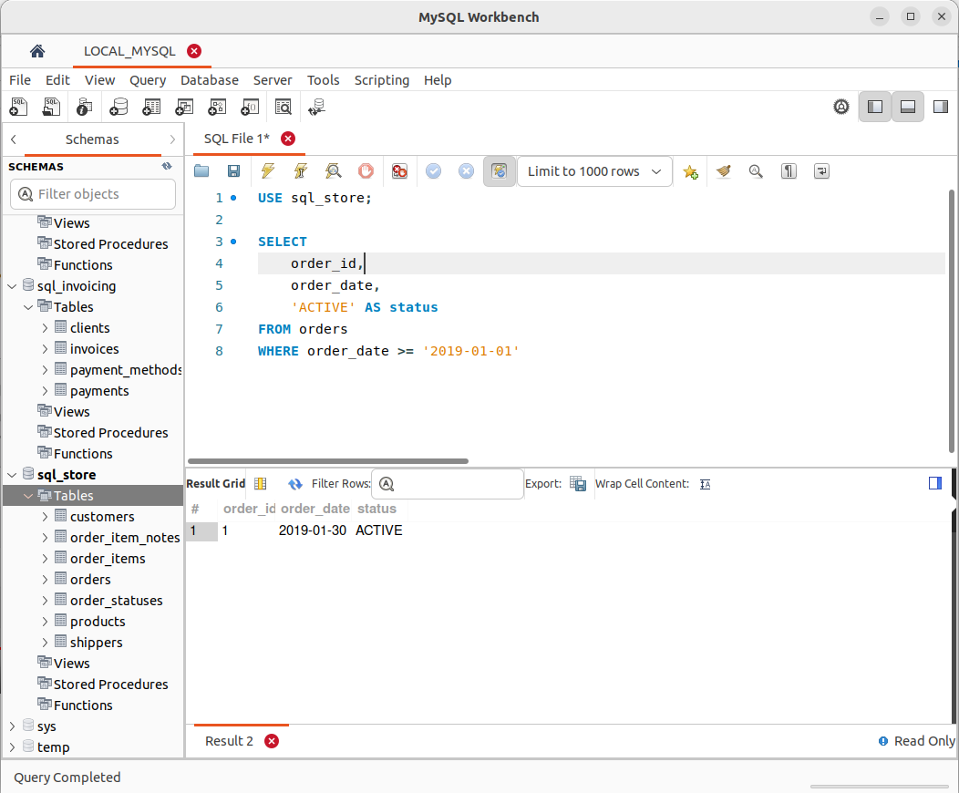
.
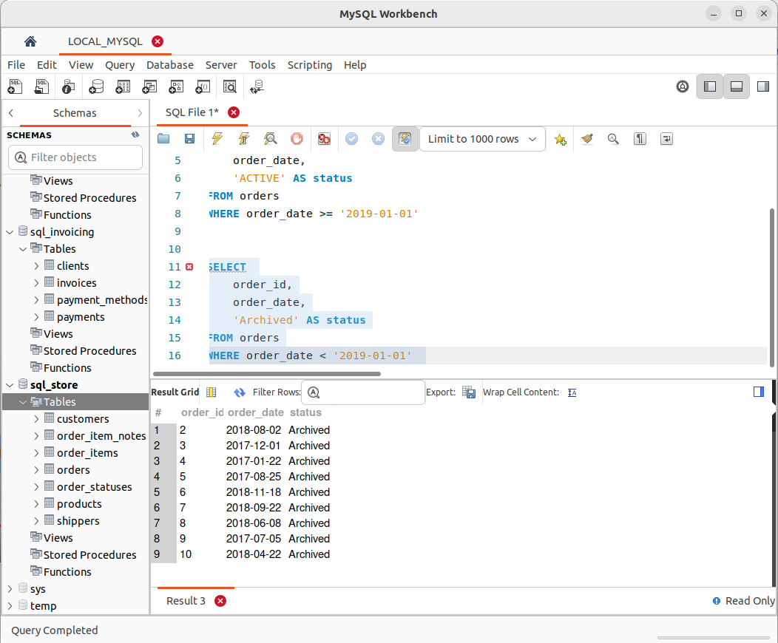

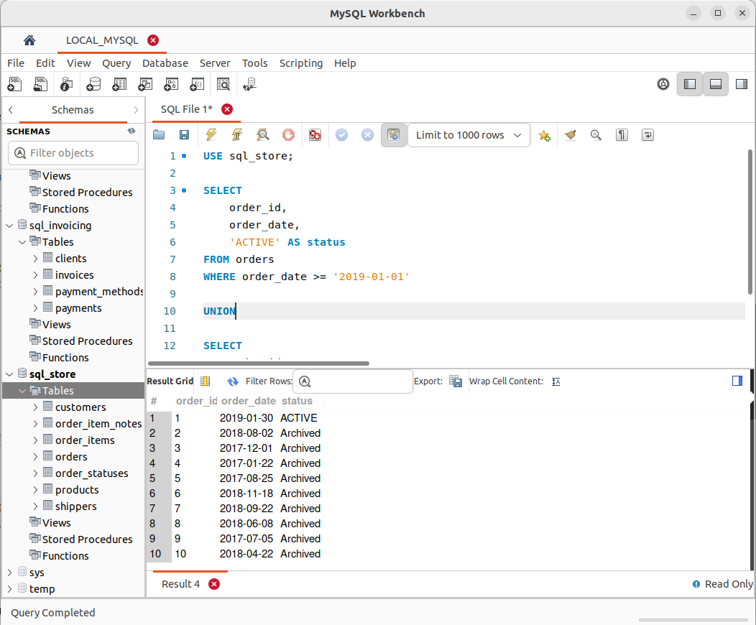

- Column Attributes
Specifies properties for table columns, such as data type, constraints, and default values. Example:
```
CREATE TABLE users (
id INT PRIMARY KEY,
username VARCHAR(50) NOT NULL,
email VARCHAR(100) UNIQUE
);
```

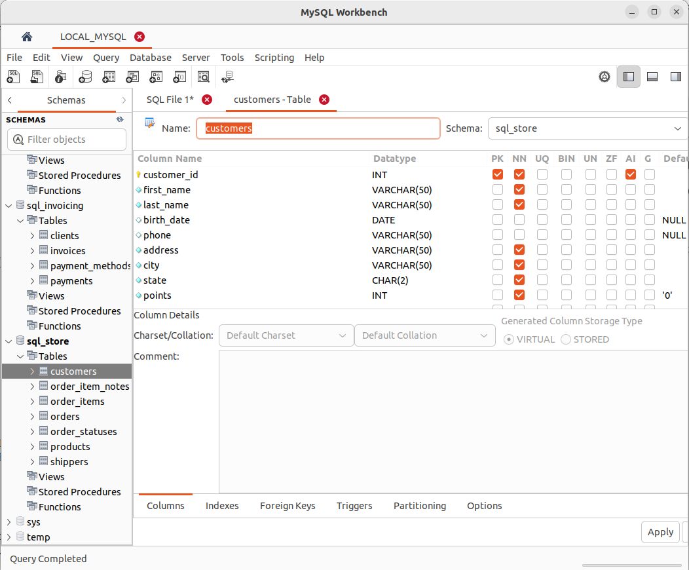
.

- Inserting a Single Row
Adds a single record into a table. Example:
```
INSERT INTO students (name, age, grade) VALUES ('Alice', 18, 'A');
```
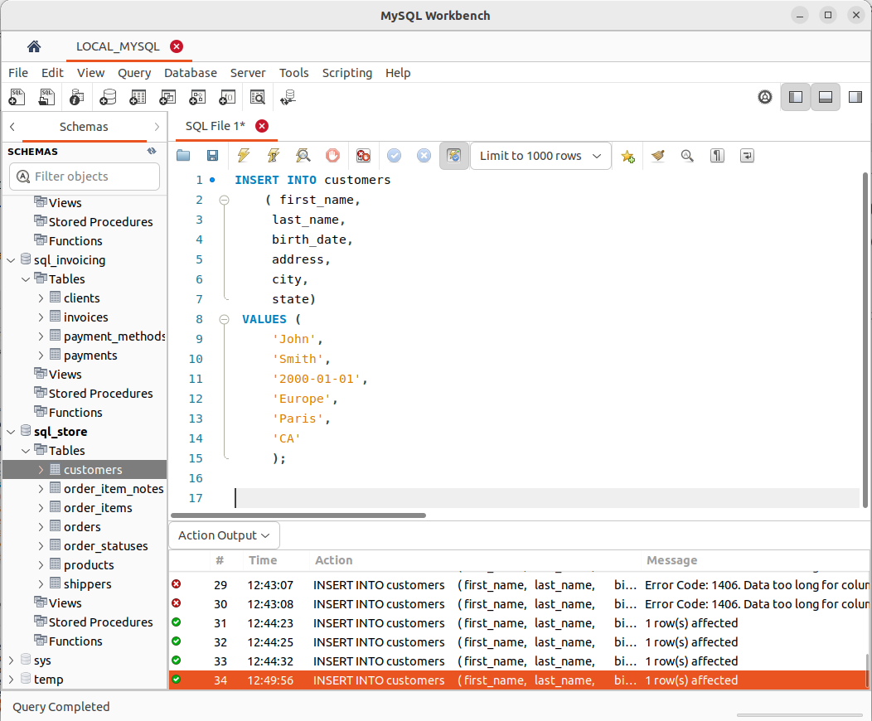
.

- Inserting Multiple Rows
Adds multiple records into a table with a single query. Example:
```
INSERT INTO books (title, author) VALUES ('Book1', 'Author1'), ('Book2', 'Author2'), ('Book3', 'Author3');
```
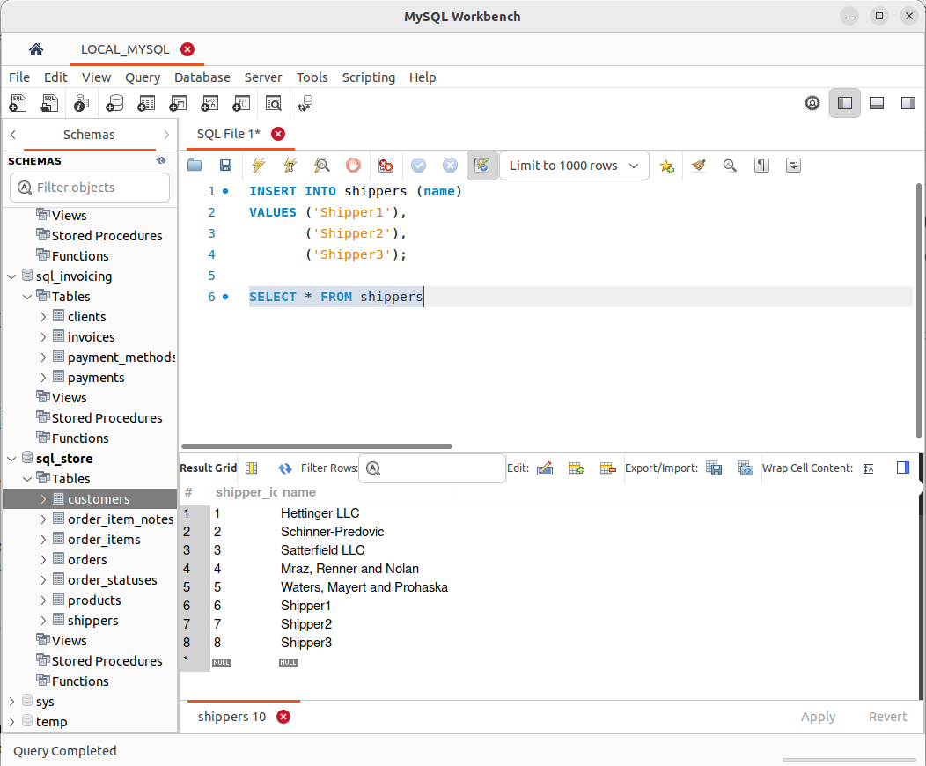
.

- Inserting Hierarchical Rows
Insert data into a table with hierarchical relationships, usually using recursive queries. Example:
```
INSERT INTO categories (name, parent_id) VALUES ('Electronics', NULL), ('Mobiles', 1), ('Laptops', 1);
```
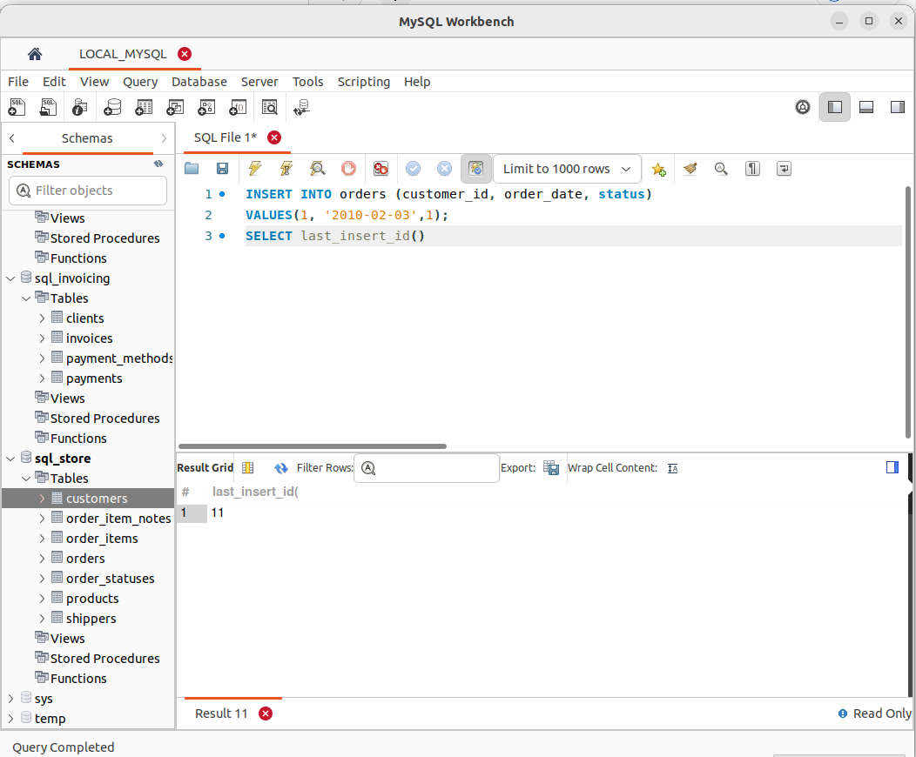
.

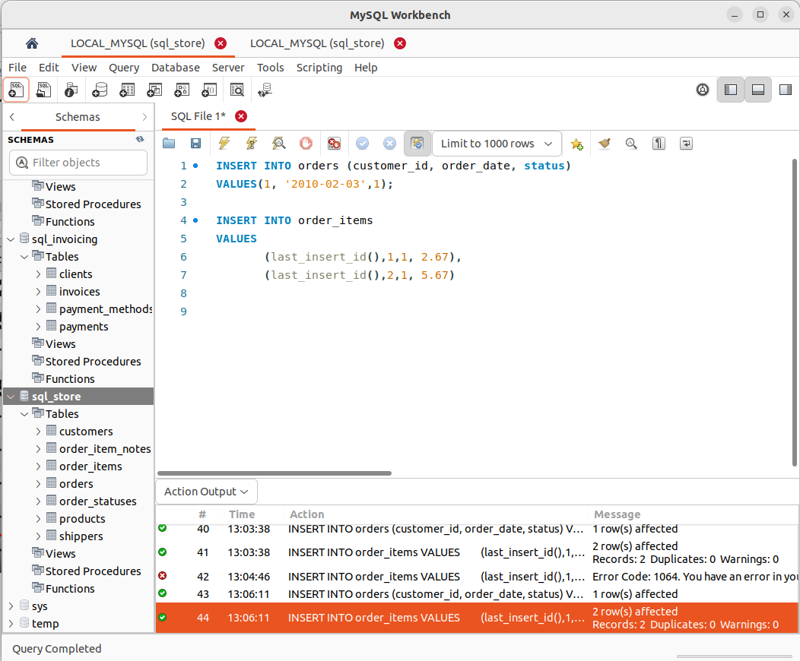
.
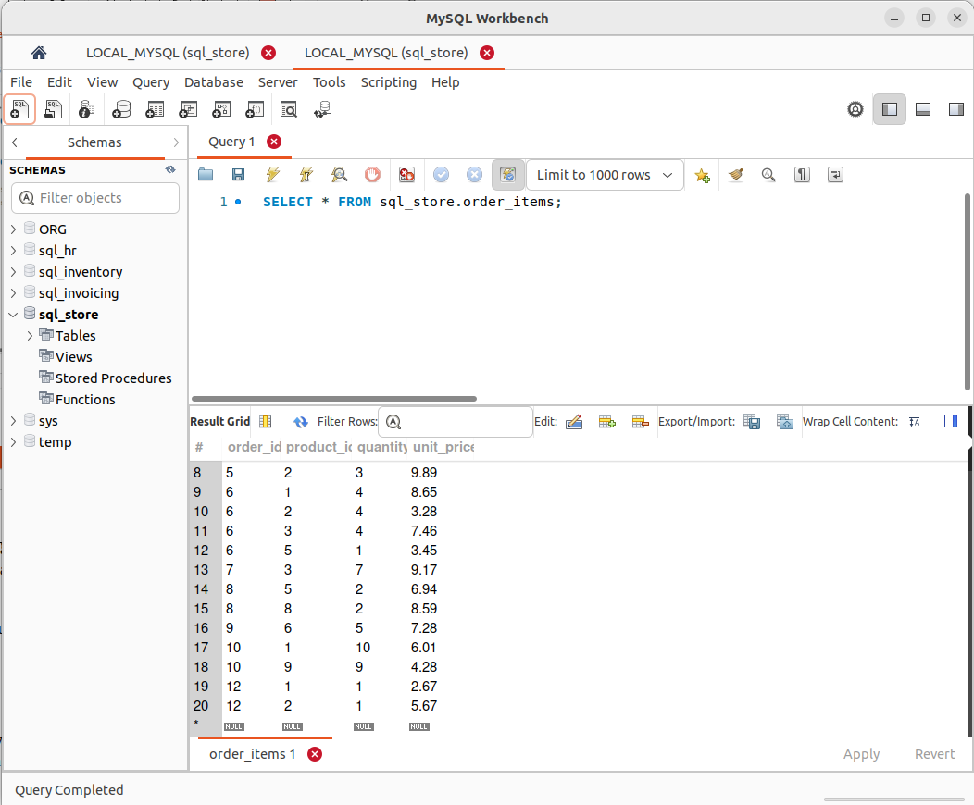
.

- Creating a Copy of a Table
Duplicate an existing table with its data and structure. Example:
```
CREATE TABLE employees_backup AS
SELECT * FROM employees;
```

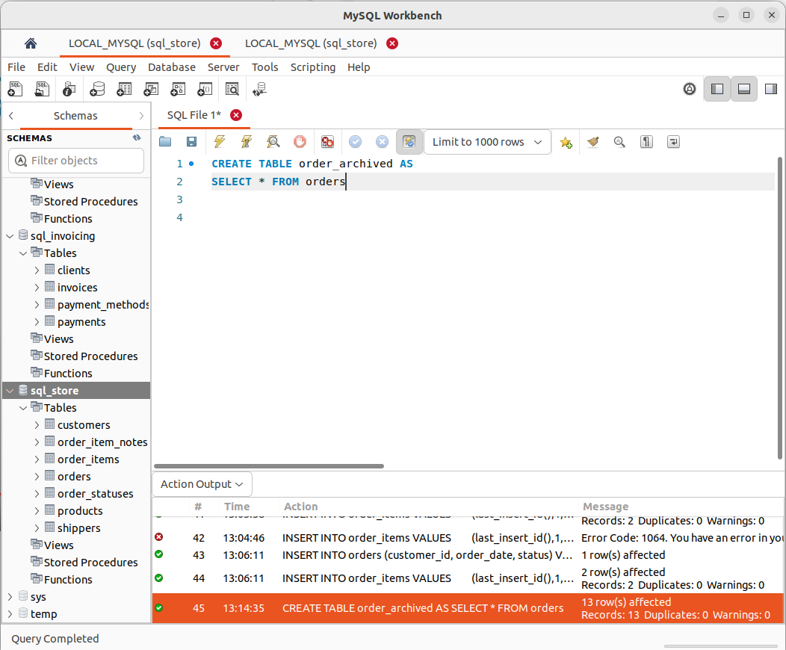

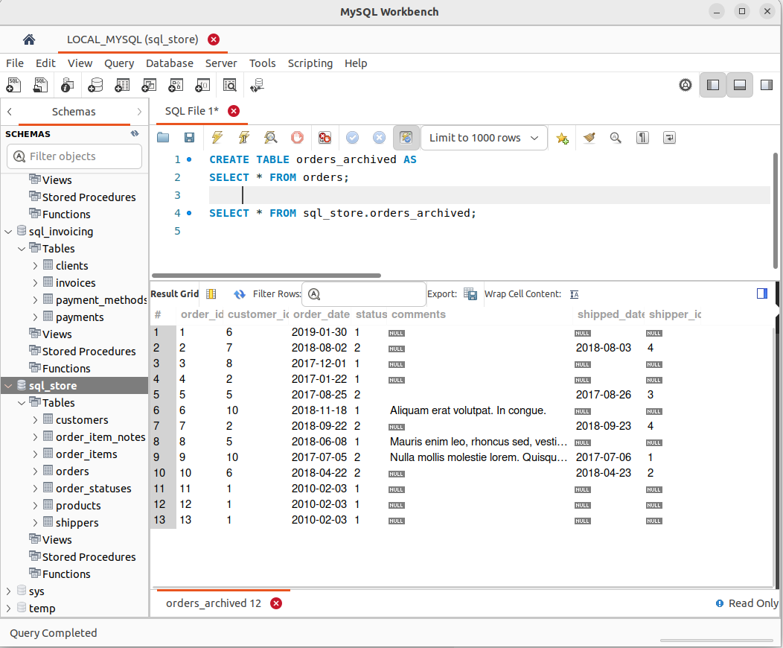

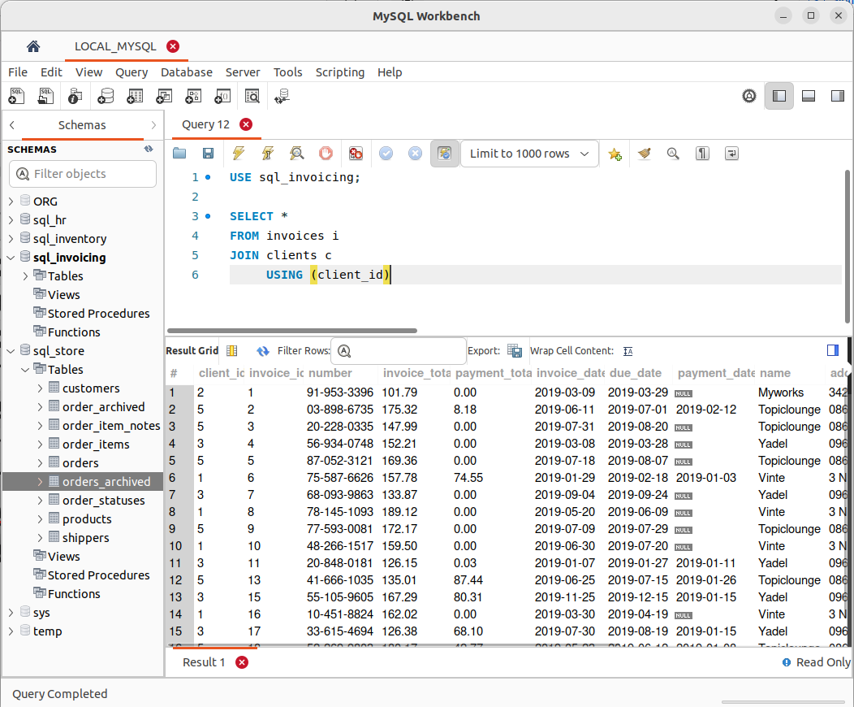

- Updating a Single Row
Modifies the data of a single row in a table. Example:
```
UPDATE products SET price = 25.99 WHERE product_id = 101;
```

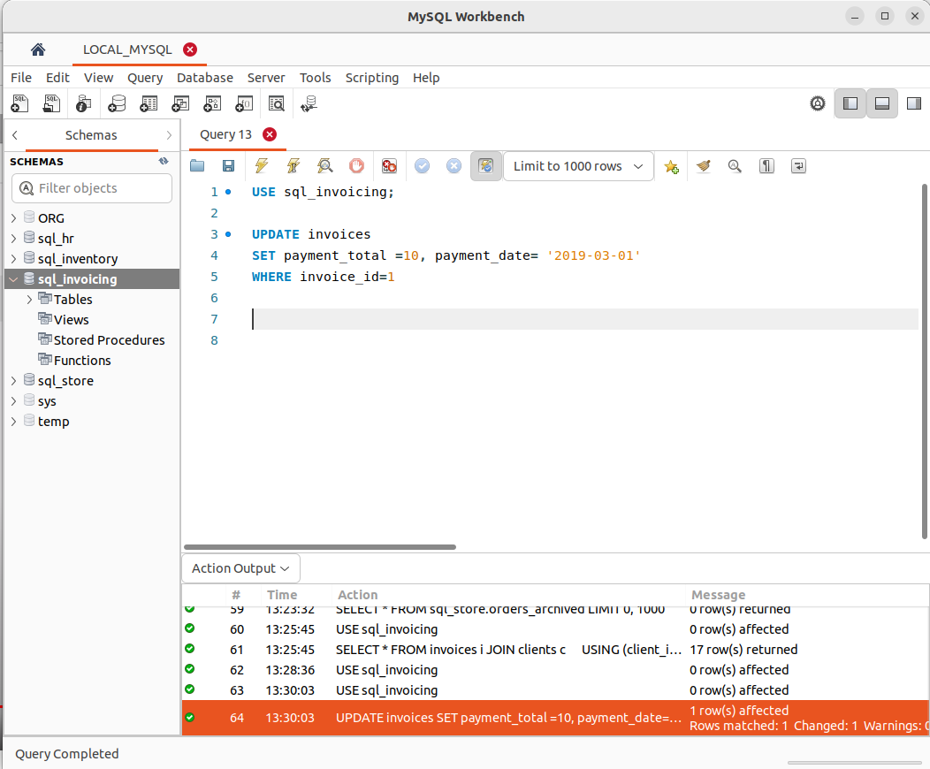
.

- Updating Multiple Rows
Modifies data in multiple rows based on a condition. Example:
```
UPDATE students SET grade = 'B' WHERE age > 20;
```
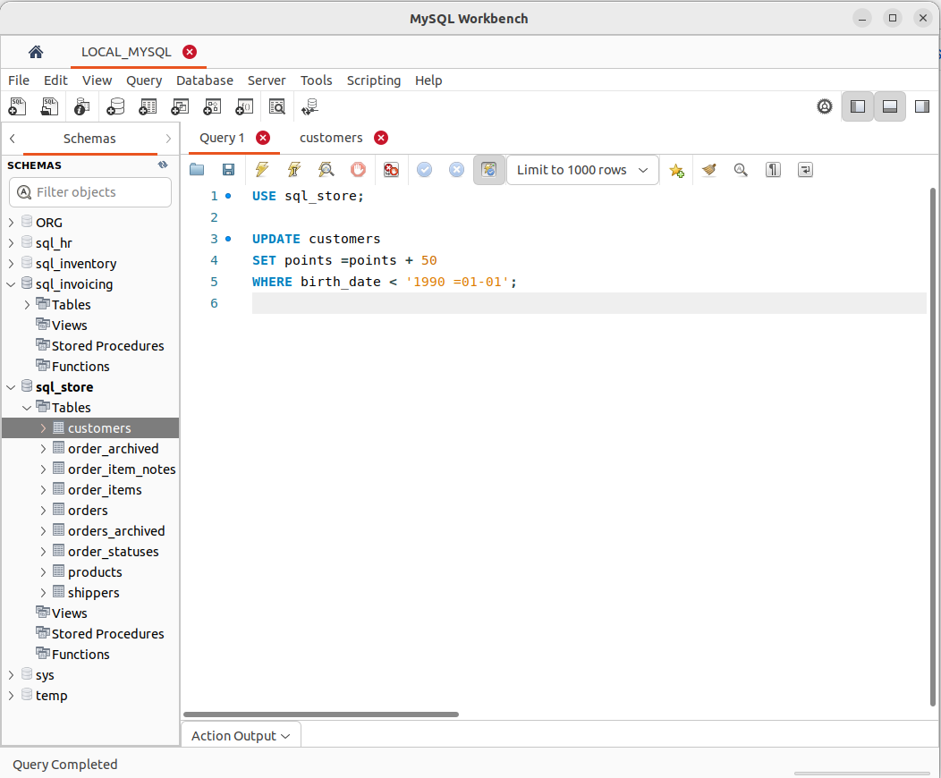
.

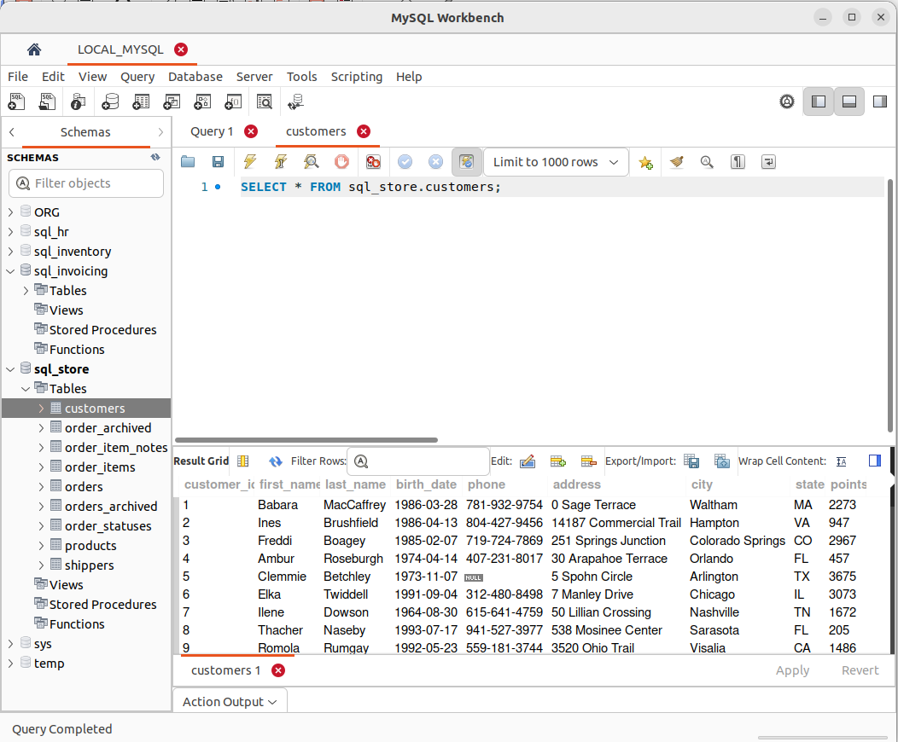
.

- Using Sub queries in Updates
Updates rows based on the results of a subquery. Example:
```
UPDATE inventory
SET stock = stock - (SELECT quantity FROM orders WHERE order_id = 101)
WHERE product_id = 101;
```

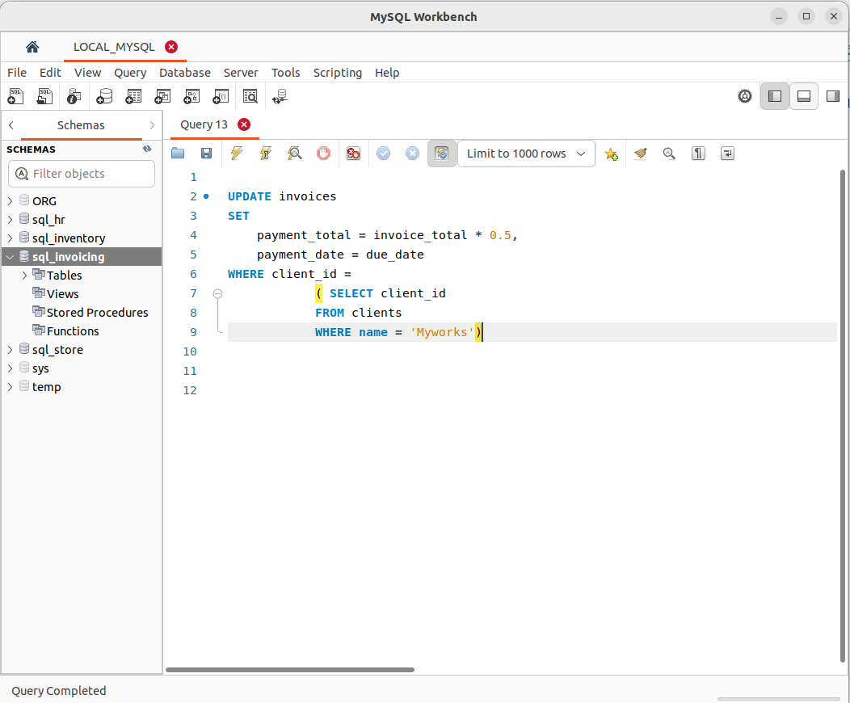

- Deleting Rows
Removes one or more rows from a table. Example:
```
DELETE FROM employees WHERE department = 'HR';
```
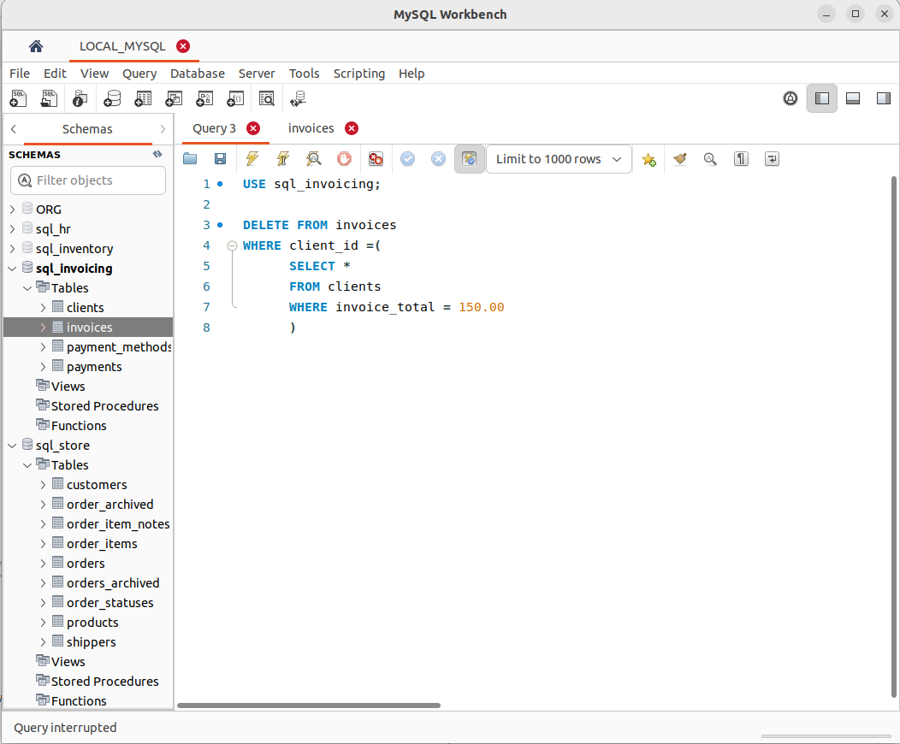

- Restoring Course Databases
Restores databases to their previous state, often using backups or historical data. The example would depend on the specific database system and backup procedure used.

STEP 1. Go to the file menu and select open sql script
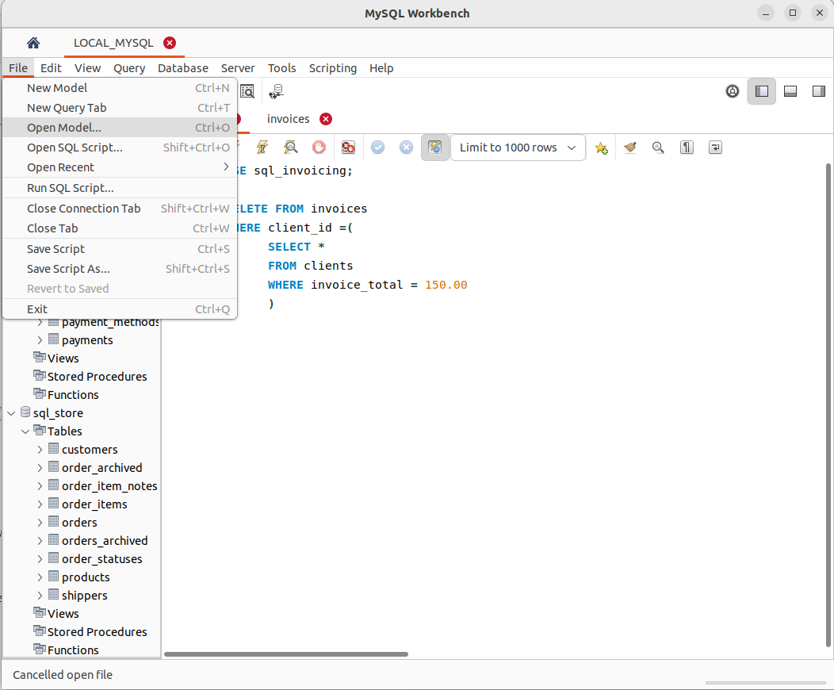
.

STEP 2. then navigate to the directory where you store database and select the the database to restore.
