Chase Brake

ITEC 3245

Professor Knighton

07 September 2024

Module 4 Assignment

**

**2.) Create & Use Commands**

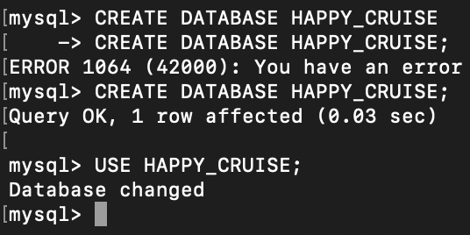

**3.) Create Table Command Screenshots**

**4.) Select * Command Screenshots**

