Develop environment：windows + python 2.7 + pyqt4

Notes：

1. **Please install pyqt4 (2.7 x32) before running, download address list below:**

**http://www.riverbankcomputing.com/software/pyqt/download**

1. only support single digit variables like a, b, c, d
2. incorrect input might lead to crash, you need to reboot the main.py

there are 5 files in total：

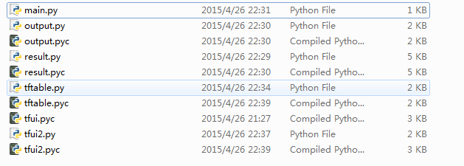

**Only need to run main.py to start the truth table (you can right click on main and select edit with IDLE and press f5 to run it if you don’t have python editor like eclipse)**

Running example:

