LEGUP
User Guide

Tim Tesluk
Bram van Heuveln • Department of Cognitive Science• Rensselaer Polytechnic Institute

Table of Contents

Introduction 1
Objectives 1
Interface 1
Launch Window 1
Main 1
Tree 1
Board 1
Justification 1
Solving Puzzles 1
Branching and merging 1
Navigating 1

LEGUP
Logic Engine for Grid-Using Puzzles
Introduction

LEGUP (Logic Engine for Grid-Using Puzzles) is an Undergraduate Research Project under Dr. Bram van Heuveln in the department of Cognitive Science. It is under the greater classification of "Visual Logic", as it is a system of logic that is based purely on applying rules to objects visual in nature.
Objectives
The principle objective of this project is to research and categorize various grid-based logic puzzles, with the intention of creating a formal system of "grid logic" applicable to various puzzles of different formats. To do this, several well-known logical puzzles will be studied, and the commonalities between them will be used as the framework for a system that can be used to represent them.
The end result of this research will be a single application that will be capable of representing many of these grid-based logical puzzles. This application would utilize a dynamic "grid-based logical engine", with programmable "modules" that allowed the introduction or modification of puzzles on the fly.
Such an application would be very useful in the field of education, as children and adults alike could be taught the basics of formal logic while seemingly playing a game. Through manipulating the objects in the puzzle and attempting to win, users will be constructing logical proofs.

Interface
The puzzle solving interface is comprised of four windows: LEGUP Main window, Justification window, Board window, and the Tree window. Together, each of these is used to progress through the puzzle solving process and create a proof for the puzzle’s solution.

Launch Window
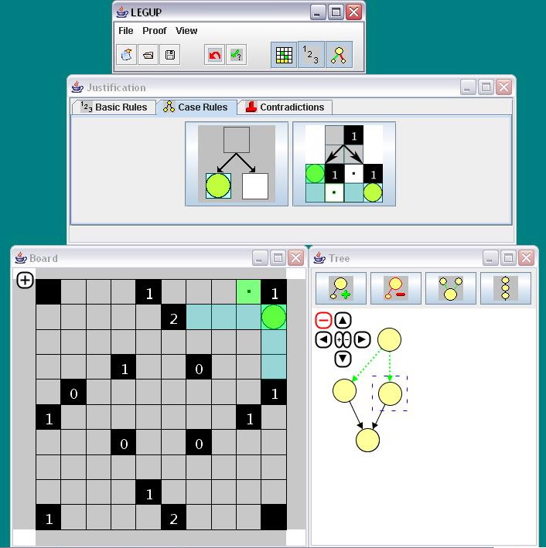
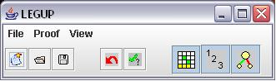
When you launch the application, you will first be prompted by a “Select Puzzle” dialogue. From here you can choose from a number of types of games in the first drop down menu. After selecting a game, the second drop down menu allows you to choose a specific puzzle board for that game. Pressing the OK button will start the solving environment for that puzzle board.

Main
This window is used to
- start new puzzles
- save puzzles in progress
- open saved puzzles
- undo actions
- check or verify a rule
- show/hide other windows
- modify extra options

Tree
This window shows the tree of board states for this puzzle’s proof, represented by yellow circles and directional arrows inter-connecting them representing the reasoning or “justification” used to progress to that state.
- The tree will start out with just one state, the initial state. The initial state cannot be modified.
- The currently active board state is surrounded by a dotted blue box.
- Left-clicking on different states will set them as the currently active state, and the dotted blue box will surround it. [Board updates]
- New “child” states can be added to the currently active board state by clicking the add state button.
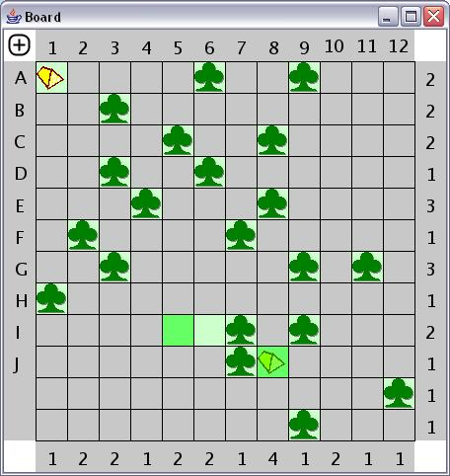
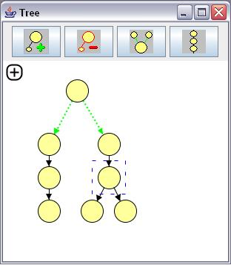
- States are able to be re-positioned by right-clicking and dragging them.
- The currently active state (and all of it’s children) can be deleted by clicking the delete state button.
- The third button in the window is the merge state button, which provides rule-specific functionality and will be explained in detail later.

Board
This window shows the currently active board state. Using the mouse to left-click the various tiles on the board cycles the tile through all of its possible states, depending on the type of game being played. Tiles which are different from the currently active board state’s parent state are highlighted green.

Justification
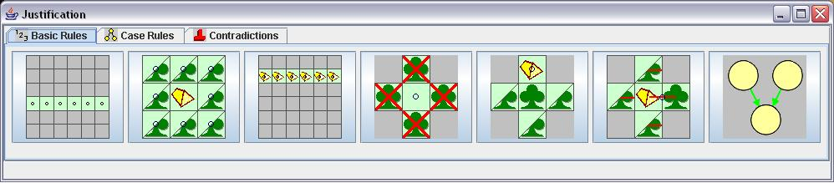
This window contains a collection of buttons labeled with images that represent higher level strategies, or rules, which can be used to justify the changes made from one board state to the next. The rules are separated into categories and vary by the type of puzzle. Hovering the mouse cursor over a rule will display an explanation of what rule is represented. By default, clicking one of the rules will run a check on the puzzle to determine if the rule is applicable in the context of the currently active board state and its parent state. A message will then appear at the bottom of this window either confirming that the rule is able to be applied correctly, or why it cannot be applied. Applying a rule correctly will change the color of the arrow connecting the currently active state to its parent to green to indicate correctness. Otherwise, it will turn red to indicate that a rule is incorrectly applied. If the rule applied means that a contradiction on the puzzle has been reached, then the states on the tree leading up to the currently active state will be labeled as leading to a contradiction.

Solving Puzzles
The basic steps to solving a puzzle in this system are:
- Create a new state on the tree.
- Change one or more tiles on the board.
- Select a rule for the change made
- Repeat steps 1 through 3 until a solution is reached
Reaching the solution to a puzzle is not always this simple, though. There are more techniques and features that are either necessary at times to reach an appropriate conclusion, or make the solving process much more efficient. LEGUP offers the ability to backtrack through reasoning processes and even branch off different paths and possibilities on the reasoning tree.

Branching and merging
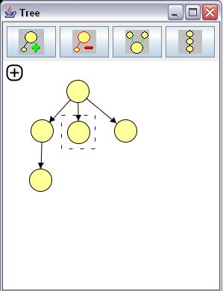
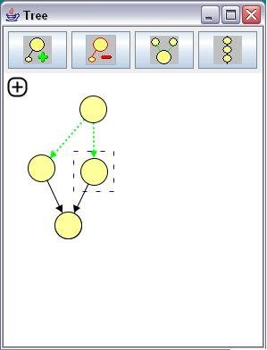
A common tool in solving puzzles is to consider the consequences of multiple possible moves. In order to represent this sort of reasoning, one would create multiple child states from a single parent state. This can occur many times in a single puzzle’s reasoning tree. This is achieved simply by clicking the add state button in the Tree window multiple times. Once this has be done, the transition lines can now be selected so that an applicable case rule can be applied. Case rules are located in a separate tab in the Justification window. With a set of branched transitions selected, clicking a case rule button will attempt to verify that the rule applies to the situation in a valid way. A correct application of a case rule will turn the transition lines into green dotted lines, much like in regular transitions, to indicate correctness.

In certain types of puzzles, multiple branched states can be merged into a single child state in accordance with an appropriate case rule. In order to apply a merge-rule, hold down the control button on the keyboard and left-click on each of the board states which are to be merged. Then, click on the merge button in the Tree window. Select the resultant merged child state and apply the corresponding merge rule from the Justification window.

Navigating
Large puzzles can result in often time large and complex reasoning trees. It is possible to navigate about the Tree window using the (+) symbol button in the upper left corner of the window. Clicking the (+) expands a selection of other buttons which, when clicked, allow zooming in and out, and panning around the field. Clicking the red (-) symbol collapses that navigation menu again. It is also possible to navigate by middle-clicking and dragging the field in the window. For convenience, this same navigation technique is present in the Board window.

