**Werkplekleren**

**Netwerkdocumentatie-oefening**



Inhoud

1. Logical topology en cisco topology. 3

2. Gebruikte onderdelen 3

3. Poorttoewijzigingen 4

4. Router en switch adressen 4

5. Adressen van computers 5

6. Router configuratie 6

7. Switch configuratie 10

7.1 Switch01 configuratie 10

7.2 Switch02 configuratie 14

**Github Link**

<https://github.com/BramSegersPXL/Networkopdracht>

# 1. Logical topology en cisco topology.

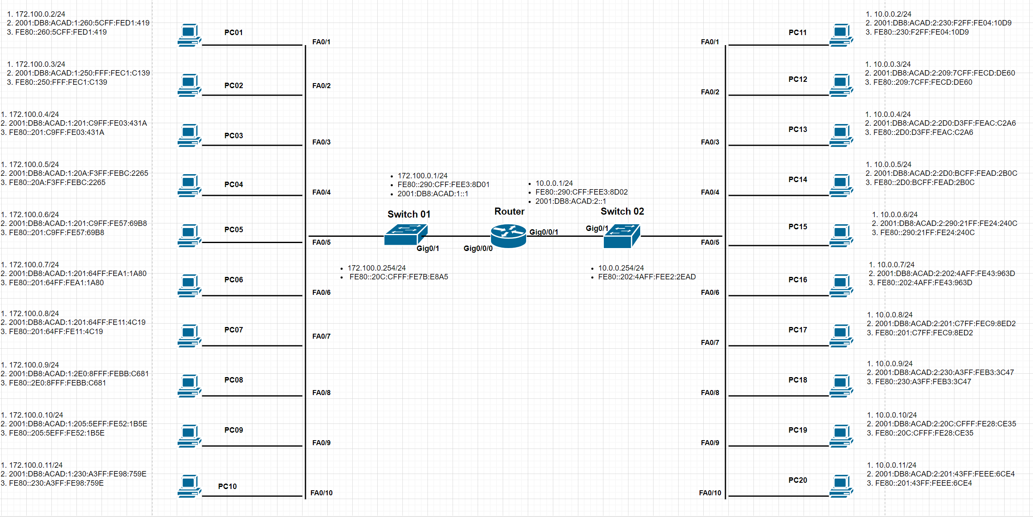

# 2. Gebruikte onderdelen

* 1 Router ISR4321

* 2 Switches 2960-24TT

* 20 Computers

# 3. Poorttoewijzigingen

|  |  |
| --- | --- |
| Switch01 | Giga 0/1 |
| PC01 | FA 0/1 |
| PC02 | FA 0/2 |
| PC03 | FA 0/3 |
| PC04 | FA 0/4 |
| PC05 | FA 0/5 |
| PC06 | FA 0/6 |
| PC07 | FA 0/7 |
| PC08 | FA 0/8 |
| PC09 | FA 0/9 |
| PC10 | FA 0/10 |
| Switch02 | Giga 0/1 |
| PC11 | FA 0/1 |
| PC12 | FA 0/2 |
| PC13 | FA 0/3 |
| PC14 | FA 0/4 |
| PC15 | FA 0/5 |
| PC16 | FA 0/6 |
| PC17 | FA 0/7 |
| PC18 | FA 0/8 |
| PC19 | FA 0/9 |
| PC20 | FA 0/10 |
| Router Switch01 | Giga 0/0/0 |
| Router switch02 | Giga0/0/1 |

# 4. Router en switch adressen

|  |  |  |  |
| --- | --- | --- | --- |
| **toestel** | **IPv6 adress** | **IPv6 adress** | **linc local adress** |
| Switch01 | 172.100.0.254/24 |  | FE80::20C:CFFF:FE7B:E8A5 |
| Switch02 | 10.0.0.254/24 |  | FE80::202:4AFF:FEE2:2EAD |
| Router Giga 0/0/0 | 172.100.0.1/24 | 2001:DB8:ACAD:1::1 | FE80::290:CFF:FEE3:8D01 |
| Router Giga 0/0/1 | 10.0.0.1/24 | 2001:DB8:ACAD:2::1 | FE80::290:CFF:FEE3:8D02 |

# 5. Adressen van computers

Switch01

|  |  |  |  |  |
| --- | --- | --- | --- | --- |
| PC | IPv4 adress | IPv6 adress | link local adress | Mac adressen |
| PC01 | 172.100.0.2 | 2001:DB8:ACAD:1:260:5CFF:FED1:419 | FE80::260:5CFF:FED1:419 | 0060.5cd1.0419 |
| PC02 | 172.100.0.3 | 2001:DB8:ACAD:1:250:FFF:FEC1:C139 | FE80::250:FFF:FEC1:C139 | 0050.0fc1.c139 |
| PC03 | 172.100.0.4 | 2001:DB8:ACAD:1:201:C9FF:FE03:431A | FE80::201:C9FF:FE03:431A | 0001.c903.431a |
| PC04 | 172.100.0.5 | 2001:DB8:ACAD:1:20A:F3FF:FEBC:2265 | FE80::20A:F3FF:FEBC:2265 | 000a.f3bc.2265 |
| PC05 | 172.100.0.6 | 2001:DB8:ACAD:1:201:C9FF:FE57:69B8 | FE80::201:C9FF:FE57:69B8 | 0001.c957.69b8 |
| PC06 | 172.100.0.7 | 2001:DB8:ACAD:1:201:64FF:FEA1:1A80 | FE80::201:64FF:FEA1:1A80 | 0001.64a1.1a80 |
| PC07 | 172.100.0.8 | 2001:DB8:ACAD:1:201:64FF:FE11:4C19 | FE80::201:64FF:FE11:4C19 | 0001.6411.4c19 |
| PC08 | 172.100.0.9 | 2001:DB8:ACAD:1:2E0:8FFF:FEBB:C681 | FE80::2E0:8FFF:FEBB:C681 | 00e0.8fbb.c681 |
| PC09 | 172.100.0.10 | 2001:DB8:ACAD:1:205:5EFF:FE52:1B5E | FE80::205:5EFF:FE52:1B5E | 0005.5e52.1b5e |
| PC10 | 172.100.0.11 | 2001:DB8:ACAD:1:230:A3FF:FE98:759E | FE80::230:A3FF:FE98:759E | 0030.a398.759e |

Switch02

|  |  |  |  |  |
| --- | --- | --- | --- | --- |
| PC | IPv4 adress | IPv6 adress | link local adress | Mac adress |
| PC11 | 10.0.0.2 | 2001:DB8:ACAD:2:230:F2FF:FE04:10D9 | FE80::230:F2FF:FE04:10D9 | 0030.f204.10d9 |
| PC12 | 10.0.0.3 | 2001:DB8:ACAD:2:209:7CFF:FECD:DE60 | FE80::209:7CFF:FECD:DE60 | 0009.7ccd.de60 |
| PC13 | 10.0.0.4 | 2001:DB8:ACAD:2:2D0:D3FF:FEAC:C2A6 | FE80::2D0:D3FF:FEAC:C2A6 | 00d0.d3ac.c2a6 |
| PC14 | 10.0.0.5 | 2001:DB8:ACAD:2:2D0:BCFF:FEAD:2B0C | FE80::2D0:BCFF:FEAD:2B0C | 00d0.bcad.2b0c |
| PC15 | 10.0.0.6 | 2001:DB8:ACAD:2:290:21FF:FE24:240C | FE80::290:21FF:FE24:240C | 0090.2124.240c |
| PC16 | 10.0.0.7 | 2001:DB8:ACAD:2:202:4AFF:FE43:963D | FE80::202:4AFF:FE43:963D | 0002.4a43.963d |
| PC17 | 10.0.0.8 | 2001:DB8:ACAD:2:201:C7FF:FEC9:8ED2 | FE80::201:C7FF:FEC9:8ED2 | 0001.c7c9.8ed2 |
| PC18 | 10.0.0.9 | 2001:DB8:ACAD:2:230:A3FF:FEB3:3C47 | FE80::230:A3FF:FEB3:3C47 | 0030.a3b3.3c47 |
| PC19 | 10.0.0.10 | 2001:DB8:ACAD:2:20C:CFFF:FE28:CE35 | FE80::20C:CFFF:FE28:CE35 | 000c.cf28.ce35 |
| PC20 | 10.0.0.11 | 2001:DB8:ACAD:2:201:43FF:FEEE:6CE4 | FE80::201:43FF:FEEE:6CE4 | 0001.43ee.6ce4 |

# 6. Router configuratie

Login password : pxl

Secret password : pxl

Current configuration : 1348 bytes

!

version 15.4

no service timestamps log datetime msec

no service timestamps debug datetime msec

service password-encryption

!

hostname router

!

!

!

enable secret 5 $1$mERr$NARFGJytzNQ.L1OAZ.TVE/

!

!

!

!

!

!

ip cef

ipv6 unicast-routing

!

no ipv6 cef

!

!

!

username bram password 7 08315442

!

!

!

!

!

!

!

!

ip domain-name pxl.be

!

!

spanning-tree mode pvst

!

!

!

!

!

!

interface GigabitEthernet0/0/0

ip address 172.100.0.1 255.255.255.0

duplex auto

speed auto

ipv6 address 2001:DB8:ACAD:1::1/64

!

interface GigabitEthernet0/0/1

ip address 10.0.0.1 255.255.255.0

duplex auto

speed auto

ipv6 address 2001:DB8:ACAD:2::1/64

!

interface Vlan1

no ip address

shutdown

!

ip classless

!

ip flow-export version 9

!

!

!

banner motd ^Cc

*********************************

* WARNING!!!! *

* *

* unauthorized entry *

* will be hanged when found *

* so don't try, *

* i will be watching *

* *

* admin:Segers Bram *

* 12402420@student.pxl.be *

*********************************

^C

!

!

!

!

line con 0

password 7 08315442

login

!

line aux 0

password 7 08315442

login

!

line vty 0 4

password 7 08315442

login local

transport input ssh

line vty 5 15

password 7 08315442

login local

transport input ssh

!

!

!

End

# 7. Switch configuratie

Login password : pxl

Secret password :pxl

## 7.1 Switch01 configuratie

Current configuration : 1767 bytes

!

version 15.0

no service timestamps log datetime msec

no service timestamps debug datetime msec

service password-encryption

!

hostname switch01

!

!

enable secret 5 $1$mERr$NARFGJytzNQ.L1OAZ.TVE/

!

!

!

ip domain-name pxl.be

!

username bram privilege 1 password 7 08315442

!

!

!

spanning-tree mode pvst

spanning-tree extend system-id

!

interface FastEthernet0/1

!

interface FastEthernet0/2

!

interface FastEthernet0/3

!

interface FastEthernet0/4

!

interface FastEthernet0/5

!

interface FastEthernet0/6

!

interface FastEthernet0/7

!

interface FastEthernet0/8

!

interface FastEthernet0/9

!

interface FastEthernet0/10

!

interface FastEthernet0/11

!

interface FastEthernet0/12

!

interface FastEthernet0/13

!

interface FastEthernet0/14

!

interface FastEthernet0/15

!

interface FastEthernet0/16

!

interface FastEthernet0/17

!

interface FastEthernet0/18

!

interface FastEthernet0/19

!

interface FastEthernet0/20

!

interface FastEthernet0/21

!

interface FastEthernet0/22

!

interface FastEthernet0/23

!

interface FastEthernet0/24

!

interface GigabitEthernet0/1

!

interface GigabitEthernet0/2

!

interface Vlan1

ip address 172.100.0.254 255.255.255.0

!

ip default-gateway 172.100.0.1

!

banner motd ^Cc

*********************************

* WARNING!!!! *

* *

* unauthorized entry *

* will be hanged when found *

* so don't try, *

* i will be watching *

* *

* admin:Segers Bram *

* 12402420@student.pxl.be *

*********************************

^C

!

!

!

!

!

line con 0

password 7 08315442

login

!

line vty 0 4

password 7 08315442

login local

transport input ssh

line vty 5 15

password 7 08315442

login local

transport input ssh

End

## 7.2 Switch02 configuratie

Current configuration : 1761 bytes

!

version 15.0

no service timestamps log datetime msec

no service timestamps debug datetime msec

service password-encryption

!

hostname switch02

!

!

enable secret 5 $1$mERr$NARFGJytzNQ.L1OAZ.TVE/

!

!

!

ip domain-name pxl.be

!

username bram privilege 1 password 7 08315442

!

!

!

spanning-tree mode pvst

spanning-tree extend system-id

!

interface FastEthernet0/1

!

interface FastEthernet0/2

!

interface FastEthernet0/3

!

interface FastEthernet0/4

!

interface FastEthernet0/5

!

interface FastEthernet0/6

!

interface FastEthernet0/7

!

interface FastEthernet0/8

!

interface FastEthernet0/9

!

interface FastEthernet0/10

!

interface FastEthernet0/11

!

interface FastEthernet0/12

!

interface FastEthernet0/13

!

interface FastEthernet0/14

!

interface FastEthernet0/15

!

interface FastEthernet0/16

!

interface FastEthernet0/17

!

interface FastEthernet0/18

!

interface FastEthernet0/19

!

interface FastEthernet0/20

!

interface FastEthernet0/21

!

interface FastEthernet0/22

!

interface FastEthernet0/23

!

interface FastEthernet0/24

!

interface GigabitEthernet0/1

!

interface GigabitEthernet0/2

!

interface Vlan1

ip address 10.0.0.254 255.255.255.0

!

ip default-gateway 10.0.0.1

!

banner motd ^Cc

*********************************

* WARNING!!!! *

* *

* unauthorized entry *

* will be hanged when found *

* so don't try, *

* i will be watching *

* *

* admin:Segers Bram *

* 12402420@student.pxl.be *

*********************************

^C

!

!

!

!

!

line con 0

password 7 08315442

login

!

line vty 0 4

password 7 08315442

login local

transport input ssh

line vty 5 15

password 7 08315442

login local

transport input ssh

!

!

!

!