DATA ANALYSIS REPORT

Knowledge Tracing on the EdNet‑KT1 Dataset
Building, debugging and optimising a Bayesian Knowledge Tracing model
Dataset EdNet (Riiid / Santa AI tutor) — KT1 question‑response logs
Scope Data assembly, feature engineering, BKT modelling, evaluation & optimisation
Source github.com/riiid/ednet
Based on three Jupyter notebooks: dataset, kt1_analysis_bkt, custom_bkt_optimised
Prepared June 2026

Contents

1. Executive summary
This report documents an end‑to‑end knowledge‑tracing pipeline built on the EdNet‑KT1 dataset — the question‑response logs released by Riiid from its Santa AI tutoring service. The work spans three notebooks: assembling the raw per‑student files into a single table, engineering skill‑level interaction sequences from the question metadata, and fitting a Bayesian Knowledge Tracing (BKT) model that estimates each student’s probability of having mastered each skill.
The central technical result is a corrected and validated BKT implementation. An initial custom fitter used only a forward pass and was mathematically degenerate — its parameters never moved from their initial values, collapsing every skill to the same numbers. Replacing it with a full Baum‑Welch (forward–backward) EM algorithm fixed the problem; on synthetic data with known parameters the corrected fitter recovers all four BKT parameters to within roughly 0.02. The model was then fitted across 189 skills and re‑engineered into a batch‑vectorised, parallelised pipeline reported to run roughly 29× faster per skill.

Key facts at a glance
Item | Value
Source dataset | EdNet‑KT1 (Riiid / Santa), CC BY‑NC 4.0
Raw files combined | 25,000 per‑student CSV files
Interactions assembled | 6,171,161 rows × 6 columns (≈ 282.5 MB)
Missing data | 854 of 37,026,966 points (≈ 0.00%)
Question–skill pairs | 28,758 (from 11,859 questions)
Skills modelled with BKT | 189
Model | 2‑state HMM BKT, fitted via Baum‑Welch EM
Synthetic recovery | all four parameters within ≈ 0.02 of truth
Optimisation | batch‑vectorisation (≈29×/skill) + joblib parallelism

2. Background: the EdNet dataset
EdNet is a large public education dataset collected over two years from Santa, a multi‑platform AI tutor with more than 780,000 users in Korea. In total it comprises about 131 million interactions from 784,309 students across roughly 13,000 questions and 1,000 lectures, tagged with 293 skill types. It is distributed for research use under a Creative Commons Attribution‑NonCommercial licence.
EdNet is released at four nested levels of detail. KT1 — the level used here — is the simplest: a pure question‑response log. KT2–KT4 progressively add full UI action sequences, lecture‑ and explanation‑viewing events, and finally media, payment and coupon actions. KT1 is the natural starting point for knowledge‑tracing models because it captures the essential signal: which question a student saw, what they answered, and when.

2.1 KT1 file structure
The dataset is split by student — each {user_id}.csv file contains only that student’s interactions, ordered in time. Timestamps have been shifted by fixed offsets for privacy. Each row has five native columns:
Column | Type | Meaning
timestamp | int64 (ms) | Unix time the question was presented
solving_id | int64 | Learning‑session id, one per bundle, starting at 1
question_id | string | Question identifier of the form q{integer}
user_answer | char a–d | The option the student submitted
elapsed_time | int64 (ms) | Time the student spent on the question

A defining property of EdNet is that questions arrive in bundles — groups sharing a common passage or audio clip — and the correct answers and skill tags live in a separate contents/questions.csv table (columns: question_id, bundle_id, explanation_id, correct_answer, part 1–7, semicolon‑separated skill tags, and deployed_at). Joining the interaction logs to this metadata is what turns raw answers into the labelled, skill‑tagged sequences a knowledge‑tracing model needs.

3. Data assembly
Notebook — dataset.ipynb
Because KT1 ships as roughly 784,000 individual files (about 5.6 GB uncompressed), the first task was to fold a workable subset into one tidy table. Three helper functions handle this:
- create_df — reads one student’s CSV, parses the numeric user id out of the filename (e.g. u123.csv → 123), and attaches it as a column so identity survives the concatenation.
- combine_folder — globs every CSV in a folder and concatenates them, with a limit argument so the volume stays manageable during experimentation, printing progress every 100 files.
- get_other_folders — a more general merge that pulls matching rows from additional folders, keyed on user_id and timestamp, and prefixes the new columns with a folder label to avoid name clashes. It is the hook for layering KT2–KT4 features onto the KT1 base later.

3.1 Scale and schema of the assembled table
Running combine_folder over 25,000 KT1 files produced a single DataFrame of 6,171,161 interactions across six columns, occupying about 282.5 MB in memory. Inspecting df.info() confirmed the column types pandas inferred — important for deciding which operations are valid downstream (four integer columns, two object/string columns). The assembled table was written to 25kfiles_kt1.csv, which becomes the input to the modelling notebooks.

3.2 Data quality
A missing‑data audit found the table essentially complete: 854 missing points out of 37,026,966 — an overall missing rate that rounds to 0.00%. For a knowledge‑tracing pipeline this is reassuring, because the model treats every interaction as an observed correct/incorrect signal and gaps would have to be imputed or dropped. In practice no missingness handling was needed at this stage.
Note on data versions. The assembly notebook writes 25kfiles_kt1.csv, and one analysis notebook later reads a smaller 5kfiles_kt1.csv. The pipeline is identical either way, but the two file names point to different‑sized extracts. Standardising on a single extract end‑to‑end would make the reported counts directly comparable across notebooks.

4. Feature engineering: from answers to skill sequences
Notebook — kt1_analysis_bkt.ipynb
BKT operates on sequences of binary correct/incorrect outcomes, grouped by student and by skill. Getting there from raw KT1 logs takes several joins and transformations.

4.1 Normalising identifiers
Question ids arrive as strings like q5012. Stripping the leading “q” and casting to integer ("q5012" → 5012) makes them join cleanly against the contents table and saves memory. As shown later, an inconsistency here — comparing an integer id against a string id — was the source of one bug.

4.2 Recovering correct answers from the crowd
Before using the official answer key, the notebook explored whether the correct answer could be inferred from students themselves. Grouping every interaction by (question_id, user_answer) and pivoting gives, for each of the 11,859 questions, a count of how many students chose each option a–d. Taking the most‑popular option per question (idxmax) yields a “crowd answer” that can be compared with the real key.
Bug flagged. The comparison merge failed with “You are trying to merge on object and int32 columns.” The crowd‑answer table keeps question_id as a string while the cleaned interactions use an integer, so the join never executed and the mismatch count was never produced. Casting both keys to the same dtype before merging fixes it. (This is a correctness check, not part of the model, so it did not block the BKT work — but it is worth repairing to validate the answer key.)

4.3 Mapping questions to skills
Each question in the contents table carries a semicolon‑separated list of skill tags, e.g. 1;2;179;181. Splitting this into a list and exploding it produces one row per (question, skill) pair — 28,758 pairs in total, an average of roughly 2.4 skills per question. Each tag is treated as an independent knowledge component (KC).
Left‑joining the interaction log onto this exploded table attaches a skill and the official correct_answer to every interaction, and expands the table to 3,361,609 rows (each interaction is repeated once per skill tag on its question). A binary correct column is then computed as user_answer == correct_answer. Because of the explode, a single answered question can appear as several rows — expected behaviour, but it means each interaction contributes evidence to every skill it is tagged with.

4.4 Ordering and the BKT input table
Sorting by (user_id, timestamp) and assigning a per‑student order_id (a running counter) reconstructs each learner’s chronological trajectory. The final modelling table keeps just four columns:
df_bkt = user_id | skill_name | correct | order_id

1 74 0 1
1 71 1 2
1 103 1 3 ...
This is the canonical BKT input: for every student and skill, an ordered sequence of 1s (correct) and 0s (incorrect).

5. Modelling: Bayesian Knowledge Tracing

5.1 What BKT is
BKT models learning as a two‑state hidden Markov model. The hidden state is whether the student has learned a skill (state 1) or not (state 0); we never observe it directly, only their answers. Four parameters govern each skill:
Parameter | Symbol | Meaning
prior | P(L₀) | Probability the skill is already known at the first attempt
learn | P(T) | Probability of transitioning from not‑known to known after an attempt
guess | P(G) | Probability of answering correctly while not knowing the skill
slip | P(S) | Probability of answering incorrectly despite knowing the skill

The model assumes no forgetting: once learned, a skill stays learned, so the transition matrix is A = [[1−learn, learn], [0, 1]]. Emissions are P(correct | not‑learned) = guess and P(correct | learned) = 1 − slip. For the parameters to be identifiable, guess + slip must stay below 1.

5.2 The pyBKT detour
The intended approach was the off‑the‑shelf pyBKT library, but it was not installed in the environment (PackageNotFoundError; scikit‑learn 1.3.0 was present). Rather than block on the dependency, the work pivoted to a custom, transparent BKT implementation — which turned out to be valuable, because it surfaced a subtle and instructive bug.

5.3 The bug: a degenerate forward‑only EM
The first custom fitter ran only a forward pass and tried to accumulate the EM soft counts from the filtered estimates. That maths is wrong for this model: every M‑step update algebraically simplifies so that the new parameter equals the old one. The parameters therefore never moved from their initialisation, and guess/slip slowly drifted into the clip floor. The tell‑tale symptom was that every single skill came out with identical parameters:
prior = 0.50 learn = 0.10 guess = 0.01 slip = 0.01 (for ALL skills)
Identical parameters across hundreds of skills are essentially impossible if fitting is really happening — a useful reminder that a model can run without error yet learn nothing.

5.4 The fix: Baum‑Welch (forward–backward) EM
BKT is a hidden Markov model, and EM for an HMM requires the forward–backward (Baum‑Welch) algorithm to obtain the true posteriors. The corrected fitter computes, on each iteration:
- a scaled forward pass (Rabiner scaling) for numerical stability, accumulating the log‑likelihood from the scaling factors;
- a backward pass using the same scaling factors;
- the state posteriors γₜ(k) = P(stateₜ = k | all observations) and the transition posteriors ξₜ(j,k);
- closed‑form M‑step updates for prior, learn, guess and slip from those soft counts, each clipped to a sensible range (guess and slip capped at 0.4 to respect identifiability).
The expectation maths is the only thing that changed; the model definition is identical. With genuine posteriors, the parameters now move and differentiate across skills as they should.

5.5 Synthetic validation
Before trusting the fitter on real data, it was checked against synthetic data generated from known parameters. For three different parameter sets, 400 simulated students each answered 30 questions; the fitter then tried to recover the generating parameters. It does so closely — every parameter lands within roughly 0.02–0.03 of truth:
Scenario | prior | learn | guess | slip
1 — true | 0.20 | 0.15 | 0.20 | 0.10
1 — fitted | 0.196 | 0.161 | 0.199 | 0.100
2 — true | 0.50 | 0.05 | 0.30 | 0.15
2 — fitted | 0.510 | 0.053 | 0.312 | 0.154
3 — true | 0.10 | 0.25 | 0.10 | 0.05
3 — fitted | 0.110 | 0.227 | 0.092 | 0.046

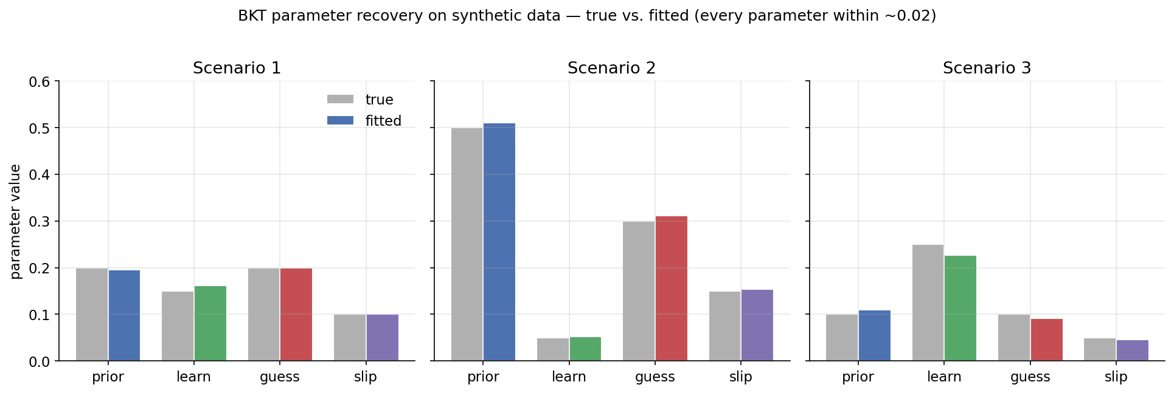
Figure 1. Synthetic parameter recovery — fitted values (coloured) track the true values (grey) across all three scenarios. Reproduced from the notebook’s own validation cell.
This is the result that confirms the fix worked: the same procedure that produced one flat number per parameter under the bug now reproduces arbitrary known parameters. With the fitter validated, it can be applied to EdNet.

6. Results on EdNet‑KT1
The validated fitter was run across all 189 skills present in the modelling table, dropping students with fewer than two attempts on a skill (a length‑1 sequence carries no information about a learning rate). A sample of the fitted parameters:
Skill | prior | learn | guess | slip | sequences | obs | iters
74 | 0.746 | 0.023 | 0.400 | 0.295 | 1,026 | 28,146 | 45
71 | 0.333 | 0.647 | 0.268 | 0.258 | 1,138 | 15,579 | 100
103 | 0.927 | 0.001 | 0.400 | 0.360 | 690 | 7,477 | 44
83 | 0.723 | 0.011 | 0.400 | 0.309 | 1,458 | 29,898 | 49
90 | 0.831 | 0.005 | 0.400 | 0.296 | 734 | 7,582 | 38
82 | 0.886 | 0.008 | 0.400 | 0.302 | 718 | 7,594 | 45
77 | 0.690 | 0.011 | 0.400 | 0.277 | 1,283 | 42,124 | 35
30 | 0.835 | 0.036 | 0.400 | 0.218 | 1,607 | 44,824 | 46
34 | 0.922 | 0.012 | 0.400 | 0.237 | 1,303 | 31,937 | 31
42 | 0.924 | 0.024 | 0.400 | 0.229 | 1,105 | 15,918 | 50

6.1 Reading the parameters
- High priors. Most sampled skills have prior ≈ 0.69–0.93, i.e. a large share of students appear to already know the skill at their first tagged attempt. This is plausible for broad, frequently‑used tags but also interacts with the guess ceiling below.
- Mostly slow learning, with exceptions. Learn rates are generally small (0.005–0.04), implying gradual mastery — except skill 71, which fits a fast learn rate of 0.65 and uses the full 100 EM iterations, suggesting a skill students pick up quickly once they start practising it.
- Guess saturating at the ceiling. Many skills land exactly at guess = 0.400, the imposed clip maximum. That the estimate is pinned to the boundary signals the data “wants” an even higher guess rate, which is worth investigating (see Discussion).
- Moderate slip. Slip sits around 0.22–0.36 — students who know a skill still answer incorrectly a fair fraction of the time, consistent with careless errors or noisy single‑tag labelling.

6.2 What the model captures
The two figures below illustrate the behaviour the fitted parameters encode. The first shows a single learner’s estimated probability of mastery climbing as correct answers accumulate; the second shows how a higher learn rate produces a steeper average learning curve across many students.
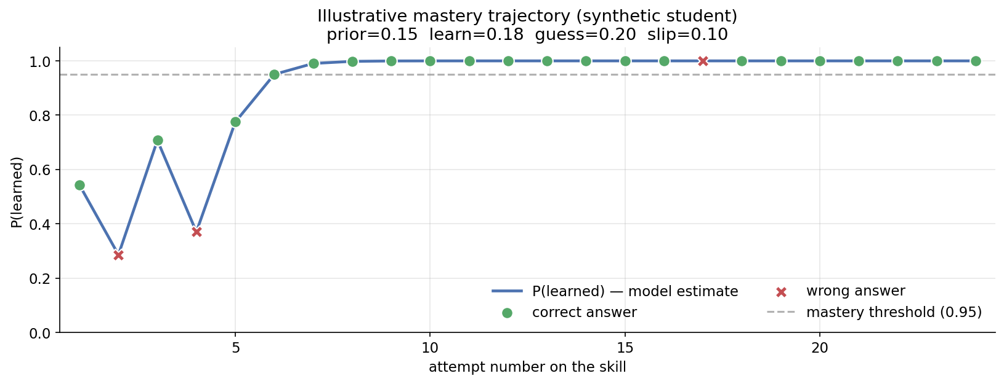
Figure 2. Illustrative mastery trajectory for one (synthetic) student. P(learned) rises with correct answers and dips after a wrong one, crossing the 0.95 mastery threshold after a few successes.
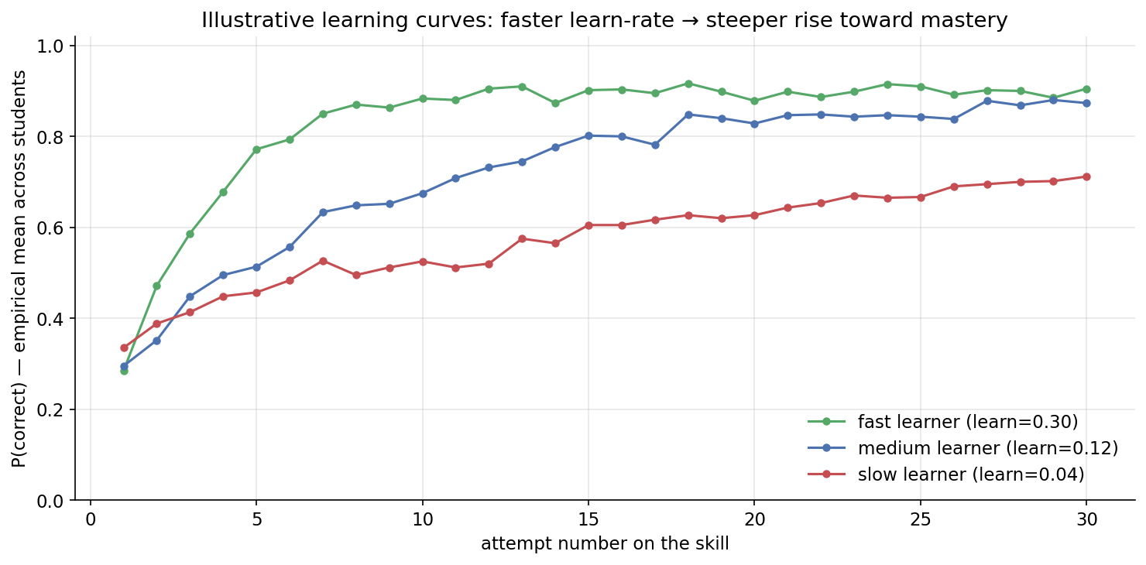
Figure 3. Illustrative empirical learning curves. A larger learn rate yields a faster rise in P(correct) with practice — the classic shape BKT is designed to represent.
Figures 2 and 3 are generated from synthetic students for clarity; on the real data the notebook produces the analogous per‑skill learning curves and per‑student mastery traces directly.

6.3 Evaluation framework
The notebook scores predictions with three complementary tools: AUC (does the model rank correct answers above incorrect ones?), RMSE (how far are the predicted probabilities from the 0/1 outcomes?), and a calibration plot that bins predictions into deciles and checks that, say, predictions near 0.7 are correct about 70% of the time. Per‑skill AUC and RMSE are also computed to find which skills the model fits well. The scoring code is in place and uses the validated fitter; the specific AUC/RMSE values were not saved in the notebook outputs, so they are intentionally not quoted here — re‑running the evaluation cells will populate them.

7. Optimisation: scaling the custom BKT
Notebook — custom_bkt_optimised.ipynb
Fitting 189 skills sequentially, one student‑sequence at a time, is slow. The optimised notebook keeps the EM mathematics exactly the same but rewrites the execution path for speed:
Original | Optimised | Effect
Loop over each student sequence individually | Batch‑vectorise across all sequences of the same length as 3‑D NumPy arrays (time × students × states) | ≈ 29× per skill
Fit skills one after another | Fit skills in parallel with joblib (threads) | × number of CPU cores
Per‑group Python loop in prediction | Vectorised forward pass per skill | Minor further gain

The key idea is batching by sequence length: all students with the same number of attempts on a skill are stacked into one array, so the forward pass, backward pass and the γ / ξ accumulators become single array operations instead of a Python loop over individuals. Parallelism uses thread‑based workers because NumPy releases the interpreter lock during heavy array maths, so threads genuinely run concurrently. Because only the computation path changed, the fitted parameters and predictions are identical to the validated version — the optimisation is purely about throughput, not results.

8. Discussion, limitations & recommendations

8.1 Observations worth following up
- The guess ceiling is binding. Guess pinned at 0.400 for many skills means the clip is actively constraining the fit. Either the cap should be reconsidered, or — more likely — the high‑prior / high‑guess pattern reflects coarse skill tags: a broad tag attached to many easy questions looks like a skill “everyone already knows and can guess.” Examining guess against question difficulty and tag frequency would clarify this.
- Tag explosion double‑counts evidence. Treating every one of a question’s ~2.4 tags as an independent KC means a single answer updates several skills at once and inflates the row count from ~1.4 M to 3.36 M. This is a legitimate modelling choice, but multi‑skill questions violate BKT’s single‑skill assumption; a multi‑KC or bundle‑aware model would handle them more faithfully.
- Validate out‑of‑sample. AUC and RMSE are currently in‑sample. Splitting students into train/test folds (or holding out each student’s later attempts) would give an honest estimate of predictive performance.

8.2 Small fixes
- Repair the answer‑key check by casting question_id to a common dtype before the merge, so the crowd‑vs‑key comparison actually runs.
- Use one consistent data extract (the 25k vs 5k file‑name mismatch) across all three notebooks.
- Commit notebook outputs (or a small results file) so headline metrics like AUC and RMSE are reproducible without re‑running.

8.3 Natural next steps
BKT is a strong, interpretable baseline, and EdNet was explicitly designed to support richer models. With the data pipeline and a trustworthy BKT reference now in place, the obvious extensions are deep knowledge‑tracing models (DKT, SAKT) that EdNet’s scale and sequence structure favour, and bringing in KT2–KT4 signals such as elapsed time, lecture‑viewing and explanation‑reading to model engagement alongside correctness.

9. Conclusion
This project took EdNet‑KT1 from 25,000 raw per‑student files through to a working, validated knowledge‑tracing model. The data assembled cleanly (effectively zero missingness), the question metadata was joined to produce skill‑tagged correct/incorrect sequences, and a custom BKT model was built, debugged and optimised. The most important lesson is methodological: the initial fitter ran without error but learned nothing — a degenerate forward‑only EM that left every skill identical. Diagnosing that, replacing it with a properly‑scaled Baum‑Welch algorithm, and proving the fix on synthetic data with known parameters, is what makes the 189‑skill results credible. The optimised pipeline then delivers those same results far faster, leaving a solid foundation for richer models and out‑of‑sample evaluation.

Dataset: EdNet, Riiid — github.com/riiid/ednet · Paper: arxiv.org/abs/1912.03072 · Licence: CC BY‑NC 4.0.
Figures 2 and 3 use synthetic students for illustration; Figure 1 reproduces the notebook’s own parameter‑recovery validation. Real‑data figures (parameter distributions, per‑skill learning curves, calibration) are produced directly by the analysis notebooks.

