AMAZON RDS Multi-AZ with one standby

Automatic fail over | Protect database performance | Enhance durability | Increase availability
Support high availability for your application with automatic databsae failover that completes as quickly as 60 seconds with zero data loss and no manual intervention | Avoid suspending I/O activity on your during backup by backing up from your standby instance. | Use amazon RDS multi-az synchronous replication technologies to keep data on your standby database instance up to date with the primary. | Enhance availability by deploying a standby instance in second AZ, and achieve fault tolerance in the event of an AZ or database instance failure.

In an amazon RDS multi-az deployment, amazon RDS automatically creates a primary database instance and synchronously replicates the data to an instance in a different availability zone. When it detects a failure, amazon RDS automatically fails over to a standby instance without manual intervention.
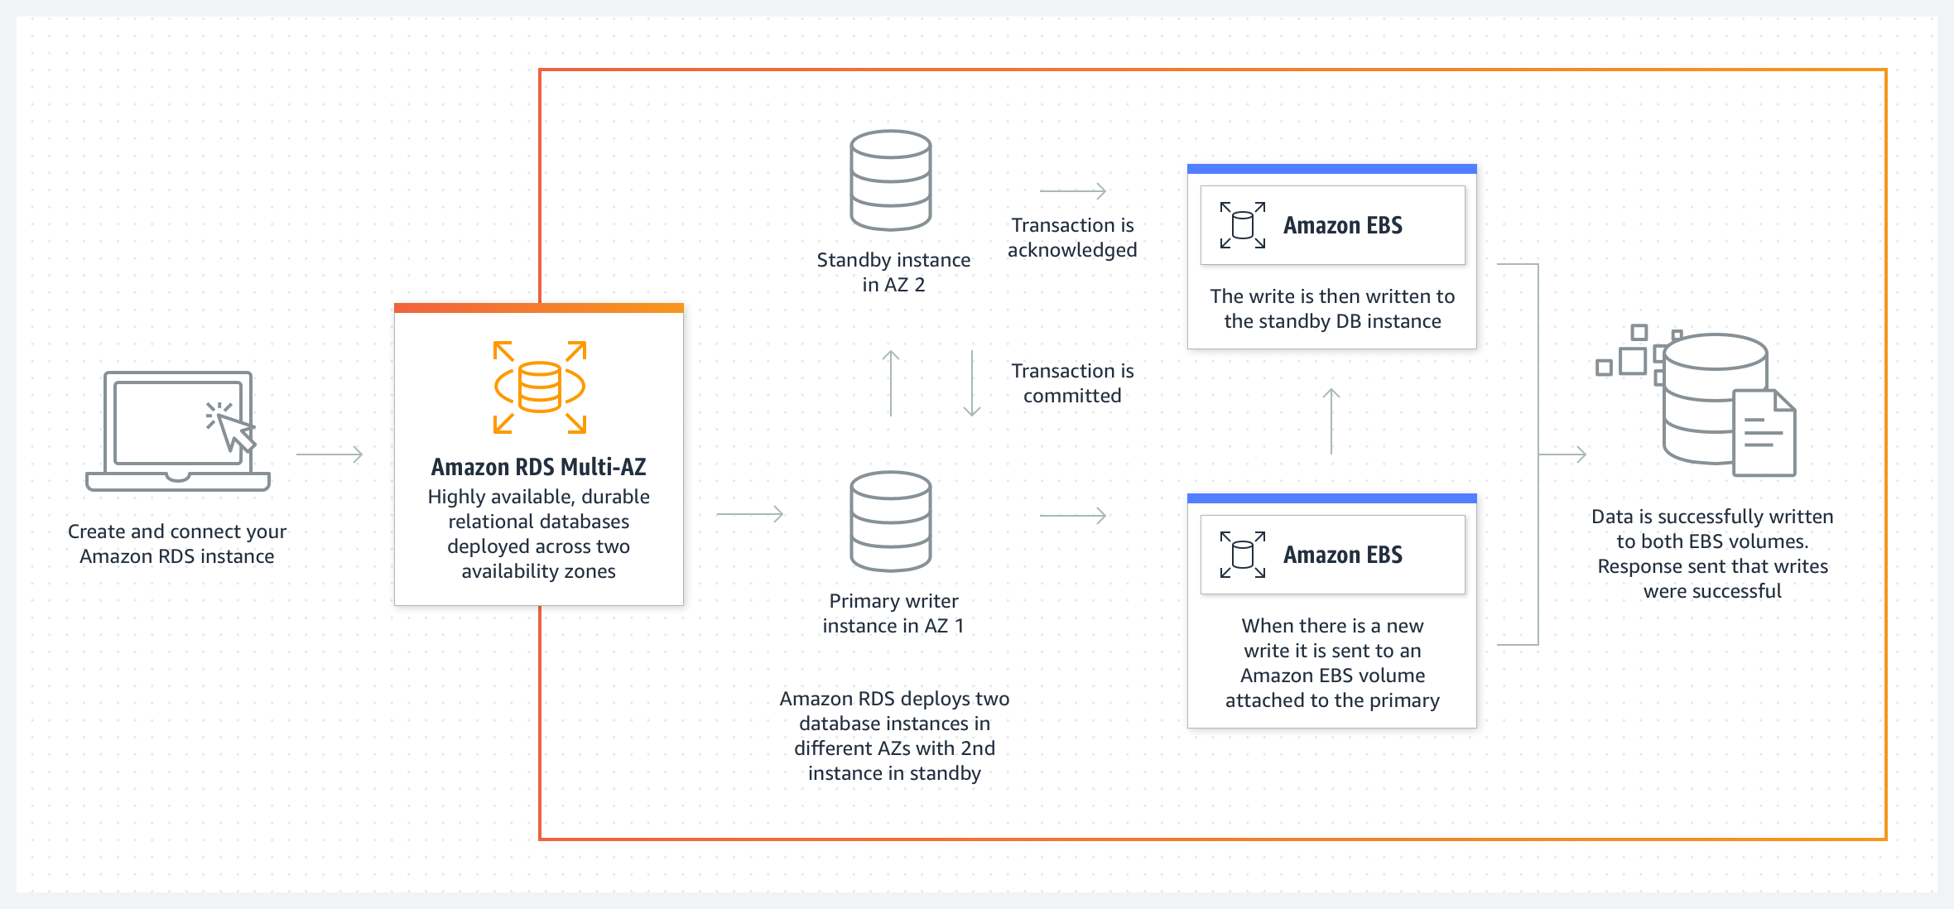

Amazon RDS Multi-AZ with two readable standbys

Automatically fail over in typically under 35 seconds | Use seperate endpoints for reads and writes | Gain up to 2x faster transaction commit latency | Increase read capacity
Automatically failover in typically under 35 seconds with zero data loss and with no manual intervention | Route queries to write servers and appropriate read replica standby instance to maximize performance and scalability | Achieve up to 2x improved write latency compared to multi-az with one standby. | Gain read scalability by distributing traffic across two readable standby instances.

How it works
Deploy highly available durable databases in three Azs using Amazon RDS Multi-AZ with two readable standbys. Gain automatic failovers in under 35 seconds, up to 2x faster transaction commit latency compared to amazon rds multi-az with one standby, additional read capacity.
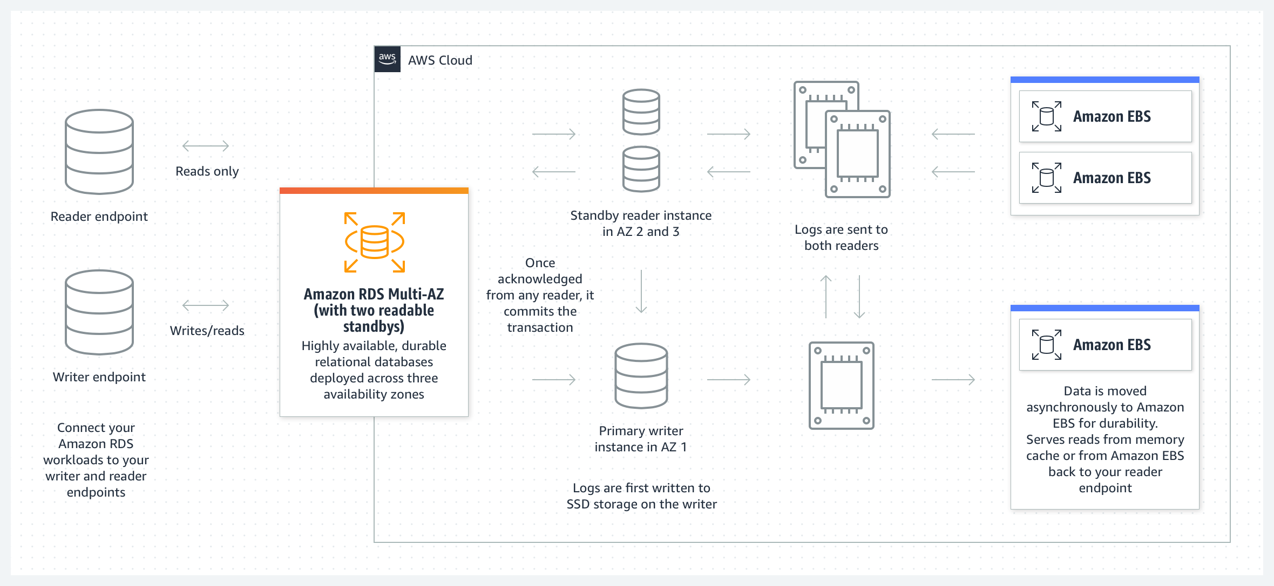

Law of divisibility, the greater the divisor the small the average, in this case, workload average will decrease with an increase in replicas db instance copies in other availability zones etc.

Reference: https://aws.amazon.com/rds/features/multi-az/

