4.) Try these commands, stash, reset soft, reset hard, diff, branch -d & -D - push each branch to the remote

Stash -
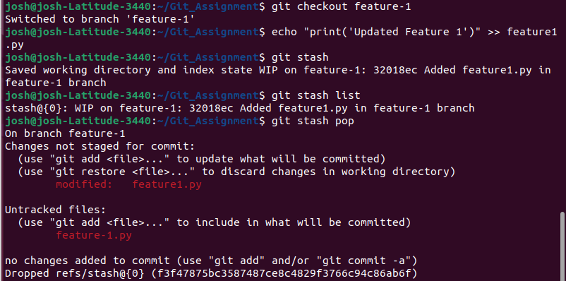

reset soft -

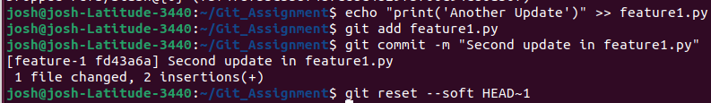
reset hard -

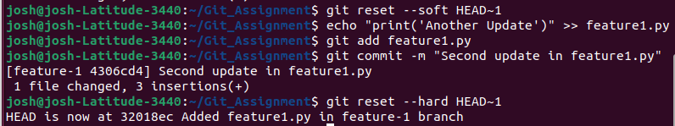
diff -

branch -d & -D -

git branch -d feature-1
git branch -D feature-2

push each branch to the remote -

